Analog and Mixed Signal
VLSI
Lab Record

Name:
USN:
Open terminal

> csh
> source cshrc.main
> cd cadence_labs
> cd cadence_analog_labs_613
> virtuoso &

INVERTER
Circuit Diagram
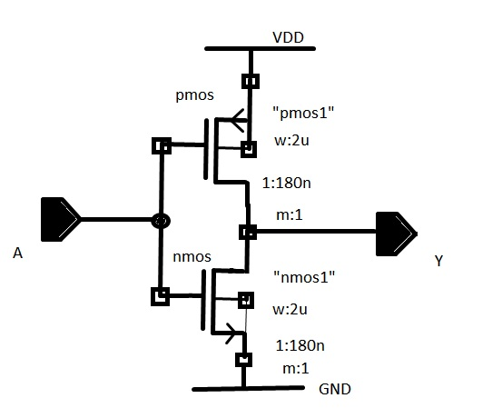
Creating a New Library
- In library manager execute FILE-NEW-Library
- In the “New Library” form, type “name”
- The field directory is set to ~/Database/cadence_analog_labs_613
- In the “Technology File For New Library” form, select “attach to an existing techfile”
- In the “attach Design Library To technology File” form select gpdk180.

Creating a Schematic Cellview
- In the Library Manager, execute File-New-Cellview.
- Fill the new file form as Name as “inverter”, View as “schematic”.

Adding Components to Schematic
- In the inverter schematic window, click instance.
- Click on the browse button.
- Select components and symbol view as give below

Library name | Cell name | Properties
gpdk180 | pmos | M0 : Model name = pmos1,W= 2u, L=180n
gpdk180 | nmos | M1 : Model name = nmos1,W= 2u, L=180n

Adding Pins to Schematic

- Click the Pin icon.
- Add the pins in the following order.

Pin names | Direction
Vin | Input
vout | Output

Adding Wires to Schematic

- Click Wires icon in the schematic view.
- Depending on the circuit diagram do the connections.

Symbol Creation

- In the inverter schematic window, execute Ceate-Cellview-From cellview.
- The From View Name is set to “schematic”, To view name set to “symbol” and Tool/Data Type set to Schematic Symbol.
- Modify the pin specifications based on the left, right, top and bottom pins.
- Click ok for symbol generation.

Creating the Inverter_Test Cellview

- In the library manager, execute File-New-Cellview.
- Click ok

Building the Inverter_Test Circuit

- In the Inverter_Test schematic window select Create-Instance.
- Select the components properties as given below.

Library name | Cellview name | Properties
name | Inverter | Symbol
analoglib | vpulse | v1=0, v2=1.8, td=0, tr=tf=1ns, ton=10n, T=20n
anloglib | vdc, gnd | vdc=1.8

Analog simulation

- To start the Simulation Environment, in the Inverter_Test schematic window, execute Launch-ADE L.
- In the simulation window(ADE) click Choose-Analysis icon.
- To setup transient analysis:
a) In the analysis section select tran.
b) Set the stop time to 20n.
c)Click the Moderate or Enabled button, and then click apply.
4) To setup DC analysis
a) In the analysis section select dc.
b) Select Save DC Operating Point.
c) Turn on Component Parameter.
d) Double click the Select Component.
e) Select input signal Vpulse for DC analysis.
f) Set start and stop values to 0 and 1.8 respectively.
g) Click apply.

Selecting Outputs to be Plotted

Execute Outputs-To be Plotted-Select on schematic and click on output net vout and input net vin.

Running The Simulation

Execute Simulation-Netlist and Run.

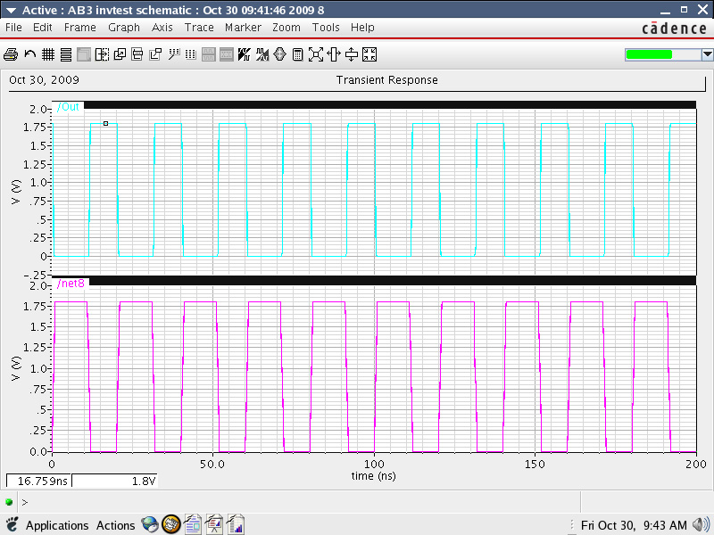

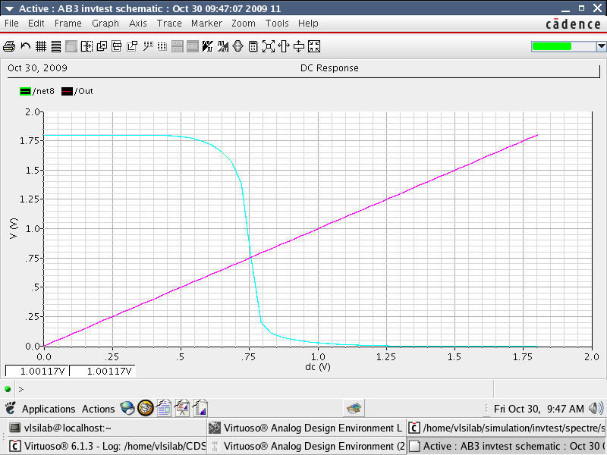

DIFFERENTIAL AMPLIFIER

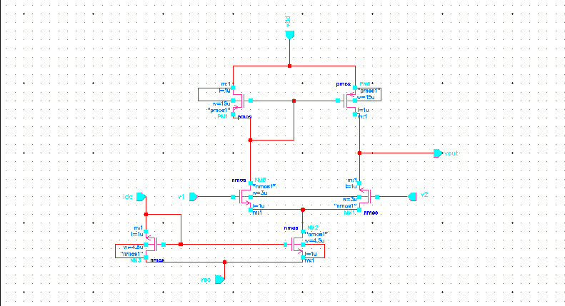

Creating a New Library
- In library manager execute FILE-NEW-Library
- In the “New Library” form, type “name”
- The field directory is set to ~/Database/cadence_analog_labs_613
- In the “Technology File For New Library” form, select “attach to an existing techfile”
- In the “attach Design Library To technology File” form select gpdk180.

Creating a Schematic Cellview
- In the Library Manager, execute File-New-Cellview.
- Fill the new file form as Name as “Diff_amp”, View as “schematic”.
Adding Components to Schematic
- In the inverter schematic window, click instance.
- Click on the browse button.
- Select components and symbol view as give below

Library name | Cell name | Properties
gpdk180 | nmos | Model Name=nmos1 (NM0,NM1), W=3u; L=1u;
gpdk180 | nmos | Model Name=nmos1 (NM2,NM3), W=4.5u; L=1u;
gpdk180 | pmos | Model Name=pmos1 (PM0,PM1), W=15u; L=1u;

Adding Pins to Schematic

- Click the Pin icon.
- Add the pins in the following order.
Pin names | Direction
Idc, V1, V2 | Input
Vout | Output
vdd, vss | Input

Adding Wires to Schematic

- Click Wires icon in the schematic view.
- Depending on the circuit diagram do the connections.

Symbol Creation

- In the inverter schematic window, execute Ceate-Cellview-From cellview.
- The From View Name is set to “schematic”, To view name set to “symbol” and Tool/Data Type set to Schematic Symbol.
- Modify the pin specifications based on the left, right, top and bottom pins.
- Click ok for symbol generation.

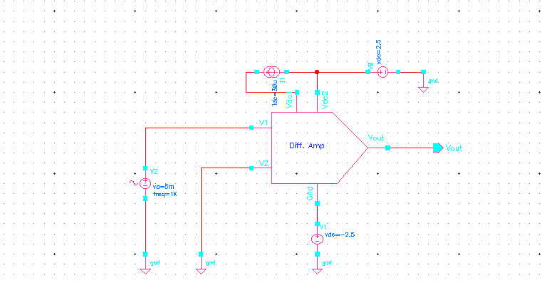

Creating the Diff_amp_Test Cellview

- In the library manager, execute File-New-Cellview.
- Click ok

Building the Diff_amp_Test Circuit

- In the Diff_amp _Test schematic window select Create-Instance.
- Select the components properties as given below.
Library name | Cellview name | Properties
name | Diff_Amp | Symbol
analogLib | vsin | AC magnitude =1, Amplitude =5m, Frequency =1K.
analogLib | vdd, vss, gnd | Vdd=2.5, Vss=-2.5
analogLib | Idc | Dc current = 30u

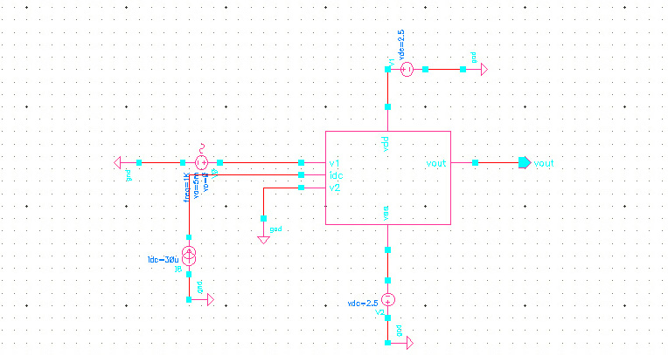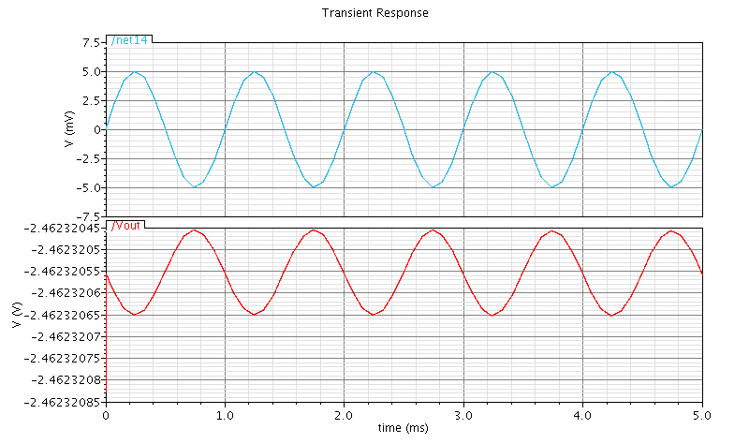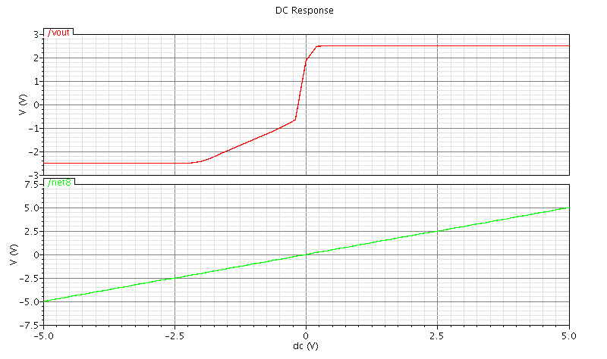

Analog simulation

- To start the Simulation Environment, in the Inverter_Test schematic window, execute Launch-ADE L.
- In the simulation window(ADE) click Choose-Analysis icon.
- To setup transient analysis:
a) In the analysis section select tran.
b) Set the stop time to 5m.
c) Click the Moderate or Enabled button, and then click apply.
4) To setup DC analysis
a) In the analysis section select dc.
b) Select Save DC Operating Point.
c) Turn on Component Parameter.
d) Double click the Select Component.
e) Select input signal Vsin for DC analysis.
f) Set start and stop values to -5 and 5 respectively.
g) Click apply.

- To setup AC analysis
- In the Analysis section select, ac.
- In AC Analysis section, turn on Frequency.
- In sweep range, select start and stop frequencies as 150 to 100M.
- Select points per decade as 20.
- Click apply.

Selecting Outputs to be Plotted

Execute Outputs-To be Plotted-Select on schematic and click on output net vout and input net vin.

Running The Simulation

Execute Simulation-Netlist and Run.

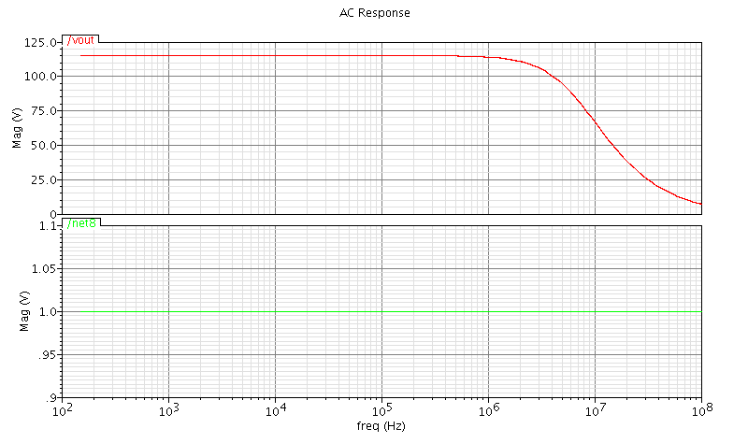

COMMON SOURCE AMPLIFIER

Schematic symbol
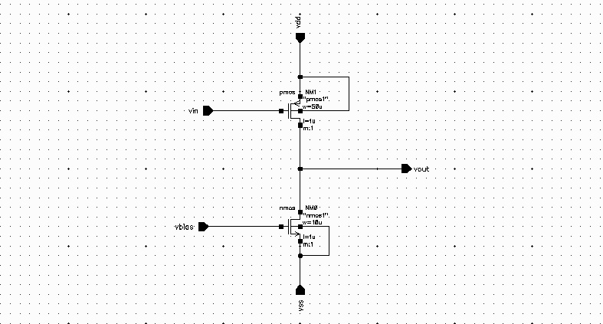
Creating a New Library
- In library manager execute FILE-NEW-Library
- In the “New Library” form, type “name”
- The field directory is set to ~/Database/cadence_analog_labs_613
- In the “Technology File For New Library” form, select “attach to an existing techfile”
- In the “attach Design Library To technology File” form select gpdk180.

Creating a Schematic Cellview
- In the Library Manager, execute File-New-Cellview.
- Fill the new file form as Name as “Comsrc_amp”, View as “schematic”.
Adding Components to Schematic
- In the schematic window, click instance.
- Click on the browse button.
- Select components and symbol view as give below

Library name | Cell name | Properties
gpdk180 | nmos | Model Name=nmos1 (NM2,NM3), W=10u; L=1u;
gpdk180 | pmos | Model Name=pmos1 (PM0,PM1), W=50u; L=1u;

Adding Pins to Schematic

- Click the Pin icon.
- Add the pins in the following order.
Pin names | Direction
Vin | Input
Vout | Output
vdd, vss | Input

Adding Wires to Schematic

- Click Wires icon in the schematic view.
- Depending on the circuit diagram do the connections.

Symbol Creation

- In the inverter schematic window, execute Ceate-Cellview-From cellview.
- The From View Name is set to “schematic”, To view name set to “symbol” and Tool/Data Type set to Schematic Symbol.
- Modify the pin specifications based on the left, right, top and bottom pins.
- Click ok for symbol generation.

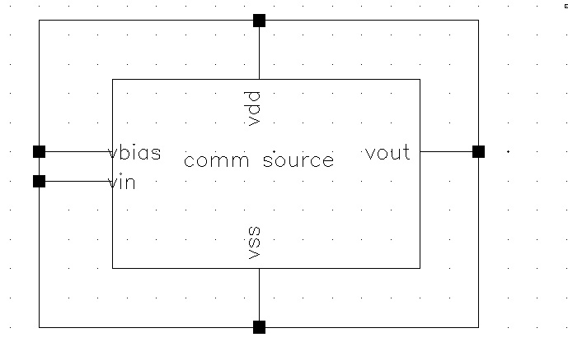
Creating the Comsrc_amp_Test Cellview

- In the library manager, execute File-New-Cellview.
- Click ok

Building the Comsrc _amp_Test Circuit

- In the Comsrc_amp_Test schematic window select Create-Instance.
- Select the components properties as given below.
Library name | Cellview name | Properties
name | Comsrc_amp | Symbol
analogLib | vsin | AC magnitude =1, Amplitude =5m, Frequency =1K.
analogLib | vdd, vss, gnd | Vdd=2.5, Vss=-2.5

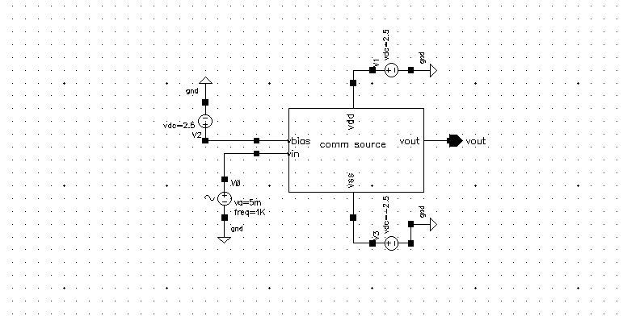
Analog simulation

- To start the Simulation Environment, in the Inverter_Test schematic window, execute Launch-ADE L.
- In the simulation window(ADE) click Choose-Analysis icon.
- To setup transient analysis:
  - In the analysis section select tran.
  - Set the stop time to 5m.
  - Click the Moderate or Enabled button, and then click apply.
- To setup DC analysis
  - In the analysis section select dc.
  - Select Save DC Operating Point.
  - Turn on Component Parameter.
  - Double click the Select Component.
  - Select input signal Vsin for DC analysis.
  - Set start and stop values to -5 and 5 respectively.
  - Click apply.

- To setup AC analysis
- In the Analysis section select, ac.
- In AC Analysis section, turn on Frequency.
- In sweep range, select start and stop frequencies as 150 to 100M.
- Select points per decade as 20.
- Click apply.

Selecting Outputs to be Plotted

Execute Outputs-To be Plotted-Select on schematic and click on output net vout and input net vin.

Running The Simulation

Execute Simulation-Netlist and Run.

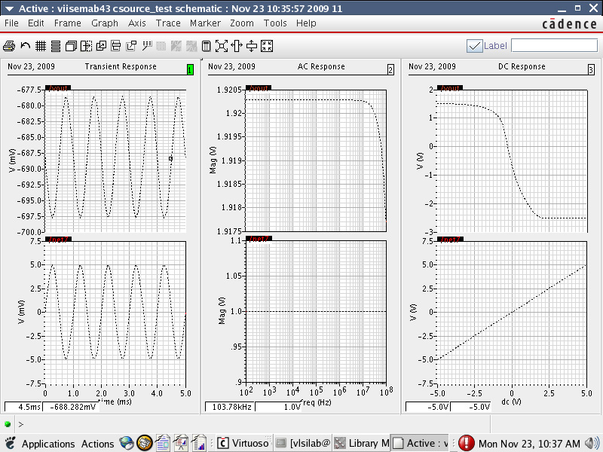

Common Drain
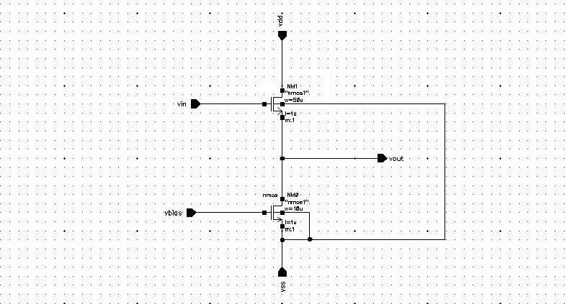
Creating a New Library
- In library manager execute FILE-NEW-Library
- In the “New Library” form, type “name”
- The field directory is set to ~/Database/cadence_analog_labs_613
- In the “Technology File For New Library” form, select “attach to an existing techfile”
- In the “attach Design Library To technology File” form select gpdk180.

Creating a Schematic Cellview
- In the Library Manager, execute File-New-Cellview.
- Fill the new file form as Name as “Comdrn_amp”, View as “schematic”.
Adding Components to Schematic
- In the schematic window, click instance.
- Click on the browse button.
- Select components and symbol view as give below

Library name | Cell name | Properties
gpdk180 | nmos | Model Name=nmos1 (NM2,NM3), W=10u; L=1u;
gpdk180 | nmos | Model Name=pmos1 (PM0,PM1), W=50u; L=1u;

Adding Pins to Schematic

- Click the Pin icon.
- Add the pins in the following order.
Pin names | Direction
Vin,Vbias | Input
Vout | Output
vdd, vss | Input

Adding Wires to Schematic

- Click Wires icon in the schematic view.
- Depending on the circuit diagram do the connections.

Symbol Creation

- In the schematic window, execute Ceate-Cellview-From cellview.
- The From View Name is set to “schematic”, To view name set to “symbol” and Tool/Data Type set to Schematic Symbol.
- Modify the pin specifications based on the left, right, top and bottom pins.
- Click ok for symbol generation.

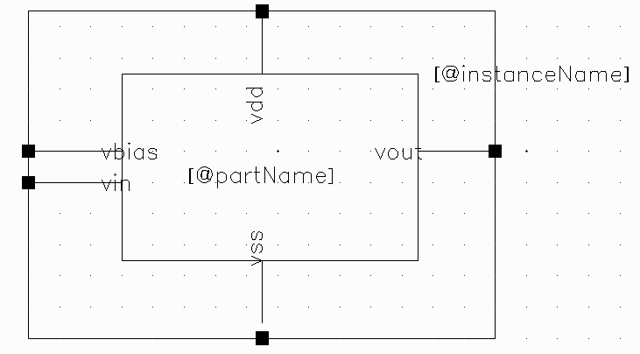
Creating the Comdrn_amp_Test Cellview

- In the library manager, execute File-New-Cellview.
- Click ok

Building the Comdrn _amp_Test Circuit

- In the Comsrc_amp_Test schematic window select Create-Instance.
- Select the components properties as given below.
Library name | Cellview name | Properties
name | Comdrn_amp | Symbol
analogLib | vsin | AC magnitude =1, Amplitude =5m, Frequency =1K.
analogLib | vdd, vss, gnd | Vdd=2.5, Vss=-2.5

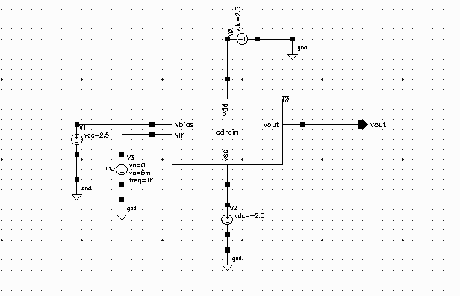
Analog simulation

To start the Simulation Environment, in the Inverter_Test schematic window, execute Launch-ADE L.

In the simulation window(ADE) click Choose-Analysis icon.

To setup transient analysis:

- In the analysis section select tran.
- Set the stop time to 5m.
- Click the Moderate or Enabled button, and then click apply.

To setup DC analysis

- In the analysis section select dc.
- Select Save DC Operating Point.
- Turn on Component Parameter.
- Double click the Select Component.
- Select input signal Vsin for DC analysis.
- Set start and stop values to -5 and 5 respectively.
- Click apply.

To setup AC analysis

In the Analysis section select, ac.
- In AC Analysis section, turn on Frequency.
- In sweep range, select start and stop frequencies as 150 to 100M.
- Select points per decade as 20.
- Click apply.

Selecting Outputs to be Plotted

Execute Outputs-To be Plotted-Select on schematic and click on output net vout and input net vin.

Running The Simulation

Execute Simulation-Netlist and Run.

