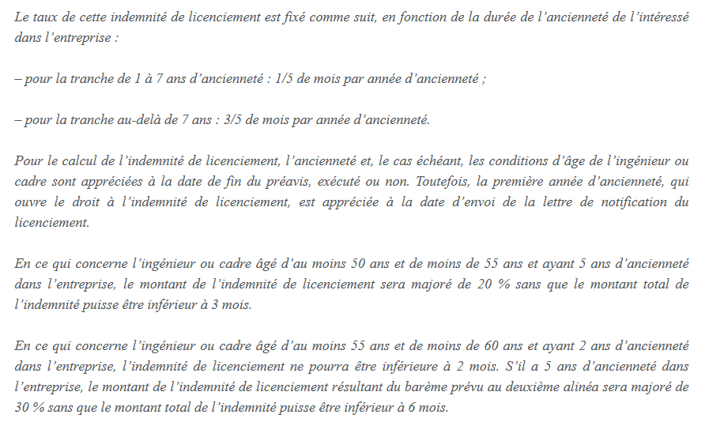
3800 * (1/5) * 7 = 5320
3800 * (3/5) * 5 = 11400
Soit 16720 euros + 3 * 3800 = 28120 euros

