P1 (0 1 ) P2(1 3)

Y = mx + b
http://www.mathsisfun.com/data/straight_line_graph.html
http://www.mathsisfun.com/straight-line-graph-calculate.html
http://www.webmath.com/equline1.html

Pour un triangle rectangle isocèle
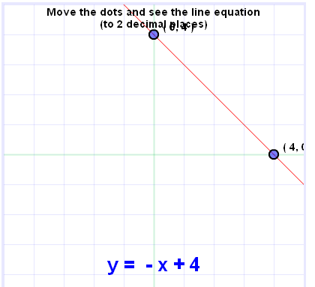

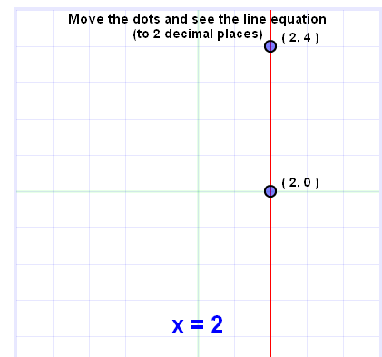

Y = -X + 4
X + 0y = 2

X + Y = 271.31
X + 0y = 15
Y = 256.31

Solution : hauteur_max = H – 10 sqrt(2) - i * step – 0.5 *step

Step = 10.0
hauteur_max = H – 10 sqrt(2) - i * step – 0.5 *step = 256.31
nb_slot = hauteur_max / 45 = 5.69
nb_slot *25 + (nb_slot – 1) 20 = 205
bord = (256.31 – 205) / 2 = 25.65
If(bord > 10 then
nb_slot = nb_slot + 1
ecart = nb_slot -1

256.31 -10 – 6*25 – 5 *x = 0
)

19.62 * 5 = 98.1
6 * 25 = 150

p1x = car(nth(0 points))
p1y = cadr(nth(0 points))
p2x = car(nth(1 points))
p2y = cadr(nth(1 points))
p3x = car(nth(2 points))
p3y = cadr(nth(2 points))

(631 413.48) (511.05 533.43) (511.05 413.48)
N1 = p2y – p1y
D1 = p2x – p1x
N2 = p3y – p2y
D2 = p3x – p2x
N3 = p3y – p1y
D3 = p3x – p1x
if(N1 != 0 && D1 != 0 then
coef1 = “non”
)
if(N1 != 0 && D1 == 0 then
coef1 = “V”
)
If(N1 == 0 && D1 != 0 then
coef1 = “H”
)
If(N2 != 0 && D2 != 0 coef 2 = “non”
If(N2 != 0 && D2 == 0 coef 2 = “V”
If(N2 == 0 && D2 != 0 coef 2 = “H”

If(N3 != 0 && D3 != 0 coef 3 = “non”
If(N3 != 0 && D3 == 0 coef 3 = “V”
If(N3 == 0 && D3 != 0 coef 3 = “H”

If(coef 1 == V && coef 2 == H then
)
If(coef 1 == H && coef 2 == V

If(coef 2 == V && coef 3 == H
If(coef 2 == H && coef 3 == V
If(coef 1 == V && coef 3 == H
If(coef 1 == H && coef 3 == V

(631 413.48) (511.05 533.43) (511.05 413.48)

