android php server send notification
https://inducesmile.com/android/android-push-notifications-using-google-cloud-messaging-gcm-php-mysql-and-okhttp-square-open-source/
https://gist.github.com/prime31/5675017
http://hmkcode.com/android-parsing-json-data/
https://olegoaer.developpez.com/tutos/mobile/android/rpc/
http://www.coderzheaven.com/2012/07/14/http-call-repeatedly-service-android/

scheduler consomme peu de ressource !
https://gist.github.com/BrandonSmith/6679223
http://www.singhajit.com/schedule-local-notification-in-android/

http://www.vogella.com/tutorials/AndroidTaskScheduling/article.html
https://github.com/anggadarkprince/scheduler-android/blob/master/app/src/main/java/com/sketchproject/scheduler/fragment/ScreenSchedule.java +++

https://www.sanfoundry.com/java-android-program-start-service-every-hour/
http://www.zoftino.com/android-job-scheduler-example
https://github.com/stefanklumpp/Simple-HTTP-Client
http://blog.teamtreehouse.com/scheduling-work-jobscheduler

http://ticketmastermobilestudio.com/blog/how-to-use-androids-job-scheduler +++
avec les sources https://github.com/twotoasters/toastdroid/tree/master/chris/how_to_use_jobscheduler

https://google-developer-training.gitbooks.io/android-developer-fundamentals-course-practicals/content/en/Unit%203/83_p_job_scheduler.html
http://android-er.blogspot.fr/2015/05/example-of-jobscheduler-and-jobservice.html

https://github.com/tutsplus/Android-JobSchedulerAPI/tree/master/app/src/main
https://github.com/AdeWijaNugraha/JobScheduler/blob/master/app/src/main/java/com/awn/app/myjobscheduler/GetCurrentWeatherJobService.java +++

Scheduling Work Within Your Application Process
https://en.proft.me/2017/10/19/scheduling-operations-jobscheduler-android/

http://android-er.blogspot.fr/2015/05/set-requirement-of-jobscheduler-i-am.html ++++

http://saurabhsharma123k.blogspot.fr/2017/02/task-scheduling-in-android-via.html +++
https://catinean.com/2014/10/19/smart-background-tasks-with-jobscheduler/ +++
https://google-developer-training.gitbooks.io/android-developer-fundamentals-course-practicals/content/en/Unit%203/83_p_job_scheduler.html +++
https://github.com/google-developer-training/android-fundamentals/tree/master/NotificationScheduler +++

http://www.devexchanges.info/2015/05/simple-using-jobscheduler-api-on.html ++++

https://openclassrooms.com/courses/recuperez-et-affichez-des-donnees-distantes/planifier-des-taches-asynchrones

https://www.mytrendin.com/introduction-job-scheduler-android/ source ++++

http://android-er.blogspot.fr/2015/05/set-requirement-of-jobscheduler-i-am.html a essai absolument ++++
https://androidexample.com/Create_Repeating_Alarm_Start_After_Each_2_Minutes/index.php?view=article_discription&aid=93 avec alarmmanager ++++

https://github.com/evernote/android-job ++++ library
https://stackoverflow.com/questions/42084112/android-job-scheduler-not-persisted-on-reboot/42084205
http://koor.fr/Java/Android/BootCompleted.wp
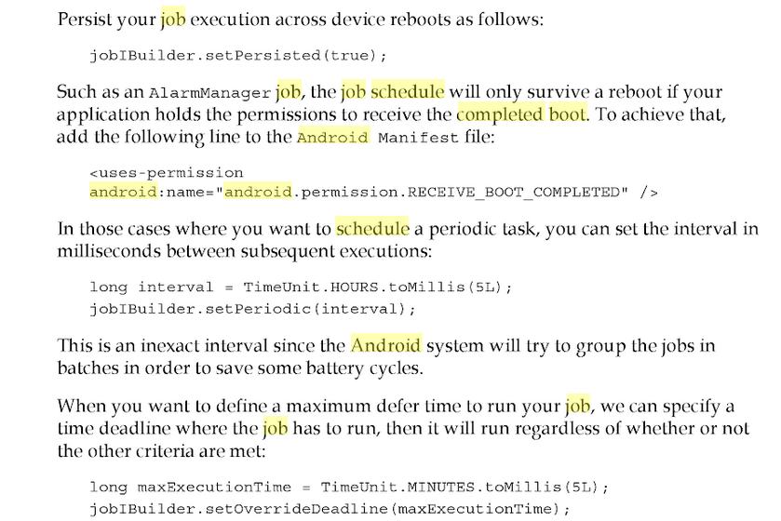

http://thecodersbreakfast.net/index.php?post/2011/01/04/Au-coeur-du-JDK-%3A-TimeUnit

android.permission.RECEIVE_BOOT_COMPLETED

https://www.dev2qa.com/android-one-time-repeat-alarm-example/

