http://abhiandroid.com/ui/baseadapter-tutorial-example.html
https://github.com/codepath/android_guides/wiki/Using-a-BaseAdapter-with-ListView
http://android.pcsalt.com/listview-using-baseadapter-android/
http://blog.nkdroidsolutions.com/android-custom-listview-example-with-baseadapter-android-tutorials/
http://theopentutorials.com/tutorials/android/listview/android-custom-listview-with-image-and-text-using-baseadapter/
http://gaudicos.blogspot.fr/2013/10/simple-adapter-hashmap.html
http://hmkcode.com/android-custom-listview-items-row/

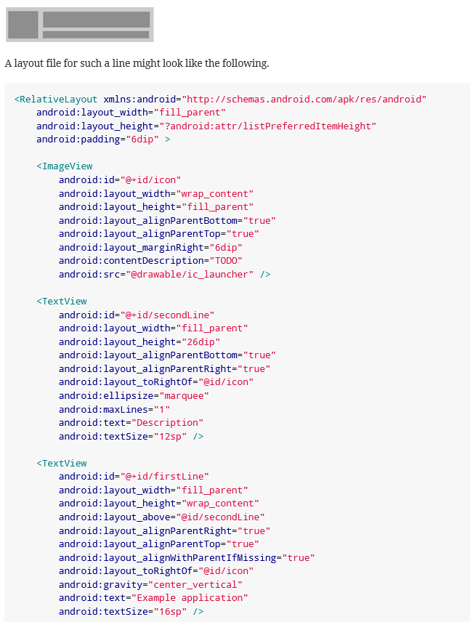

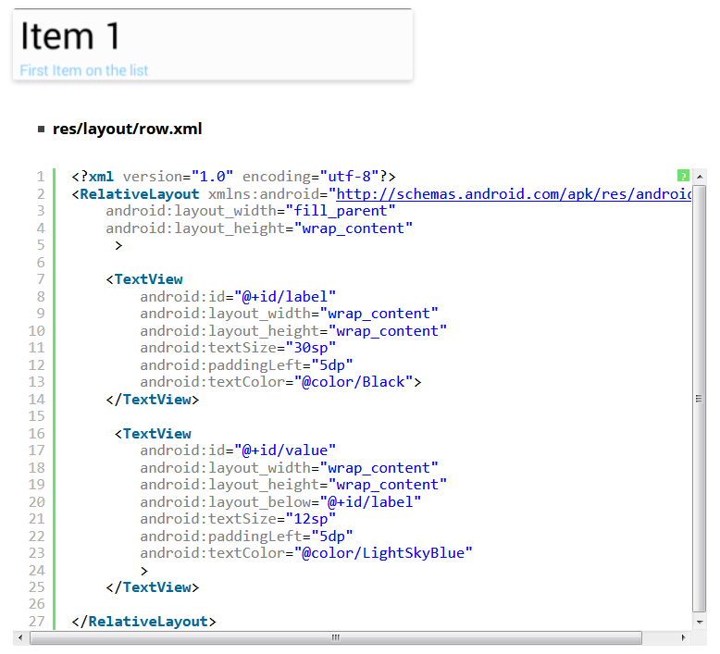

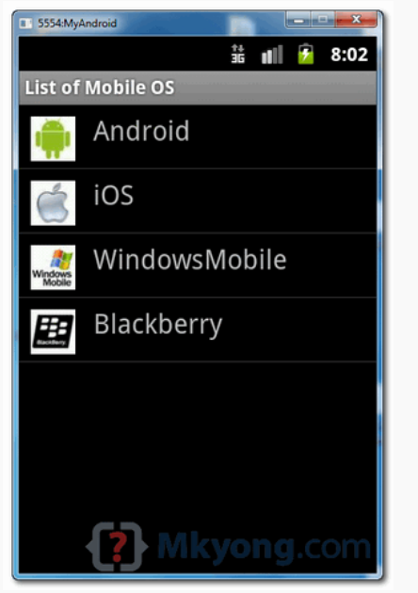

https://www.journaldev.com/10416/android-listview-with-custom-adapter-example-tutorial

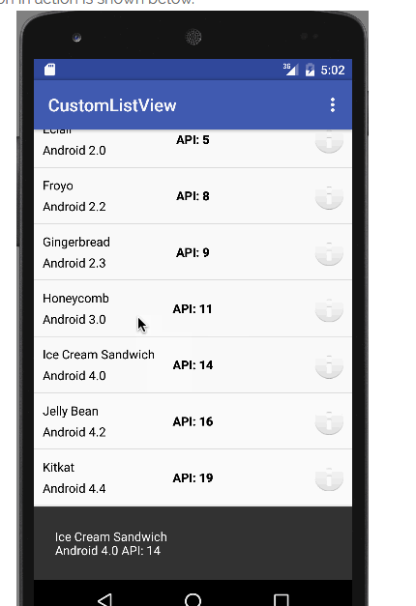

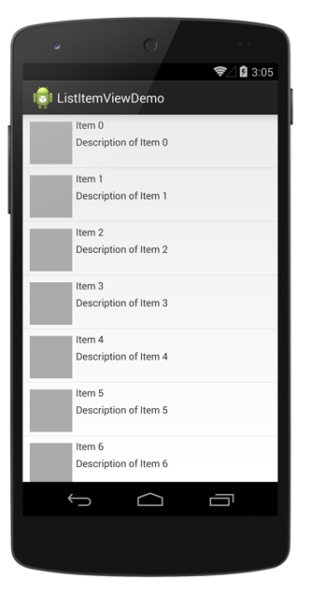

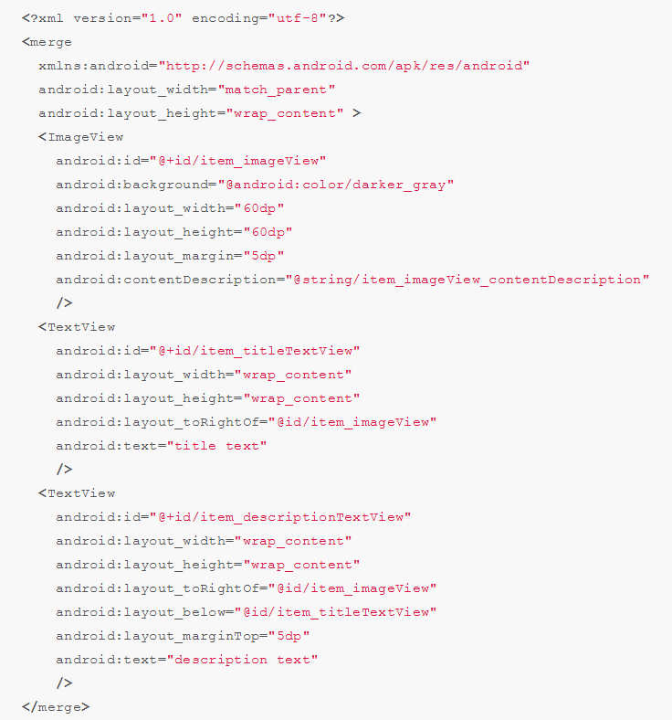
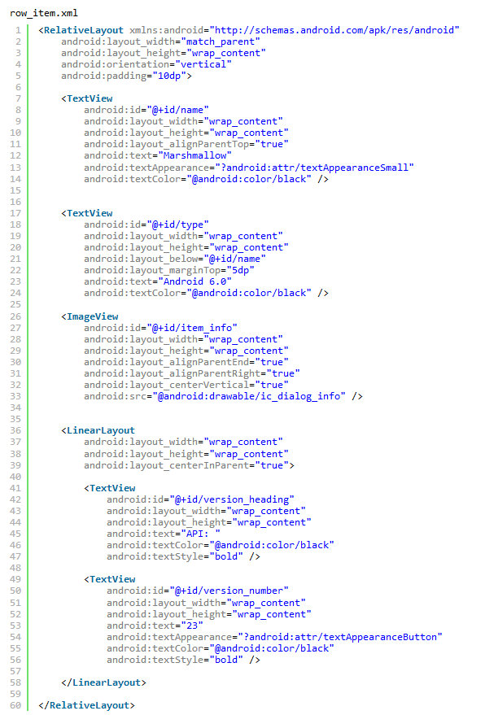

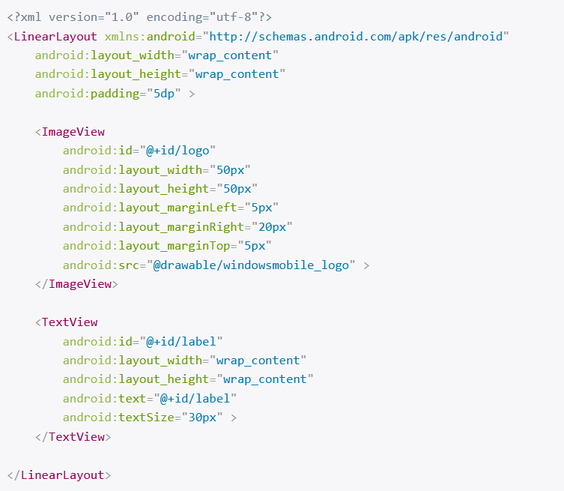

http://tutos-android-france.com/listview-afficher-une-liste-delements/

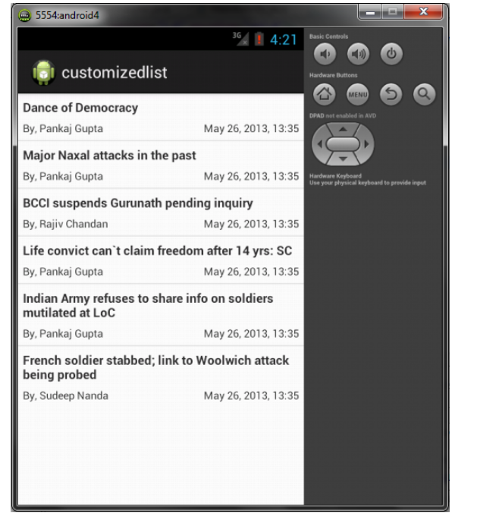

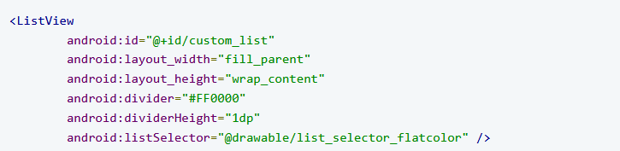

http://stacktips.com/tutorials/android/android-listview-tutorial

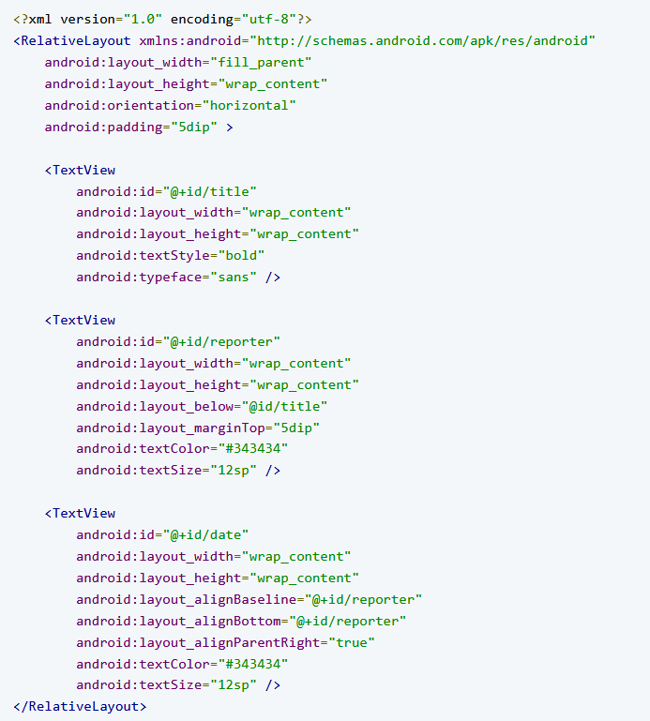

http://techlovejump.com/android-multicolumn-listview/

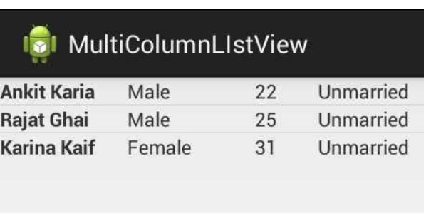

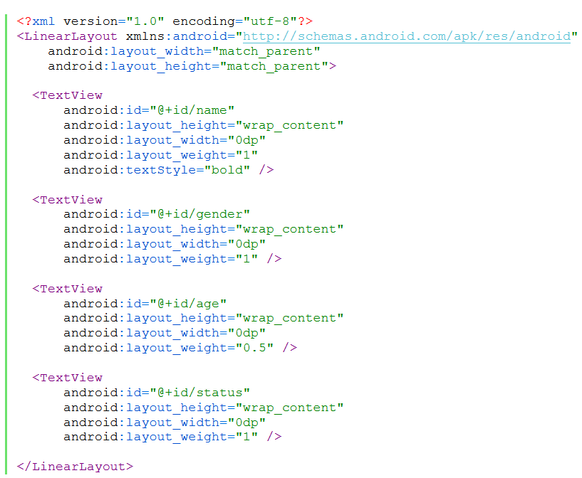

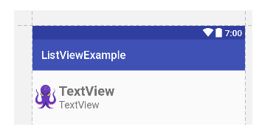

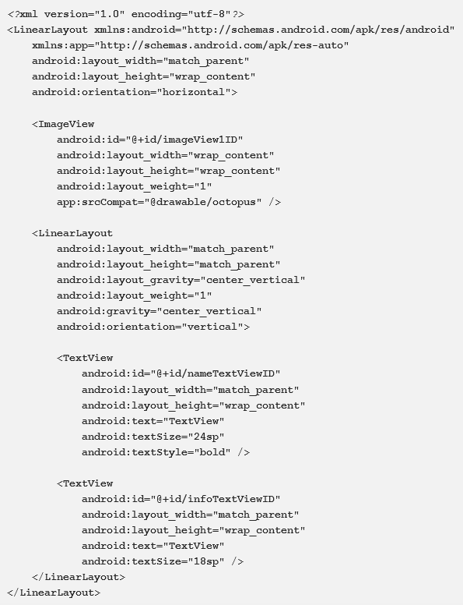

http://www.dev2qa.com/android-listview-example/

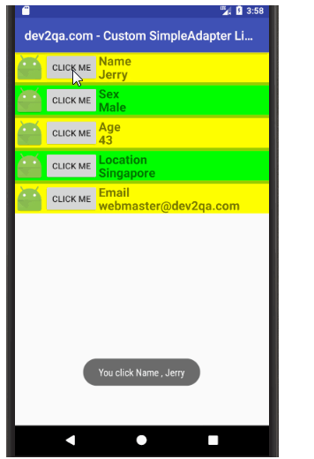

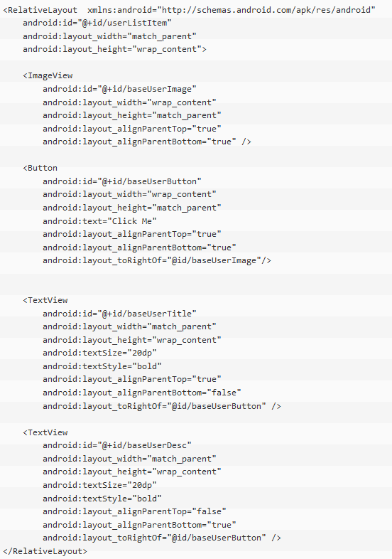

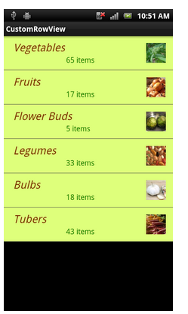

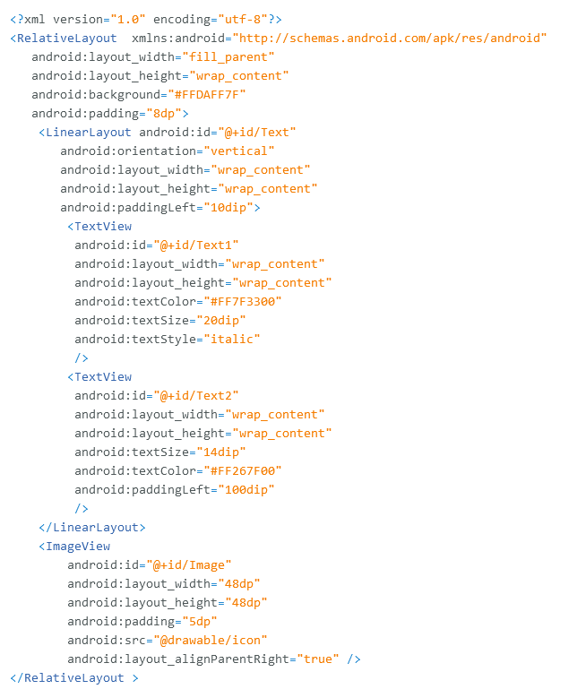

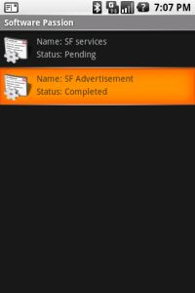

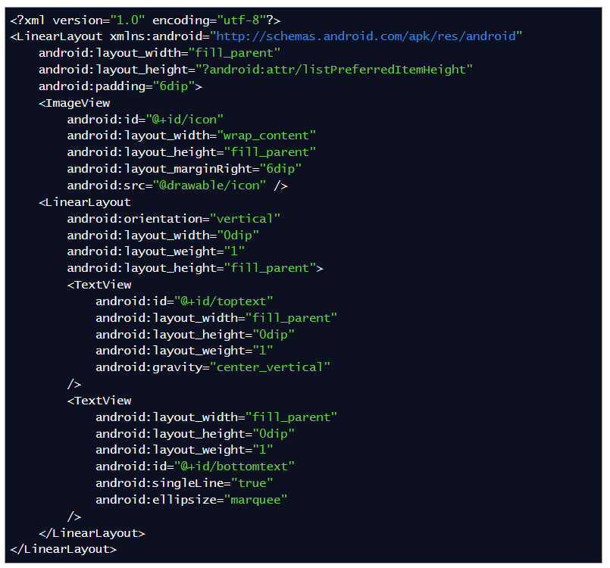

http://abhiandroid.com/ui/listview

http://www.androidinterview.com/android-custom-listview-with-image-and-text-using-arrayadapter/
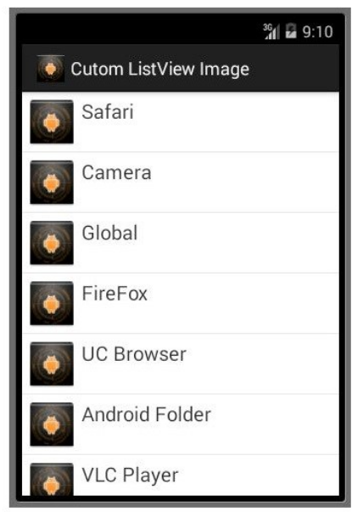

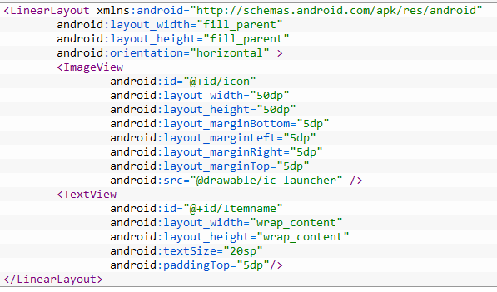

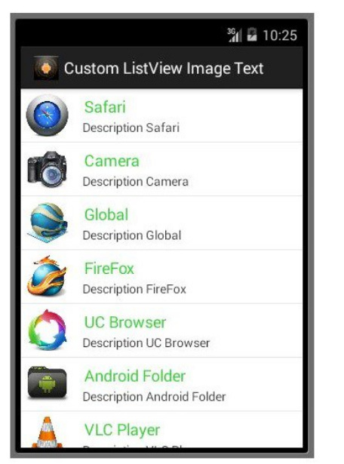

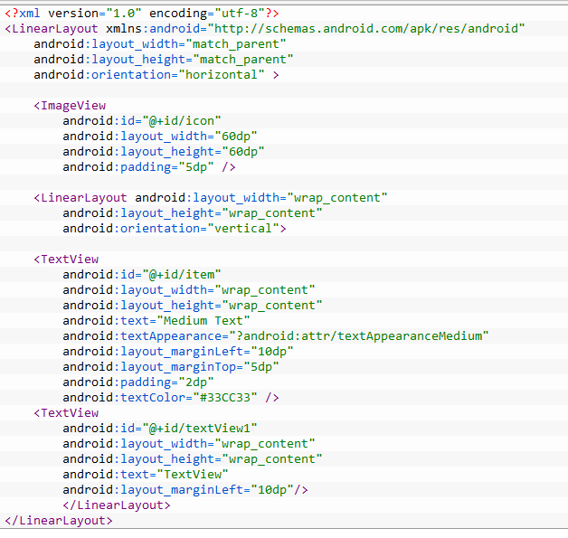

http://www.ezzylearning.com/tutorial/customizing-android-listview-items-with-custom-arrayadapter

https://www.androidhive.info/2012/02/android-custom-listview-with-image-and-text/

https://www.codeproject.com/Articles/507651/Customized-Android-ListView-with-Image-and-Text
https://inducesmile.com/android/how-to-set-recycleview-item-row-background-color-in-android/

