XML examples
<?xml version="1.0" encoding="utf-8"?>
<RelativeLayout xmlns:android="http://schemas.android.com/apk/res/android"
xmlns:tools="http://schemas.android.com/tools"
android:id="@+id/activity_main"
android:layout_width="match_parent"
android:layout_height="match_parent"
android:paddingBottom="@dimen/activity_vertical_margin"
android:paddingLeft="@dimen/activity_horizontal_margin"
android:paddingRight="@dimen/activity_horizontal_margin"
android:paddingTop="@dimen/activity_vertical_margin"
tools:context="com.example.edittextexample.MainActivity">

<EditText
android:id="@+id/editText1"
android:layout_width="wrap_content"
android:layout_height="wrap_content"
android:layout_alignParentLeft="true"
android:layout_alignParentStart="true"
android:layout_alignParentTop="true"
android:layout_marginLeft="50dp"
android:layout_marginStart="50dp"
android:layout_marginTop="24dp"
android:ems="10"
android:hint="@string/name"
android:inputType="textPersonName"
android:selectAllOnFocus="true" />

<EditText
android:id="@+id/editText2"
android:layout_width="wrap_content"
android:layout_height="wrap_content"
android:layout_alignLeft="@+id/editText1"
android:layout_alignStart="@+id/editText1"
android:layout_below="@+id/editText1"
android:layout_marginTop="19dp"
android:ems="10"
android:hint="@string/password_0_9"
android:inputType="numberPassword" />

<EditText
android:id="@+id/editText3"
android:layout_width="wrap_content"
android:layout_height="wrap_content"
android:layout_alignLeft="@+id/editText2"
android:layout_alignStart="@+id/editText2"
android:layout_below="@+id/editText2"
android:layout_marginTop="12dp"
android:ems="10"
android:hint="@string/e_mail"
android:inputType="textEmailAddress" />

<EditText
android:id="@+id/editText4"
android:layout_width="wrap_content"
android:layout_height="wrap_content"
android:layout_alignLeft="@+id/editText3"
android:layout_alignStart="@+id/editText3"
android:layout_below="@+id/editText3"
android:layout_marginTop="18dp"
android:ems="10"
android:hint="@string/date"
android:inputType="date" />

<EditText
android:id="@+id/editText5"
android:layout_width="wrap_content"
android:layout_height="wrap_content"
android:layout_alignLeft="@+id/editText4"
android:layout_alignStart="@+id/editText4"
android:layout_below="@+id/editText4"
android:layout_marginTop="18dp"
android:ems="10"
android:hint="@string/contact_number"
android:inputType="phone" />

<Button
android:id="@+id/button"
style="@android:style/Widget.Button"
android:layout_width="match_parent"
android:layout_height="wrap_content"
android:layout_alignParentLeft="true"
android:layout_alignParentStart="true"
android:layout_below="@+id/editText5"
android:layout_marginTop="62dp"
android:text="@string/submit"
android:textSize="16sp"
android:textStyle="normal|bold" />
</RelativeLayout>

http://abhiandroid.com/ui/edittext
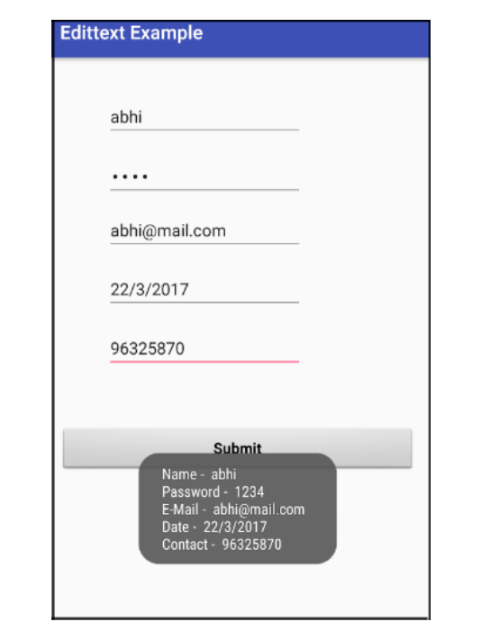
https://github.com/nostra13/Android-Universal-Image-Loader
http://www.thaicreate.com/mobile/android-download-listview-progress-unit.html
https://github.com/Trinea/android-open-project/tree/master/English%20Version
https://jmsliu.com/1431/download-images-by-asynctask-in-listview-android-example.html
https://androidexample.com/Download_Images_From_Web_And_Lazy_Load_In_ListView_-_Android_Example/index.php?view=article_discription&aid=112
https://dzone.com/articles/android-listview-optimizations-0
http://www.technotalkative.com/android-asynchronous-image-loading-in-listview/

http://antoine-merle.com/listview-optimisations-part-2-displaying-images-in-your-lists/
https://www.simplifiedcoding.net/custom-listview-android/
http://wptrafficanalyzer.in/blog/android-lazy-loading-images-and-text-in-listview-from-http-json-data/
https://inducesmile.com/android/android-upload-image-to-remote-server-and-download-image-from-remote-server-to-external-storage/

