Verilog tips
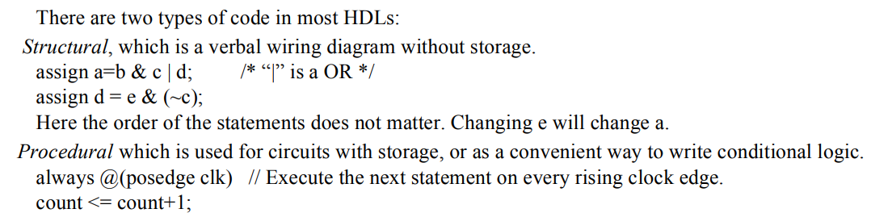

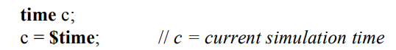

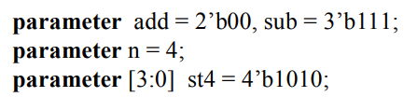

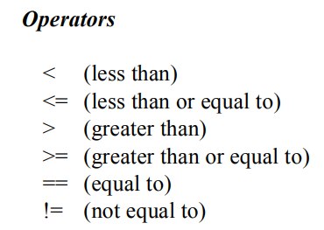

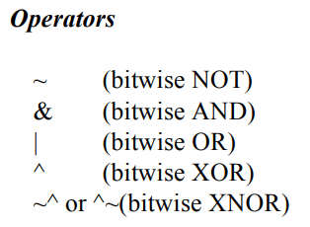
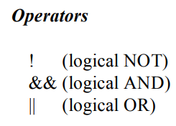

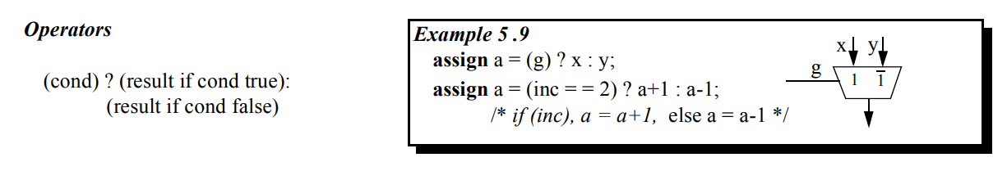

Continous assignment
The continuous assignment is used to assign a value onto a wire in a module. It is the normal assignment outside of always or initial blocks (See Sect. 10. ). Continuous assignment is done with an explicit assign statement or by assigning a value to a wire during its declaration. Note that continuous assignment statements are concurrent and are continuously executed during simulation. The order of assign statements does not matter. Any change in any of the right-hand-side inputs will immediately change a left-hand-side output.

Procedural Assignments
Procedural assignments are assignment statements used within Verilog procedures (always and initial blocks). Only reg variables and integers (and their bit/part-selects and concatenations) can be placed left of the “=” in procedures. The right hand side of the assignment is an expression which may use any of the operator types.

Blocking Assignments
Procedural (blocking) assignments (=) are done sequentially in the order the statements are written. A second assignment is not started until the preceding one is complete
Nonblocking (RTL) Assignments
RTL (nonblocking) assignments (<=), which follow each other in the code, are started in parallel. The right hand side of nonblocking assignments is evaluated starting from the completion of the last blocking assignment or if none, the start of the procedure. The transfer to the left hand side is made according to the delays. An intra-assignment delay in a non-blocking statement will not delay the start of any subsequent statement blocking or non-blocking. However a normal delays will are cummulative and will delay the output.

Event Control, @

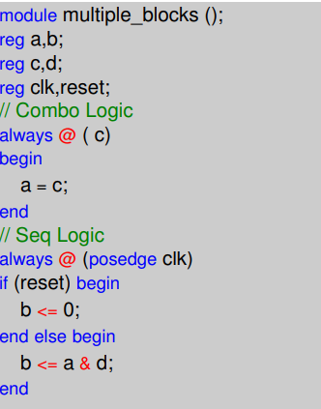

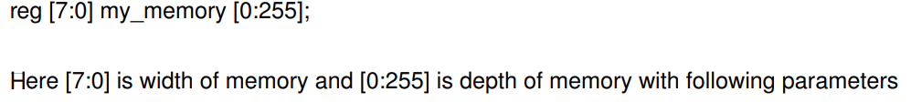
Shared variables in modules ????
Variables written to by multiple processes create shared resource conflicts

Gotchas 101 Common Coding Errors and How to Avoid Them

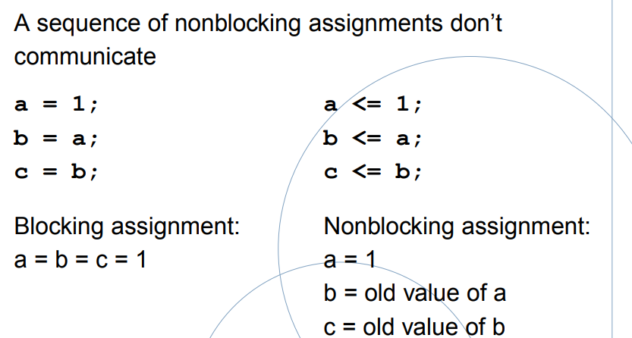

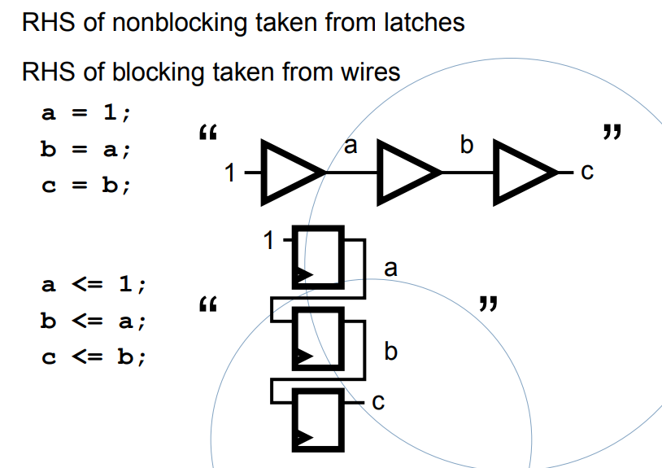

http://vol.verilog.com/VOL/main.htm

reg z; register vector called invect

always @ (x1 or x2 or x3)
begin
z = x1 | x2 | x3;
end

assign z = x1 | x2 | x3;

https://books.google.fr/books?id=yAlEDwAAQBAJ&pg=SA4-PA126&lpg=SA4-PA126&dq=verilog+event+control+changed+value&source=bl&ots=zG-6uScLWr&sig=ACfU3U2prIOZ2xKBmXW3Er0NBHHaSdYbHw&hl=fr&sa=X&ved=2ahUKEwj-tZvenuPgAhVo1-AKHdMcDA84ChDoATAAegQIABAB#v=onepage&q=verilog%20event%20control%20changed%20value&f=false

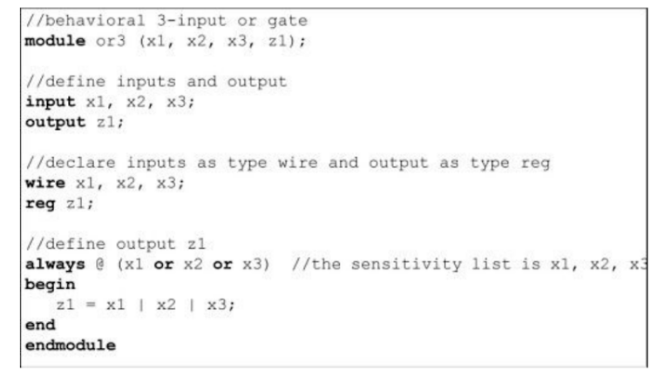

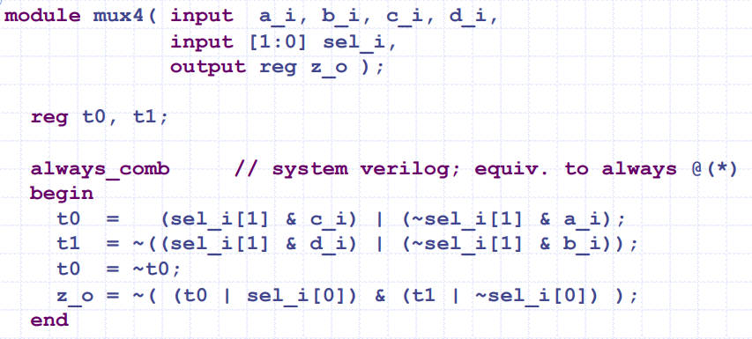

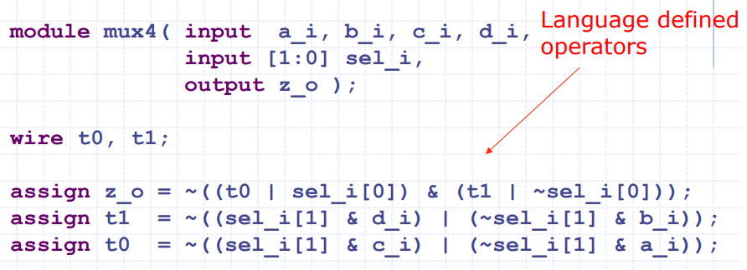

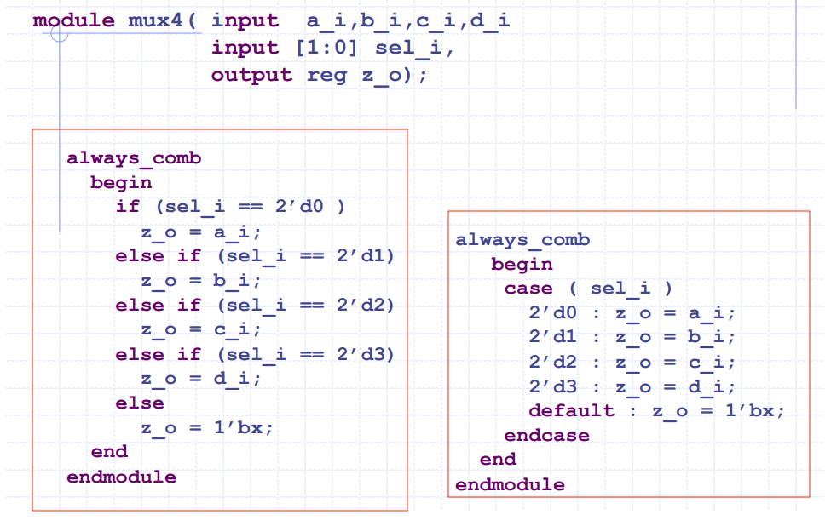

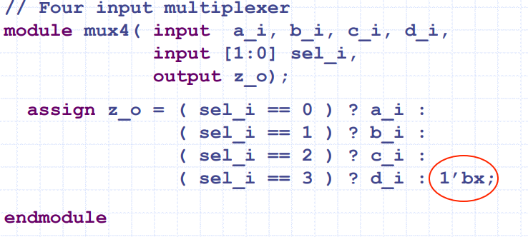

Les descriptions ci-dessus ont un comportement identiques.

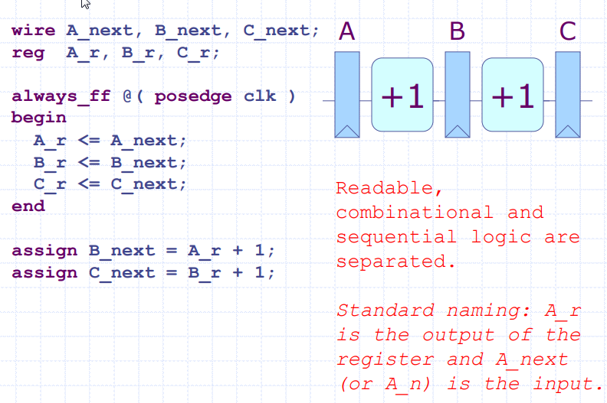

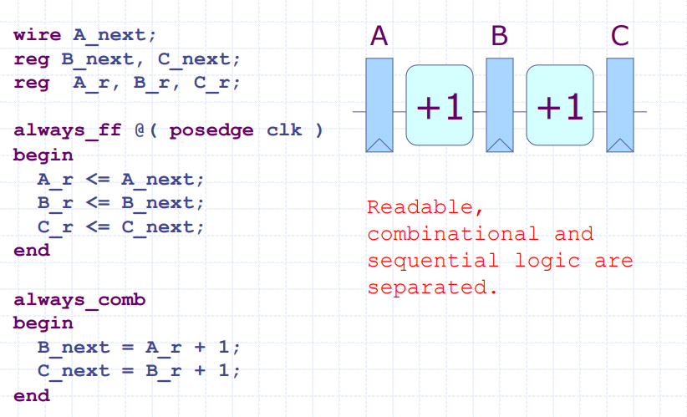

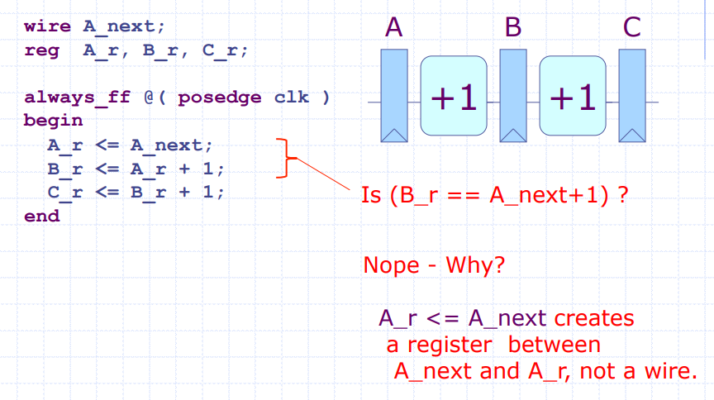

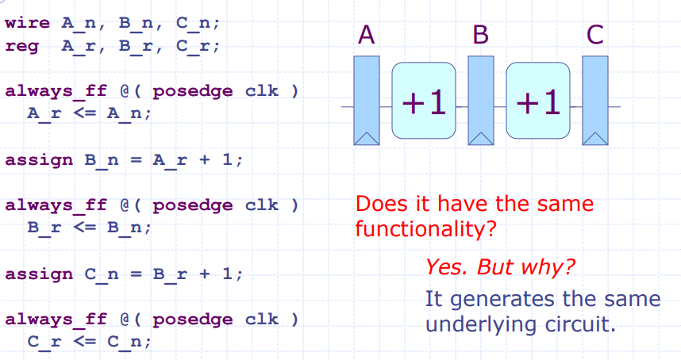

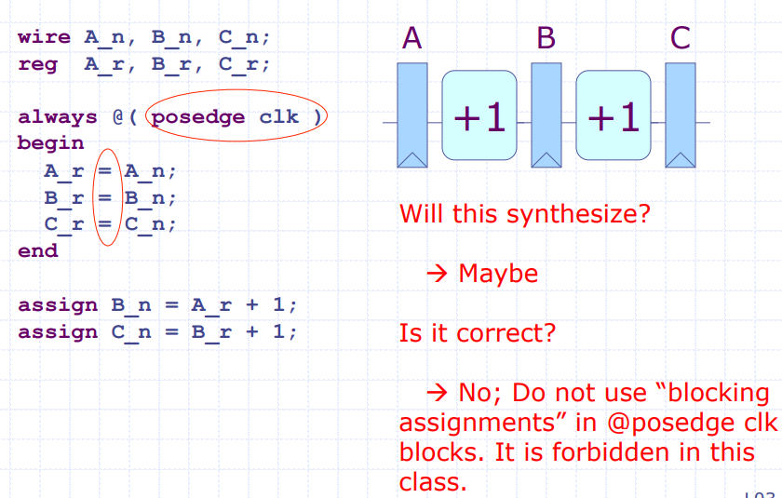

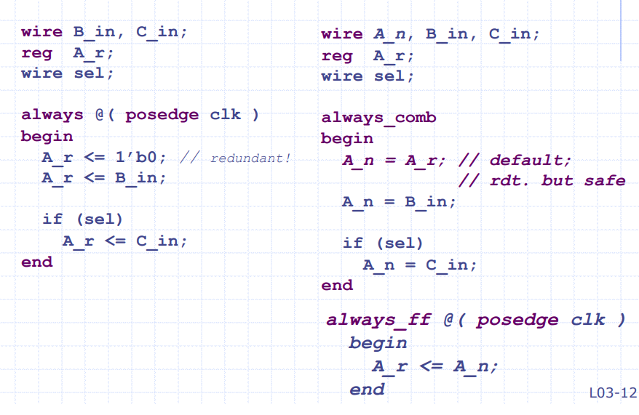

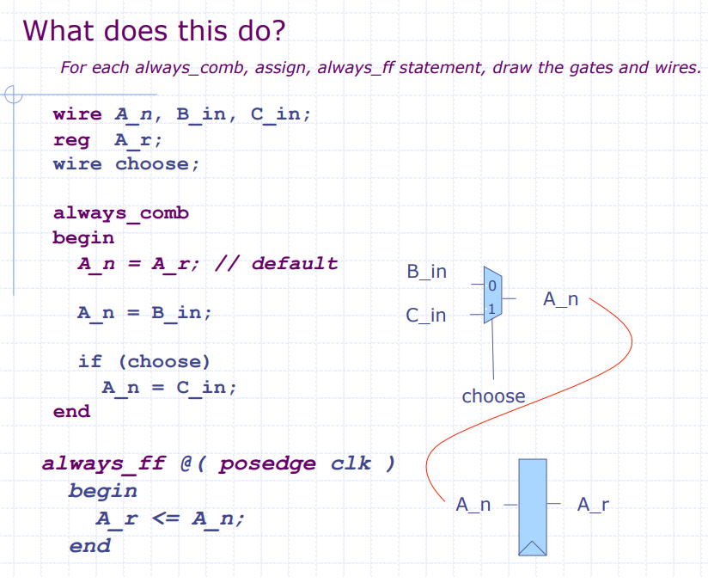

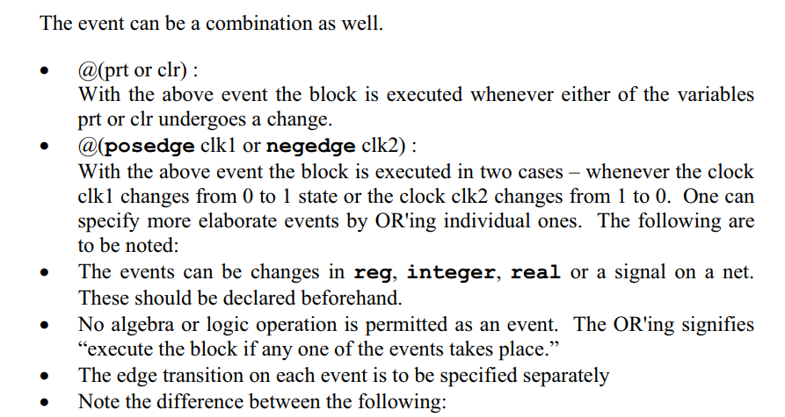

The Verilog Hardware Description Language” by Thomas & Moorby,

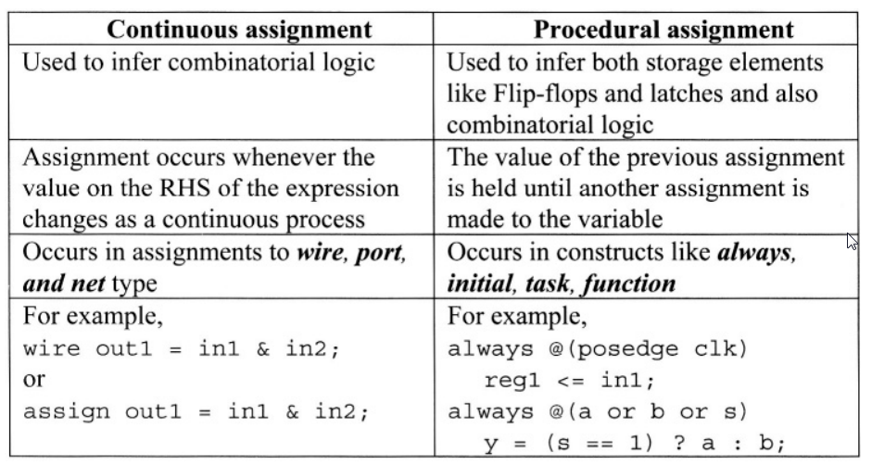

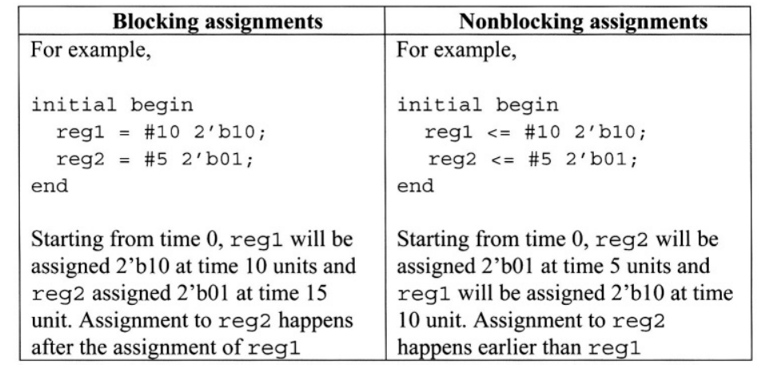

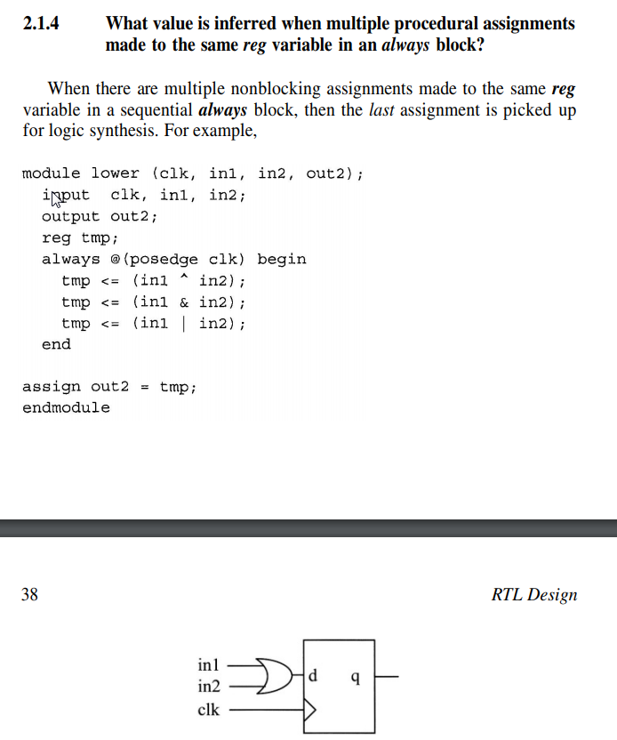

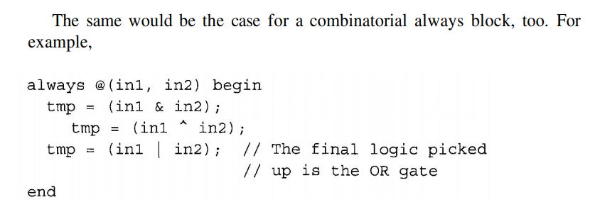

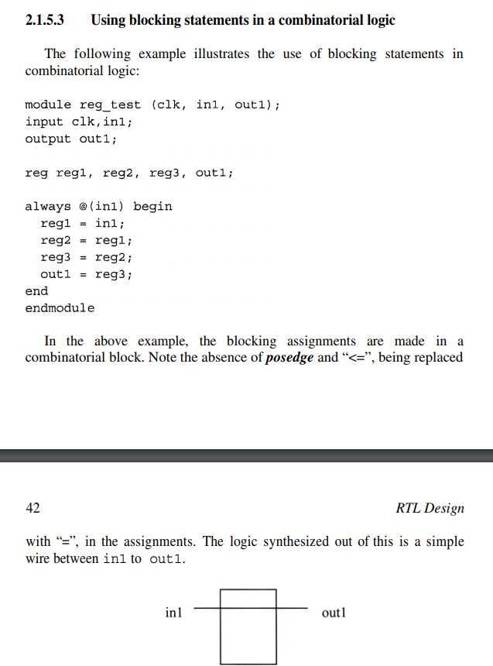

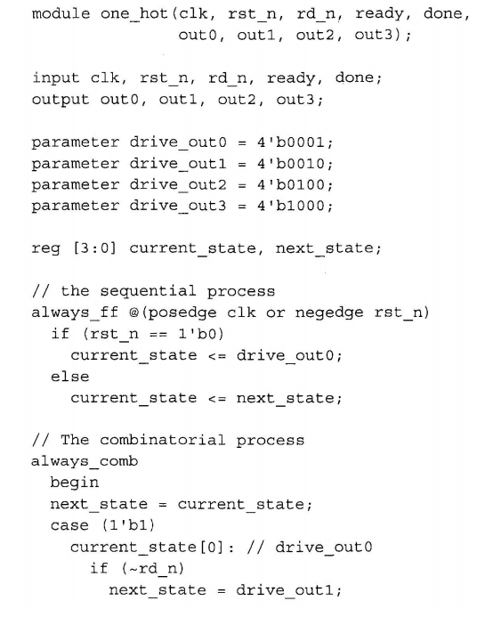

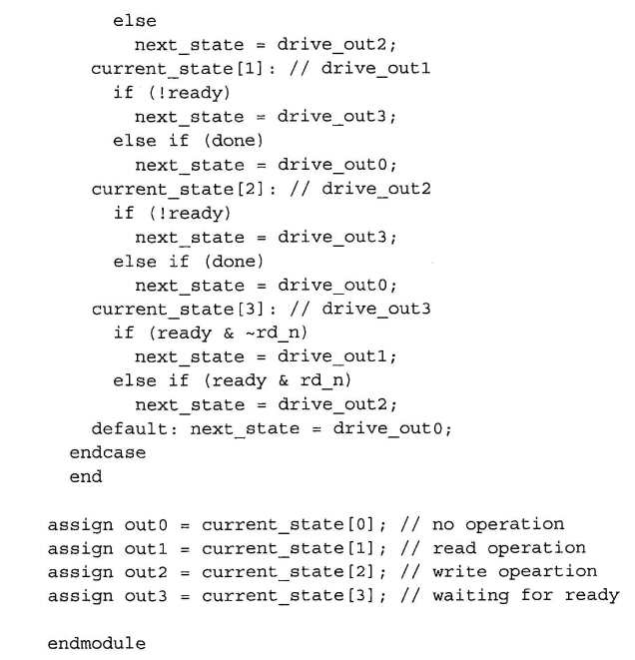

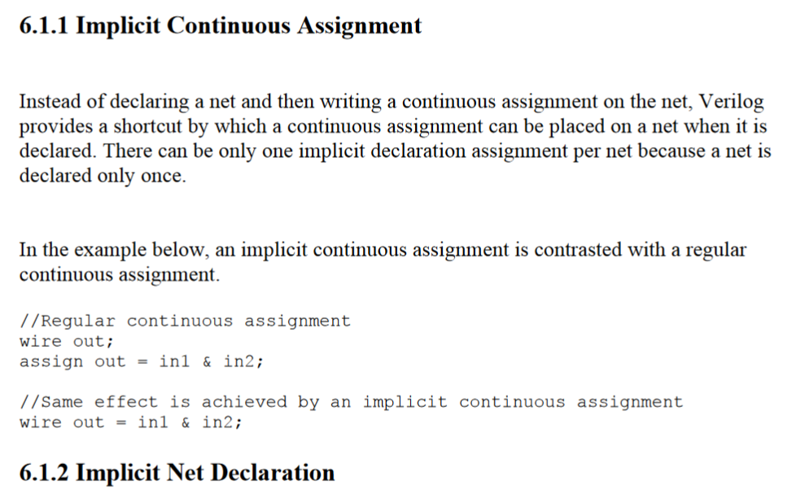

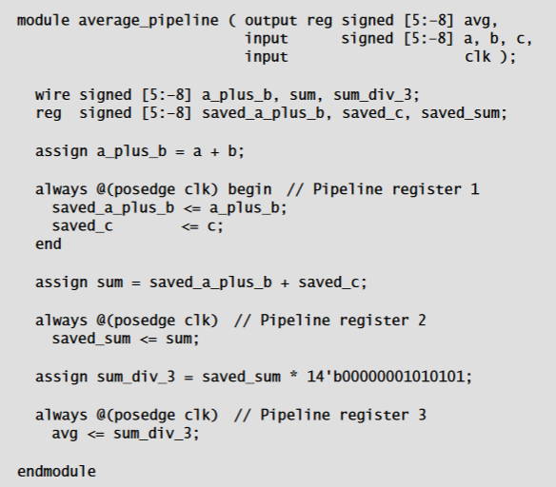

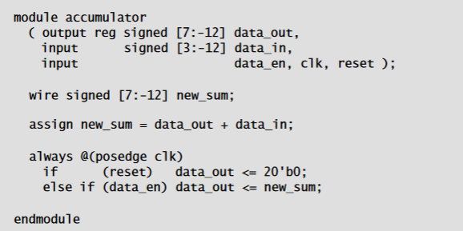

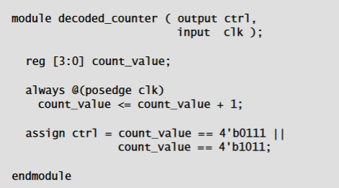

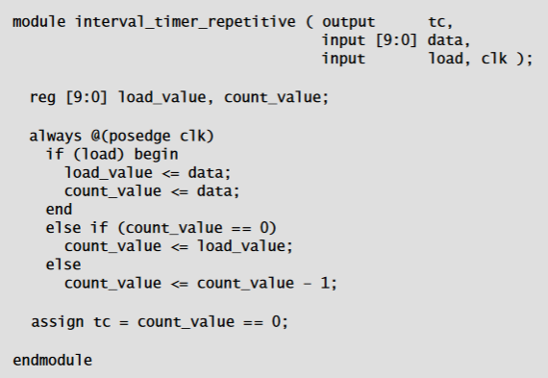

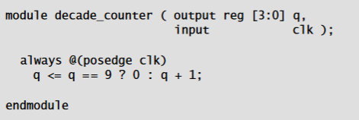

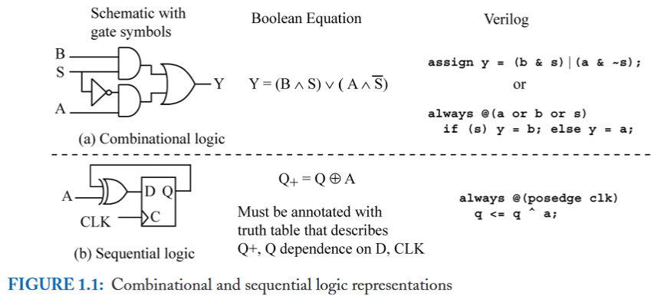

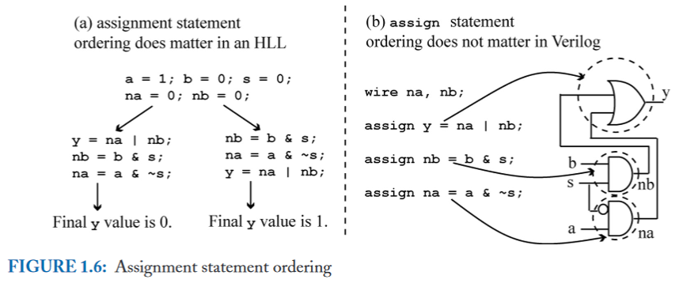

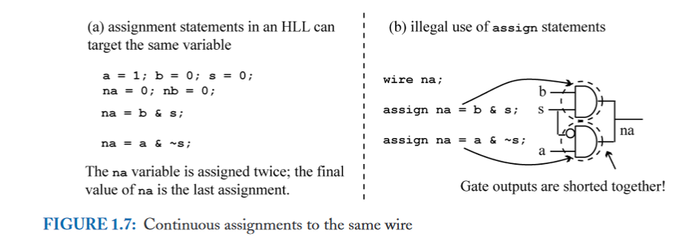

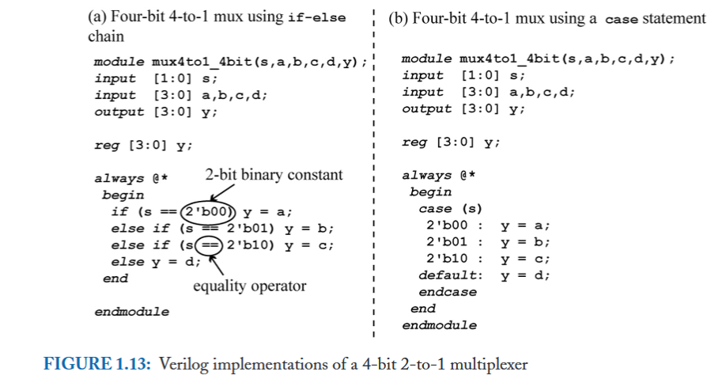

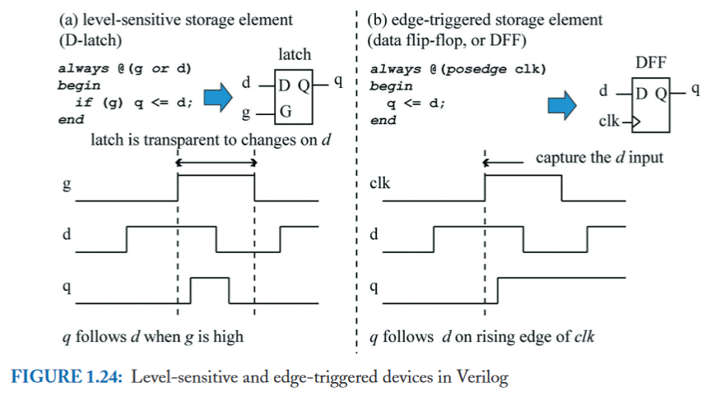

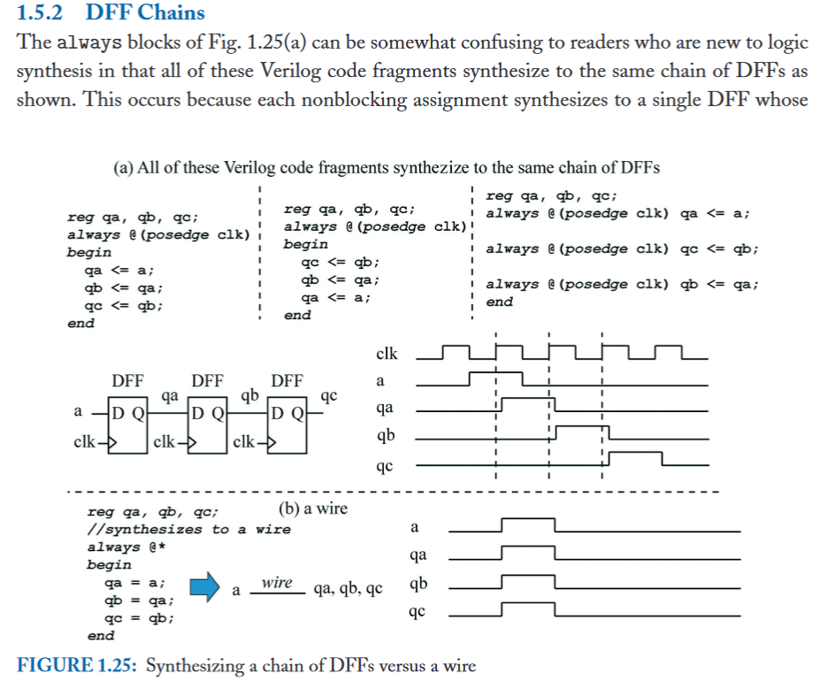

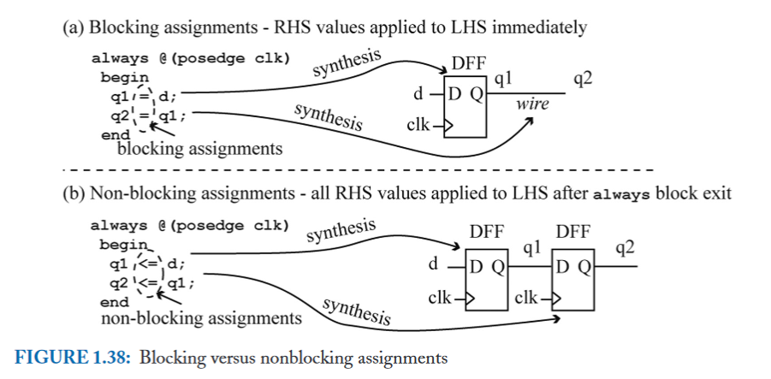

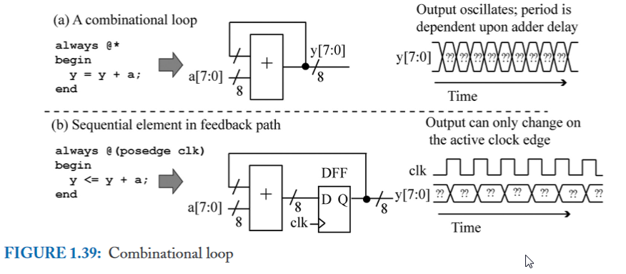

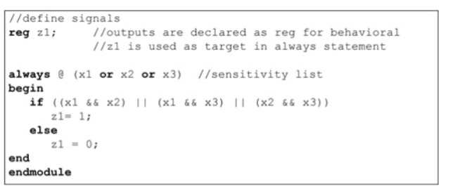

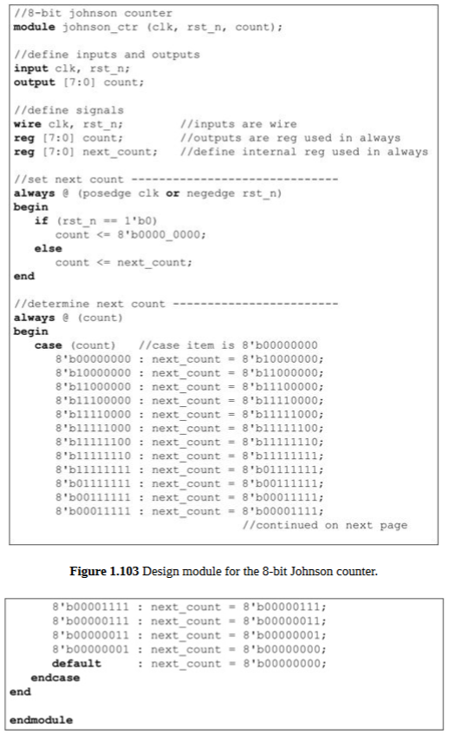

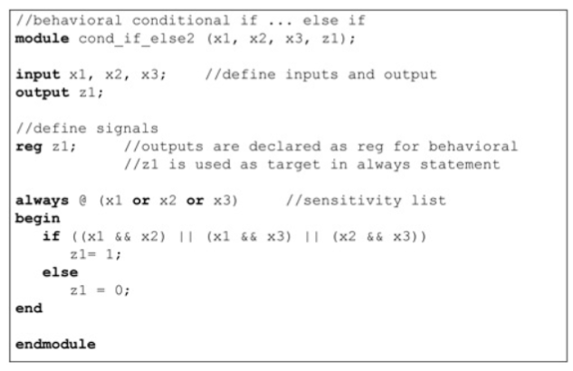

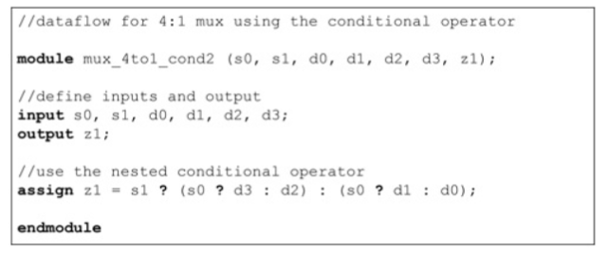

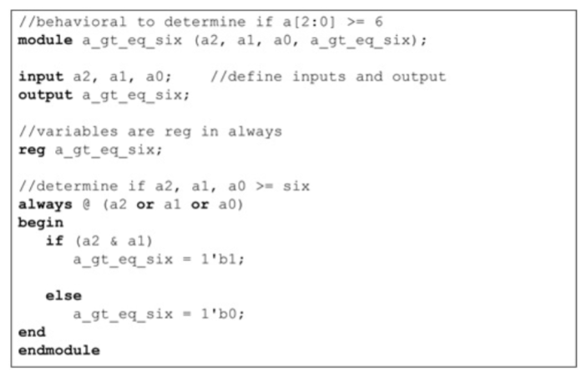

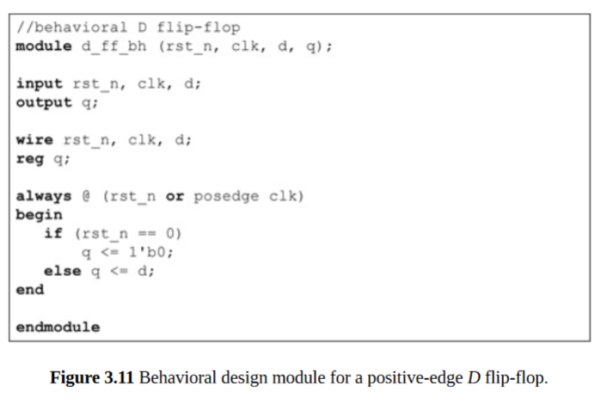

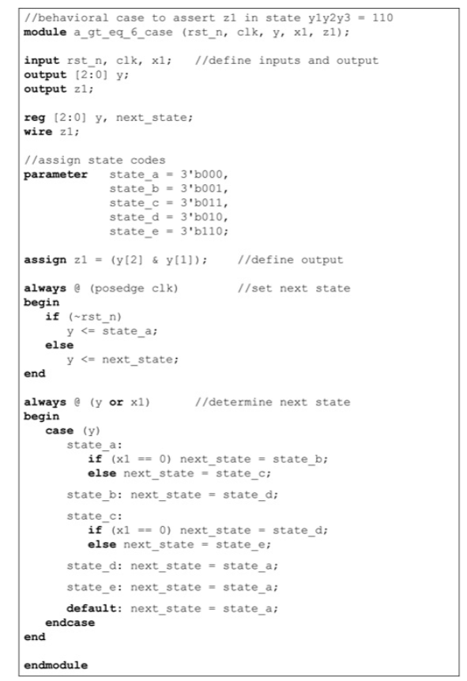

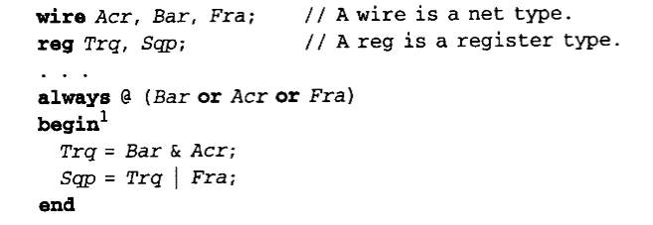

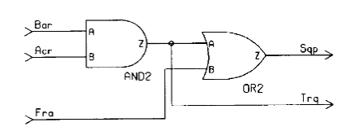

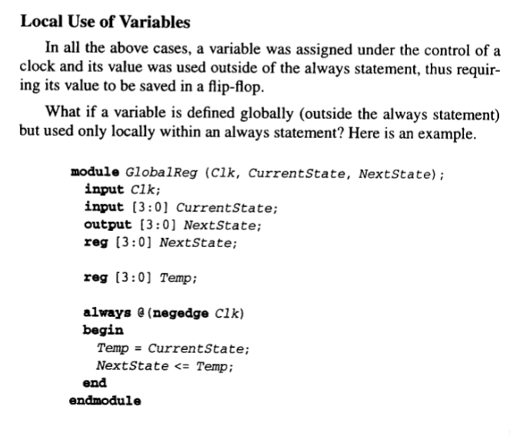
Temp est assigner en premier
Puis on l’utilise

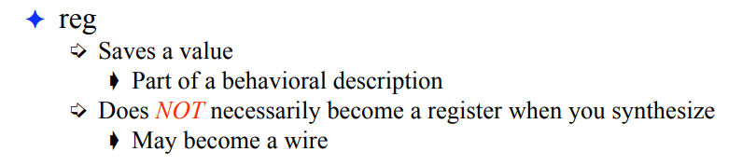

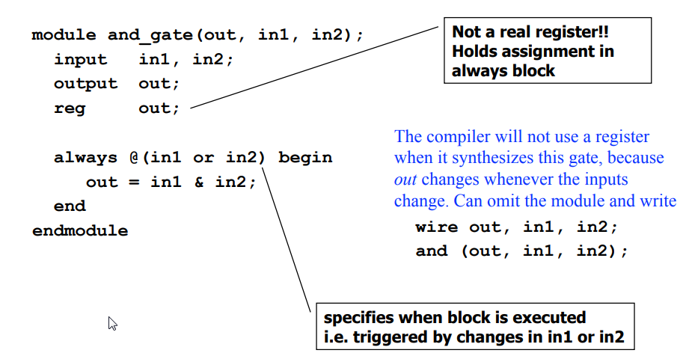

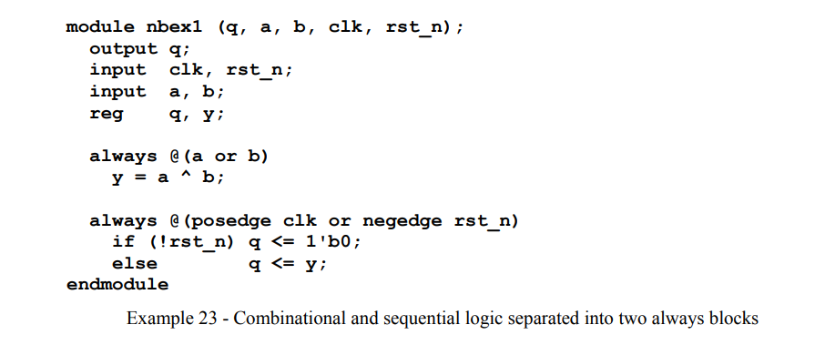

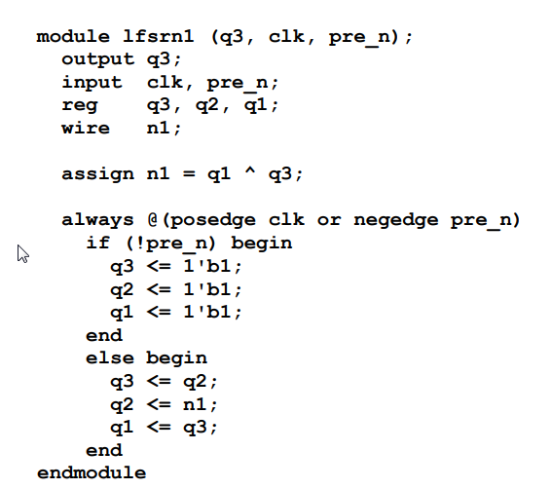

Combinational and sequential logic

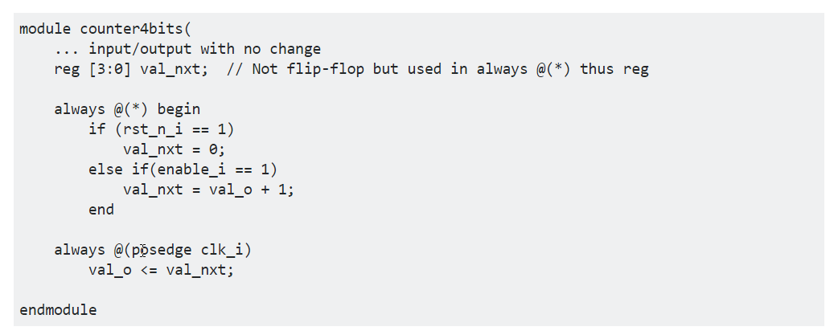

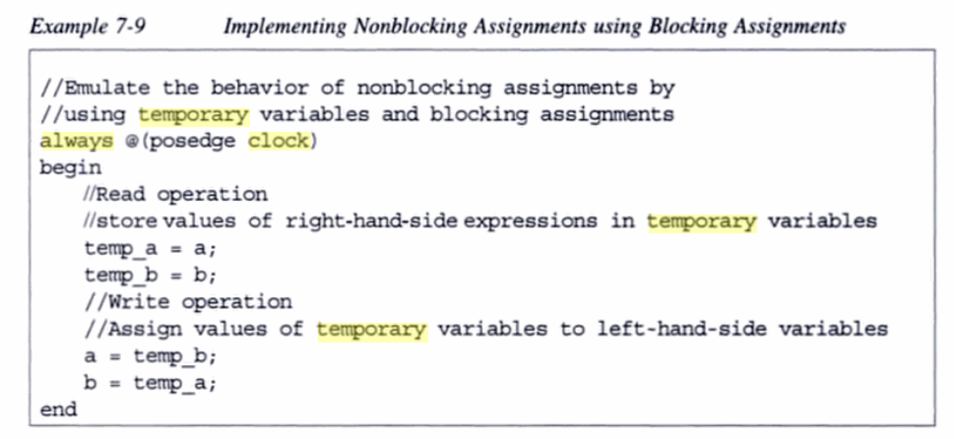

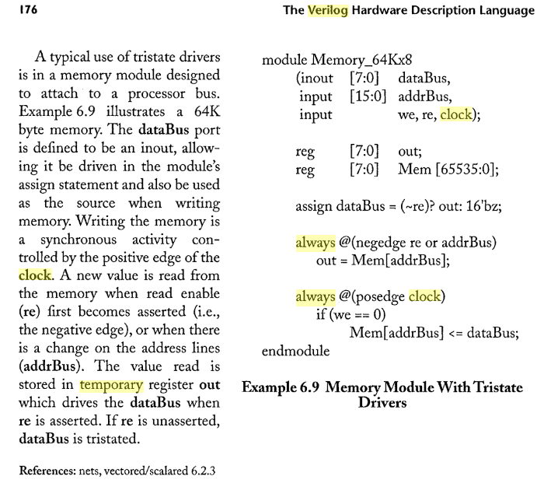

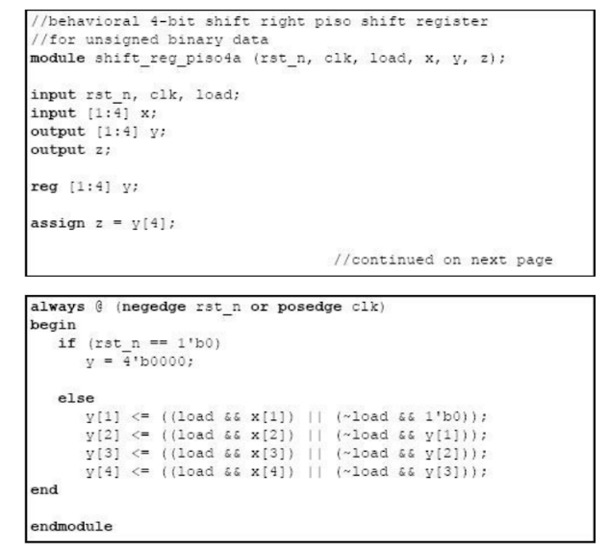

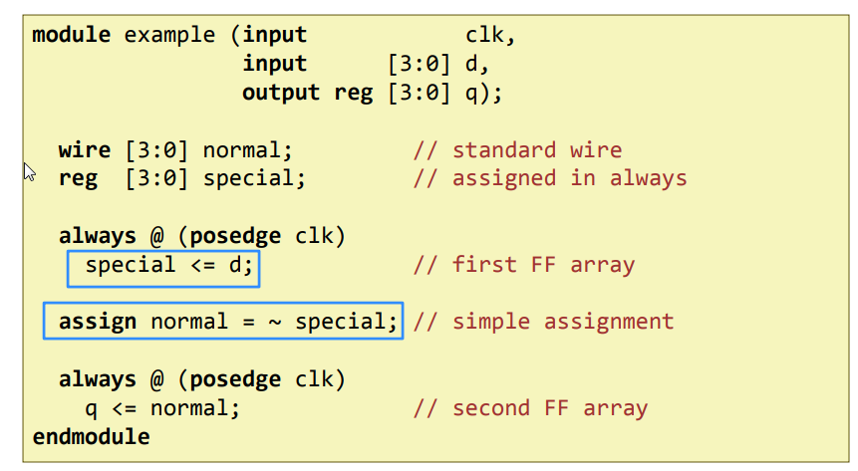

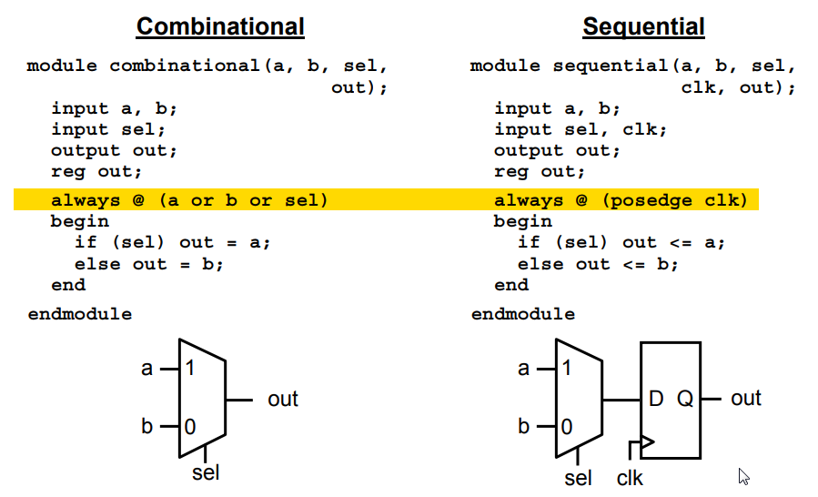

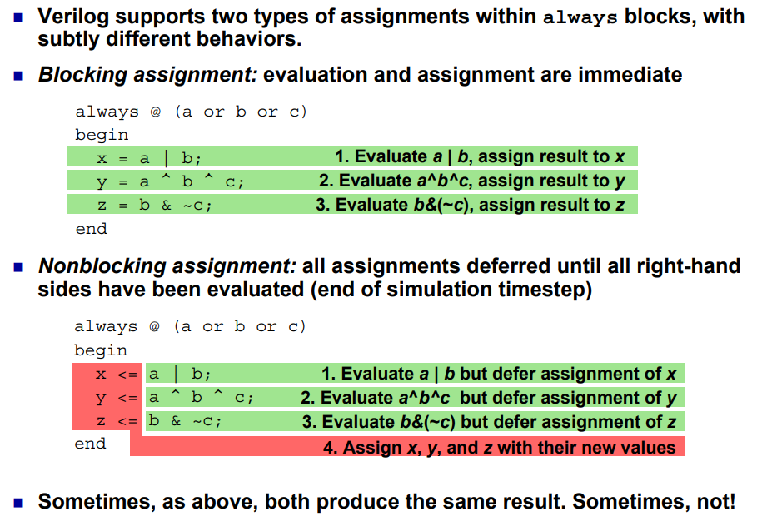

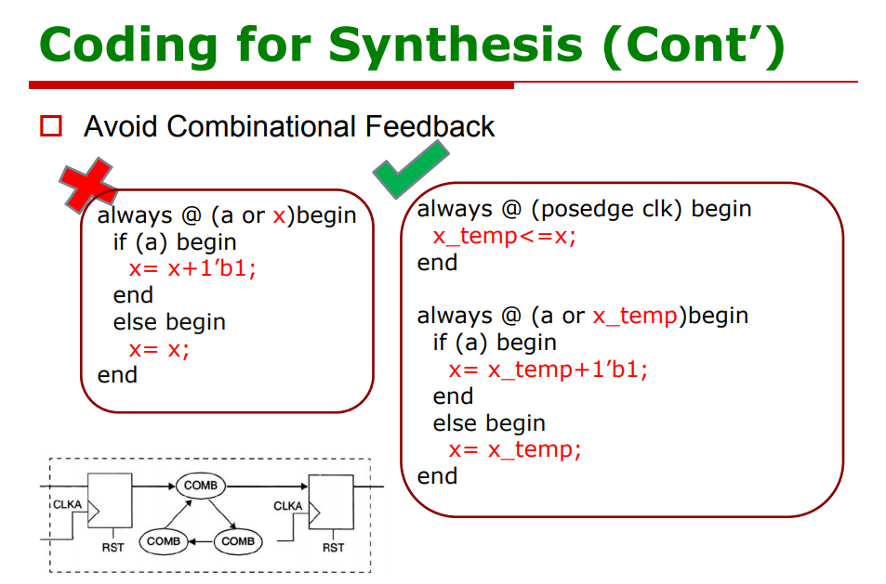

http://www.csit-sun.pub.ro/~cpop/VerilogHDL_Tools/synver.pdf

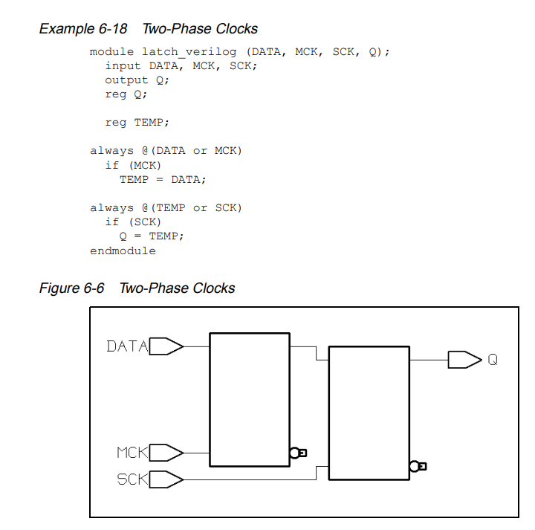

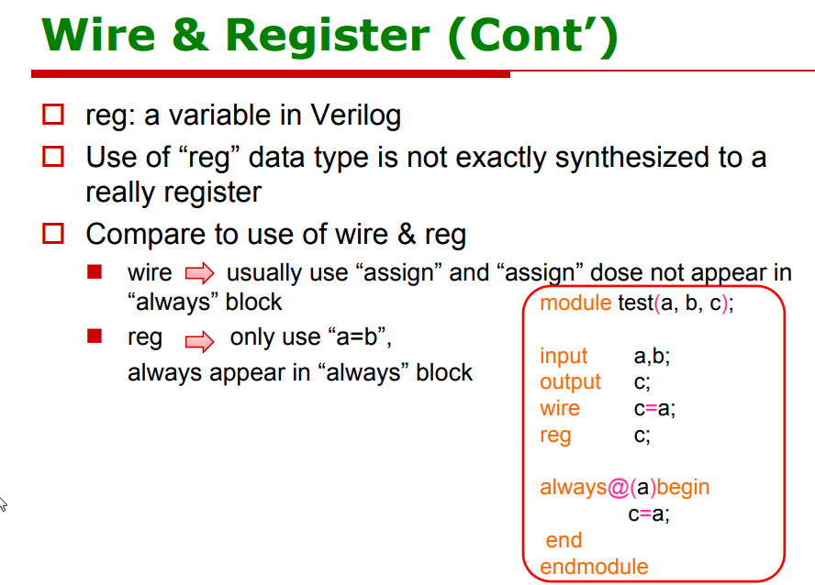

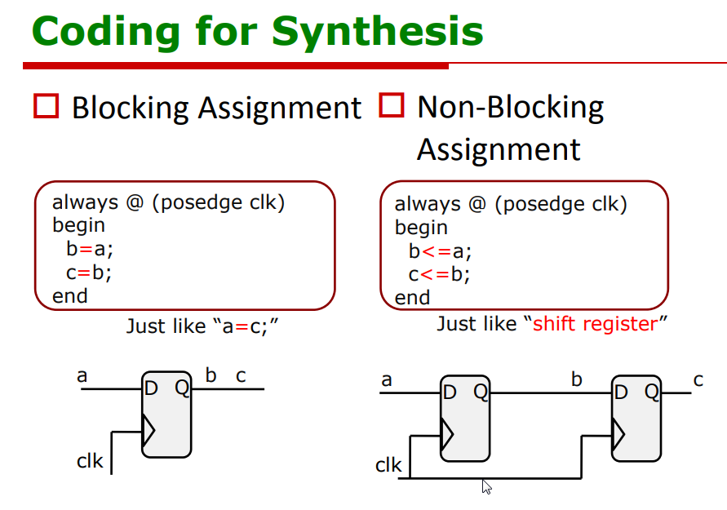

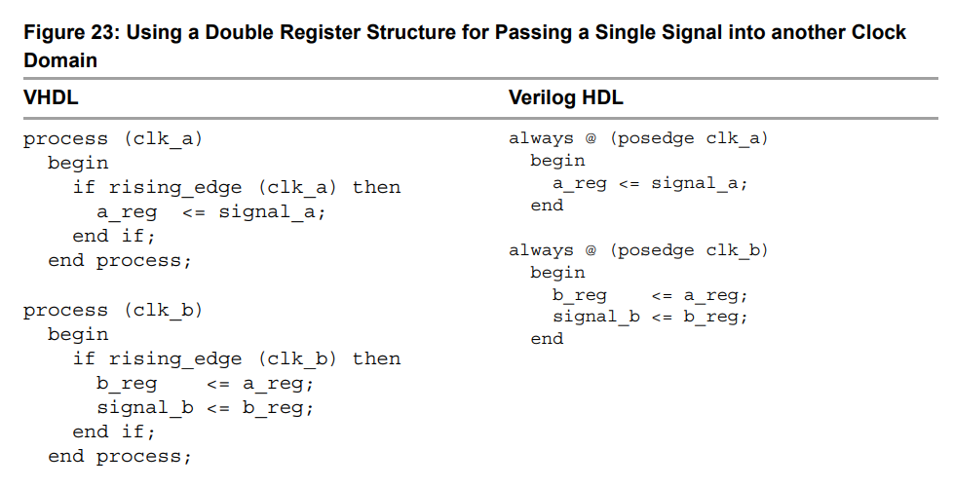
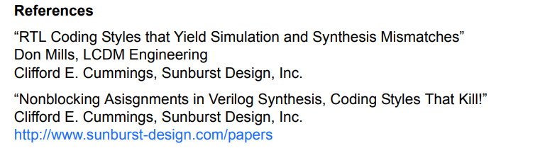

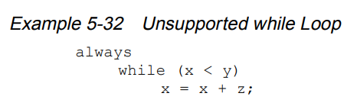
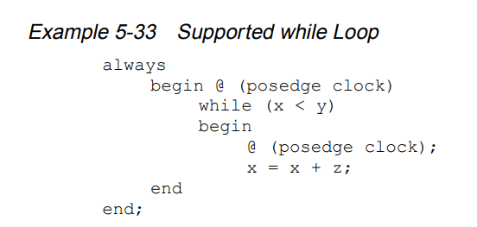
Synospys manual
http://analog-design.net/JOB/DIGITAL/VERILOG/VERILOG%20HDL%20manual.pdf
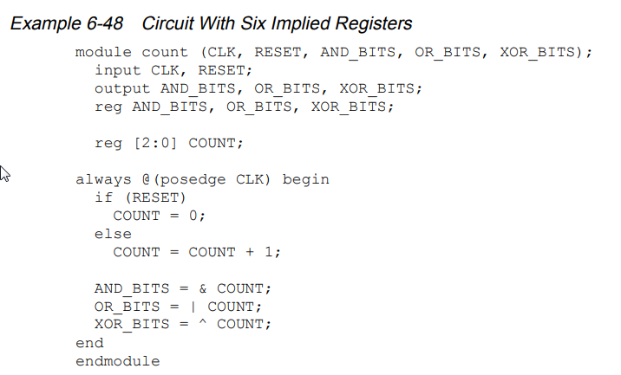
In this design, the outputs—AND_BITS, OR_BITS, and XOR_BITS— depend solely on the value of the variable COUNT. If the variable COUNT is registered, these three outputs do not need to be registered.

To avoid inferring extra registers, assign the outputs in an always block that does not have a clock edge in its condition expression. Example 6-49 shows a description with two always blocks, one with a clock edge condition and one without. Put the registered (synchronous) assignments into the block with the clock edge condition. Put the other (asynchronous) assignments in the other block. This description style lets you choose the variables that are registered and those that are not.

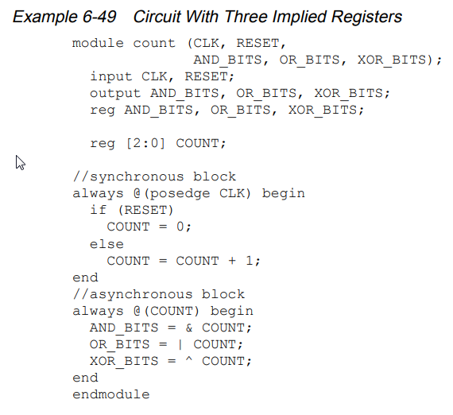

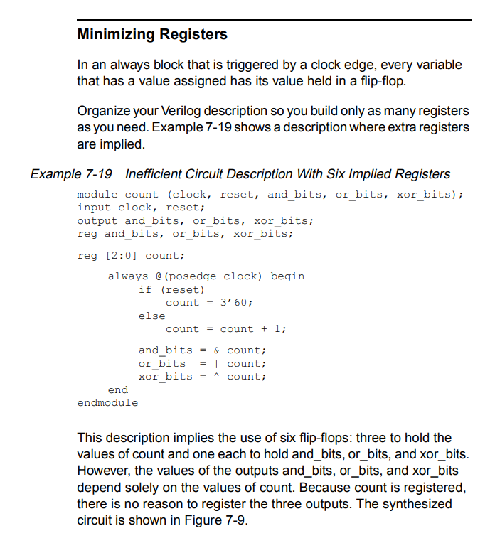
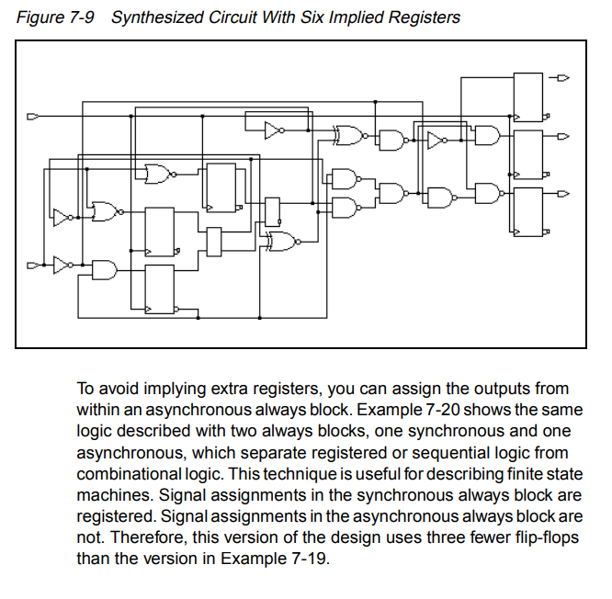
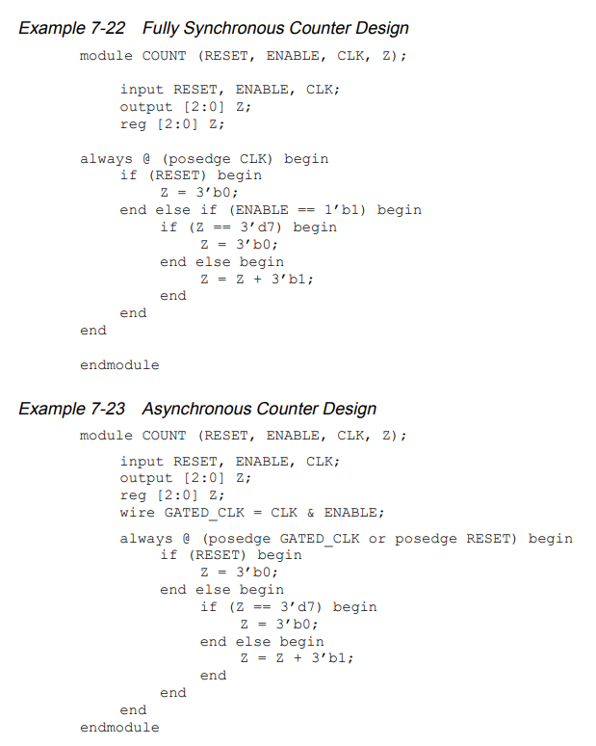
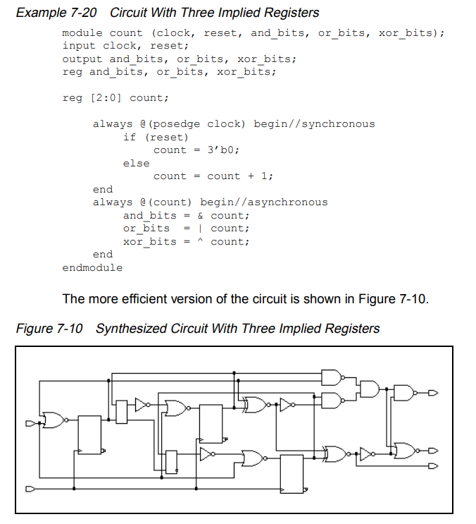

http://in.ncu.edu.tw/ncume_ee/digilogi/vhdl/Verilog_Reference_Guide.pdf

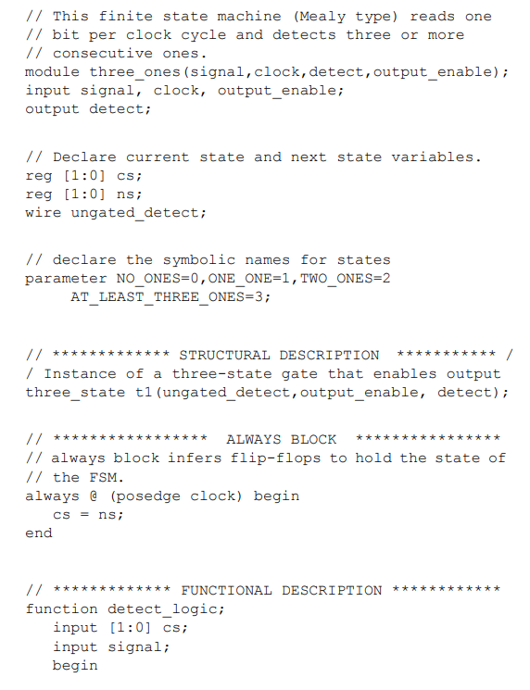

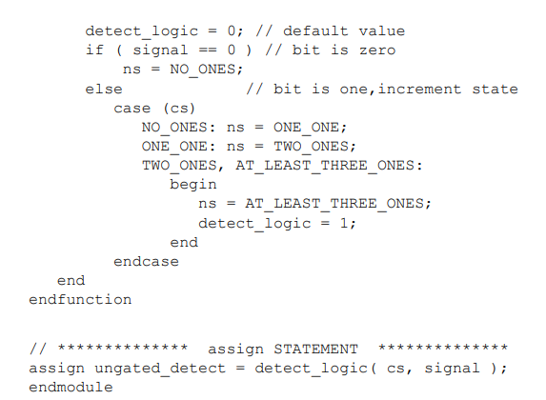

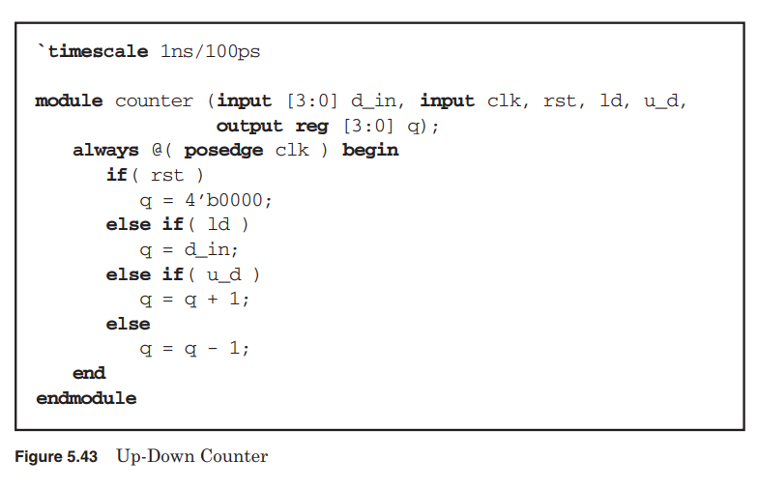
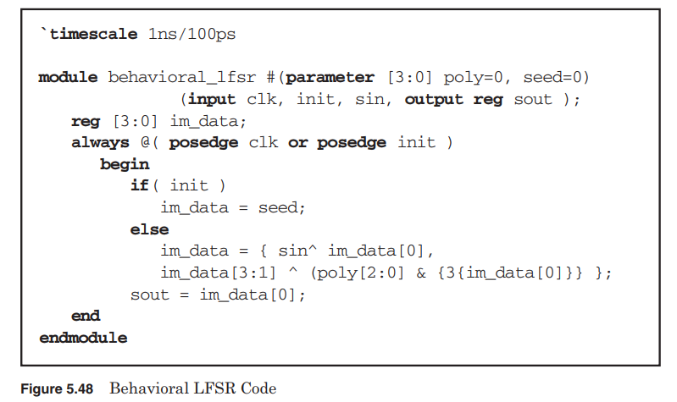

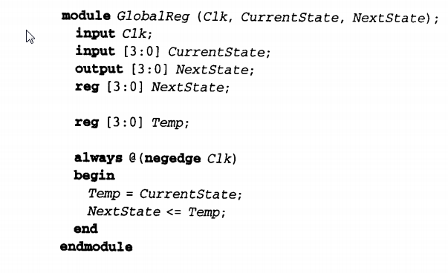

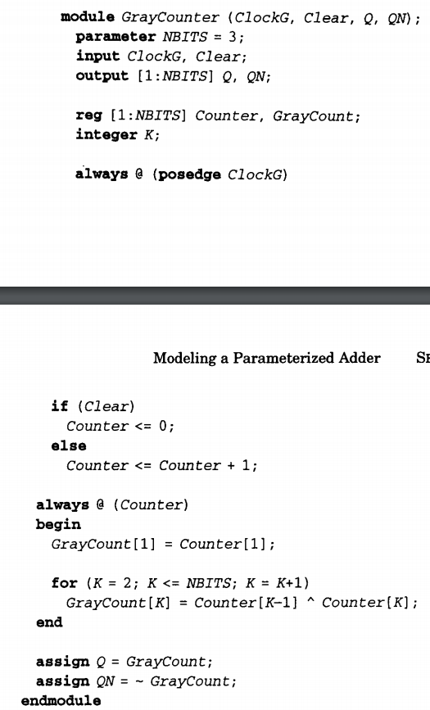

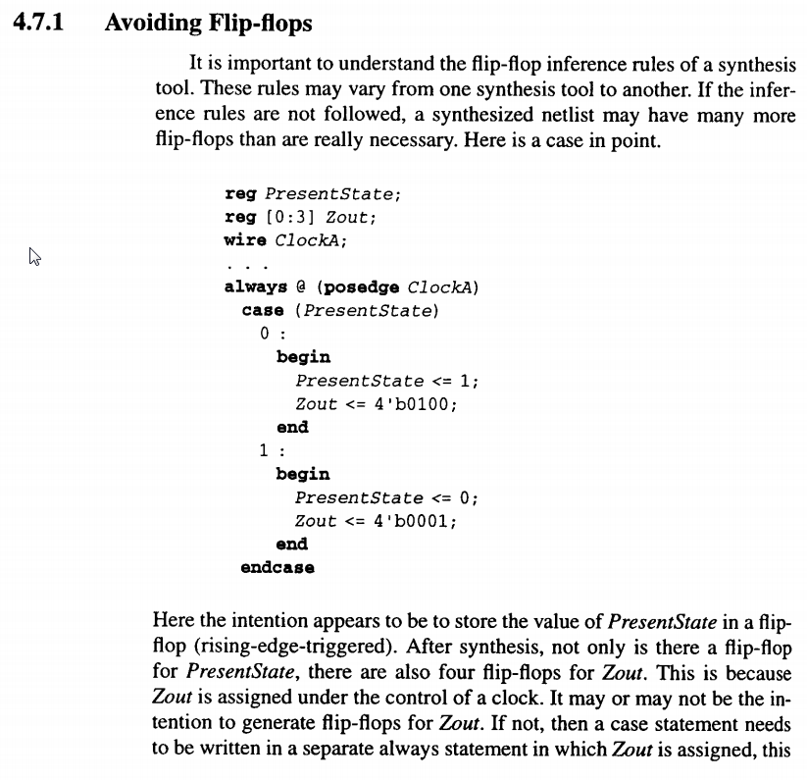
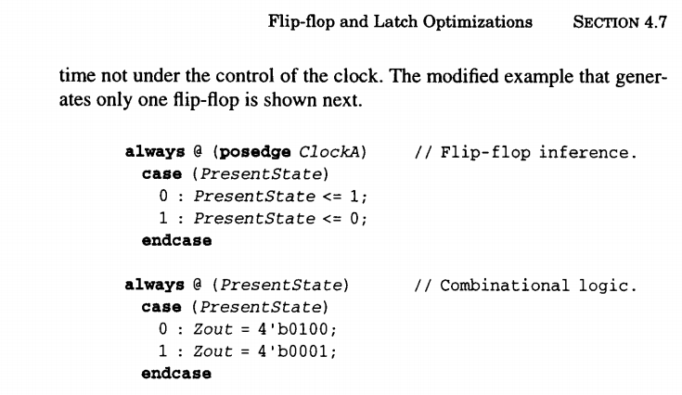

http://www.sunburst-design.com/

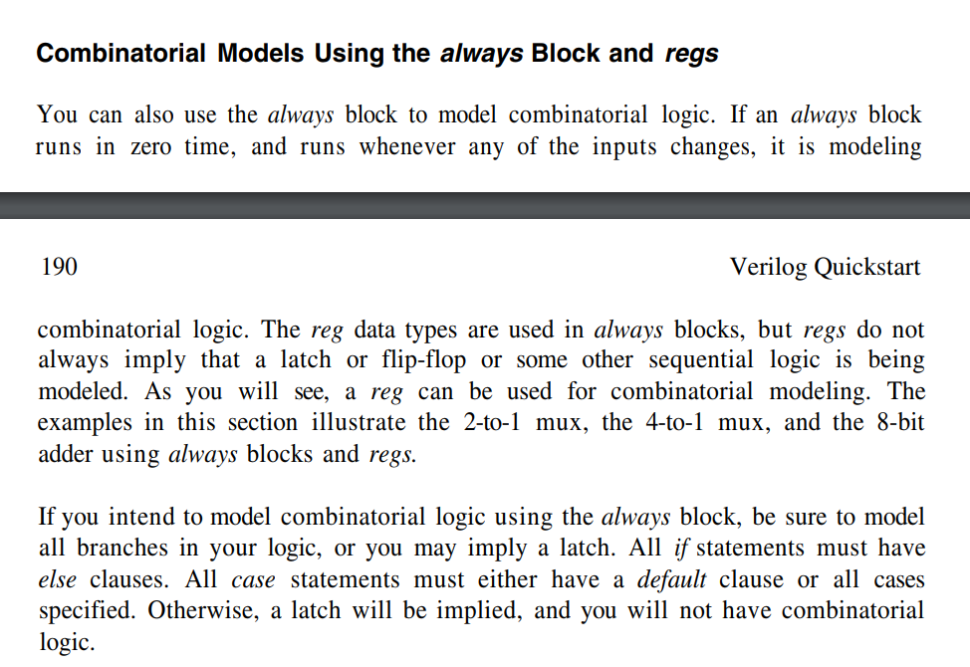

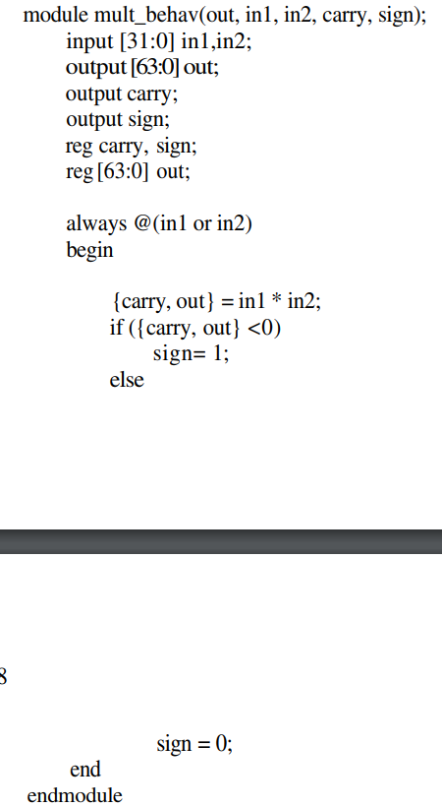

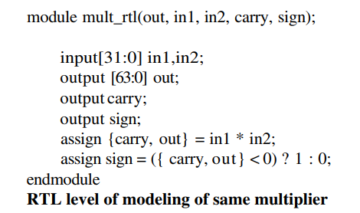

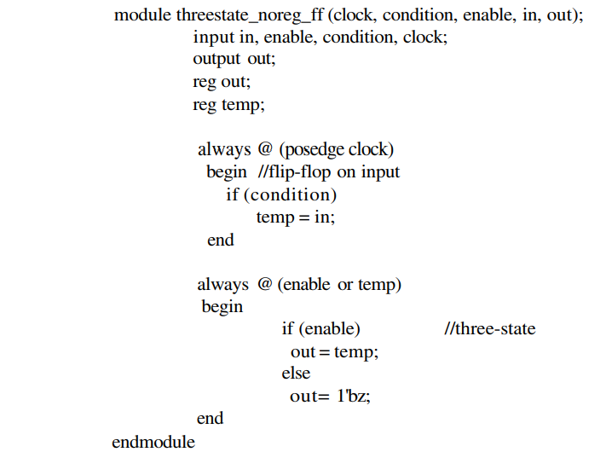

On utilize 2 always au lie de 1 afin de retirer le registre lié au enable
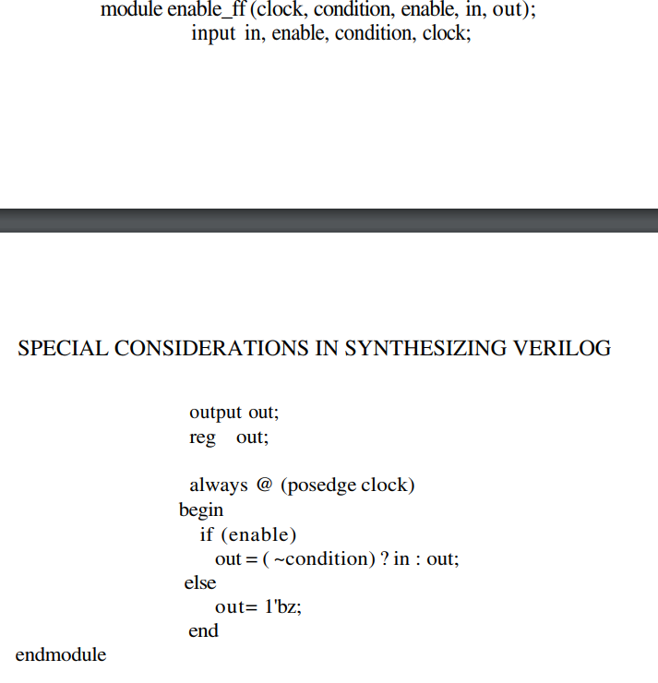

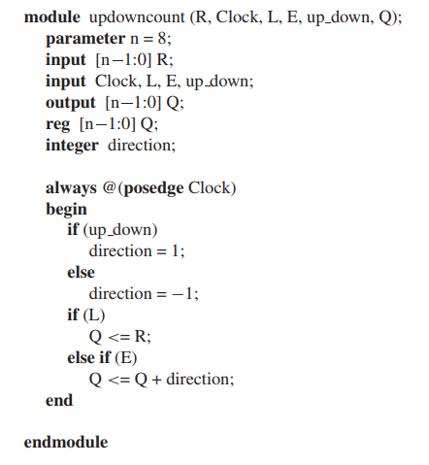

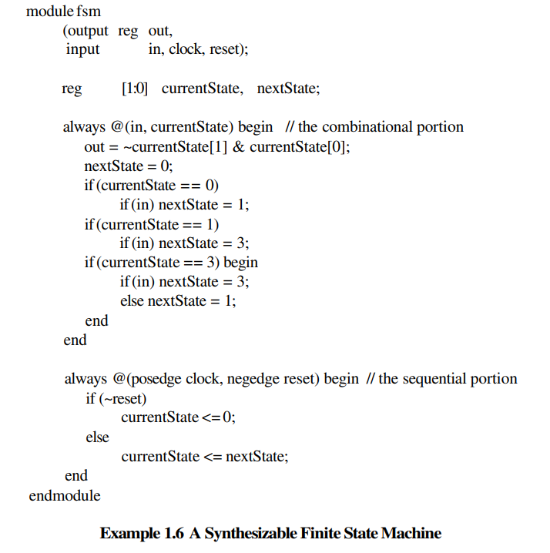

The unintentional combinational loops ?????

http://www.sutherland-hdl.com/papers/2007-SNUG-SanJose_gotcha_again_paper.pdf

https://www.intel.com/content/dam/www/programmable/us/en/pdfs/literature/manual/stx_cookbook.pdf
http://vlsi-soc.blogspot.com/2013/05/combinational-loops.html

