Verilog testbanch
always
begin clk = 1; #5; clk = 0; #5; // 10ns period
end
always #1 clk=~clk;

reg [3:0] testvectors[10000:0];// array of testvectors
initial
begin $readmemb("example.tv", testvectors);
end
‘timescale 1 ns / 100 ps
I = 1 ;
sum = 0 ;
while(i <= 10)
begin
sum = sum + i; //add i to sum
i = i + 1; //increment i.
end

while (operator<5)begin
operator += 1;
$display("Operator is %0d\n", operator);
end

initial begin
for(count = 0, i=0; i*count<50; i++, count++)
$display("Value i = %0d\n", i);
end

initial begin
do
begin
$display("i = %0d \n", i);
i++;
end
while (i < 10);
end

vec_file = $fopen("/usr/example.vec“);
results = $fopen(" /usr/results .dat");
reg [3:0] my_vector length [0:3] ; //The number of vectors and number of bits to be read for each vector.
c = $fgetc(file);
while (c !== `EOF)
begin
$readmemh (“vec_file”, length ); //Read hex file content into a memory array.
$readmemb (“vec_file”, length ); //Read binary file content into a memory array.
$fdisplay (results, variable list with format specifiers);
$fmonitor (results, variable list with format specifiers);
$fclose (results);
$fclose (vec_file );
end

initial save_sim_time = $time;
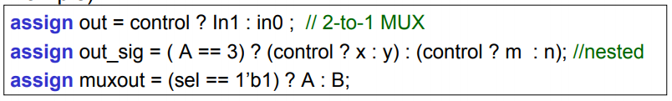

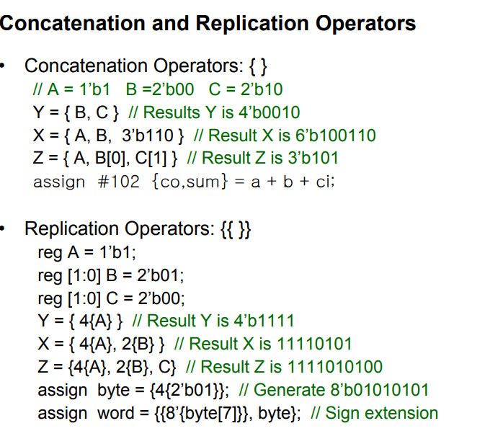
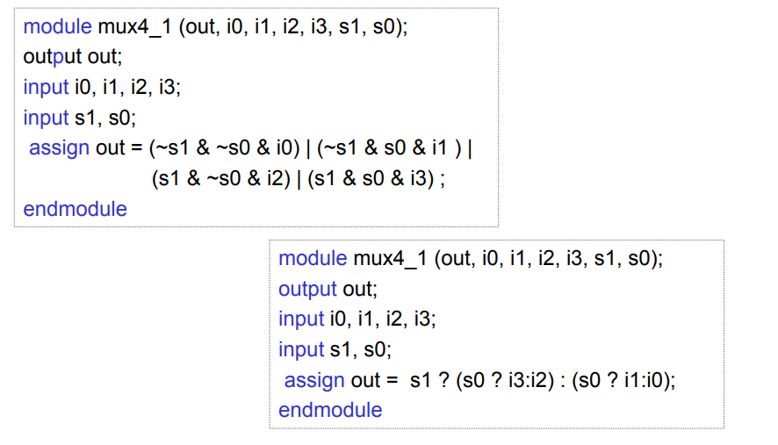

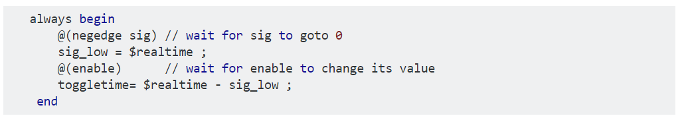

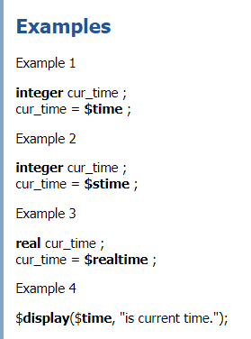
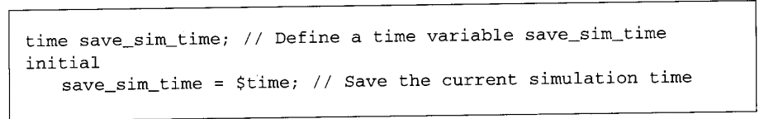
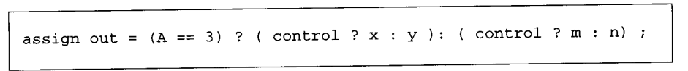

Blocking assignment statements are executed in the order they are specified in a sequential block

desasign
force et release on registers
$random
ss

