Online Controller BRP069A42
http://www.climweb.com/carte-wifi-daikin/
console daikin fvxs35f
https://www.daikin.fr/fr_fr/produits/FVXS-F.html
https://www.daikin.fr/content/dam/document-library/operation-manuals/ac/split/FVXS25-50F,FVXM25-50F_3PEN477071-1C_Operation%20Manual_English.pdf

https://www.daikin.fr/content/dam/document-library/installation-manuals/ac/split/FTXZ-N,A-FTXS-K,%20FTXLS-K,%20FTXM-K,FTXS-G,FTX-G,FVXG-K,FVXS-F,FVXM-F,FLXS-B_9,FTX-KN_BRP069B42_installation%20manual_Photo%20manual.pdf
description

Carte WiFi, BRP069A42 Compatible FTXS-K-35/42/50 et FTXS-G

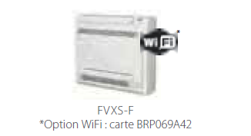
Pilotage de l’unité à distance grâce à l'Option WIFI (Carte BRP069A42)
https://www.domotelec.fr/imagesbd/boutique/4910_1510_BRP069A42_IM_4PFR359542-2G_tcm849-353219.pdf

https://www.domotelec.fr/achat/carte-electronique-Daikin/p-4910-pour-connexion-wifi.html
https://www.service-clients-daikin.fr/attachment/685331/ freebox

https://www.youtube.com/watch?v=FDCbsmwvpMQ ++++++ video d’installation

