57.0 Firefox Release November 14, 20 64 bits

fusionCharts.js ???

Version 62.0.3202.94 (Build officiel) (64 bits)
Enfin, je viens d'ajouter dans .ovhconfig :
app.engine.flags=noforcetmp

Prefer:Safe mode

about:config

https://www.ghacks.net/2017/06/13/firefox-disable-this-connection-is-not-secure-warnings/

firefox disable red lock connexion insecure

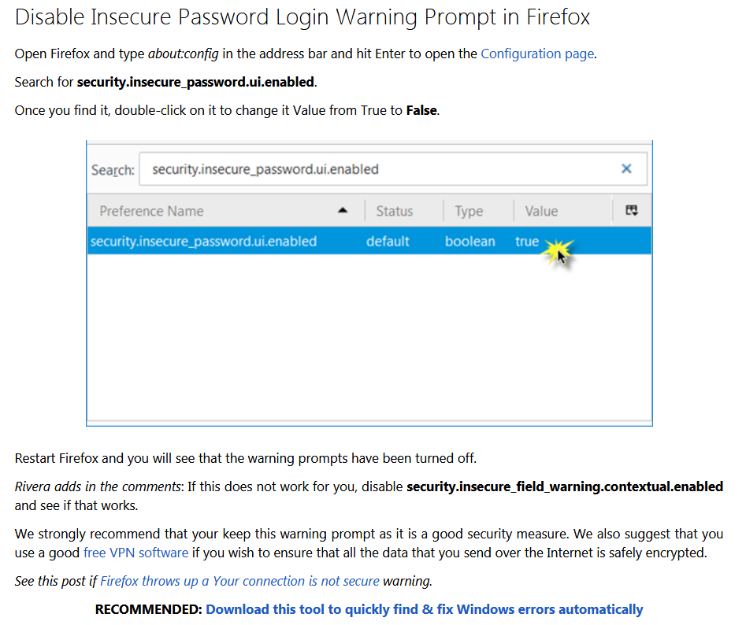

https://support.mozilla.org/fr/kb/blocage-du-contenu-mixte-avec-firefox

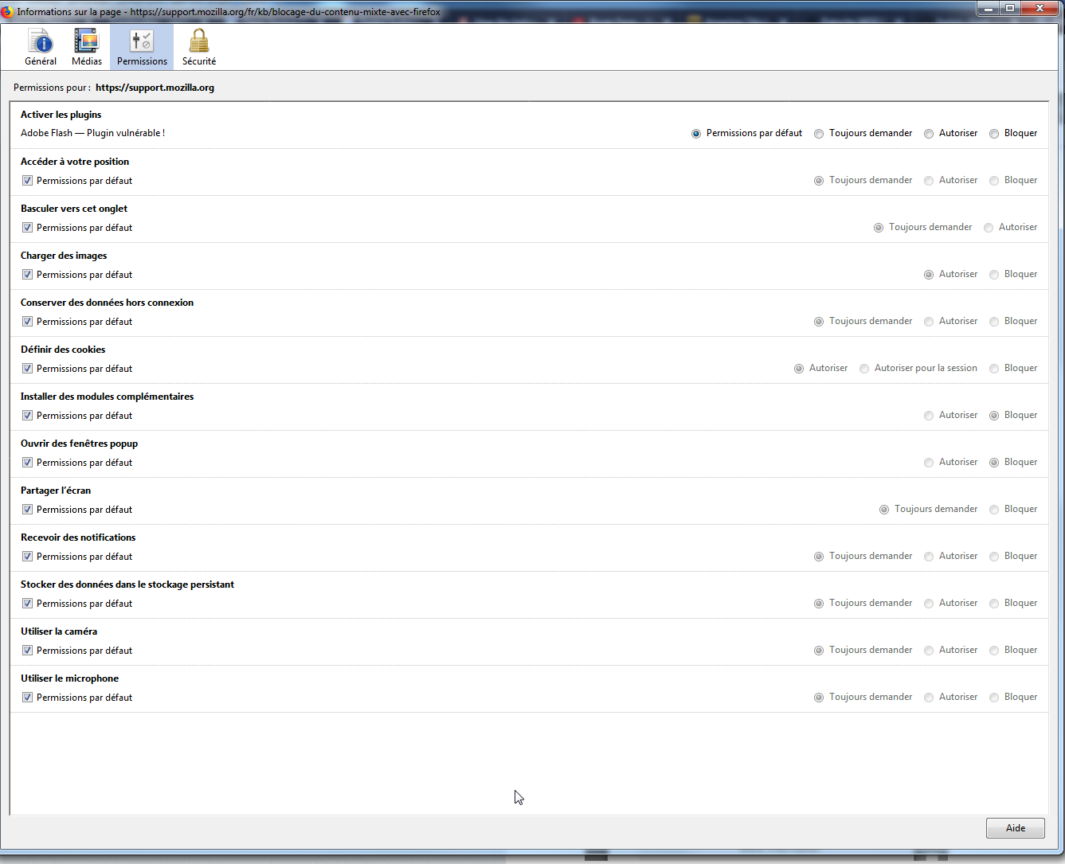

https://lenewbie.com/2017/06/29/desactiver-alerte-connexion-non-securisee-firefox/

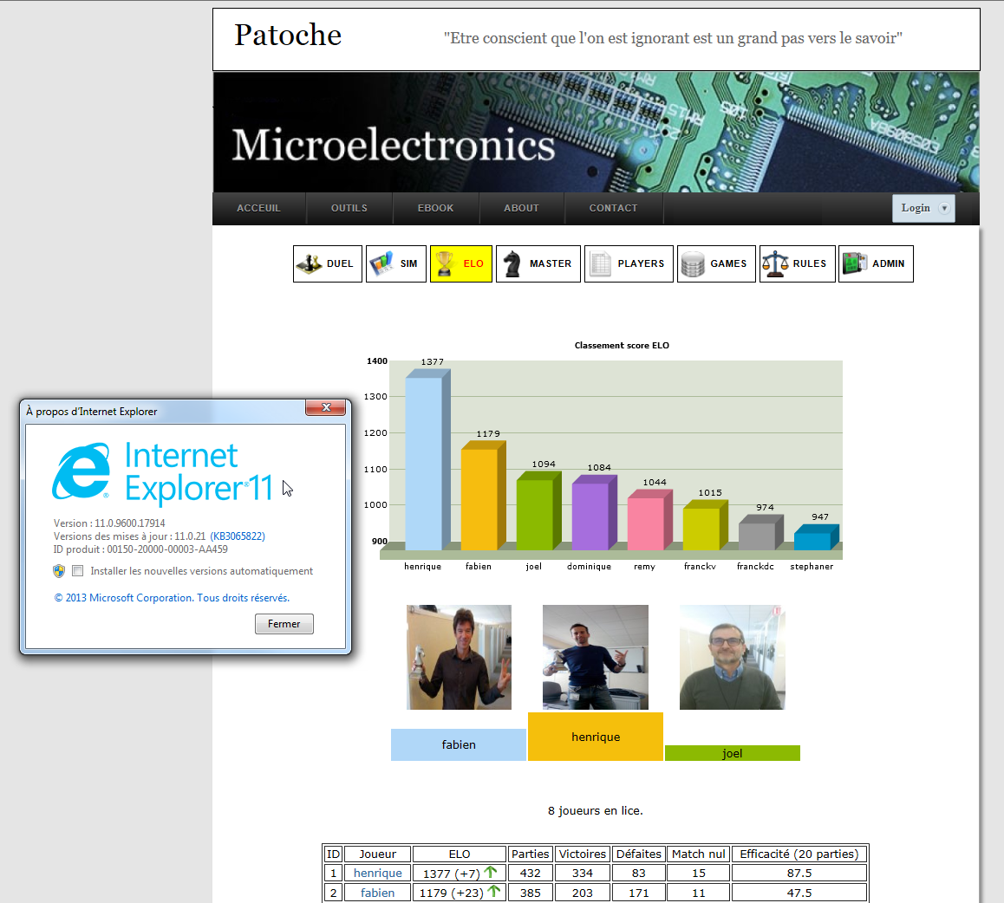

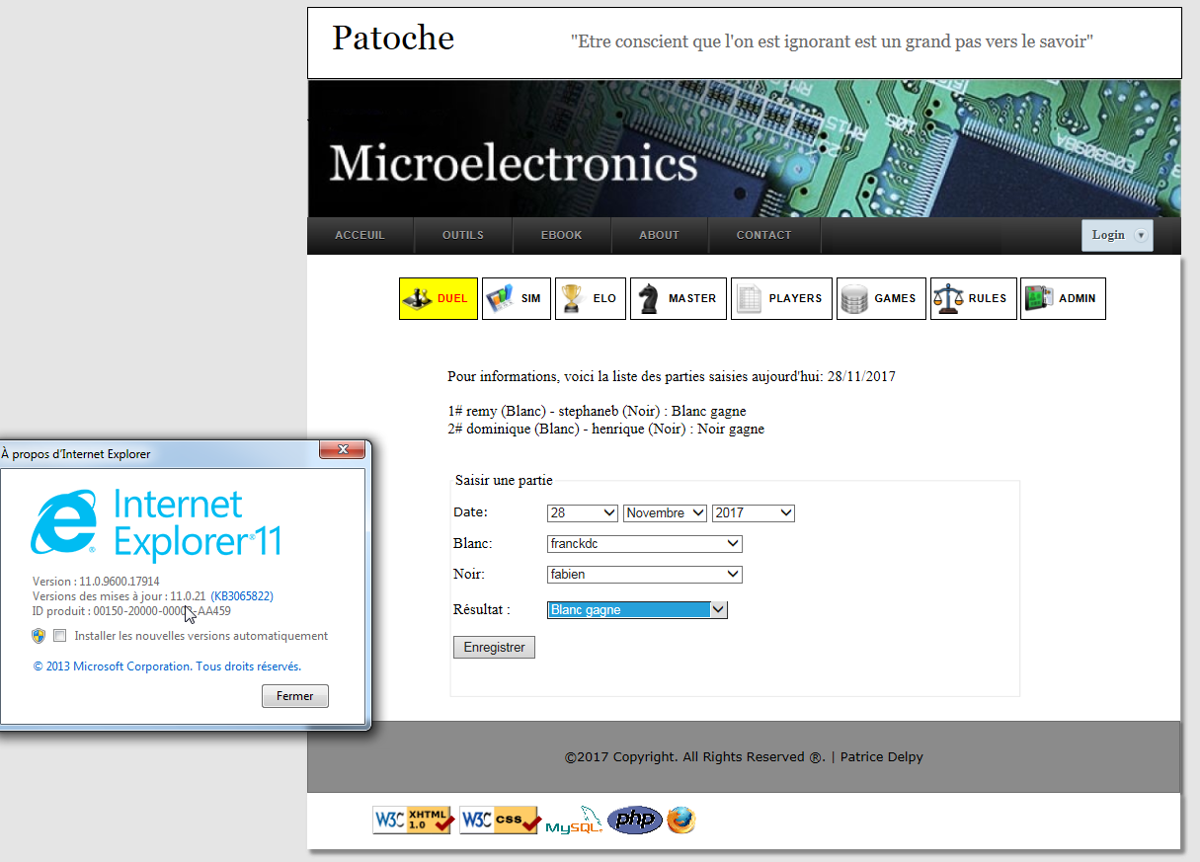

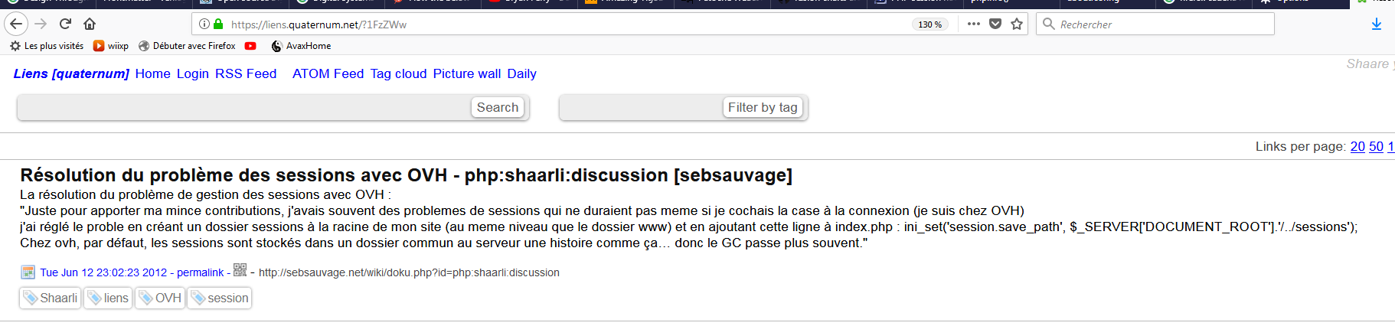

chrome://settings/

