http://www.tinkerforge.com/en/doc/Kits/WeatherStation/WeatherStation.html

https://www.adafruit.com/product/439
http://boutique.semageek.com/fr/38-luminosit%C3%A9-ir-uv
http://www.circuitbasics.com/how-to-set-up-the-dht11-humidity-sensor-on-the-raspberry-pi/
http://www.raspiviv.com/raspberry-pi-vivarium-controller/sensors
DHT11 ou DHT22

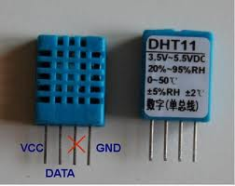

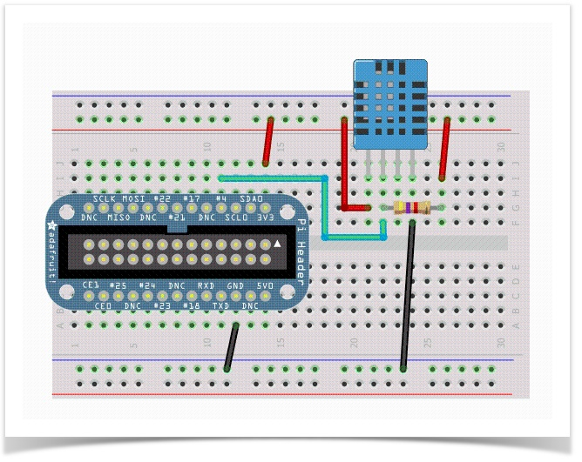
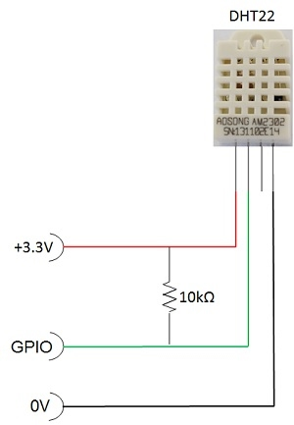

http://www.uugear.com/portfolio/read-dht1122-temperature-humidity-sensor-from-raspberry-pi/
http://www.uugear.com/portfolio/dht11-humidity-temperature-sensor-module/
http://www.manuel-esteban.com/lire-une-sonde-dht22-avec-un-raspberry-pi/
http://www.tme.eu/fr/Document/7a4fd48d400b8c4c8309ef1e2b13cdd4/MR003-005-1.pdf
Datas : trame de 4 bits
https://www.carnetdumaker.net/articles/utiliser-un-capteur-de-temperature-et-dhumidite-dht11-dht22-avec-une-carte-arduino-genuino/
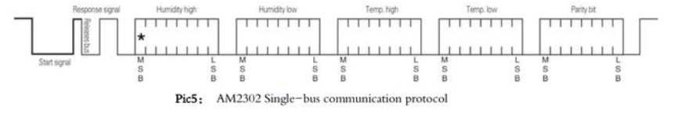
https://www.adafruit.com/distributors
https://learn.adafruit.com/bmp085
http://www.gotronic.fr/cat-humidistances-1144.htm
data logger
https://david.meziere.eu/fr/raspberry-pi/dht11-et-dht22-de-chez-aosong/
https://github.com/dmeziere/rpi-dht/blob/master/util/dht11.c
https://github.com/dmeziere/rpi-dht/tree/master/util
https://github.com/dmeziere/rpi-dht/blob/master/util/dht22.c
https://github.com/adafruit/DHT-sensor-library
http://nasfamilyone.synology.me/tutoterraspi/#3
Highcharts
WiringPi
https://github.com/adafruit/Adafruit-BMP085-Library
http://wiki.mchobby.be/index.php?title=Rasp-Hack-BMP085
http://wiki.mchobby.be/index.php?title=Rasp-Hack-BMP085-Python-Lib
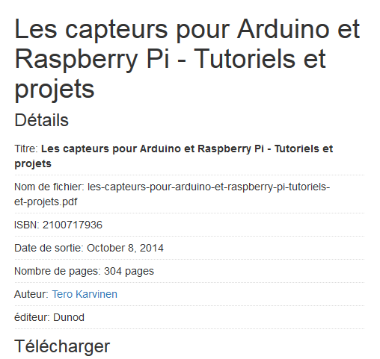

https://github.com/lexruee/bmp180
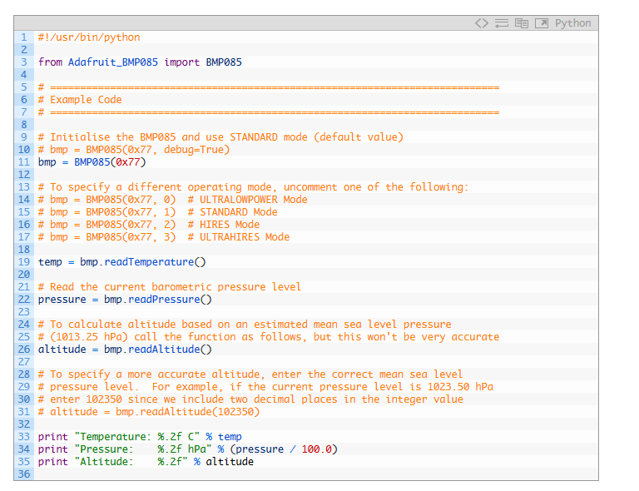
https://www.john.geek.nz/2012/08/reading-data-from-a-bosch-bmp085-with-a-raspberry-pi/
https://www.sunfounder.com/learn/sensor-kit-v2-0-for-raspberry-pi-b-plus/lesson-31-barometer-sensor-kit-v2-0-for-b-plus.html
https://github.com/BoschSensortec/BMP280_driver
https://www.raspberrypi.org/forums/viewtopic.php?t=16968&p=177210
http://hirt.se/blog/?p=652

#include <fcntl.h>
#include <stdio.h>
#include <stdlib.h>
#include <unistd.h>
#include <linux/i2c-dev.h>
#include <sys/ioctl.h>
#define DS1621_I2C_BUS "/dev/i2c-1"
#define DS1621_SLAVE_ADDR 0x4F
#define DS1621_ACCESS_CONFIG 0xAC
#define DS1621_START_CONVERT 0xEE
#define DS1621_READ_TEMPERATURE 0xAA
#define DS1621_ONE_SHOT 0x01
#define DS1621_DONE 0x80
int main(int argc, char * argv[])
{
int fd;
int value;

// Obtenir l’accès au bus i2c
fd = open(DS1621_I2C_BUS, O_RDWR);
if (fd < 0) {
perror(DS1621_I2C_BUS);
exit(EXIT_FAILURE);
}
// Fixer l'adresse de l'esclave avec qui communiquer
if (ioctl(fd, I2C_SLAVE, DS1621_SLAVE_ADDR) < 0) {
perror("Slave unreachable");
exit(EXIT_FAILURE);
}
// Lire le registre ACCESS_CONFIG
value = i2c_smbus_read_byte_data(fd, DS1621_ACCESS_CONFIG);
if (value < 0) {
perror("Read ACCESS_CONFIG");
exit(EXIT_FAILURE);
}
value |= DS1621_ONE_SHOT;
// Réécrire ACCESS_CONFIG
if (i2c_smbus_write_byte_data(fd, DS1621_ACCESS_CONFIG, value) < 0) {
perror("Write ACCESS_CONFIG");
exit(EXIT_FAILURE);
}

// Démarrer l'acquisition
if (i2c_smbus_write_byte(fd, DS1621_START_CONVERT) < 0) {
perror("Write START_CONVERT");
exit(EXIT_FAILURE);
}
// Attendre qu'une acquisition soit terminée
do {
value = i2c_smbus_read_byte_data(fd, DS1621_ACCESS_CONFIG);
if (value < 0) {
perror("Read ACCESS_CONFIG");
exit(EXIT_FAILURE);
}
} while ((value & DS1621_DONE) == 0);
// Lire la température
value = i2c_smbus_read_byte_data(fd, DS1621_READ_TEMPERATURE);
if (value < 0) {
perror("Read TEMPERATURE");
exit(EXIT_FAILURE);
}
if (value > 127)
value -= 256;
fprintf(stdout, "%d\n", value);
return EXIT_SUCCESS;
}
http://connect.ed-diamond.com/GNU-Linux-Magazine/GLMFHS-075/Communiquer-en-i2c-avec-un-capteur-de-temperature
http://eduscol.education.fr/sti/sites/eduscol.education.fr.sti/files/ressources/pedagogiques/4346/4346-6-rpi-i2c.pdf

SMBUS
ds18b20
http://www.manuel-esteban.com/raspi-capteur-de-temperature-ds18b20/
http://www.modmypi.com/blog/ds18b20-one-wire-digital-temperature-sensor-and-the-raspberry-pi
http://bradsrpi.blogspot.fr/2013/12/c-program-to-read-temperature-from-1.html
http://www.raspberrypi-spy.co.uk/2013/10/analogue-sensors-on-the-raspberry-pi-using-an-mcp3008/
https://cdn-learn.adafruit.com/downloads/pdf/adafruits-raspberry-pi-lesson-11-ds18b20-temperature-sensing.pdf bien
http://bradsmc.blogspot.fr/2014/06/c-program-to-read-multiple-ds18b20-1.html

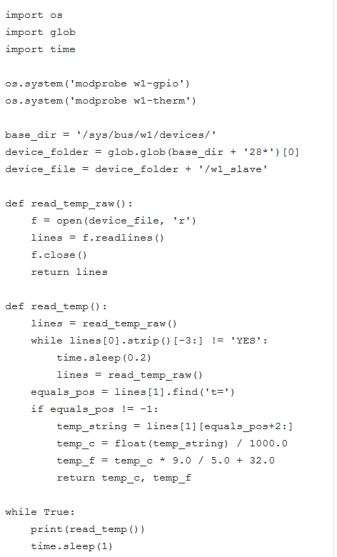

http://www.framboise314.fr/mesure-de-temperature-1-wire-ds18b20-avec-le-raspberry-pi/
http://nagashur.com/wiki/doku.php?id=raspberry_pi:photoresistance_mesure_lumi

