CentOS67
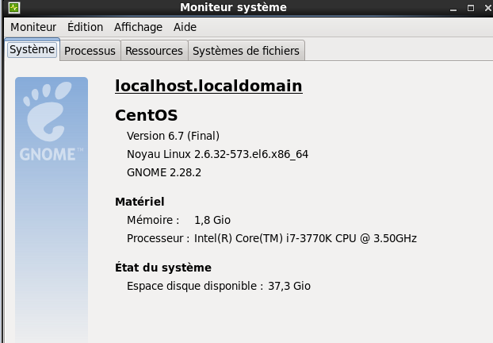
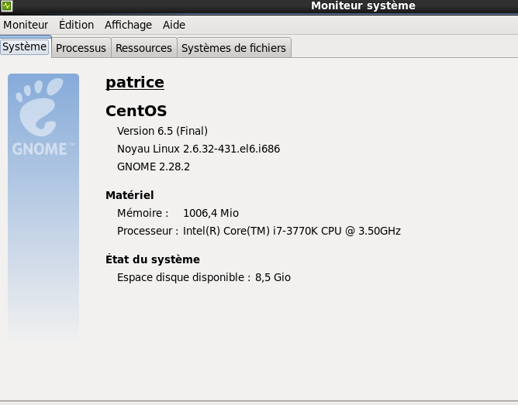

yum install libstdc++*i686* toujours le PB

/lib/ld-linux.so.2: bad ELF interpreter: Aucun fichier ou dossier de ce type

yum install /lib/ld-linux.so.2 No more mirrors to try

yum -y install glibc.i686 erreur de telechargement

yum update glibc erreur de telechargement

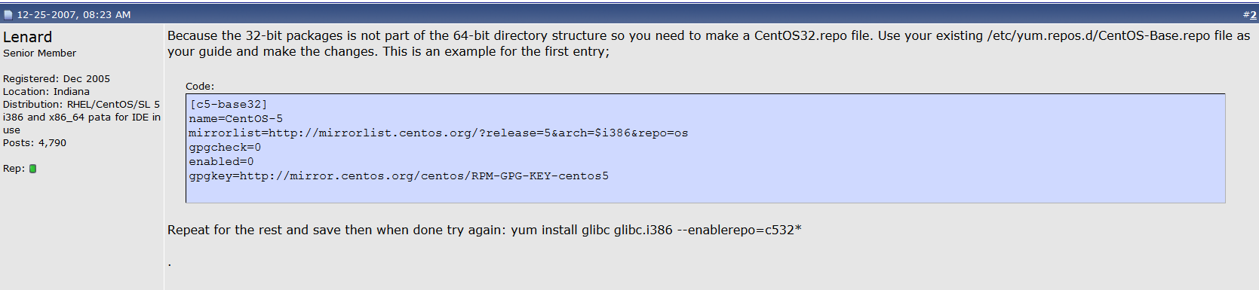

http://www.linuxquestions.org/questions/linux-newbie-8/error-no-package-matching-glibc-i686-608948/

yum install glibc.i686 meme PB

Linux localhost.localdomain 2.6.32-573.el6.x86_64 #1 SMP Thu Jul 23 15:44:03 UTC 2015 x86_64 x86_64 x86_64 GNU/Linux

yum install glibc.i686 reussi - eth0 actif

./sfk: error while loading shared libraries: libstdc++.so.6: cannot open shared object file: No such file or directory
sudo yum install libstdc++.i686 probléme

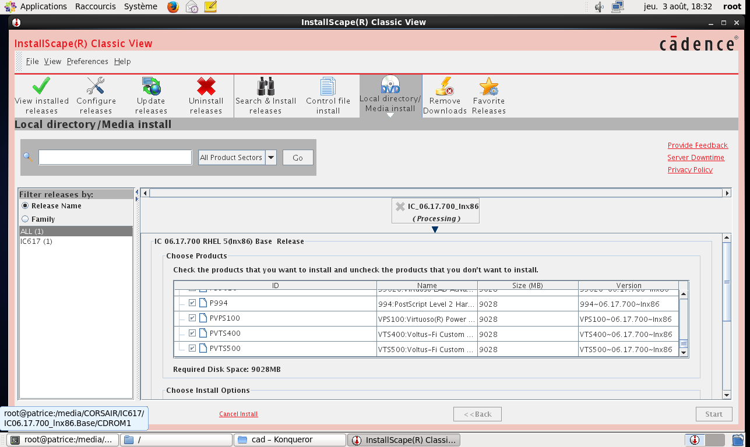
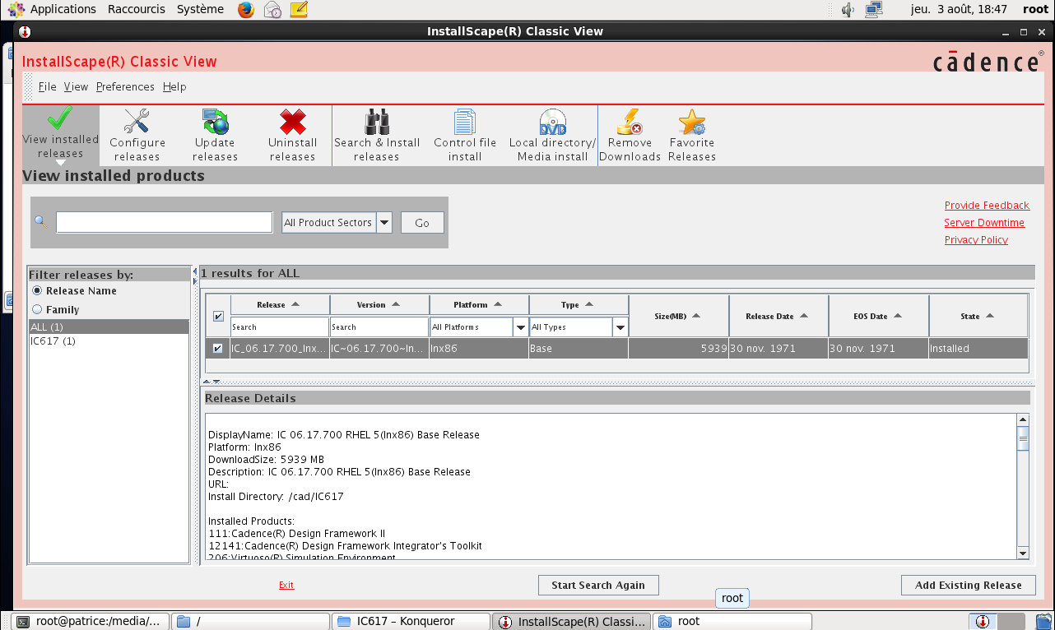
http://blog.sina.com.cn/s/blog_7385e45f0102x3yn.html
http://bbs.eetop.cn/viewthread.php?tid=579936
./cadence_patch.sh IC617
[total hits/matching patterns/non-matching patterns]
[001/1/2] ...2.50.036/lib/linux_rhel50_gcc48x_64/opt/libcmTracking.so
[001/1/2] ...v22.50.036/lib/linux_rhel50_gcc48x_64/opt/libcmExport.so
[001/1/2] ...2.50.036/lib/linux_rhel50_gcc48x_32/opt/libcmTracking.so
[001/1/2] ...v22.50.036/lib/linux_rhel50_gcc48x_32/opt/libcmExport.so
[001/1/2] .../tools.lnx86/cdsSkillPcell/lib/64bit/libcdsSkillPcell.so
[001/1/2] IC617/tools.lnx86/extraction/bin/64bit/emtoict
[001/1/2] IC617/tools.lnx86/extraction/bin/64bit/ircxtoict
[001/1/2] IC617/tools.lnx86/jre64/lib/i386/server/libjvm.so
[001/1/2] IC617/tools.lnx86/bin/allegro_batch.exe
[001/1/2] IC617/tools.lnx86/bin/ckout_test
[001/1/2] IC617/tools.lnx86/bin/64bit/cdsCopyShell
[001/1/2] IC617/tools.lnx86/bin/64bit/cdsHierEditor
[001/1/2] IC617/tools.lnx86/bin/64bit/hedConfigTraverse
[001/1/2] IC617/tools.lnx86/bin/64bit/cdsConfigCvt
[001/1/2] IC617/tools.lnx86/bin/64bit/cdsmps
[001/1/2] IC617/tools.lnx86/bin/64bit/cdslmd
[001/1/2] IC617/tools.lnx86/bin/64bit/hedConfigCompare
[001/1/2] IC617/tools.lnx86/bin/cdslmd
[001/1/2] IC617/tools.lnx86/bin/perf_test
[001/1/2] IC617/tools.lnx86/bin/32bit/cdsCopyShell
[001/1/2] IC617/tools.lnx86/bin/32bit/cdsHierEditor
[001/1/2] IC617/tools.lnx86/bin/32bit/hedConfigTraverse
[001/1/2] IC617/tools.lnx86/bin/32bit/cdsConfigCvt
[001/1/2] IC617/tools.lnx86/bin/32bit/cdsmps
[001/1/2] IC617/tools.lnx86/bin/32bit/hedConfigCompare
[001/1/2] IC617/tools.lnx86/nvnDfII/bin/64bit/netReaderDfII
[001/1/2] IC617/tools.lnx86/dracula/bin/64bit/MRGNOD
[001/1/2] IC617/tools.lnx86/dracula/bin/64bit/PARCHK
[001/1/2] IC617/tools.lnx86/dracula/bin/64bit/HCREATX
[001/1/2] IC617/tools.lnx86/dracula/bin/64bit/CELLNAME
[001/1/2] IC617/tools.lnx86/dracula/bin/64bit/MRGNET
[001/1/2] IC617/tools.lnx86/dracula/bin/64bit/printrap
[001/1/2] IC617/tools.lnx86/dracula/bin/64bit/LABSER
[001/1/2] IC617/tools.lnx86/dracula/bin/64bit/EDIFOUT
[001/1/2] IC617/tools.lnx86/dracula/bin/64bit/LPEQRY
[001/1/2] IC617/tools.lnx86/dracula/bin/64bit/PREWID
[001/1/2] IC617/tools.lnx86/dracula/bin/64bit/RECTCHK
[001/1/2] IC617/tools.lnx86/dracula/bin/64bit/PXLONG
[001/1/2] IC617/tools.lnx86/dracula/bin/64bit/SHORTR
[001/1/2] IC617/tools.lnx86/dracula/bin/64bit/PACKNET
[001/1/2] IC617/tools.lnx86/dracula/bin/64bit/LABSEL
[001/1/2] IC617/tools.lnx86/dracula/bin/64bit/EMASK
[001/1/2] IC617/tools.lnx86/dracula/bin/64bit/GENRECT
[001/1/2] IC617/tools.lnx86/dracula/bin/64bit/GENSHD
[001/1/2] IC617/tools.lnx86/dracula/bin/64bit/GENXRF
[001/1/2] IC617/tools.lnx86/dracula/bin/64bit/NODAL
[001/1/2] IC617/tools.lnx86/dracula/bin/64bit/DRACD
[001/1/2] IC617/tools.lnx86/dracula/bin/64bit/EBESIN
[001/1/2] IC617/tools.lnx86/dracula/bin/64bit/SCELWS
[001/1/2] IC617/tools.lnx86/dracula/bin/64bit/BASE
[001/1/2] IC617/tools.lnx86/dracula/bin/64bit/printnet
[001/1/2] IC617/tools.lnx86/dracula/bin/64bit/BBOX
[001/1/2] IC617/tools.lnx86/dracula/bin/64bit/EXTNRX
[001/1/2] IC617/tools.lnx86/dracula/bin/64bit/REDUCE
[001/1/2] IC617/tools.lnx86/dracula/bin/64bit/SPACING
[001/1/2] IC617/tools.lnx86/dracula/bin/64bit/TRCVPO
[001/1/2] IC617/tools.lnx86/dracula/bin/64bit/MANN
[001/1/2] IC617/tools.lnx86/dracula/bin/64bit/PREINQUERY
[001/1/2] IC617/tools.lnx86/dracula/bin/64bit/POSCAT
[001/1/2] IC617/tools.lnx86/dracula/bin/64bit/RMDEVI
[001/1/2] IC617/tools.lnx86/dracula/bin/64bit/EXPLODE
[001/1/2] IC617/tools.lnx86/dracula/bin/64bit/LUMPCAP
[001/1/2] IC617/tools.lnx86/dracula/bin/64bit/SELECT
[001/1/2] IC617/tools.lnx86/dracula/bin/64bit/ATTNRX
[001/1/2] IC617/tools.lnx86/dracula/bin/64bit/ERCSEL
[001/1/2] IC617/tools.lnx86/dracula/bin/64bit/XVIA
[001/1/2] IC617/tools.lnx86/dracula/bin/64bit/CKT2CKT
[001/1/2] IC617/tools.lnx86/dracula/bin/64bit/PDRACULA
[001/1/2] IC617/tools.lnx86/dracula/bin/64bit/OUTEXT
[001/1/2] IC617/tools.lnx86/dracula/bin/64bit/UPDPAD
[001/1/2] IC617/tools.lnx86/dracula/bin/64bit/SEAMES
[001/1/2] IC617/tools.lnx86/dracula/bin/64bit/MERGECAP
[001/1/2] IC617/tools.lnx86/dracula/bin/64bit/LVSNET
[001/1/2] IC617/tools.lnx86/dracula/bin/64bit/OAIN22
[001/1/2] IC617/tools.lnx86/dracula/bin/64bit/APPLEOUT
[001/1/2] IC617/tools.lnx86/dracula/bin/64bit/KXGROUP
[001/1/2] IC617/tools.lnx86/dracula/bin/64bit/EBES
[001/1/2] IC617/tools.lnx86/dracula/bin/64bit/ELENET
[001/1/2] IC617/tools.lnx86/dracula/bin/64bit/FILPARAM
[001/1/2] IC617/tools.lnx86/dracula/bin/64bit/EXPAND
[001/1/2] IC617/tools.lnx86/dracula/bin/64bit/NODREF
[001/1/2] IC617/tools.lnx86/dracula/bin/64bit/IDLABL
[001/1/2] IC617/tools.lnx86/dracula/bin/64bit/HIEREN
[001/1/2] IC617/tools.lnx86/dracula/bin/64bit/BOXPLY
[001/1/2] IC617/tools.lnx86/dracula/bin/64bit/LOGLVS
[001/1/2] IC617/tools.lnx86/dracula/bin/64bit/TRTEXT
[001/1/2] IC617/tools.lnx86/dracula/bin/64bit/DEXT
[001/1/2] IC617/tools.lnx86/dracula/bin/64bit/LPEPRO
[001/1/2] IC617/tools.lnx86/dracula/bin/64bit/COMPUT
[001/1/2] IC617/tools.lnx86/dracula/bin/64bit/PXCONT
[001/1/2] IC617/tools.lnx86/dracula/bin/64bit/CTCENV
[001/1/2] IC617/tools.lnx86/dracula/bin/64bit/PXRMOD
[001/1/2] IC617/tools.lnx86/dracula/bin/64bit/UPDXREF
[001/1/2] IC617/tools.lnx86/dracula/bin/64bit/PERI
[001/1/2] IC617/tools.lnx86/dracula/bin/64bit/SHTEST
[001/1/2] IC617/tools.lnx86/dracula/bin/64bit/APPLEIN
[001/1/2] IC617/tools.lnx86/dracula/bin/64bit/COVERAGE
[001/1/2] IC617/tools.lnx86/dracula/bin/64bit/LVSCHM
[001/1/2] IC617/tools.lnx86/dracula/bin/64bit/DEVTAG
[001/1/2] IC617/tools.lnx86/dracula/bin/64bit/CAT
[001/1/2] IC617/tools.lnx86/dracula/bin/64bit/AREAPATH
[001/1/2] IC617/tools.lnx86/dracula/bin/64bit/vchconv
[001/1/2] IC617/tools.lnx86/dracula/bin/64bit/CREATX
[001/1/2] IC617/tools.lnx86/dracula/bin/64bit/ADDTXT
[001/1/2] IC617/tools.lnx86/dracula/bin/64bit/LISTSPF
[001/1/2] IC617/tools.lnx86/dracula/bin/64bit/XCELL
[001/1/2] IC617/tools.lnx86/dracula/bin/64bit/KPOSATT
[001/1/2] IC617/tools.lnx86/dracula/bin/64bit/HATTAH
[001/1/2] IC617/tools.lnx86/dracula/bin/64bit/OAOUT
[001/1/2] IC617/tools.lnx86/dracula/bin/64bit/CUTTRM
[001/1/2] IC617/tools.lnx86/dracula/bin/64bit/POSTENC
[001/1/2] IC617/tools.lnx86/dracula/bin/64bit/LISTLPE
[001/1/2] IC617/tools.lnx86/dracula/bin/64bit/GENBOX
[001/1/2] IC617/tools.lnx86/dracula/bin/64bit/mxyconv
[001/1/2] IC617/tools.lnx86/dracula/bin/64bit/FILTER
[001/1/2] IC617/tools.lnx86/dracula/bin/64bit/EDIFIN
[001/1/2] IC617/tools.lnx86/dracula/bin/64bit/DISKMASK
[001/1/2] IC617/tools.lnx86/dracula/bin/64bit/PGEMERGE
[001/1/2] IC617/tools.lnx86/dracula/bin/64bit/KCREATX
[001/1/2] IC617/tools.lnx86/dracula/bin/64bit/LOGMRG
[001/1/2] IC617/tools.lnx86/dracula/bin/64bit/LPEXTR
[001/1/2] IC617/tools.lnx86/dracula/bin/64bit/MANNIN
[001/1/2] IC617/tools.lnx86/dracula/bin/64bit/SIZE
[001/1/2] IC617/tools.lnx86/dracula/bin/64bit/GENTXT
[001/1/2] IC617/tools.lnx86/dracula/bin/64bit/DRACCP
[001/1/2] IC617/tools.lnx86/dracula/bin/64bit/FLATTEN
[001/1/2] IC617/tools.lnx86/dracula/bin/64bit/LINKLABL
[001/1/2] IC617/tools.lnx86/dracula/bin/64bit/TRCVPOLY
[001/1/2] IC617/tools.lnx86/dracula/bin/64bit/CUMULATE
[001/1/2] IC617/tools.lnx86/dracula/bin/64bit/TRIANGLE
[001/1/2] IC617/tools.lnx86/dracula/bin/64bit/CELSTRIP
[001/1/2] IC617/tools.lnx86/dracula/bin/64bit/KEDTEXT
[001/1/2] IC617/tools.lnx86/dracula/bin/64bit/CAPDIS
[001/1/2] IC617/tools.lnx86/dracula/bin/64bit/PRESPF
[001/1/2] IC617/tools.lnx86/dracula/bin/64bit/GENENV
[001/1/2] IC617/tools.lnx86/dracula/bin/64bit/MASKDISK
[001/1/2] IC617/tools.lnx86/dracula/bin/64bit/OAOUT22
[001/1/2] IC617/tools.lnx86/dracula/bin/64bit/D2RXRF
[001/1/2] IC617/tools.lnx86/dracula/bin/64bit/HEDTEX
[001/1/2] IC617/tools.lnx86/dracula/bin/64bit/MEBES
[001/1/2] IC617/tools.lnx86/dracula/bin/64bit/PRESEL
[001/1/2] IC617/tools.lnx86/dracula/bin/64bit/slconv
[001/1/2] IC617/tools.lnx86/dracula/bin/64bit/EMASKIN
[001/1/2] IC617/tools.lnx86/dracula/bin/64bit/GDS2IN
[001/1/2] IC617/tools.lnx86/dracula/bin/64bit/EXTERM
[001/1/2] IC617/tools.lnx86/dracula/bin/64bit/DENC
[001/1/2] IC617/tools.lnx86/dracula/bin/64bit/NLVSPT
[001/1/2] IC617/tools.lnx86/dracula/bin/64bit/ATTACH
[001/1/2] IC617/tools.lnx86/dracula/bin/64bit/XYWCHK
[001/1/2] IC617/tools.lnx86/dracula/bin/64bit/STAMP
[001/1/2] IC617/tools.lnx86/dracula/bin/64bit/MEBESIN
[001/1/2] IC617/tools.lnx86/dracula/bin/64bit/KSCHMND
[001/1/2] IC617/tools.lnx86/dracula/bin/64bit/CRENET
[001/1/2] IC617/tools.lnx86/dracula/bin/64bit/LOGPART
[001/1/2] IC617/tools.lnx86/dracula/bin/64bit/dracToRcx
[001/1/2] IC617/tools.lnx86/dracula/bin/64bit/LVLCHM
[001/1/2] IC617/tools.lnx86/dracula/bin/64bit/EDGECHK
[001/1/2] IC617/tools.lnx86/dracula/bin/64bit/CPAIR
[001/1/2] IC617/tools.lnx86/dracula/bin/64bit/PATHCK
[001/1/2] IC617/tools.lnx86/dracula/bin/64bit/SCHNET
[001/1/2] IC617/tools.lnx86/dracula/bin/64bit/NDFLOAT
[001/1/2] IC617/tools.lnx86/dracula/bin/64bit/SUMRES
[001/1/2] IC617/tools.lnx86/dracula/bin/64bit/XBOX
[001/1/2] IC617/tools.lnx86/dracula/bin/64bit/CIFOUT
[001/1/2] IC617/tools.lnx86/dracula/bin/64bit/COMPEN
[001/1/2] IC617/tools.lnx86/dracula/bin/64bit/LOGICAL
[001/1/2] IC617/tools.lnx86/dracula/bin/64bit/LVSPLT
[001/1/2] IC617/tools.lnx86/dracula/bin/64bit/CIFIN
[001/1/2] IC617/tools.lnx86/dracula/bin/64bit/SEPLAY
[001/1/2] IC617/tools.lnx86/dracula/bin/64bit/RELOCATE
[001/1/2] IC617/tools.lnx86/dracula/bin/64bit/DRACCLNT
[001/1/2] IC617/tools.lnx86/dracula/bin/64bit/GENNET
[001/1/2] IC617/tools.lnx86/dracula/bin/64bit/CORNER
[001/1/2] IC617/tools.lnx86/dracula/bin/64bit/DBCONVER
[001/1/2] IC617/tools.lnx86/dracula/bin/64bit/BOXLAY
[001/1/2] IC617/tools.lnx86/dracula/bin/64bit/LVSXREF
[001/1/2] IC617/tools.lnx86/dracula/bin/64bit/INVSMH
[001/1/2] IC617/tools.lnx86/dracula/bin/64bit/REGION
[001/1/2] IC617/tools.lnx86/dracula/bin/64bit/CREGION
[001/1/2] IC617/tools.lnx86/dracula/bin/64bit/KNODSVS
[001/1/2] IC617/tools.lnx86/dracula/bin/64bit/EDTEXG
[001/1/2] IC617/tools.lnx86/dracula/bin/64bit/CALCULAT
[001/1/2] IC617/tools.lnx86/dracula/bin/64bit/ENVPLO
[001/1/2] IC617/tools.lnx86/dracula/bin/64bit/LVSMD3
[001/1/2] IC617/tools.lnx86/dracula/bin/64bit/DRAC2CDL
[001/1/2] IC617/tools.lnx86/dracula/bin/64bit/SCHMIN
[001/1/2] IC617/tools.lnx86/dracula/bin/64bit/DRAC2QRC
[001/1/2] IC617/tools.lnx86/dracula/bin/64bit/GPATHCK
[001/1/2] IC617/tools.lnx86/dracula/bin/64bit/PXJUNC
[001/1/2] IC617/tools.lnx86/dracula/bin/64bit/GROW
[001/1/2] IC617/tools.lnx86/dracula/bin/64bit/XDEVIC
[001/1/2] IC617/tools.lnx86/dracula/bin/64bit/EDTEXN
[001/1/2] IC617/tools.lnx86/dracula/bin/64bit/ANTENNA
[001/1/2] IC617/tools.lnx86/dracula/bin/64bit/DRACLM
[001/1/2] IC617/tools.lnx86/dracula/bin/64bit/HOLE
[001/1/2] IC617/tools.lnx86/dracula/bin/64bit/PROBE
[001/1/2] IC617/tools.lnx86/dracula/bin/64bit/GENXCN
[001/1/2] IC617/tools.lnx86/dracula/bin/64bit/LISTRSPF
[001/1/2] IC617/tools.lnx86/dracula/bin/64bit/SYSORT
[001/1/2] IC617/tools.lnx86/dracula/bin/64bit/PREATT
[001/1/2] IC617/tools.lnx86/dracula/bin/64bit/XCELPN
[001/1/2] IC617/tools.lnx86/dracula/bin/64bit/KLVLTXT
[001/1/2] IC617/tools.lnx86/dracula/bin/64bit/GENANO
[001/1/2] IC617/tools.lnx86/dracula/bin/64bit/STRIP
[001/1/2] IC617/tools.lnx86/dracula/bin/64bit/pdata
[001/1/2] IC617/tools.lnx86/dracula/bin/64bit/ddbToRcx
[001/1/2] IC617/tools.lnx86/dracula/bin/64bit/ENCRECT
[001/1/2] IC617/tools.lnx86/dracula/bin/64bit/MASKMAKER
[001/1/2] IC617/tools.lnx86/dracula/bin/64bit/GDS2OUT
[001/1/2] IC617/tools.lnx86/dracula/bin/64bit/POSATT
[001/1/2] IC617/tools.lnx86/lea/bin/64bit/outperform
[001/1/2] IC617/tools.lnx86/lea/bin/64bit/gen_lea_model
[001/1/2] IC617/tools.lnx86/lea/bin/64bit/cws
[001/1/2] IC617/tools.lnx86/jre/lib/i386/server/libjvm.so
[001/1/2] IC617/tools.lnx86/sev/bin/64bit/vsaplot
[001/1/2] IC617/tools.lnx86/sev/bin/64bit/vpsbatch
[002/1/2] IC617/tools.lnx86/dfII/bin/64bit/layoutPlus
[001/1/2] IC617/tools.lnx86/dfII/bin/64bit/LVS
[001/1/2] IC617/tools.lnx86/dfII/bin/64bit/strmout
[001/1/2] IC617/tools.lnx86/dfII/bin/64bit/bbtEditor
[001/1/2] IC617/tools.lnx86/dfII/bin/64bit/vhdlin
[001/1/2] IC617/tools.lnx86/dfII/bin/64bit/amsd
[001/1/2] IC617/tools.lnx86/dfII/bin/64bit/dbAccess
[001/1/2] IC617/tools.lnx86/dfII/bin/64bit/psfxl
[001/1/2] IC617/tools.lnx86/dfII/bin/64bit/spiceIn
[001/1/2] IC617/tools.lnx86/dfII/bin/64bit/sdf2sdf3
[001/1/2] IC617/tools.lnx86/dfII/bin/64bit/ccpCPHUpdtr
[001/1/2] IC617/tools.lnx86/dfII/bin/64bit/lefin
[001/1/2] IC617/tools.lnx86/dfII/bin/64bit/df2zparse
[001/1/2] IC617/tools.lnx86/dfII/bin/64bit/mapper
[001/1/2] IC617/tools.lnx86/dfII/bin/64bit/cdb2oail
[001/1/2] IC617/tools.lnx86/dfII/bin/64bit/verifier
[001/1/2] IC617/tools.lnx86/dfII/bin/64bit/cdsCreate5x
[001/1/2] IC617/tools.lnx86/dfII/bin/64bit/oasisout
[001/1/2] IC617/tools.lnx86/dfII/bin/64bit/skill
[001/1/2] IC617/tools.lnx86/dfII/bin/64bit/ncktMigrateDB
[001/1/2] IC617/tools.lnx86/dfII/bin/64bit/lvsbx
[001/1/2] IC617/tools.lnx86/dfII/bin/64bit/libManager
[001/1/2] IC617/tools.lnx86/dfII/bin/64bit/itcComm
[001/1/2] IC617/tools.lnx86/dfII/bin/64bit/edifin
[001/1/2] IC617/tools.lnx86/dfII/bin/64bit/abstract
[001/1/2] IC617/tools.lnx86/dfII/bin/64bit/tb2oa
[001/1/2] IC617/tools.lnx86/dfII/bin/64bit/ccpDFIIPostCopyOA
[001/1/2] IC617/tools.lnx86/dfII/bin/64bit/xpcmerge
[001/1/2] IC617/tools.lnx86/dfII/bin/64bit/cdsLibEditor
[001/1/2] IC617/tools.lnx86/dfII/bin/64bit/XScale
[001/1/2] IC617/tools.lnx86/dfII/bin/64bit/hdldebug
[001/1/2] IC617/tools.lnx86/dfII/bin/64bit/oa2dfII
[001/1/2] IC617/tools.lnx86/dfII/bin/64bit/vhdlNet
[001/1/2] IC617/tools.lnx86/dfII/bin/64bit/colorAnnotate
[001/1/2] IC617/tools.lnx86/dfII/bin/64bit/psf
[001/1/2] IC617/tools.lnx86/dfII/bin/64bit/ERC
[001/1/2] IC617/tools.lnx86/dfII/bin/64bit/ccpDFIIUpdtr
[001/1/2] IC617/tools.lnx86/dfII/bin/64bit/ivVerify
[001/1/2] IC617/tools.lnx86/dfII/bin/64bit/asg
[001/1/2] IC617/tools.lnx86/dfII/bin/64bit/defin
[001/1/2] IC617/tools.lnx86/dfII/bin/64bit/pvs4dfii
[001/1/2] IC617/tools.lnx86/dfII/bin/64bit/techLoadDump
[001/1/2] IC617/tools.lnx86/dfII/bin/64bit/smgVerilogPostProcessor
[001/1/2] IC617/tools.lnx86/dfII/bin/64bit/mptUpdate
[001/1/2] IC617/tools.lnx86/dfII/bin/64bit/qtrek
[001/1/2] IC617/tools.lnx86/dfII/bin/64bit/cdb2oa
[001/1/2] IC617/tools.lnx86/dfII/bin/64bit/ccpDFIIChecker
[001/1/2] IC617/tools.lnx86/dfII/bin/64bit/fastTree
[001/1/2] IC617/tools.lnx86/dfII/bin/64bit/ihdl
[001/1/2] IC617/tools.lnx86/dfII/bin/64bit/strmin
[001/1/2] IC617/tools.lnx86/dfII/bin/64bit/amsdirect
[001/1/2] IC617/tools.lnx86/dfII/bin/64bit/smgGui
[001/1/2] IC617/tools.lnx86/dfII/bin/64bit/qrcToDfII
[001/1/2] IC617/tools.lnx86/dfII/bin/64bit/conn2sch
[001/1/2] IC617/tools.lnx86/dfII/bin/64bit/oasisin
[001/1/2] IC617/tools.lnx86/dfII/bin/64bit/defout
[001/1/2] IC617/tools.lnx86/dfII/bin/64bit/smgGenerateModel
[001/1/2] IC617/tools.lnx86/dfII/bin/64bit/si
[001/1/2] IC617/tools.lnx86/dfII/bin/64bit/artil
[001/1/2] IC617/tools.lnx86/dfII/bin/64bit/lefout
[001/1/2] IC617/tools.lnx86/dfII/bin/64bit/runams
[001/1/2] IC617/tools.lnx86/dfII/bin/64bit/ccpAdexlUpdtr
[001/1/2] IC617/tools.lnx86/dfII/bin/64bit/edifout
[001/1/2] IC617/tools.lnx86/dfII/bin/32bit/skill
[001/1/2] IC617/tools.lnx86/dfII/etc/smg/lib/64bit/libvpi.so
[001/1/2] IC617/tools.lnx86/tlfUtil/bin/32bit/tlfMerge
[001/1/2] IC617/tools.lnx86/tlfUtil/bin/32bit/tlfEncrypt
[001/1/2] IC617/tools.lnx86/tlfUtil/bin/32bit/tlfConvert
[001/1/2] IC617/tools.lnx86/lib/64bit/libcomDiffEngCore_sh.so
[001/1/2] IC617/tools.lnx86/lib/64bit/libdrl.so
[001/1/2] IC617/tools.lnx86/lib/64bit/libsrrjni.so
[001/1/2] IC617/tools.lnx86/lib/64bit/srrjni/libsrrjni.so
[001/1/2] IC617/tools.lnx86/lib/64bit/srrjni/libwslicense.so
[001/1/2] IC617/tools.lnx86/lib/64bit/libsrr.so
[001/1/2] IC617/tools.lnx86/lib/64bit/libwslicense.so
[001/1/2] IC617/tools.lnx86/iota/bin/64bit/oa2defCDS
[001/1/2] IC617/tools.lnx86/iota/bin/64bit/mptScan
[001/1/2] IC617/tools.lnx86/iota/bin/64bit/lef2oaCDS
[001/1/2] IC617/tools.lnx86/iota/bin/64bit/oa2lefCDS
[001/1/2] IC617/tools.lnx86/iota/bin/64bit/def2oaCDS
[001/1/2] IC617/tools.lnx86/iota/bin/32bit/oa2defCDS
[001/1/2] IC617/tools.lnx86/iota/bin/32bit/mptScan
[001/1/2] IC617/tools.lnx86/iota/bin/32bit/lef2oaCDS
[001/1/2] IC617/tools.lnx86/iota/bin/32bit/oa2lefCDS
[001/1/2] IC617/tools.lnx86/iota/bin/32bit/def2oaCDS
[001/1/2] IC617/tools.lnx86/catena/bin/64bit/finaleXTS
[001/1/2] IC617/tools.lnx86/catena/bin/64bit/finaleEAD
[001/1/2] IC617/tools.lnx86/catena/bin/64bit/eadModelGen
[001/1/2] IC617/tools.lnx86/mmg/bin/64bit/cmms
[001/1/2] IC617/tools.lnx86/ssvtools/bin/64bit/itaputil
[001/1/2] IC617/tools.lnx86/ssvtools/bin/64bit/voltus_rail
[001/1/2] IC617/tools.lnx86/ssvtools/bin/64bit/voltus_libgen
[001/1/2] IC617/tools.lnx86/ssvtools/bin/64bit/voltus_libsim
[001/1/2] IC617/tools.lnx86/ssvtools/bin/64bit/pgdb2spf
[001/1/2] IC617/tools.lnx86/ssvtools/bin/64bit/lightning.tty
[001/1/2] IC617/tools.lnx86/ssvtools/bin/64bit/lightning
[001/1/2] IC617/tools.lnx86/ssvtools/bin/64bit/dspf2pgdb
[001/1/2] IC617/tools.lnx86/ret/bin/64bit/lpacsikeygen
[001/1/2] IC617/tools.lnx86/ret/bin/64bit/lpacstclsh
[001/1/2] IC617/tools.lnx86/ret/bin/64bit/winExtract
[001/1/2] IC617/tools.lnx86/ret/bin/64bit/modelImport
[001/1/2] IC617/tools.lnx86/ret/bin/64bit/gdsm
[001/1/2] IC617/tools.lnx86/ret/bin/64bit/lpainshape
[001/1/2] IC617/tools.lnx86/ret/bin/64bit/istechgen
[001/1/2] IC617/tools.lnx86/ret/bin/64bit/gds2x
[001/1/2] IC617/tools.lnx86/ret/bin/64bit/gdstile
[001/1/2] IC617/tools.lnx86/ret/bin/64bit/lpaidlc
[001/1/2] IC617/tools.lnx86/ret/bin/64bit/modelGlimpse
[001/1/2] IC617/tools.lnx86/ret/bin/64bit/istexpand
[001/1/2] IC617/tools.lnx86/ret/bin/64bit/preprocessor
[001/1/2] IC617/tools.lnx86/ret/bin/64bit/lpacsicompile
[001/1/2] IC617/tools.lnx86/ret/lib/64bit/liblpa.so
[001/1/2] IC617/tools.lnx86/iccraft/bin/64bit/ccar
[001/1/2] IC617/tools.lnx86/itkDB/lib/64bit/itkDB_pic.a
[001/1/2] IC617/tools.lnx86/itkDB/lib/64bit/itkDB.a
[001/1/2] IC617/tools.lnx86/inca/bin/ifr
[001/1/2] IC617/tools.lnx86/inca/bin/ncsdfc
[001/1/2] IC617/tools.lnx86/inca/bin/ncdc
[001/1/2] IC617/tools.lnx86/inca/bin/ncvlog
[001/1/2] IC617/tools.lnx86/inca/bin/ncipa
[001/1/2] IC617/tools.lnx86/inca/bin/64bit/ifr
[001/1/2] IC617/tools.lnx86/inca/bin/64bit/ncsdfc
[001/1/2] IC617/tools.lnx86/inca/bin/64bit/ncdc
[001/1/2] IC617/tools.lnx86/inca/bin/64bit/ncvlog
[001/1/2] IC617/tools.lnx86/inca/bin/64bit/ncipa
[001/1/2] IC617/tools.lnx86/inca/bin/64bit/ncelab
[001/1/2] IC617/tools.lnx86/inca/bin/64bit/ncrelocate
[001/1/2] IC617/tools.lnx86/inca/bin/64bit/ncvhdl_p
[001/1/2] IC617/tools.lnx86/inca/bin/64bit/ncsvams
[001/1/2] IC617/tools.lnx86/inca/bin/ncelab
[001/1/2] IC617/tools.lnx86/inca/bin/ncrelocate
[001/1/2] IC617/tools.lnx86/inca/bin/mcvlogcg
[001/1/2] IC617/tools.lnx86/inca/bin/ncvhdl_p
[001/1/2] IC617/tools.lnx86/inca/bin/ncsvams
[001/1/2] IC617/tools.lnx86/inca/lib/ncelab.o
[001/1/2] IC617/tools.lnx86/inca/lib/64bit/ncelab.o
[001/1/2] IC617/tools.lnx86/inca/lib/64bit/libvisadev.so
[001/1/2] IC617/tools.lnx86/inca/lib/libvisadev.so
103503 files checked, 354 changed.

http://wwweslam-abdo.blogspot.fr/2016/11/cadence-virtuoso-ic616-mmsim.html
exec: /cad/IC617/tools/dfII/bin/64bit/virtuoso: cannot execute [Exec format error]
http://vlsi.die.upm.es/cadence_ubuntu
http://ece-research.unm.edu/jimp/vlsiII/cadence_install/installing_cadence.pdf

Now change dir to Cadence bin folder.
$ cd ~/cadence/installs/IC616/bin/
$ ./virtuoso -64
http://bellyfatcat.com/index.php/2016/09/20/how-to-install-cadence-ic616-on-ubuntu-16-04/
https://www.phys.hawaii.edu/~mza/ASIC/Cadence/cadence.html
cadence iscape post configuration

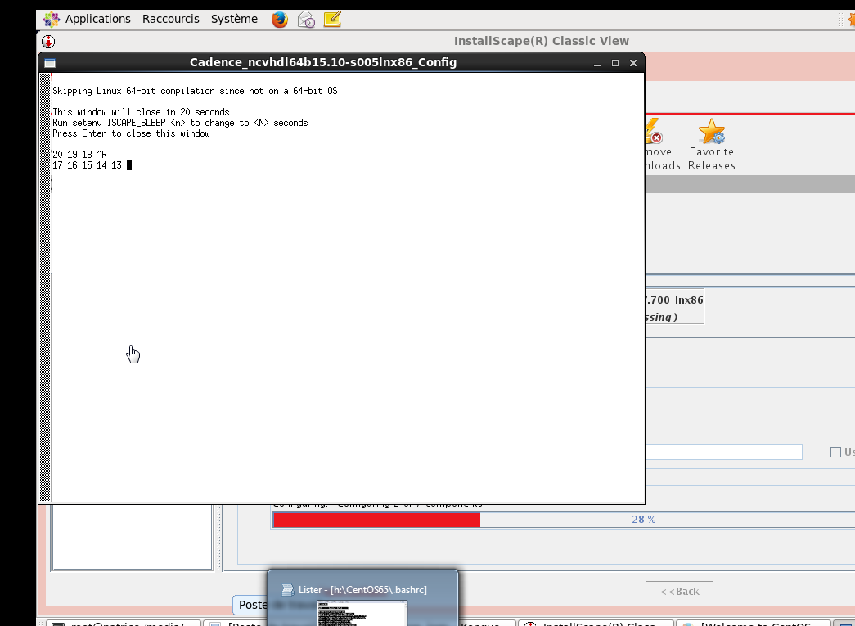

https://downloadly.ir/software/engineering-specialized/cadence-ic-design-virtuoso/

https://community.cadence.com/cadence_technology_forums/f/48/t/31409

http://allpcworld.com/download-red-hat-enterprise-linux-6-4-dvd-iso-free/
http://allpcworld.com/download-red-hat-enterprise-linux-6-4-dvd-iso-free/
pour obtenir RedHAT

http://allpcworld.com/red-hat-enterprise-linux-7-3-dvd-iso-free-download/
http://allpcworld.com/download-rhel-red-hat-linux-6-6-free/

http://www.linux-magazine.com/Issues/2015/172/Swiss-File-Knife

#!/bin/bash

yum update

yes | yum install autoconf automake libtool flex bison gperf git openssl-devel readline-devel

export VIRTUOSO_NAME=virtuoso-opensource

export VIRTUOSO_VERSION=7.1.0

export VIRTUOSO_FULLNAME=$VIRTUOSO_NAME-$VIRTUOSO_VERSION

export VIRTUOSO_TARBALL=$VIRTUOSO_FULLNAME.tar.gz

export VIRTUOSO_SRCURL=http://sourceforge.net/projects/virtuoso/files/virtuoso/$VIRTUOSO_VERSION/$VIRTUOSO_TARBALL

export SRCDIR=/usr/local/src

export VIRTUOSO_SRCDIR=$SRCDIR/$VIRTUOSO_FULLNAME

cd $SRCDIR

wget $VIRTUOSO_SRCURL

tar -xzf $VIRTUOSO_TARBALL

CFLAGS="-O2 -m64"

export CFLAGS

export VIRTUOSOPATH='/opt/virtuoso-7.1.0'

cd $VIRTUOSO_FULLNAME

./configure \

--program-transform-name="s/isql/isql-vt/" \

--with-readline \

--prefix=$VIRTUOSOPATH

make
make install

http://emlab.uiuc.edu/jose/Theses/Ratan.pdf

https://wiki.uib.no/ift/index.php/Cadence

https://wenku.baidu.com/view/e19db3da33d4b14e85246818.html?re=view
export CDS_AUTO_32BIT=ALL
http://bbs.hwrf.com.cn/thread-58176-1.html

mkdir ~/glibc_install; cd ~/glibc_install

wget http://ftp.gnu.org/gnu/glibc/glibc-2.14.tar.gz

tar zxvf glibc-2.14.tar.gz

cd glibc-2.14

mkdir build

cd build

../configure --prefix=/opt/glibc-2.14

make -j4

sudo make install

export LD_LIBRARY_PATH=/opt/glibc-2.14/lib

https://www.imperx.com/wp-content/uploads/Member/Cameras/Bobcat_Gen2/GEV%20Linux/Workaround_to_install_GLIBC_2.14_to_CentOS_6.7.pdf

Linux/Mac:
rename the .exe to just "sfk" like: mv sfk-mac-i686.exe
sfk then make it executable by: chmod +x sfk
and finally type: ./sfk

http://ekim616.blogspot.fr/2016/03/tools-on-rhel6.html
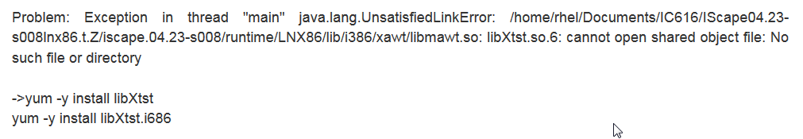
Pour que iscape soit lancer

http://amctylertx.com/software/7881-cadence-encounter-test-1512000.html

https://www.youtube.com/watch?v=CmNcXiq_QfM pour configure NCSU +++

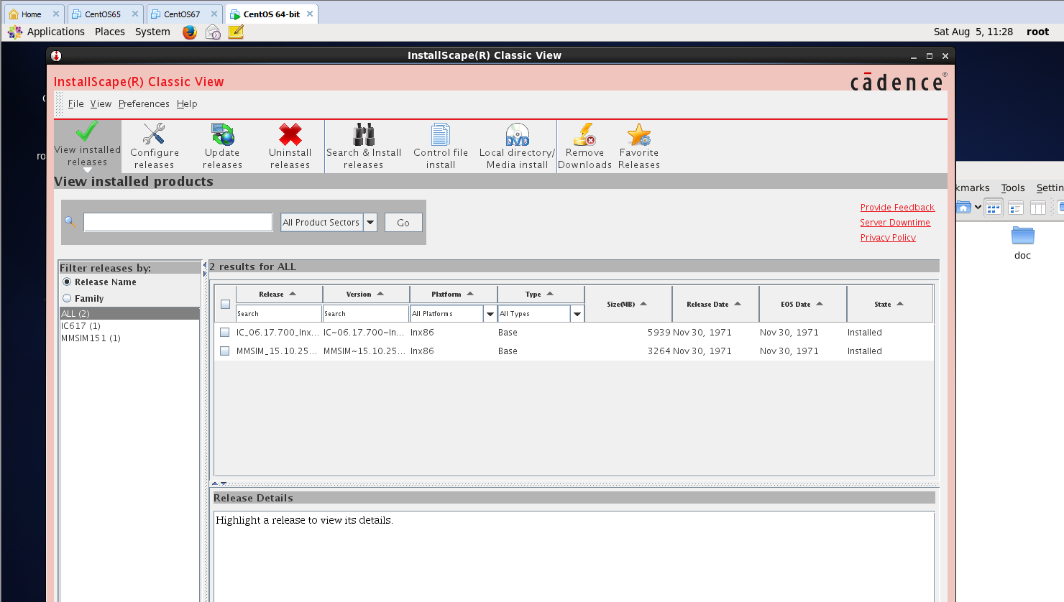

[root@patrice cad]# ./cadence_patch.sh MMSIM1510
[total hits/matching patterns/non-matching patterns]
[001/1/2] MMSIM1510/tools/bin/cdslmd
[001/1/2] MMSIM1510/tools/bin/32bit/cdsmps
[001/1/2] MMSIM1510/tools/bin/perf_test
[001/1/2] MMSIM1510/tools/bin/64bit/cdslmd
[001/1/2] MMSIM1510/tools/bin/64bit/cdsmps
[001/1/2] MMSIM1510/tools/bin/ncprotect
[001/1/2] MMSIM1510/tools/bin/ckout_test
[001/1/2] MMSIM1510/tools/emir/bin/32bit/spfchecker
[001/1/2] MMSIM1510/tools/emir/bin/32bit/emirutilOA
[001/1/2] MMSIM1510/tools/emir/bin/64bit/spfchecker
[001/1/2] MMSIM1510/tools/emir/bin/64bit/emirutilOA
[001/1/2] MMSIM1510/tools/relxpert/bin/32bit/prebert2
[001/1/2] MMSIM1510/tools/relxpert/bin/32bit/postbert
[001/1/2] MMSIM1510/tools/relxpert/bin/32bit/prebert
[001/1/2] MMSIM1510/tools/relxpert/bin/32bit/prebert33
[001/1/2] MMSIM1510/tools/relxpert/bin/64bit/prebert2
[001/1/2] MMSIM1510/tools/relxpert/bin/64bit/postbert
[001/1/2] MMSIM1510/tools/relxpert/bin/64bit/prebert
[001/1/2] MMSIM1510/tools/relxpert/bin/64bit/prebert33
[001/1/2] MMSIM1510/tools/relxpert/lib/libprestress_sh.so
[001/1/2] MMSIM1510/tools/relxpert/lib/librelaging_sh.so
[001/1/2] MMSIM1510/tools/relxpert/lib/libstress_sh.so
[001/1/2] MMSIM1510/tools/relxpert/lib/64bit/libprestress_sh.so
[001/1/2] MMSIM1510/tools/relxpert/lib/64bit/librelaging_sh.so
[001/1/2] MMSIM1510/tools/relxpert/lib/64bit/libstress_sh.so
[001/1/2] MMSIM1510/tools/SpeedXP/bin/broadbandspice.exe
[001/1/2] MMSIM1510/tools/cdnshelp/lib/libsrr.so
[001/1/2] MMSIM1510/tools/cdnshelp/lib/srrjni/libwslicense.so
[001/1/2] MMSIM1510/tools/cdnshelp/lib/srrjni/libsrrjni.so
[001/1/2] MMSIM1510/tools/cdnshelp/lib/libsrrjni.so
[001/1/2] MMSIM1510/tools/cdnshelp/lib/64bit/libsrr.so
[001/1/2] ...MSIM1510/tools/cdnshelp/lib/64bit/srrjni/libwslicense.so
[001/1/2] MMSIM1510/tools/cdnshelp/lib/64bit/srrjni/libsrrjni.so
[001/1/2] MMSIM1510/tools/cdnshelp/lib/64bit/libsrrjni.so
[001/1/2] MMSIM1510/tools/inca/bin/ifr
[001/1/2] MMSIM1510/tools/inca/bin/mcvlogcg
[001/1/2] MMSIM1510/tools/inca/bin/ncelab
[001/1/2] MMSIM1510/tools/inca/bin/ncvlog
[001/1/2] MMSIM1510/tools/inca/bin/ncipa
[001/1/2] MMSIM1510/tools/inca/bin/ncdc
[001/1/2] MMSIM1510/tools/inca/bin/ncsdfc
[001/1/2] MMSIM1510/tools/inca/bin/64bit/ifr
[001/1/2] MMSIM1510/tools/inca/bin/64bit/mcvlogcg
[001/1/2] MMSIM1510/tools/inca/bin/64bit/ncelab
[001/1/2] MMSIM1510/tools/inca/bin/64bit/ncvlog
[001/1/2] MMSIM1510/tools/inca/bin/64bit/ncipa
[001/1/2] MMSIM1510/tools/inca/bin/64bit/ncdc
[001/1/2] MMSIM1510/tools/inca/bin/64bit/ncsdfc
[001/1/2] MMSIM1510/tools/inca/lib/libvisadev.so
[001/1/2] MMSIM1510/tools/inca/lib/ncelab.o
[001/1/2] MMSIM1510/tools/inca/lib/64bit/libvisadev.so
[001/1/2] MMSIM1510/tools/inca/lib/64bit/ncelab.o
[001/1/2] MMSIM1510/tools/dfII/bin/32bit/skill
[001/1/2] MMSIM1510/tools/dfII/bin/64bit/skill
[001/1/2] MMSIM1510/tools/spectre/bin/32bit/spectre_encrypt
[001/1/2] MMSIM1510/tools/spectre/bin/32bit/cmiGet
[001/1/2] MMSIM1510/tools/spectre/bin/32bit/spectreserver
[001/1/2] MMSIM1510/tools/spectre/bin/32bit/spectre
[001/1/2] MMSIM1510/tools/spectre/bin/64bit/spectre_encrypt
[001/1/2] MMSIM1510/tools/spectre/bin/64bit/cmiGet
[001/1/2] MMSIM1510/tools/spectre/bin/64bit/spectre
[001/1/2] MMSIM1510/tools/ultrasim/bin/32bit/ultrasim
[001/1/2] MMSIM1510/tools/ultrasim/bin/64bit/ultrasim64
[001/1/2] MMSIM1510/tools/sev/bin/64bit/vfibatch
[001/1/2] MMSIM1510/tools/sev/bin/64bit/vsaplot
[001/1/2] ...0/share/oa/lib/linux_rhel50_gcc44x_64/opt/libcmExport.so
[001/1/2] ...share/oa/lib/linux_rhel50_gcc44x_64/opt/libcmTracking.so
[001/1/2] ...0/share/oa/lib/linux_rhel50_gcc44x_32/opt/libcmExport.so
[001/1/2] ...share/oa/lib/linux_rhel50_gcc44x_32/opt/libcmTracking.so
44798 files checked, 69 changed.
[root@patrice cad]#

WARNING* (LX-2002): Cannot create layout instance for schematic instance 'M0' because there is no layout master defined.
INFO (LX-1001): Schematic instance 'M3' has no corresponding layout instance.
INFO (LX-1001): Schematic instance 'M0' has no corresponding layout instance.

envSetVal("asimenv.startup" "simulator" 'string "spectre")

-- Base gpdk045 library definition file

DEFINE analogLib $CDSHOME/tools/dfII/etc/cdslib/artist/analogLib
DEFINE US_8ths $CDSHOME/tools/dfII/etc/cdslib/sheets/US_8ths
DEFINE basic $CDSHOME/tools/dfII/etc/cdslib/basic

DEFINE gpdk045 ./gpdk045

////
# Base IC61 gpdk045 library definition file
DEFINE analogLib $CDSHOME/tools/dfII/etc/cdslib/artist/analogLib
ASSIGN analogLib libMode readOnly
DEFINE US_8ths $CDSHOME/tools/dfII/etc/cdslib/sheets/US_8ths
ASSIGN US_8ths libMode readOnly
DEFINE basic $CDSHOME/tools/dfII/etc/cdslib/basic
ASSIGN basic libMode readOnly
DEFINE gpdk045 ./gpdk045
ASSIGN gpdk045 libMode readOnly

DEFINE GPDK45 /root/Bureau/GPDK45

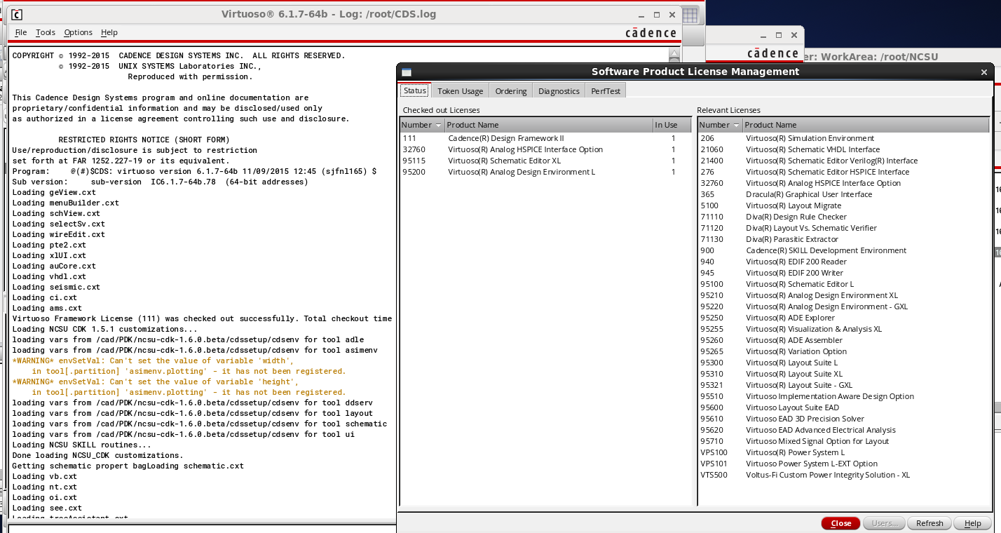

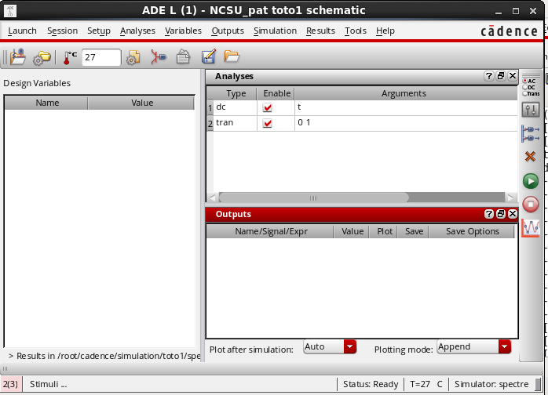

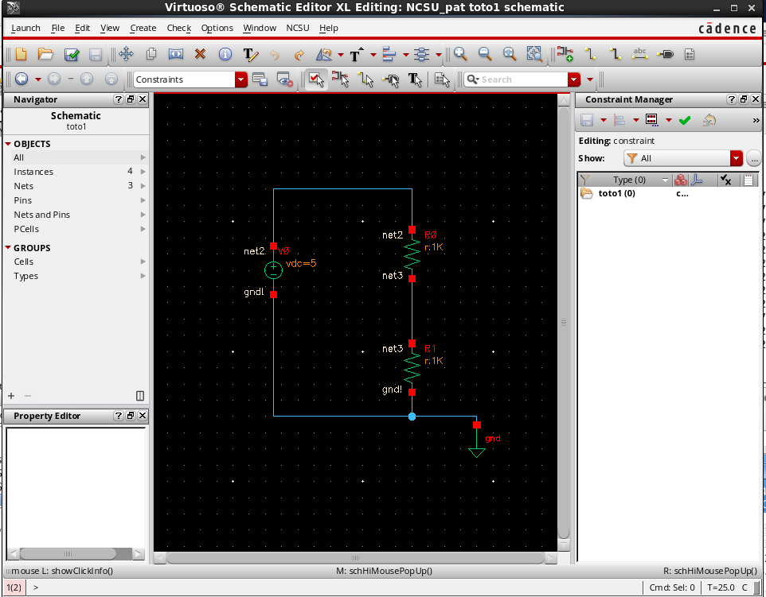

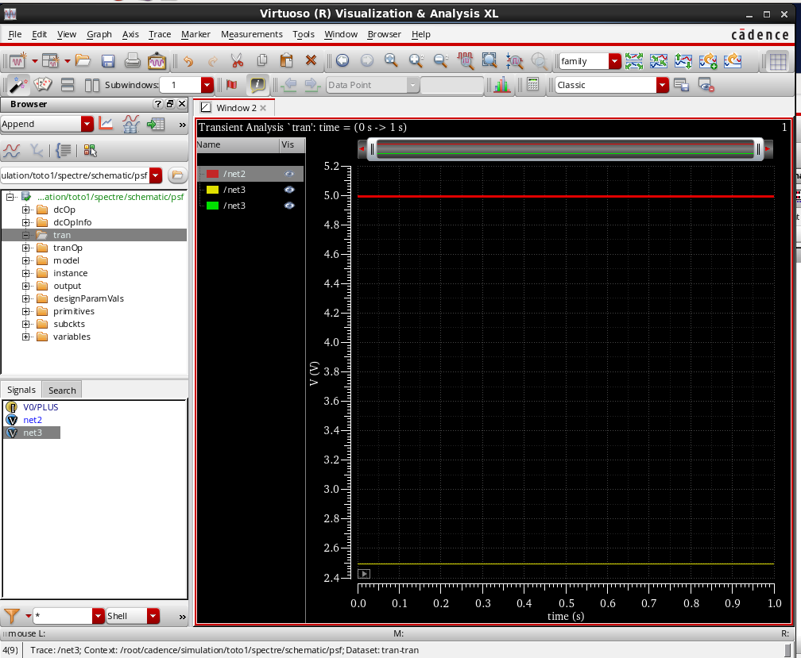
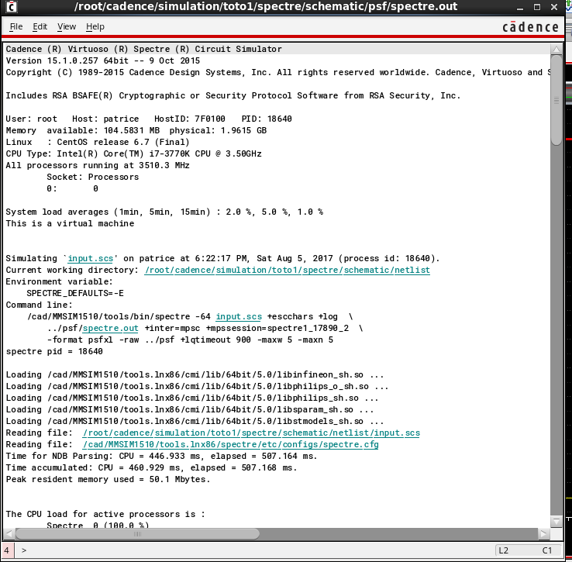

envOption('switchViewList '("veriloga" "spectre" "cmos_sch" "cmos.sch" "schematic")

envOption('switchViewList '( "spectre" "cmos_sch" "cmos.sch" "schematicExtract" "veriloga" "ahdl"))
envOption('stopViewList '("spectre"))

envOption('switchViewList '( "spectre" "cmos_sch" "cmos.sch" "schematic" "veriloga" "ahdl"))
envOption('stopViewList '("spectre"))
important dans .basrc : ne pas oublier d’insérer le lifne de commande
$OA_HOME not $OAHOME afin de faire le settings des views list et de spectre
CDS_TEXT_EDITOR gedit ???

Le lien symbolique n’est plus utile : ln -s tools.lnx86 tools

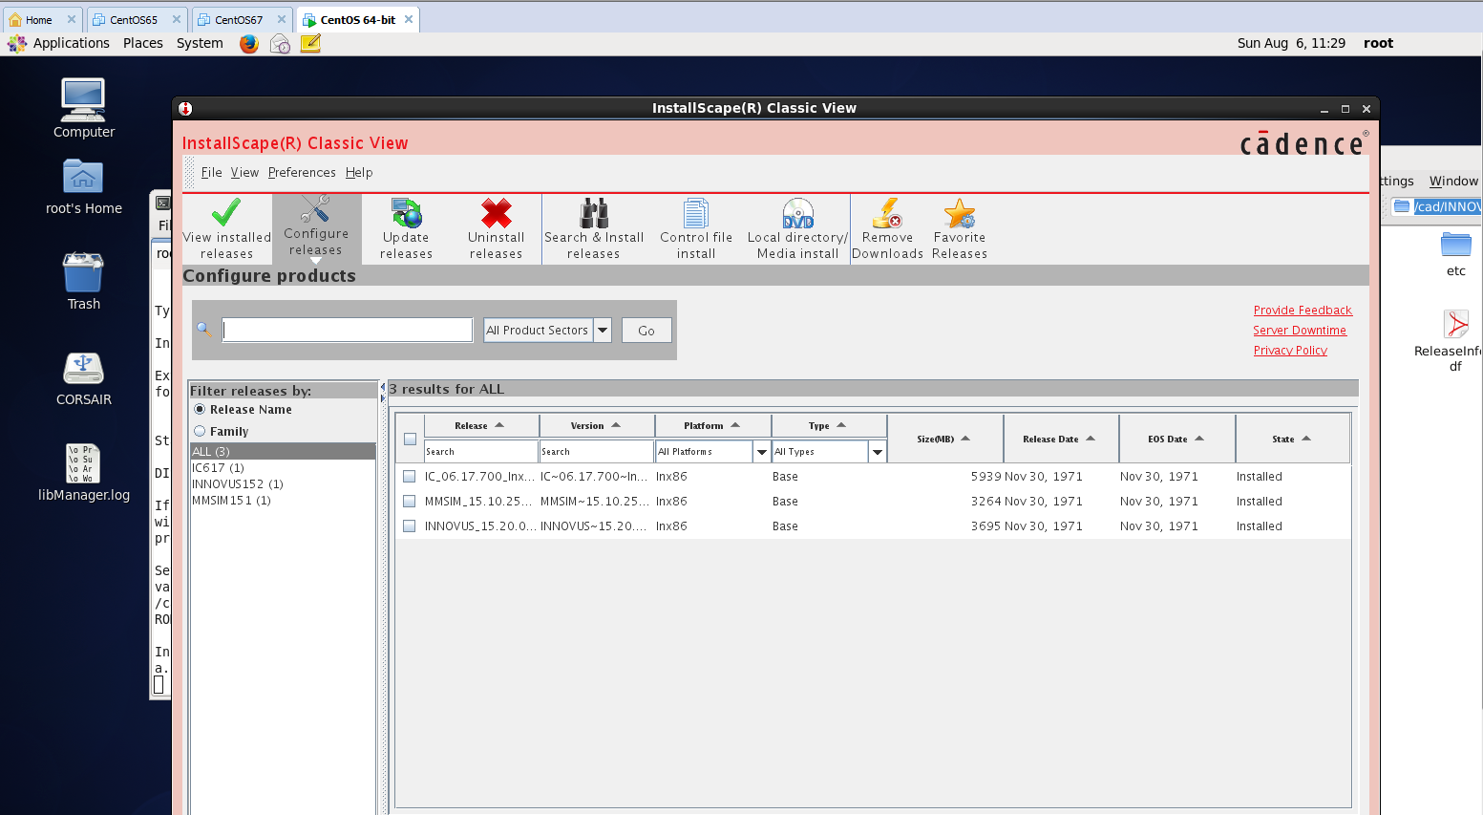

./cadence_patch.sh INNOVUS1520
[total hits/matching patterns/non-matching patterns]
[001/1/2] INNOVUS1520/tools/extraction/bin/32bit/emerge
[001/1/2] INNOVUS1520/tools/extraction/bin/32bit/connect
[001/1/2] INNOVUS1520/tools/extraction/bin/32bit/grow
[001/1/2] INNOVUS1520/tools/extraction/bin/32bit/nebulamesh
[001/1/2] INNOVUS1520/tools/extraction/bin/32bit/etoxy
[001/1/2] INNOVUS1520/tools/extraction/bin/32bit/sip
[001/1/2] INNOVUS1520/tools/extraction/bin/32bit/geom
[001/1/2] INNOVUS1520/tools/extraction/bin/32bit/inter
[001/1/2] INNOVUS1520/tools/extraction/bin/32bit/stamp
[001/1/2] INNOVUS1520/tools/extraction/bin/32bit/pax16
[001/1/2] INNOVUS1520/tools/extraction/bin/32bit/mergecap
[001/1/2] INNOVUS1520/tools/extraction/bin/32bit/nebula
[001/1/2] INNOVUS1520/tools/extraction/bin/32bit/epick
[001/1/2] INNOVUS1520/tools/extraction/bin/64bit/emerge
[001/1/2] INNOVUS1520/tools/extraction/bin/64bit/connect
[001/1/2] INNOVUS1520/tools/extraction/bin/64bit/grow
[001/1/2] INNOVUS1520/tools/extraction/bin/64bit/nebulamesh
[001/1/2] INNOVUS1520/tools/extraction/bin/64bit/etoxy
[001/1/2] INNOVUS1520/tools/extraction/bin/64bit/sip
[001/1/2] INNOVUS1520/tools/extraction/bin/64bit/geom
[001/1/2] INNOVUS1520/tools/extraction/bin/64bit/inter
[001/1/2] INNOVUS1520/tools/extraction/bin/64bit/stamp
[001/1/2] INNOVUS1520/tools/extraction/bin/64bit/pax16
[001/1/2] INNOVUS1520/tools/extraction/bin/64bit/mergecap
[001/1/2] INNOVUS1520/tools/extraction/bin/64bit/nebula
[001/1/2] INNOVUS1520/tools/extraction/bin/64bit/epick
[001/1/2] INNOVUS1520/tools/bin/cdslmd
[001/1/2] INNOVUS1520/tools/bin/32bit/cdsmps
[001/1/2] INNOVUS1520/tools/bin/perf_test
[001/1/2] INNOVUS1520/tools/bin/64bit/cdslmd
[001/1/2] INNOVUS1520/tools/bin/64bit/cdsmps
[001/1/2] INNOVUS1520/tools/bin/64bit/cdsCopyShell
[001/1/2] INNOVUS1520/tools/bin/ckout_test
[001/1/2] ...US1520/tools/cdsSkillPcell/lib/64bit/libcdsSkillPcell.so
[001/1/2] INNOVUS1520/tools/ssvtools/bin/64bit/lightning.tty
[001/1/2] INNOVUS1520/tools/ssvtools/bin/64bit/voltus_power
[001/1/2] INNOVUS1520/tools/ssvtools/bin/64bit/lightning
[001/1/2] INNOVUS1520/tools/ssvtools/bin/64bit/dspf2pgdb
[001/1/2] INNOVUS1520/tools/ssvtools/bin/64bit/stitcher
[001/1/2] INNOVUS1520/tools/ssvtools/bin/64bit/voltus_extractor
[001/1/2] INNOVUS1520/tools/ssvtools/bin/64bit/voltus_railmg
[001/1/2] INNOVUS1520/tools/ssvtools/bin/64bit/voltus_libsim
[001/1/2] INNOVUS1520/tools/ssvtools/bin/64bit/pgdb2spf
[001/1/2] INNOVUS1520/tools/ssvtools/bin/64bit/voltus_rail
[001/1/2] INNOVUS1520/tools/ssvtools/bin/64bit/voltus_gds2def
[001/1/2] INNOVUS1520/tools/ssvtools/bin/64bit/psviewer
[001/1/2] INNOVUS1520/tools/ssvtools/bin/64bit/mergedef
[001/1/2] INNOVUS1520/tools/ssvtools/bin/64bit/voltus_libgds
[001/1/2] INNOVUS1520/tools/ssvtools/bin/64bit/voltus_libgen
[001/1/2] INNOVUS1520/tools/ssvtools/bin/64bit/itaputil
[001/1/2] INNOVUS1520/tools/timinglibutil/bin/64bit/valus
[001/1/2] INNOVUS1520/tools/timinglibutil/bin/64bit/libdiff
[001/1/2] INNOVUS1520/tools/timinglibutil/bin/64bit/lib2cpf
[001/1/2] INNOVUS1520/tools/celtic/bin/64bit/make_cdb
[001/1/2] INNOVUS1520/tools/itkDB/lib/64bit/itkDB.a
[001/1/2] INNOVUS1520/tools/itkDB/lib/64bit/itkDB_pic.a
[001/1/2] INNOVUS1520/tools/innovus/bin/64bit/dfII2enc
[001/1/2] INNOVUS1520/tools/innovus/bin/64bit/generateCapTbl
[001/1/2] INNOVUS1520/tools/innovus/bin/64bit/viewlog
[001/1/2] INNOVUS1520/tools/cdnshelp/bin/64bit/cdnshelpindexer
[001/1/2] INNOVUS1520/tools/cdnshelp/bin/64bit/cdnshelp.exe
[001/1/2] INNOVUS1520/tools/cdnshelp/lib/64bit/libsrr.so
[001/1/2] ...OVUS1520/tools/cdnshelp/lib/64bit/srrjni/libwslicense.so
[001/1/2] INNOVUS1520/tools/cdnshelp/lib/64bit/srrjni/libsrrjni.so
[001/1/2] INNOVUS1520/tools/cdnshelp/lib/64bit/libsrrjni.so
[001/1/2] INNOVUS1520/tools/iota/bin/32bit/mptScan
[001/1/2] INNOVUS1520/tools/iota/bin/32bit/lef2oaCDS
[001/1/2] INNOVUS1520/tools/iota/bin/32bit/oa2lefCDS
[001/1/2] INNOVUS1520/tools/iota/bin/32bit/def2oaCDS
[001/1/2] INNOVUS1520/tools/iota/bin/32bit/oa2defCDS
[001/1/2] INNOVUS1520/tools/iota/bin/64bit/mptScan
[001/1/2] INNOVUS1520/tools/iota/bin/64bit/lef2oaCDS
[001/1/2] INNOVUS1520/tools/iota/bin/64bit/oa2lefCDS
[001/1/2] INNOVUS1520/tools/iota/bin/64bit/def2oaCDS
[001/1/2] INNOVUS1520/tools/iota/bin/64bit/oa2defCDS
[001/1/2] INNOVUS1520/tools/inca/bin/ifr
[001/1/2] INNOVUS1520/tools/inca/bin/mcvlogcg
[001/1/2] INNOVUS1520/tools/inca/bin/ncelab
[001/1/2] INNOVUS1520/tools/inca/bin/ncvlog
[001/1/2] INNOVUS1520/tools/inca/bin/ncipa
[001/1/2] INNOVUS1520/tools/inca/bin/ncdc
[001/1/2] INNOVUS1520/tools/inca/bin/ncsdfc
[001/1/2] INNOVUS1520/tools/inca/bin/64bit/ifr
[001/1/2] INNOVUS1520/tools/inca/bin/64bit/mcvlogcg
[001/1/2] INNOVUS1520/tools/inca/bin/64bit/ncelab
[001/1/2] INNOVUS1520/tools/inca/bin/64bit/ncvlog
[001/1/2] INNOVUS1520/tools/inca/bin/64bit/ncipa
[001/1/2] INNOVUS1520/tools/inca/bin/64bit/ncdc
[001/1/2] INNOVUS1520/tools/inca/bin/64bit/ncsdfc
[001/1/2] INNOVUS1520/tools/inca/lib/libvisadev.so
[001/1/2] INNOVUS1520/tools/inca/lib/ncelab.o
[001/1/2] INNOVUS1520/tools/inca/lib/64bit/libvisadev.so
[001/1/2] INNOVUS1520/tools/inca/lib/64bit/ncelab.o
[001/1/2] INNOVUS1520/tools/dfII/bin/32bit/libManager
[001/1/2] INNOVUS1520/tools/dfII/bin/32bit/cdsLibEditor
[001/1/2] INNOVUS1520/tools/dfII/bin/64bit/libManager
[001/1/2] INNOVUS1520/tools/dfII/bin/64bit/cdsLibEditor
[001/1/2] INNOVUS1520/tools/dfII/bin/64bit/techLoadDump
[001/1/2] INNOVUS1520/tools/dfII/bin/64bit/skill
[001/1/2] INNOVUS1520/tools/spectre/bin/32bit/spectreserver
[001/1/2] INNOVUS1520/tools/spectre/bin/64bit/spectre_encrypt
[001/1/2] INNOVUS1520/tools/spectre/bin/64bit/cmiGet
[001/1/2] INNOVUS1520/tools/spectre/bin/64bit/spectre
[001/1/2] INNOVUS1520/tools/simvision/bin/simvisdbutil.exe
[001/1/2] INNOVUS1520/tools/simvision/bin/cds-dsn-gen.exe
[003/2/1] INNOVUS1520/tools/simvision/bin/simvision.exe
[001/1/2] INNOVUS1520/tools/simvision/bin/simcompare.exe
[001/1/2] INNOVUS1520/tools/simvision/bin/64bit/simvisdbutil.exe
[001/1/2] INNOVUS1520/tools/simvision/bin/64bit/cds-dsn-gen.exe
[001/1/2] INNOVUS1520/tools/simvision/bin/64bit/simvision.exe
[001/1/2] INNOVUS1520/tools/simvision/bin/64bit/simcompare.exe
[001/1/2] INNOVUS1520/tools/plato/bin/64bit/nanoroute
[001/1/2] ...0/share/oa/lib/linux_rhel50_gcc48x_64/opt/libcmExport.so
[001/1/2] ...share/oa/lib/linux_rhel50_gcc48x_64/opt/libcmTracking.so
[001/1/2] ...0/share/oa/lib/linux_rhel50_gcc48x_32/opt/libcmExport.so
[001/1/2] ...share/oa/lib/linux_rhel50_gcc48x_32/opt/libcmTracking.so
34973 files checked, 116 changed.
[root@patrice cad]#

invs Innovus Implementation System 15.2 Denied
invsb Innovus Implementation System Basic 15.2 Denied

https://github.com/OSVVM/OSVVM/issues/7 incisiv
/cad/IC617/tools/dfII/bin/64bit/virtuoso: error while loading shared libraries: libvisadev.so: cannot open shared object file: No such file or directory

virtuoso -debug3264 -64
https://www.centos.org/forums/viewtopic.php?t=6027
https://github.com/leoheck/ubuntu-config/issues/22
http://bbs.eetop.cn/viewthread.php?tid=612714

LD_LIBRARY_PATH $CDSDIR/tools/libCDSDIR/tools/inca/lib/64bit
http://bbs.eetop.cn/viewthread.php?tid=434542
$CDSHOME/tools.lnx86/inca/lib/libvisadev.so
$CDSHOME/tools.lnx86/inca/lib/64bit/libvisadev.so

https://www.reddit.com/r/chipdesign/comments/4crjj9/cadence_virtuoso_ic615/
/////////////
/tools/bin/checkSysConf IC6.17 ???? comment on s’en sert

virtuoso -debug3264
# CDS_AUTO_64BIT = ALL
#
# PATH = /cad/IC617/bin:/cad/IC617/tools/bin/64bit:/cad/IC617/tools/bin:/cad/IC617/oa_v22.50.036/bin:/cad/MMSIM1510/tools/ultrasim/bin:/cad/MMSIM1510/tools/spectre/bin:/cad/MMSIM1510/tools/dfII/bin:/cad/MMSIM1510/bin:/cad/MMSIM1510/tools/bin:/cad/MMSIM1510/tools/bin:/usr/lib64/qt-3.3/bin:/usr/local/sbin:/usr/sbin:/sbin:/usr/local/bin:/usr/bin:/bin:/cad/IC617/tools/dfII/bin:/cad/IC617/tools/plot/bin:/root/bin:/cad/IC617/tools/dfII/bin:/cad/IC617/tools/plot/bin:/cad/MMSIM1510/bin:/cad/MMSIM1510/tools/relxpert/bin
#
# LD_LIBRARY_PATH = /cad/IC617/oa_v22.50.036/lib/linux_rhel50_gcc48x_64/opt:/cad/IC617/tools/Qt/64bit/lib:/cad/IC617/tools/dfII/lib/64bit:/cad/IC617/tools/sev/lib/64bit:/cad/IC617/tools/lib/64bit:/cad/IC617/tools/lib:/cad/IC617/tools/inca/lib/64bit
#
# LOCAL_ASSUME_KERNEL = unset
#
# Launching: /cad/IC617/tools/dfII/bin/64bit/virtuoso

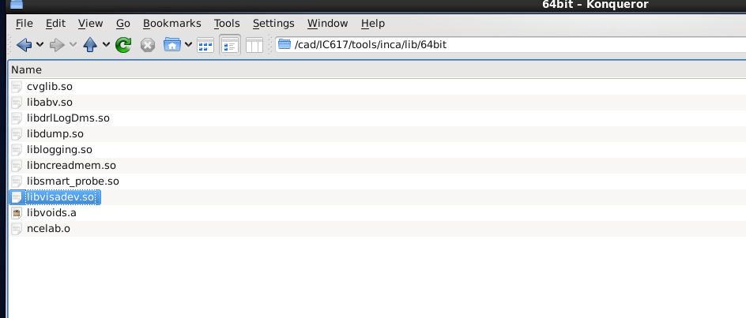

Dans /cad/MMSIM1510/tools/inca/lib/64bit on retrouve

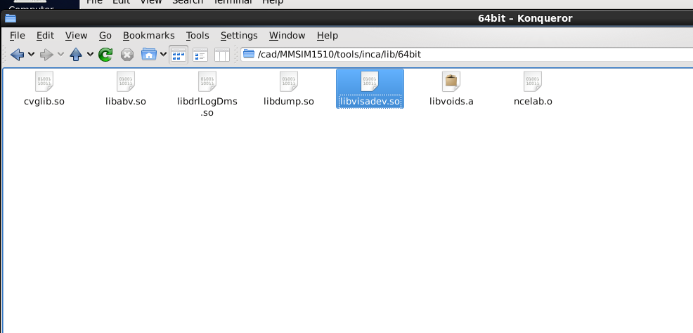

http://www.eng.auburn.edu/~niuguof/cadence/bio/index.html a voir pour la config

https://www.amazon.fr/Sandisk-Ultra-Nouvelle-Version-SDCZ43-064G-GAM46/dp/B01BGTG3JA/ref=pd_sim_147_2?_encoding=UTF8&psc=1&refRID=BYVT33J2ZZPR4P4EF2DG
Jelt E-NET
https://www.amazon.fr/SanDisk-vitesse-lecture-allant-SDCZ48-032G-U46/dp/B00DQG9OZ2/ref=zg_bs_computers_5?_encoding=UTF8&psc=1&refRID=B4QJ65WEVV5HTW1NC7VH
https://www.amazon.fr/Connectland-USB-V3-AA-1-8M-C%C3%A2ble-Version-M%C3%A2le/dp/B003TFHYMA/ref=sr_1_56?m=A1X6FK5RDHNB96&s=computers&ie=UTF8&qid=1502050873&sr=1-56&keywords=cable+usb+3.0+male+male

https://www.amazon.fr/gp/product/B01M214ZZK/ref=ox_sc_act_title_1?smid=A1X6FK5RDHNB96&psc=1

https://www.amazon.fr/Verbatim-43500-25-pack-Optical-Media/dp/B0006L2I76/ref=sr_1_3?s=computers&ie=UTF8&qid=1502098385&sr=1-3&keywords=dvd+verbatim

http://www.cs.utah.edu/~elb/cadbook/Chapters/AppendixA/setup-cadence.txt config
/*****/
http://vlsi.die.upm.es/cadence_ubuntu

a essayer
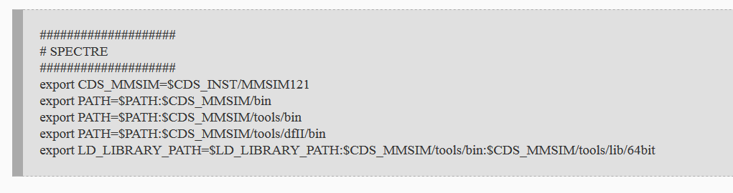
/*****

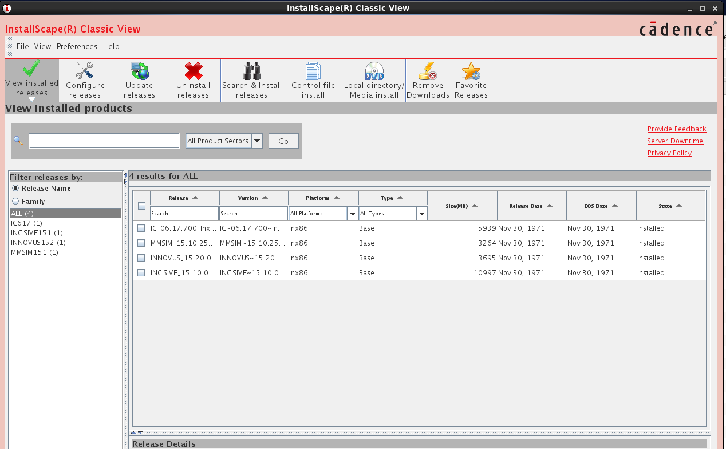

http://www.dientuvietnam.net/forums/forum/vi-%C4%90i%E1%BB%87n-t%E1%BB%AD-thi%E1%BA%BFt-k%E1%BA%BF-ph%C3%A1t-tri%E1%BB%83n-v%C3%A0-%E1%BB%A8ng-d%E1%BB%A5ng/eda-tools/5491-c%C3%A1c-c%C3%B4ng-c%E1%BB%A5-hay-d%C3%B9ng-trong-thi%E1%BA%BFt-k%E1%BA%BF-vi-%C4%91i%E1%BB%87n-t%E1%BB%AD/page18 config

./cadence_patch.sh INCISIVE1510
[total hits/matching patterns/non-matching patterns]
[001/1/2] INCISIVE1510/tools/esl/bin/modelimport
[001/1/2] INCISIVE1510/tools/esl/bin/vprun
[001/1/2] INCISIVE1510/tools/esl/bin/vpzip
[001/1/2] INCISIVE1510/tools/esl/bin/cpuwrap
[001/1/2] INCISIVE1510/tools/esl/bin/vspsim
[001/1/2] INCISIVE1510/tools/esl/bin/64bit/vspsim
[001/1/2] INCISIVE1510/tools/esl/bin/tlmgen.exe
[003/1/2] INCISIVE1510/tools/esl/vpcat/vpcat_base_pkg-002.tar
[003/1/2] INCISIVE1510/tools/esl/vpcat/vpcat_base_pkg-003.tar
[001/1/2] ...sl/ImperasOVP/Imperas.20121212/bin/Linux64/libDocGen.exe
[001/1/2] ...ols/esl/ImperasOVP/Imperas.20121212/bin/Linux64/imperasd
[001/1/2] ...ls/esl/ImperasOVP/Imperas.20121212/bin/Linux64/ipost.exe
[001/1/2] ...ImperasOVP/Imperas.20121212/bin/Linux64/libCpuManager.so
[001/1/2] ...sl/ImperasOVP/Imperas.20121212/bin/Linux32/libDocGen.exe es
[001/1/2] ...ols/esl/ImperasOVP/Imperas.20121212/bin/Linux32/imperasd
[001/1/2] ...ls/esl/ImperasOVP/Imperas.20121212/bin/Linux32/ipost.exe
[001/1/2] ...ImperasOVP/Imperas.20121212/bin/Linux32/libCpuManager.so
[001/1/2] ....core.gtk.linux.x86_64_1.0.0.201507221928/lib/libvecl.so
[001/1/2] ...vsp.core.gtk.linux.x86_1.0.0.201507221928/lib/libvecl.so
[001/1/2] INCISIVE1510/tools/vmanager/lib/sn_wish
[001/1/2] INCISIVE1510/tools/vmanager/lib/lic.specman
[001/1/2] INCISIVE1510/tools/vmanager/lib/64bit/sn_wish
[001/1/2] INCISIVE1510/tools/vmanager/lib/64bit/lic.specman
[001/1/2] INCISIVE1510/tools/bin/ifr
[001/1/2] INCISIVE1510/tools/bin/iregval
[001/1/2] INCISIVE1510/tools/bin/cdslmd
[001/1/2] INCISIVE1510/tools/bin/speedd
[001/1/2] INCISIVE1510/tools/bin/ncrelocate
[001/1/2] INCISIVE1510/tools/bin/ambitd
[001/1/2] INCISIVE1510/tools/bin/mcvlogcg
[001/1/2] INCISIVE1510/tools/bin/ncsvams
[001/1/2] INCISIVE1510/tools/bin/ncelab
[001/1/2] INCISIVE1510/tools/bin/32bit/cdsmps
[001/1/2] INCISIVE1510/tools/bin/32bit/cdsCopyShell
[001/1/2] INCISIVE1510/tools/bin/cshape
[001/1/2] INCISIVE1510/tools/bin/cfe
[001/1/2] INCISIVE1510/tools/bin/platod
[001/1/2] INCISIVE1510/tools/bin/staticbuild
[001/1/2] INCISIVE1510/tools/bin/perf_test
[001/1/2] INCISIVE1510/tools/bin/ncvlog
[001/1/2] INCISIVE1510/tools/bin/verisityd
[001/1/2] INCISIVE1510/tools/bin/verplex
[001/1/2] INCISIVE1510/tools/bin/xtensad
[001/1/2] INCISIVE1510/tools/bin/checkConnSpec
[001/1/2] INCISIVE1510/tools/bin/g2c_d
[001/1/2] INCISIVE1510/tools/bin/dsmtlmd
[001/1/2] INCISIVE1510/tools/bin/axislmd
[001/1/2] INCISIVE1510/tools/bin/readT
[001/1/2] INCISIVE1510/tools/bin/ncipa
[001/1/2] INCISIVE1510/tools/bin/spdaemon
[001/1/2] INCISIVE1510/tools/bin/alta
[001/1/2] INCISIVE1510/tools/bin/ncdc
[001/1/2] INCISIVE1510/tools/bin/qtdaemon
[001/1/2] INCISIVE1510/tools/bin/ncvhdl_p
[001/1/2] INCISIVE1510/tools/bin/miter
[001/1/2] INCISIVE1510/tools/bin/genConnAssert
[001/1/2] INCISIVE1510/tools/bin/amsspice
[001/1/2] INCISIVE1510/tools/bin/halpallad
[001/1/2] INCISIVE1510/tools/bin/halstruct
[001/1/2] INCISIVE1510/tools/bin/halcheck
[001/1/2] INCISIVE1510/tools/bin/ssa_test
[001/1/2] INCISIVE1510/tools/bin/NEOLINLD
[001/1/2] INCISIVE1510/tools/bin/ncsdfc
[001/1/2] INCISIVE1510/tools/bin/cadmosd
[001/1/2] INCISIVE1510/tools/bin/ncdump
[001/1/2] INCISIVE1510/tools/bin/chrond
[001/1/2] INCISIVE1510/tools/bin/halprop
[001/1/2] INCISIVE1510/tools/bin/ClickWrap
[001/1/2] INCISIVE1510/tools/bin/altosda
[001/1/2] INCISIVE1510/tools/bin/sigrity
[001/1/2] INCISIVE1510/tools/bin/wicsC
[001/1/2] INCISIVE1510/tools/bin/haltlb
[001/1/2] INCISIVE1510/tools/bin/qtrekd
[001/1/2] INCISIVE1510/tools/bin/bbgen
[001/1/2] INCISIVE1510/tools/bin/assertWriter
[001/1/2] INCISIVE1510/tools/bin/dailmd
[001/1/2] INCISIVE1510/tools/bin/k2techld
[001/1/2] INCISIVE1510/tools/bin/hal
[001/1/2] INCISIVE1510/tools/bin/64bit/ifr
[001/1/2] INCISIVE1510/tools/bin/64bit/iregval
[001/1/2] INCISIVE1510/tools/bin/64bit/cdslmd
[001/1/2] INCISIVE1510/tools/bin/64bit/speedd
[001/1/2] INCISIVE1510/tools/bin/64bit/ncrelocate
[001/1/2] INCISIVE1510/tools/bin/64bit/ambitd
[001/1/2] INCISIVE1510/tools/bin/64bit/ncsvams
[001/1/2] INCISIVE1510/tools/bin/64bit/ncelab
[001/1/2] INCISIVE1510/tools/bin/64bit/cshape
[001/1/2] INCISIVE1510/tools/bin/64bit/cfe
[001/1/2] INCISIVE1510/tools/bin/64bit/platod
[001/1/2] INCISIVE1510/tools/bin/64bit/staticbuild
[001/1/2] INCISIVE1510/tools/bin/64bit/formalverifier.exe
[001/1/2] INCISIVE1510/tools/bin/64bit/ncvlog
[001/1/2] INCISIVE1510/tools/bin/64bit/verisityd
[001/1/2] INCISIVE1510/tools/bin/64bit/verplex
[001/1/2] INCISIVE1510/tools/bin/64bit/xtensad
[001/1/2] INCISIVE1510/tools/bin/64bit/checkConnSpec
[001/1/2] INCISIVE1510/tools/bin/64bit/g2c_d
[001/1/2] INCISIVE1510/tools/bin/64bit/dsmtlmd
[001/1/2] INCISIVE1510/tools/bin/64bit/axislmd
[001/1/2] INCISIVE1510/tools/bin/64bit/ncipa
[001/1/2] INCISIVE1510/tools/bin/64bit/spdaemon
[001/1/2] INCISIVE1510/tools/bin/64bit/alta
[001/1/2] INCISIVE1510/tools/bin/64bit/ncdc
[001/1/2] INCISIVE1510/tools/bin/64bit/qtdaemon
[001/1/2] INCISIVE1510/tools/bin/64bit/ncvhdl_p
[001/1/2] INCISIVE1510/tools/bin/64bit/miter
[001/1/2] INCISIVE1510/tools/bin/64bit/genConnAssert
[001/1/2] INCISIVE1510/tools/bin/64bit/amsspice
[001/1/2] INCISIVE1510/tools/bin/64bit/halpallad
[001/1/2] INCISIVE1510/tools/bin/64bit/halstruct
[001/1/2] INCISIVE1510/tools/bin/64bit/halcheck
[001/1/2] INCISIVE1510/tools/bin/64bit/ssa_test
[001/1/2] INCISIVE1510/tools/bin/64bit/NEOLINLD
[001/1/2] INCISIVE1510/tools/bin/64bit/ncsdfc
[001/1/2] INCISIVE1510/tools/bin/64bit/cadmosd
[001/1/2] INCISIVE1510/tools/bin/64bit/ncdump
[001/1/2] INCISIVE1510/tools/bin/64bit/chrond
[001/1/2] INCISIVE1510/tools/bin/64bit/halprop
[001/1/2] INCISIVE1510/tools/bin/64bit/altosda
[001/1/2] INCISIVE1510/tools/bin/64bit/cdsmps
[001/1/2] INCISIVE1510/tools/bin/64bit/sigrity
[001/1/2] INCISIVE1510/tools/bin/64bit/cdsCopyShell
[001/1/2] INCISIVE1510/tools/bin/64bit/haltlb
[001/1/2] INCISIVE1510/tools/bin/64bit/qtrekd
[001/1/2] INCISIVE1510/tools/bin/64bit/bbgen
[001/1/2] INCISIVE1510/tools/bin/64bit/assertWriter
[001/1/2] INCISIVE1510/tools/bin/64bit/dailmd
[001/1/2] INCISIVE1510/tools/bin/64bit/k2techld
[001/1/2] INCISIVE1510/tools/bin/64bit/faninT
[001/1/2] INCISIVE1510/tools/bin/64bit/hal
[001/1/2] INCISIVE1510/tools/bin/64bit/ncsim
[001/1/2] INCISIVE1510/tools/bin/64bit/hlds
[001/1/2] INCISIVE1510/tools/bin/64bit/cpiDebugger
[001/1/2] INCISIVE1510/tools/bin/ncprotect
[001/1/2] INCISIVE1510/tools/bin/ckout_test
[001/1/2] INCISIVE1510/tools/bin/ncsim
[001/1/2] INCISIVE1510/tools/bin/hlds
[001/1/2] INCISIVE1510/tools/bin/cpiDebugger
[001/1/2] INCISIVE1510/tools/iprof/lib/libiprofNativeLib.so
[001/1/2] INCISIVE1510/tools/iprof/lib/64bit/libiprofNativeLib.so
[001/1/2] INCISIVE1510/tools/iccr/bin/ict.main_slave.exe
[001/1/2] INCISIVE1510/tools/iccr/bin/iccr.exe
[001/1/2] INCISIVE1510/tools/iccr/lib/libiccrlib.so
[001/1/2] INCISIVE1510/tools/iccr/lib/64bit/libiccrlib.64.so
[001/1/2] INCISIVE1510/tools/simvisdai/bin/simvisdbutil.exe
[001/1/2] INCISIVE1510/tools/simvisdai/bin/cds-dsn-gen.exe
[003/2/1] INCISIVE1510/tools/simvisdai/bin/simvision.exe
[001/1/2] INCISIVE1510/tools/simvisdai/bin/simcompare.exe
[001/1/2] INCISIVE1510/tools/simvisdai/bin/64bit/simvisdbutil.exe
[001/1/2] INCISIVE1510/tools/simvisdai/bin/64bit/cds-dsn-gen.exe
[001/1/2] INCISIVE1510/tools/simvisdai/bin/64bit/simvision.exe
[001/1/2] INCISIVE1510/tools/txe/bin/64bit/txe.exe
[001/1/2] INCISIVE1510/tools/txe/bin/txe.exe
[001/1/2] INCISIVE1510/tools/tti/lib/libipa.so
[001/1/2] INCISIVE1510/tools/tti/lib/64bit/libipa.so
[001/1/2] INCISIVE1510/tools/affirma_ams/bin/dna_assembler
[001/1/2] INCISIVE1510/tools/affirma_ams/bin/64bit/dna_assembler
[001/1/2] ...NCISIVE1510/tools/affirma_ams/amsenv/bin/32bit/sst2merge
[001/1/2] INCISIVE1510/tools/sfe/lib/libsfeAms_sh.so
[001/1/2] INCISIVE1510/tools/sfe/lib/64bit/libsfeAms_sh.so
[001/1/2] ...10/tools/methodology/iregGen/src/tools.lnx86/bin/iregGen
[001/1/2] INCISIVE1510/tools/jre1.70-64b/lib/i386/server/libjvm.so
[001/1/2] INCISIVE1510/tools/vmgr/lib/libimc.so
[001/1/2] INCISIVE1510/tools/vmgr/lib/64bit/libimc.so
[001/1/2] INCISIVE1510/tools/amp/lib/libncengine15.10p001.so
[001/1/2] INCISIVE1510/tools/amp/lib/64bit/libncengine15.10p001.so
[001/1/2] ...NCISIVE1510/tools/jre1.8.0-64b/lib/i386/client/libjvm.so
[005/1/2] ...NCISIVE1510/tools/jre1.8.0-64b/lib/i386/server/libjvm.so
[001/1/2] INCISIVE1510/tools/vtools/vfault/bin/vfadviser
[001/1/2] INCISIVE1510/tools/vtools/vfault/bin/verimerge
[001/1/2] INCISIVE1510/tools/vtools/vfault/bin/32bit/vfpost
[001/1/2] INCISIVE1510/tools/vtools/vfault/bin/32bit/verifault
[001/1/2] INCISIVE1510/tools/vtools/vfault/bin/32bit/vffastfind
[001/1/2] INCISIVE1510/tools/vtools/vfault/bin/veriddq
[001/1/2] INCISIVE1510/tools/vtools/vfault/bin/vfmerge
[001/1/2] INCISIVE1510/tools/vtools/vfault/bin/vfmgr
[001/1/2] INCISIVE1510/tools/vtools/vfault/bin/vfstat
[001/1/2] INCISIVE1510/tools/vtools/vfault/bin/64bit/vfpost
[001/1/2] INCISIVE1510/tools/vtools/vfault/bin/64bit/verifault
[001/1/2] INCISIVE1510/tools/vtools/vfault/bin/64bit/vffastfind
[001/1/2] INCISIVE1510/tools/vtools/vfault/lib/vfault.o
[001/1/2] INCISIVE1510/tools/vtools/vfault/lib/64bit/vfault.o
[001/1/2] INCISIVE1510/tools/SpeedXP/bin/broadbandspice.exe
[001/1/2] INCISIVE1510/tools/ucd/lib/libucis.so
[001/1/2] INCISIVE1510/tools/ucd/lib/64bit/libucis.so
[001/1/2] INCISIVE1510/tools/cdnshelp/lib/libspectre_sh.so
[001/1/2] INCISIVE1510/tools/cdnshelp/lib/libTCO.so
[001/1/2] INCISIVE1510/tools/cdnshelp/lib/libsrr.so
[001/1/2] INCISIVE1510/tools/cdnshelp/lib/srrjni/libsrrjni.so
[001/1/2] INCISIVE1510/tools/cdnshelp/lib/libvisadev.so
[001/1/2] INCISIVE1510/tools/cdnshelp/lib/libsrrjni.so
[001/1/2] INCISIVE1510/tools/cdnshelp/lib/64bit/libsrr.so
[001/1/2] ...NCISIVE1510/tools/cdnshelp/lib/64bit/srrjni/libsrrjni.so
[001/1/2] INCISIVE1510/tools/cdnshelp/lib/64bit/libvisadev.so
[001/1/2] INCISIVE1510/tools/cdnshelp/lib/64bit/libsrrjni.so
[001/1/2] INCISIVE1510/tools/ifv/bin/formalverifier.exe
[001/1/2] INCISIVE1510/tools/ifv/bin/faninT
[001/1/2] INCISIVE1510/tools/inca/lib/ncelab.o
[001/1/2] INCISIVE1510/tools/inca/lib/libncquery.so
[001/1/2] INCISIVE1510/tools/inca/lib/ncsim.o
[001/1/2] INCISIVE1510/tools/inca/lib/64bit/ncelab.o
[001/1/2] INCISIVE1510/tools/inca/lib/64bit/libncquery.so
[001/1/2] INCISIVE1510/tools/inca/lib/64bit/ncsim.o
[001/1/2] INCISIVE1510/tools/dfII/bin/32bit/hdldebug
[001/1/2] INCISIVE1510/tools/indago/lib64/libindagodump.so
[001/1/2] INCISIVE1510/tools/indago/lib/libindagodump.so
[001/1/2] INCISIVE1510/tools/jre1.70/lib/i386/server/libjvm.so
[001/1/2] INCISIVE1510/tools/hal/bin/ncbrowse.exe
[001/1/2] INCISIVE1510/tools/hal/bin/64bit/ncbrowse.exe
[001/1/2] INCISIVE1510/tools/spectre/bin/32bit/spectre_encrypt
[001/1/2] INCISIVE1510/tools/spectre/bin/64bit/spectre_encrypt
[001/1/2] INCISIVE1510/tools/spectre/bin/64bit/amsprimtool
[001/1/2] ...SIVE1510/tools/spectre/amsprimtool/bin/32bit/amsprimtool
[001/1/2] INCISIVE1510/tools/spectre/lib/64bit/libspectre_sh.so
[001/1/2] INCISIVE1510/tools/ultrasim/lib/libAmsUltra.so
[001/1/2] INCISIVE1510/tools/ultrasim/lib/64bit/libAmsUltra.so
[001/1/2] INCISIVE1510/tools/sev/bin/64bit/vsa2
[001/1/2] INCISIVE1510/tools/sev/bin/64bit/vfibatch
[001/1/2] INCISIVE1510/tools/sev/bin/64bit/vsaplot
[001/1/2] INCISIVE1510/tools/specman/lib/libncsv_sn_adapter.so
[001/1/2] INCISIVE1510/tools/specman/lib/libncvhdl_sn_adapter.so
[001/1/2] INCISIVE1510/tools/specman/lib/sn_wish
[001/1/2] INCISIVE1510/tools/specman/lib/lic.specman
[001/1/2] INCISIVE1510/tools/specman/lib/libncvlog_sn_adapter.so
[001/1/2] ...CISIVE1510/tools/specman/lib/64bit/libncsv_sn_adapter.so
[001/1/2] ...SIVE1510/tools/specman/lib/64bit/libncvhdl_sn_adapter.so
[001/1/2] INCISIVE1510/tools/specman/lib/64bit/sn_wish
[001/1/2] INCISIVE1510/tools/specman/lib/64bit/lic.specman
[001/1/2] ...SIVE1510/tools/specman/lib/64bit/libncvlog_sn_adapter.so
[001/1/2] INCISIVE1510/tools/haldefedit/bin/haldefedit.exe
[001/1/2] INCISIVE1510/tools/jre1.8.0/lib/i386/client/libjvm.so
[005/1/2] INCISIVE1510/tools/jre1.8.0/lib/i386/server/libjvm.so
[001/1/2] ...10/vmanager/japp/linux/jre_1.3/lib/i386/client/libjvm.so
[001/1/2] ...10/vmanager/japp/linux/jre_1.3/lib/i386/server/libjvm.so
[001/1/2] ...mponents/sn/japp/linux/jre_1.3/lib/i386/client/libjvm.so
[001/1/2] ...mponents/sn/japp/linux/jre_1.3/lib/i386/server/libjvm.so
[001/1/2] ...onents/sn/japp/linux64/jre_1.3/lib/i386/client/libjvm.so
[001/1/2] ...onents/sn/japp/linux64/jre_1.3/lib/i386/server/libjvm.so
117107 files checked, 238 changed.
[root@patrice cad]# ./cadence_patch.sh INCISIVE1510

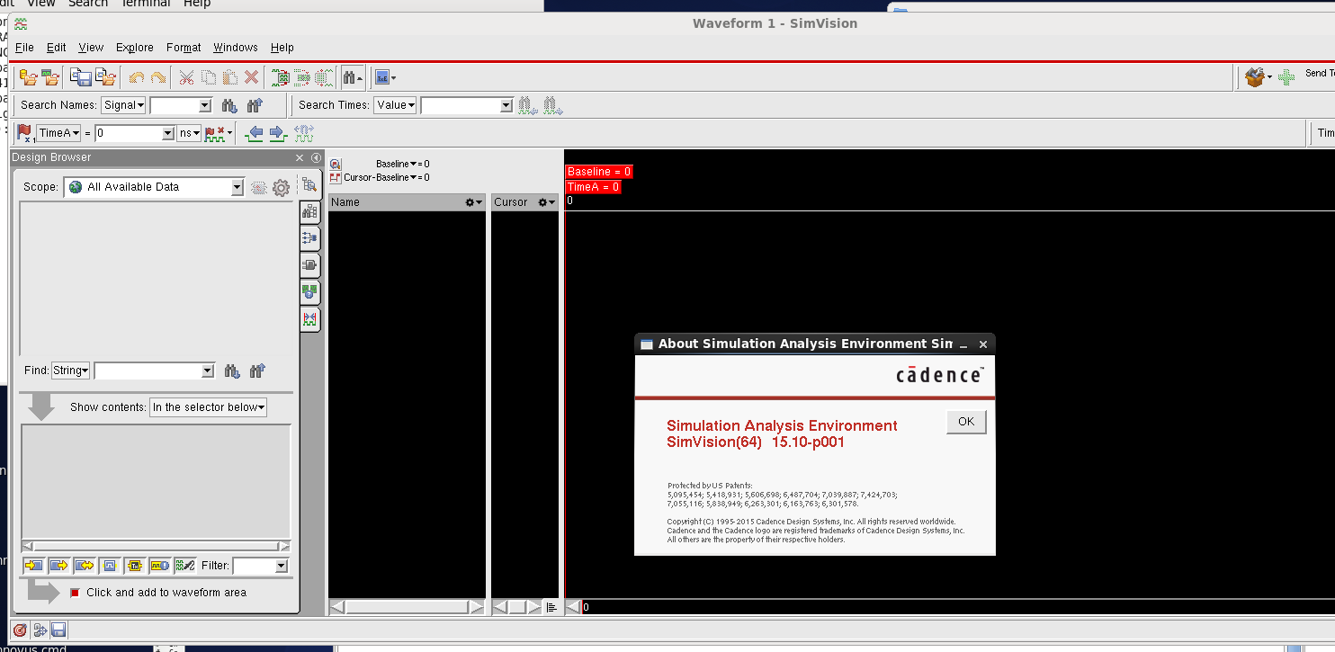

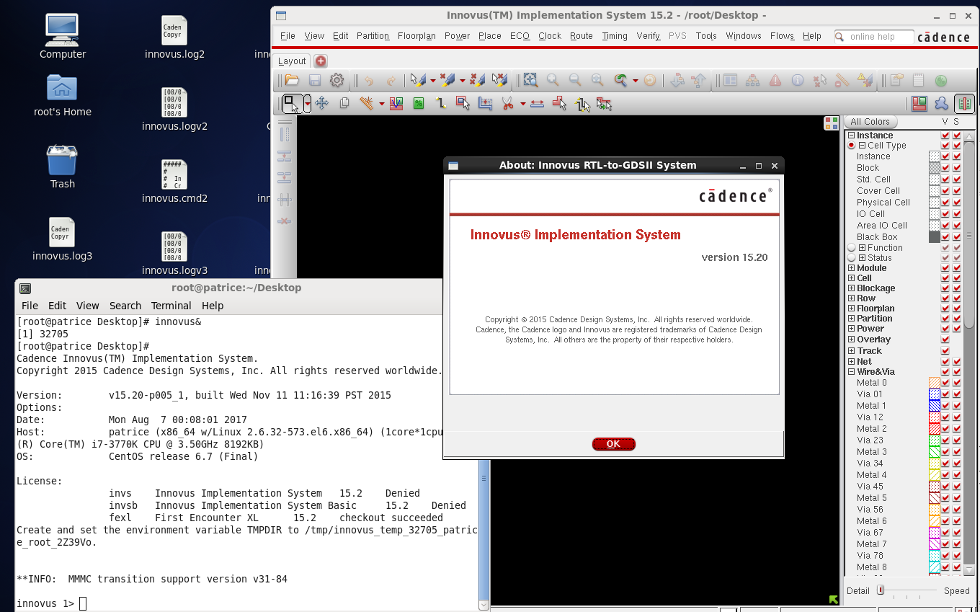

vmware-vdiskmanager -x 190Gb /var/vm/sample_vm/sample_vm.vmdk

Etendre le disque virtuel (vdiskmanager)

cd C:\Program Files\VMware\VMware Workstation
C:\Program Files\VMware\VMware Workstation>vmware-vdiskmanager.exe -x 13GB E:\Ub
untu.vmdk

-x pour expand... puis la taille en GO

vmware-vdiskmanager -x 40GB myDisk.vmdk

vmware-vdiskmanager.exe -x 15GB Q:\Virtual Machines\RH_610\Red Hat Entreprise Linux 4.vmdk

vmware-vdiskmanager -n myDisk.vmdk myNewDisk.vmdk

cd C:\VMware Workstation
C:\VMware Workstation>vmware-vdiskmanager.exe -x 13GB E:\mavm.vmdk
http://ajrindou-youssef.blogspot.fr/2010/09/redimensionner-un-disque-sous-vmware.html

http://rene.margar.fr/2009/10/changer-la-taille-dune-partition-ext3-lvm-sous-centos/
http://www.supinfo.com/articles/single/346-augmenter-chaud-taille-une-partition-linux-une-machine-virtuelle

http://fr.positon.org/redimensionner-une-partition-ext3-ext4

redimensionner partition LVM

http://www.serveur-linux.info/2012/01/lvm-gestion-disques/

df -h

resize2fs /dev/vg/lv_home

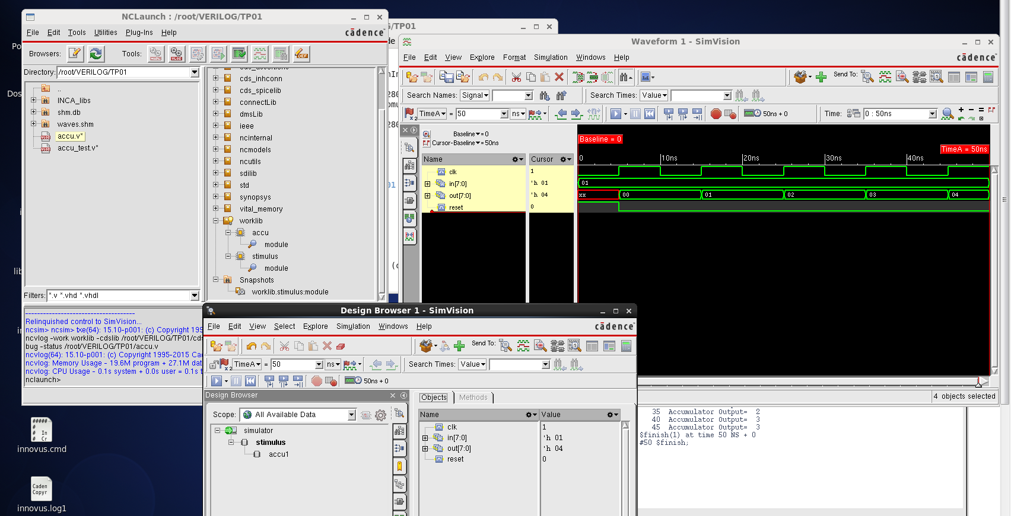

/////////////////////////////////////////////////////////////////////////////////////

nclaunch&
ncbrowse -64bit -cdslib /root/VERILOG/TP01/cds.lib -sortby severity -sortby category -sortby tag hal.log
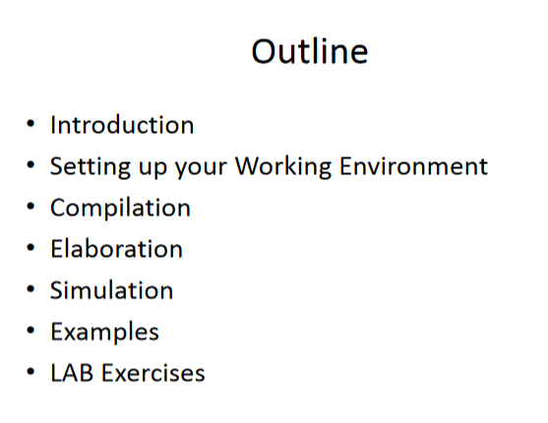
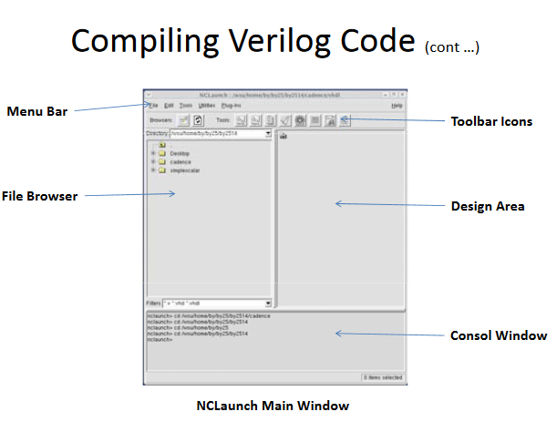

http://www.eng.biu.ac.il/temanad/files/2017/02/Lecture-3-STA.pdf
genus -legacy_ui
http://www.ece.eng.wayne.edu/~nabil/ece4680/labs/cadence_tutorial.pdf

Source pour l’exemple ci-dessous
http://userwww.sfsu.edu/necrc/files/cadence%20tutorials/Verilog%20Setup%20Tutorial.pdf

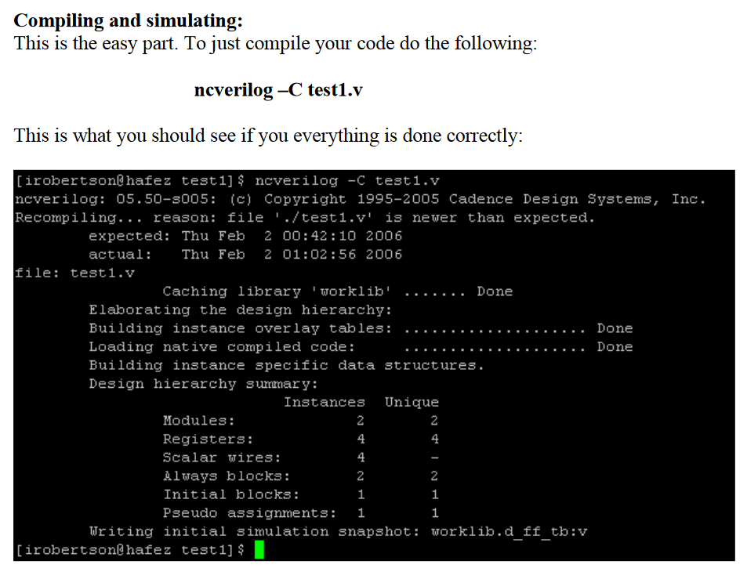

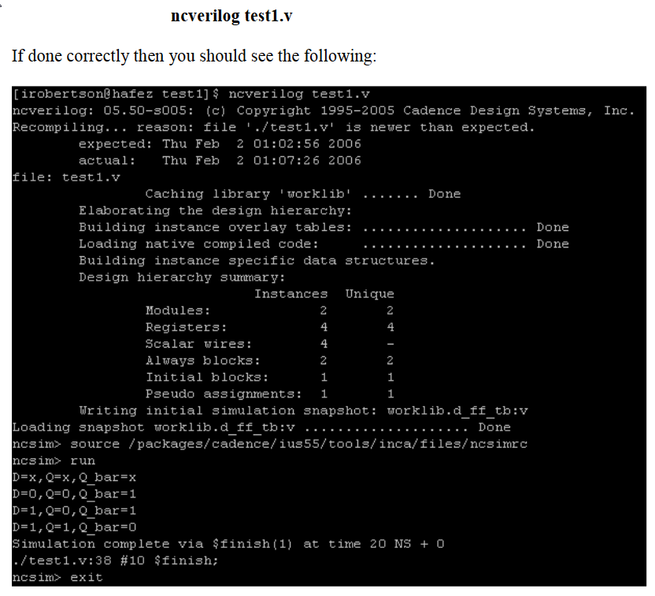

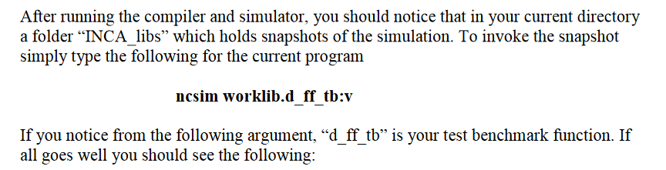

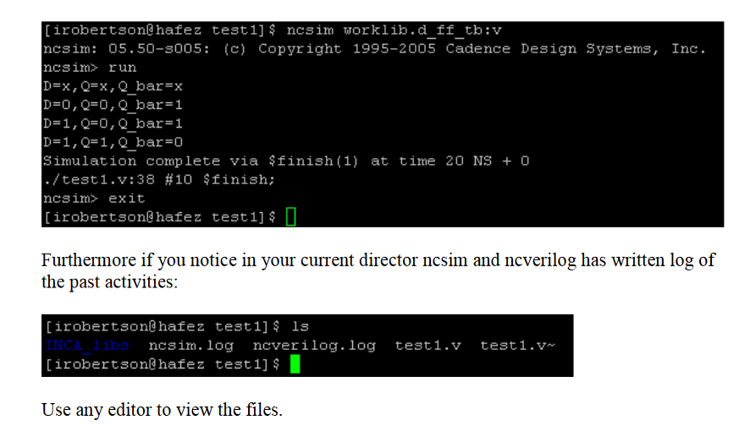

https://dormanthink.files.wordpress.com/2011/04/amstutorials.pdf
http://read.pudn.com/downloads162/doc/737935/ncvlogtut.pdf
http://eehpc.csee.umbc.edu/src/docs/tutorials/NCVerilog_Tutorial.pdf
http://www.cis.nagasaki-u.ac.jp/~shibata/slsi/pdf/ncvlog.pdf
https://www.mics.ece.vt.edu/ICDesign/Tutorials/Cadence/dg_front_analyze.html +++ plusieurs tuto
https://ay14-15.moodle.wisc.edu/prod/pluginfile.php/153782/mod_resource/content/2/ECE_755_Tutorial_1.pdf

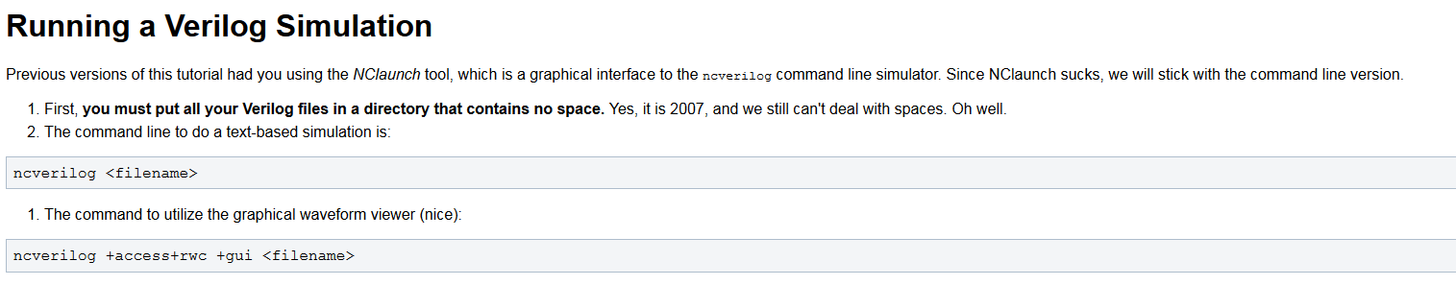
http://cmp3.imag.fr/aboutus/slides/Slides2016/10_28nmFD-SOI_RTL_to_GDS_design_flow_tutorial.pdf
http://www.ee.virginia.edu/~mrs8n/cadence/nclaunchtut.pdf
http://www.doe.carleton.ca/~gallan/478/digflow.pdf

https://www.eastpak.com/fr-fr/sacs-a-bandouliere-c130/the-one-black-stitched-pEK04533Q+00+999.html
http://www.samsonite.fr/besaces-loisirs/
http://hdvacademy.blogspot.fr/2014/07/simulation-using-cadence-ncsimncverilog.html

http://mspic.ee.nchu.edu.tw/class_course/university/97_VLSI-design/handout/2_2%20Cadence%20Verilog%20Languaje%20and%20Simulation%20Course.pdf
cadence officiel

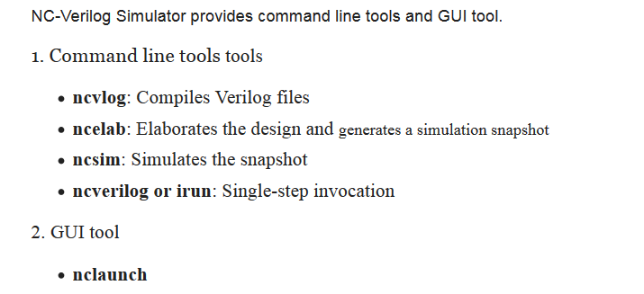

https://www.youtube.com/watch?v=URILAlvMDjk
https://piazza-resources.s3.amazonaws.com/ixhux8jyk0b3pe/iy98y3jguuj2p1/tool_demo_manual.pdf?AWSAccessKeyId=AKIAIEDNRLJ4AZKBW6HA&Expires=1502155513&Signature=GpeTYbWLzFro%2BlEzzikZVXusoy4%3D irun

http://www.edaboard.com/thread200447.html

Overview
The irun utility lets you run the simulator by specifying all input files and command-line options on a single command line.
The utility simplifies the invocation process by letting you use one tool to invoke the simulator instead of invoking multiple tools separately to piece together a snapshot that can be simulated.
After the input files have been compiled, irun automatically invokes ncelab to elaborate the design and then invokes the ncsim simulator.
The most basic way to use irun is to list the files that are to comprise the simulation on the command line, along with all command-line options that irun will pass to the appropriate compiler, the elaborator, and the simulator. For example:

% irun -ieee1364 -v93 -access +r -gui verify.e top.v middle.vhd sub.v
In this example:
The files top.v and sub.v are recognized as Verilog files and are compiled by the Verilog parser ncvlog. The -ieee1364 option is passed to the ncvlog compiler.

The file middle.vhd is recognized as a VHDL file and is compiled by the VHDL parser ncvhdl. The -v93 option is passed to the ncvhdl compiler.

The file verify.e is recognized as a Specman e file and is compiled using sn_compile.sh.

After compiling the files, irun then calls ncelab to elaborate the design. The -access option is passed to the elaborator to provide read access to simulation objects.

After the elaborator has generated a simulation snapshot, ncsim is invoked with both the SimVision and Specview graphical user interfaces.
Use the irun help system to get information on tool-specific command-line options. The help options are described in Chapter 2, "Getting Help on irun".

How irun Works
This section summarizes how irun works and what happens by default.
The first time you run the simulator with the irun command, it:

1.Creates a directory called INCA_libs.
2.Creates a subdirectory under the INCA_libs directory called
irun.<platform | platform.64>.<irun_version>.nc
For example:
irun.lnx86.09.20.nc/
irun creates files and directories under this subdirectory to support tool operations.
As a convenience, a symbolic link named irun.nc is created that points to the irun scratch subdirectory.
3. Parses the command line.
4. Invokes the appropriate compiler for each file specified on the command line.
Design units contained in HDL design files are compiled into the work library (worklib).
Verilog design units specified in -y libraries or -v library files are compiled into libraries that have the same names. These libraries are stored in subdirectories of irun.nc/xllibs. For example, the following command compiles top.v into worklib (INCA_libs/worklib). Design units in ./libs are compiled into a library called libs (INCA_libs/irun.nc/xllibs/libs), and design units in ./models are compiled into a library called models (INCA_libs/irun.nc/xllibs/models).
% irun top.v -y ./libs -y ./models +libext+.v
The output from the Specman e compiler, sn_compile.sh, is stored in subdirectories under the irun.nc directory.
Note: When using the -y option, the module name requested in the Verilog code instance must be identical to the file name found in the source directory. The file extension listed using -libext must also be the same. If <module_name>.<ext> is not identical, then the tool will be unable to read the file that contains the definition.
5.
Invokes the elaborator (ncelab) to elaborate the design and generate a simulation snapshot.
6.
Invokes the simulator (ncsim) to simulate the snapshot.
The output of all tools is written to a common log file called irun.log in the directory in which irun was invoked. You can change the name of the log file with the -l option. For example:

% irun -l run1.log ...

For redirecting the output of certain executables, such as hal or ncsim, from the irun.log file, see the -log_* command-line options.

Recompilation and Re-Elaboration

When irun is invoked again (that is, using an already existing INCA_libs scratch directory), irun determines if changes on the command line require any files to be recompiled (and then re-elaborated) or if the design needs to be re-elaborated.

irun will go directly to simulation if:

The content of the input files has not changed since the last time they were compiled. This includes the content of Verilog -v library files and -y directories.

The order of the input files on the command line is the same, including the order of Verilog -v library files and -y directories.

Command-line options are the same, or, if they are different, the changes do not affect the output of the different language compilers or ncelab.
For example, some options, such as +gui and -s, affect only run-time behavior. Adding or removing them from the command line does not cause recompilation or re-elaboration. However, adding, removing, or changing other options that can affect compilation or elaboration (for example, removing the -notimingchecks option or changing -access +r to -access +rw) will force recompilation or re-elaboration.
Irun -version

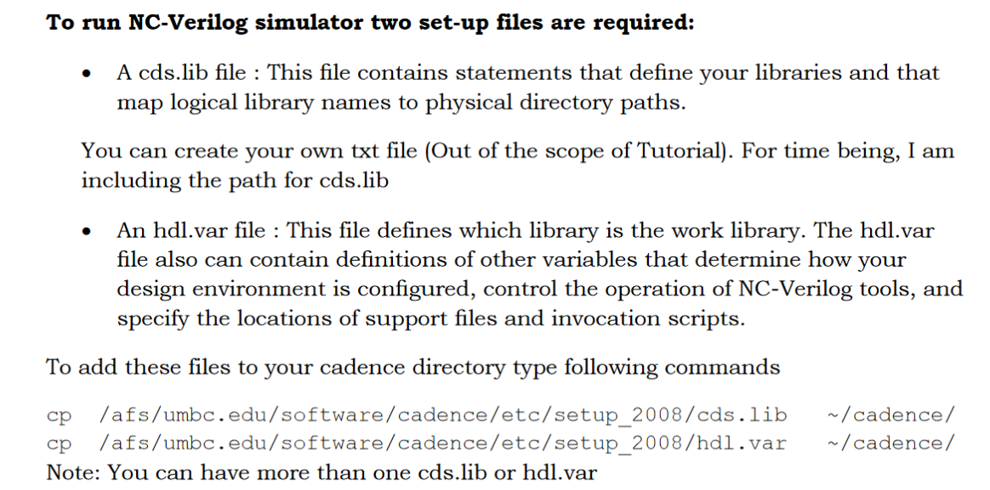

https://www.csee.umbc.edu/~tinoosh/cmpe641/tutorials/ncverilog/NCVerilog_Tutorial2.pdf
cds.lib
hdl.var
https://www.csee.umbc.edu/~tinoosh/cmpe641/tutorials/
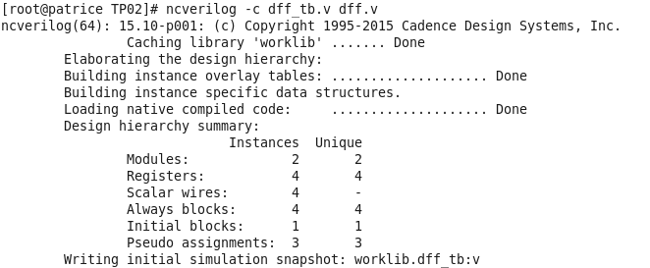

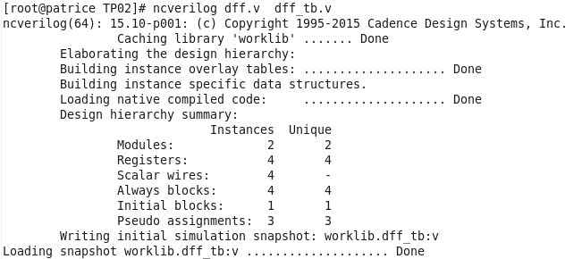

http://hdvacademy.blogspot.fr/2014/07/simulation-using-cadence-ncsimncverilog.html
ncvlog : compilation
ncverilog : compilation, elaboration and simulation == single step

In multi step mode
ncvlog
ncelab
ncsim
NCLaunch is a graphical user interface
nclaunch
https://gist.github.com/morganp/5797016

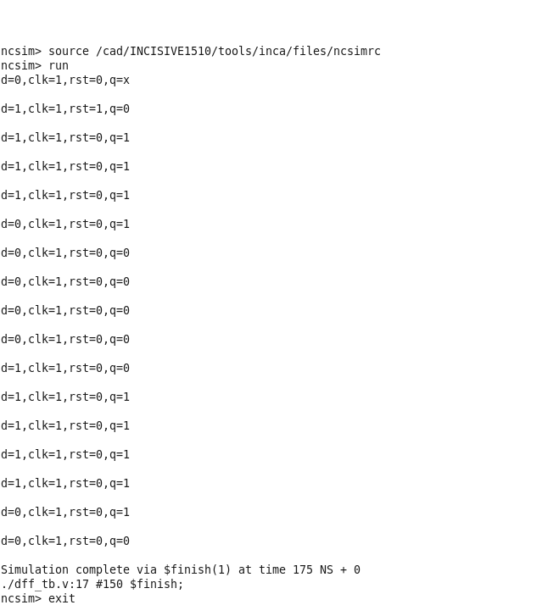

ncsim worklib.dff_tb:v

https://www.mics.ece.vt.edu/ICDesign/Tutorials/Cadence/dg_front_analyze.html
ncverilog +access+r updown_counter.v tb_cnt_updown.v

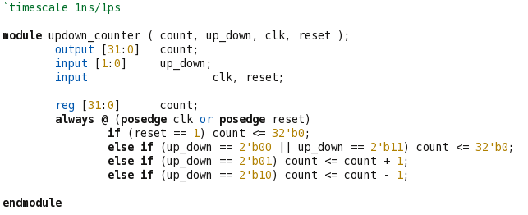

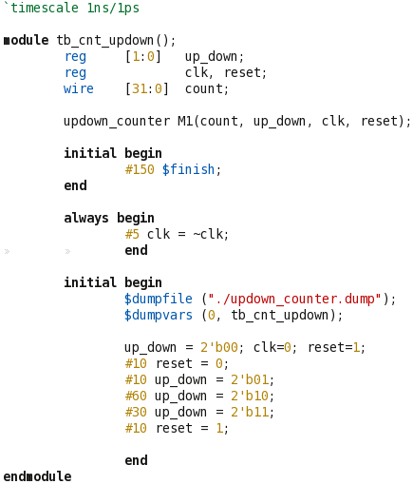

ncverilog +access+r updown_counter.v tb_cnt_updown.v

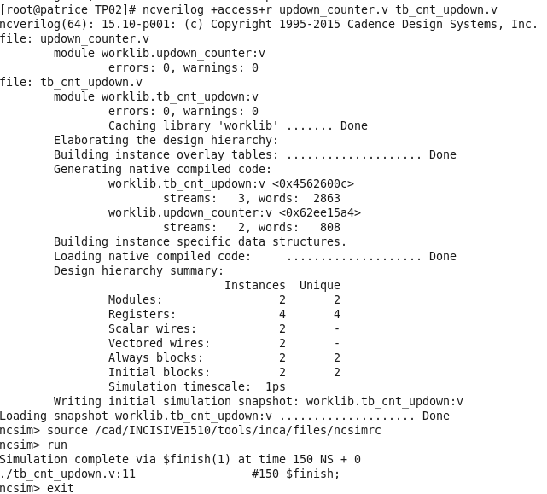

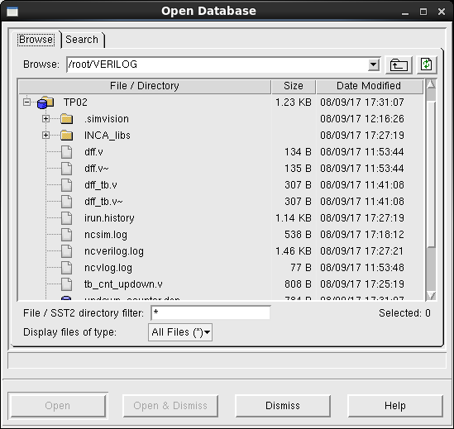

Select updown_counter.dump

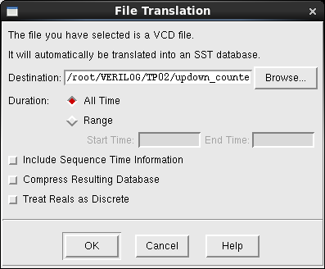

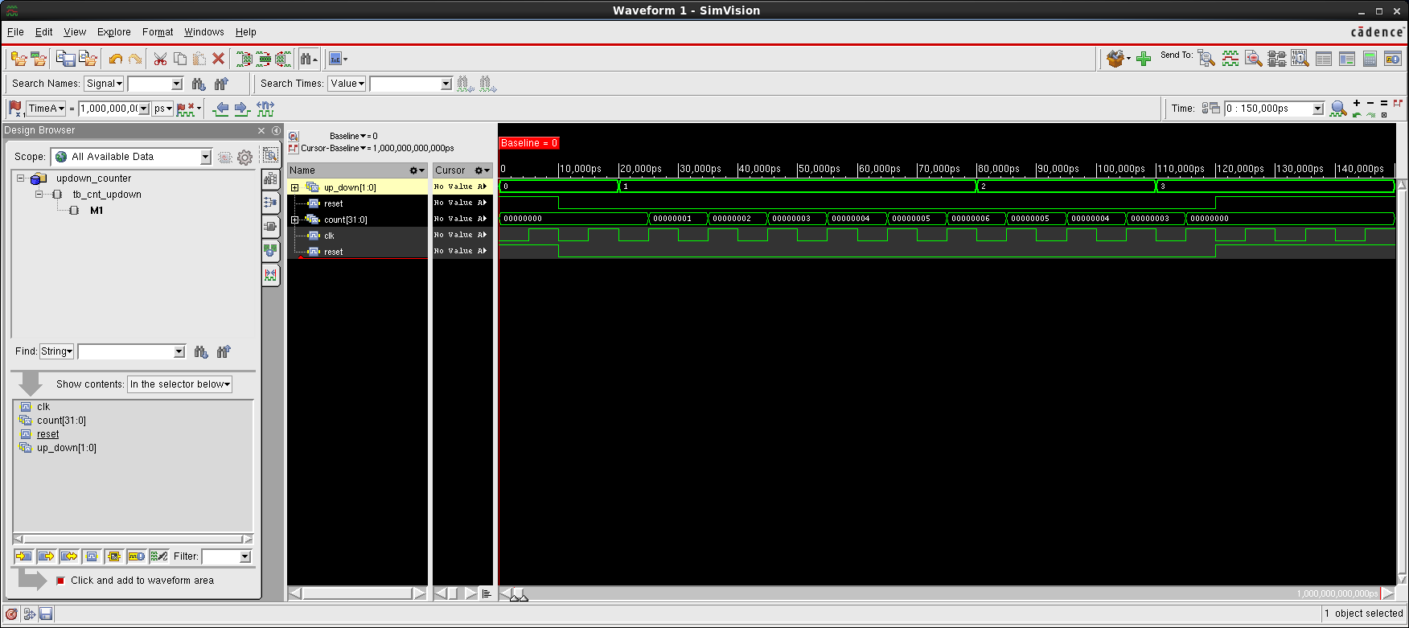

vcd trn dsn shm ?? snapshot
ncverilog -f "filelist"
scvf (waveformat of simvision)

`ifdef SAVE_SST_FILE
initial begin
// Waveforms definition record file
$recordfile("all_chip.trn");
// Record the entire device
$recordvars("depth=0",top_tb);
end
`endif

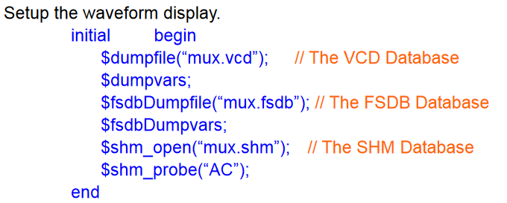

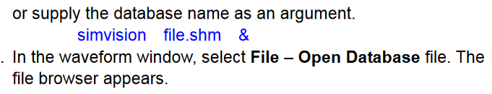
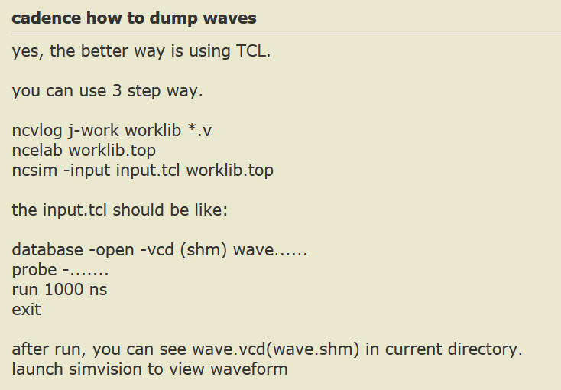
https://gist.github.com/morganp/5797016
http://www.asic.co.in/ppt/cadense_commands.htm
https://stackoverflow.com/questions/28407882/setting-probes-for-simvision-in-verilog-code
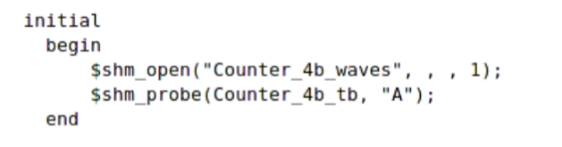
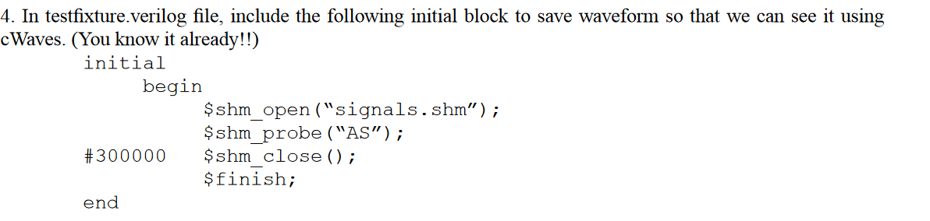
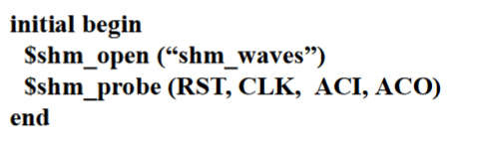
http://www.csd.uoc.gr/~hy225/11a/auxiliary/vloguser.pdf
SHM (Simulation History Manager)

Re: Simple script to simulate.
irun -64bit -work worklib -message -access +rwc -licqueue \
-ALLOWREDEFINITION \
-vlogext h \
-vlogext vh \
-notimingchecks \
-loadpli1 ${MG_LIB}/cadence_nc_verilog/mm_nc_dynamic:mgboot_nc \
-input fsdb.tcl \
-define ***** \
-v93 \
-endlib \
test_tb.v
bfm_1.v
bfm_1.v
test_case_1.v
test_rtl.v
\

https://www.mikrocontroller.net/topic/374458
https://piazza-resources.s3.amazonaws.com/ixhux8jyk0b3pe/iz971fza29bc1/SimVisionIntro.pdf?AWSAccessKeyId=AKIAIEDNRLJ4AZKBW6HA&Expires=1502365758&Signature=9a7mYfdE8T2KrPBY7XKxzAkTmQs%3D
simvision

https://www.achronix.com/wp-content/uploads/2016/10/Simulation_User_Guide_UG072.pdf

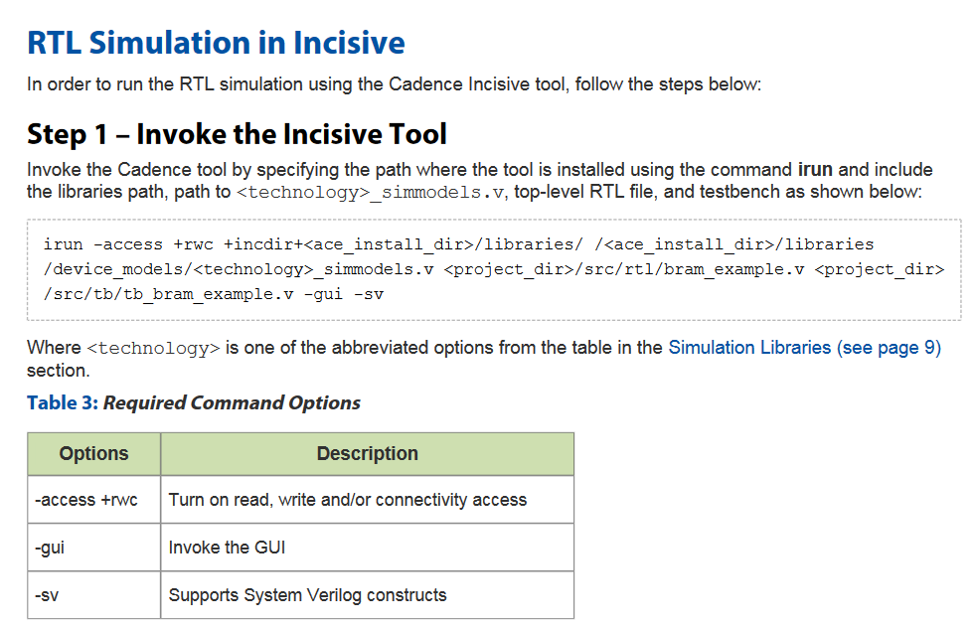

///////////////////////////////////////////////////////////////////////////////////////////////
http://linuxtoolkit.blogspot.fr/2014/05/install-adobe-reader-9-on-centos-65.html
https://www.if-not-true-then-false.com/2010/install-adobe-acrobat-pdf-reader-on-fedora-centos-red-hat-rhel/
wget http://ardownload.adobe.com/pub/adobe/reader/unix/9.x/9.5.5/enu/AdbeRdr9.5.5-1_i486linux_enu.rpm

http://www.linuxserve.com/2015/05/how-to-install-adobe-reader-955-on.html
http://linuxdownload.adobe.com/adobe-release/adobe-release-x86_64-1.0-1.noarch.rpm

yum install --nogpgcheck http://linuxdownload.adobe.com/adobe-release/adobe-release-x86_64-1.0-1.noarch.rpm

yum localinstall http://li.nux.ro/download/nux/dextop/el7/x86_64/nux-dextop-release-0-5.el7.nux.noarch.rpm

