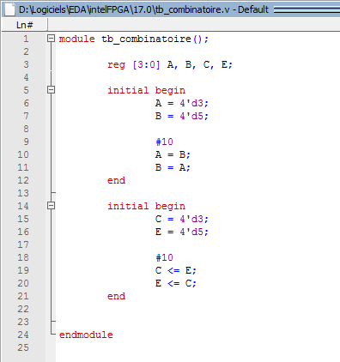

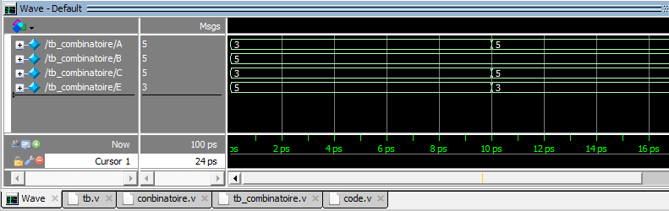

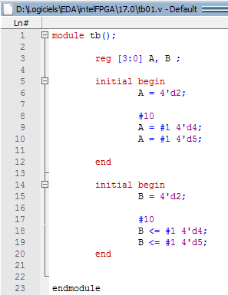

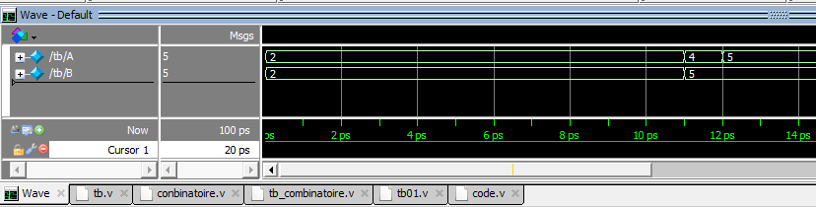

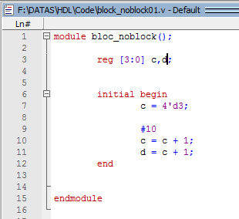

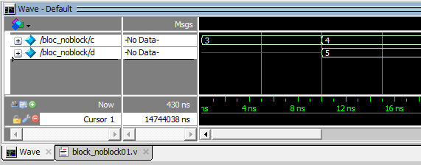

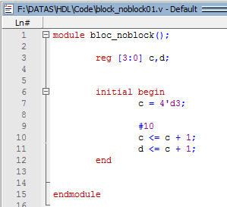

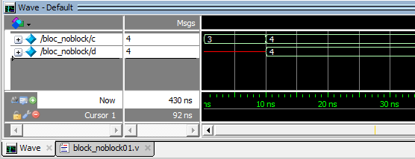

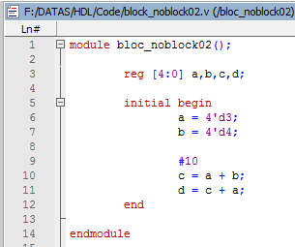

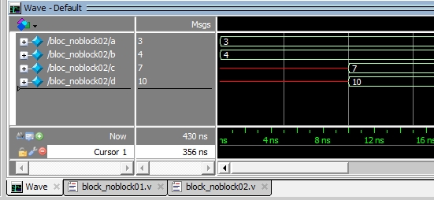

http://nptel.ac.in/courses/106106088/pdf/nptel-cad1-14.pdf

PB

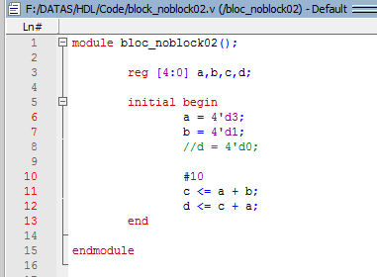 ????????

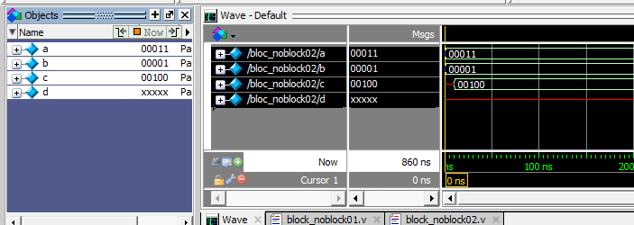

A voir http://nptel.ac.in/courses/106106088/pdf/nptel-cad1-14.pdf

A voir https://cseweb.ucsd.edu/classes/fa08/cse141L/slides/vlog-part2.pdf

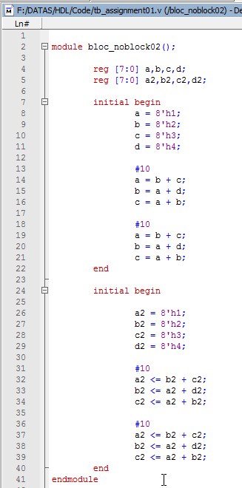

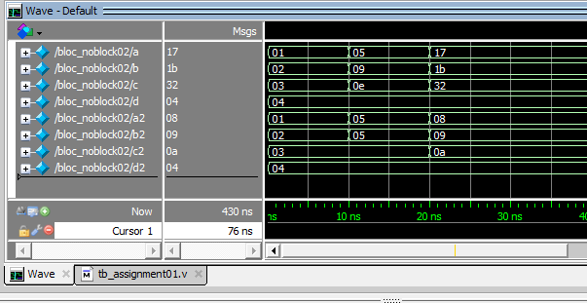

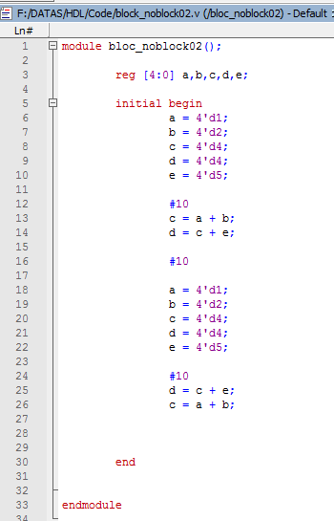
invert

Ordre important , ici on a pas le même resultat : execution en serie
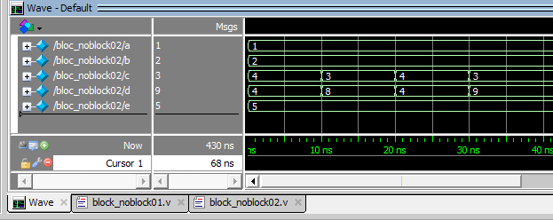

https://cseweb.ucsd.edu/classes/fa08/cse141L/slides/vlog-part2.pdf
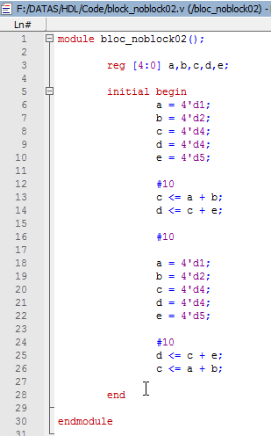
invert

On a le meme resultat si on swap les lignes : execution paralléles

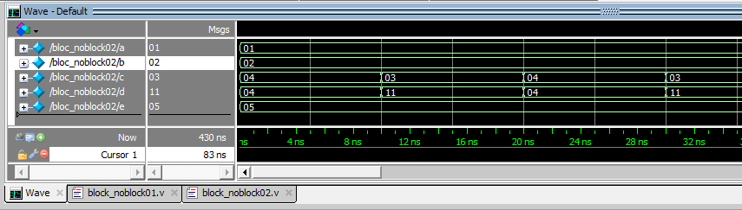
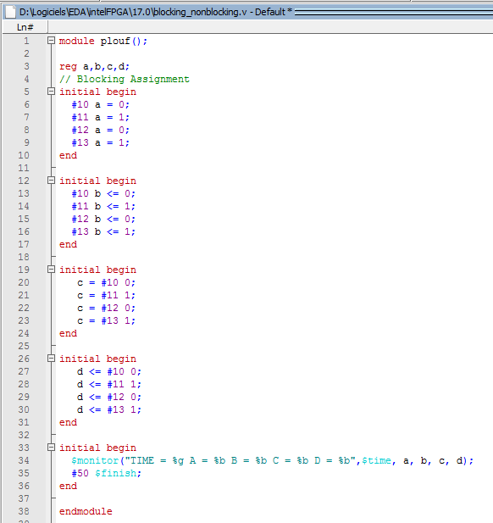

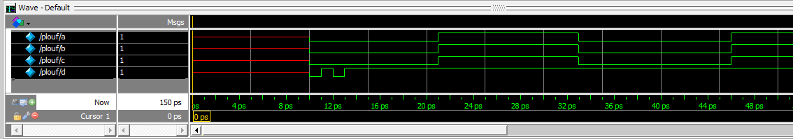
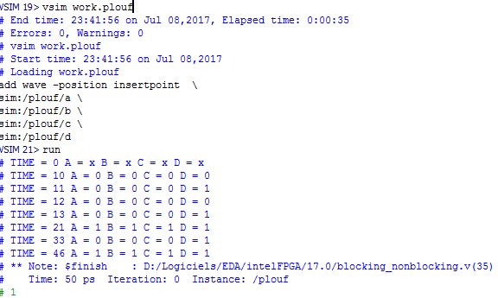

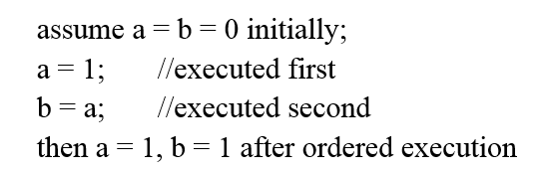

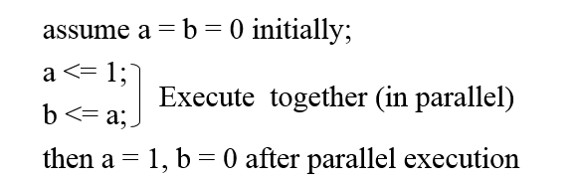

Encodeur 8 vers 3
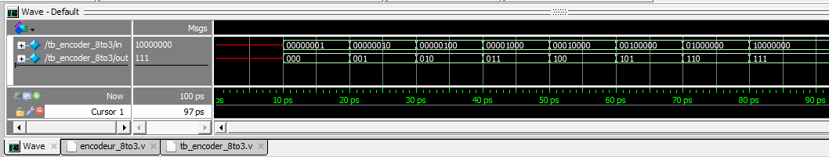

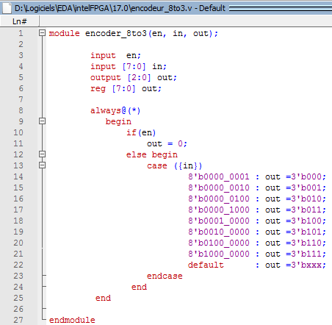

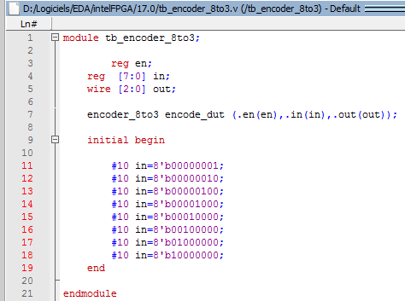

Decodeur 3 vers 8

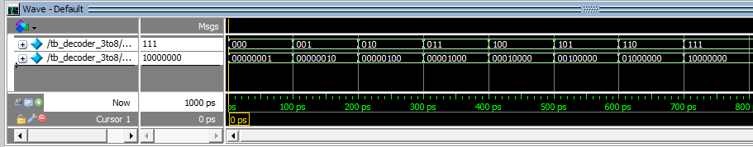

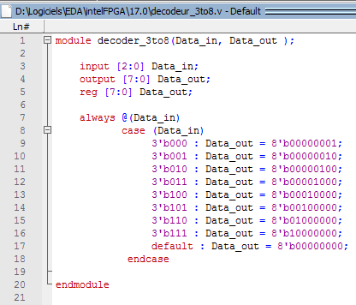

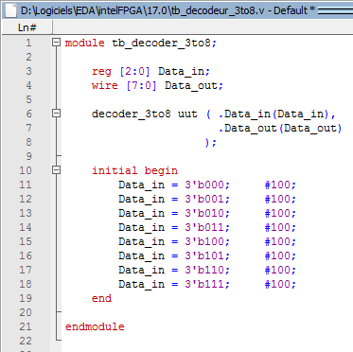

Multiplexeur

https://vlsimaster.wordpress.com/category/vhdl/verilog-code-for-encoder-and-testbench/
http://verilogcodes.blogspot.fr/2015/10/verilog-code-for-digital-clock.html
http://www.testbench.in/verilog_basic_examples.html
module demux1to4(Data_in, sel, Data_out);
input Data_in;
input [1:0] sel;
output Data_out[3:0];
reg Data_out[3:0];
//always block with Data_in and sel in its sensitivity list
always @(Data_in or sel)
begin
case (sel) //case statement with "sel"
//multiple statements can be written inside each case.
//you just have to use 'begin' and 'end' keywords as shown below.
2'b00 : begin
Data_out_0 = Data_in;
Data_out_1 = 0;
Data_out_2 = 0;
Data_out_3 = 0;
end
2'b01 : begin
Data_out_0 = 0;
Data_out_1 = Data_in;
Data_out_2 = 0;
Data_out_3 = 0;
end
2'b10 : begin
Data_out_0 = 0;
Data_out_1 = 0;
Data_out_2 = Data_in;
Data_out_3 = 0;
end
2'b11 : begin
Data_out_0 = 0;
Data_out_1 = 0;
Data_out_2 = 0;
Data_out_3 = Data_in;
end
endcase
end
endmodule

http://verilogcodes.blogspot.fr/2015/10/verilog-code-for-14-demux-using-case.html

module
mux4to1(data, select, out);
input [3:0]
data;
input [1:0]
select;
output
out;
reg
out;
always@(data,select)
case(select)
2’b00: out = data[0];
2’b01: out = data[1];
2’b10: out = data[2];
2’b11:out = data[3];
endcase
endmodule

https://vlsimaster.wordpress.com/2013/01/26/verilog-code-for-4-bit-mux-and-test-bench/

Multiplexeur 4 to 1

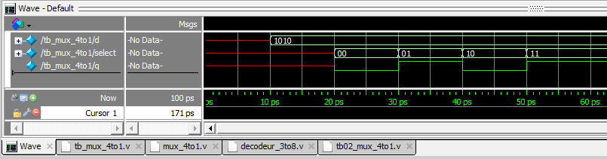

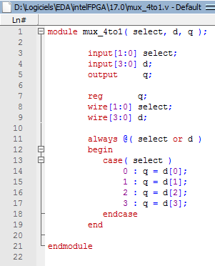

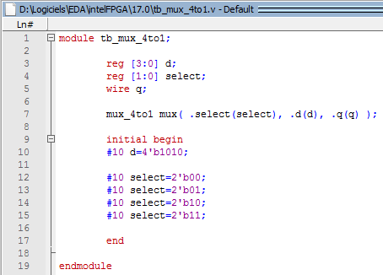

Demultiplexeur 1 vers 4
http://verilogcodes.blogspot.fr/2015/10/verilog-code-for-14-demux-using-case.html

http://www.techmasterplus.com/verilog/demultiplexer.php
module demux (in, sel, out);
input in;
input [1:0] sel;
output [3:0] out;

assign out = in << sel;
endmodule

http://www.edaboard.com/thread106724.html

https://ba.mirror.garr.it/1/groundup/a36.html

Compteur

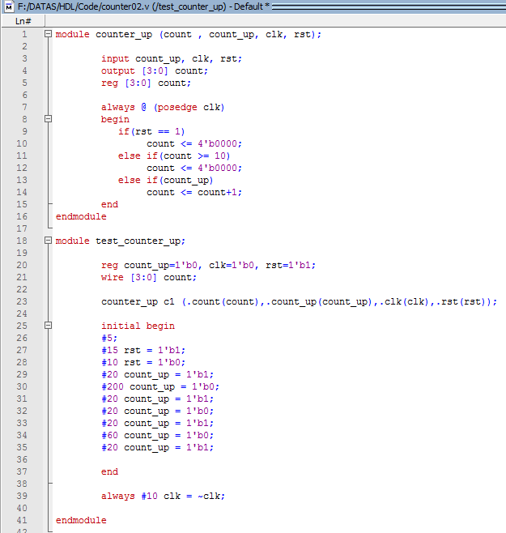

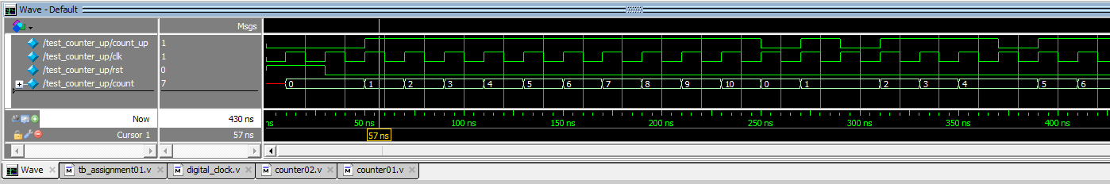

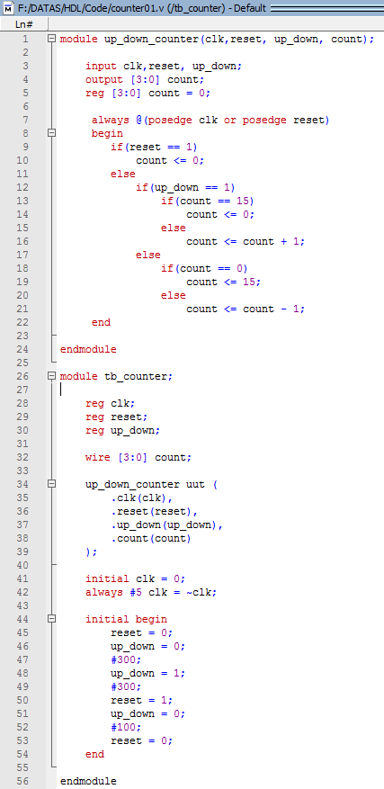

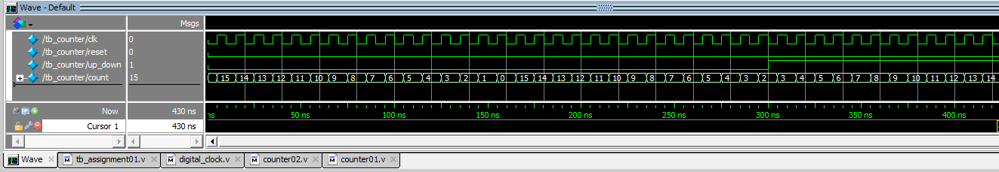

http://asic.co.in/Index_files/verilogexamples.htm

System Verilog
- SystemVerilog is a hardware description and Verification language(HDVL)
- SystemVerilog is an extensive set of enhancements to IEEE 1364 Verilog-2001 standards

What is System Verilog ?
- It’s a super Verilog
- It supports all features of verilog with new features

Adds abstract, system-level modeling constructs to Verilog
–
Adds extended test bench features to Verilog

Data types : logic can replace reg and wire

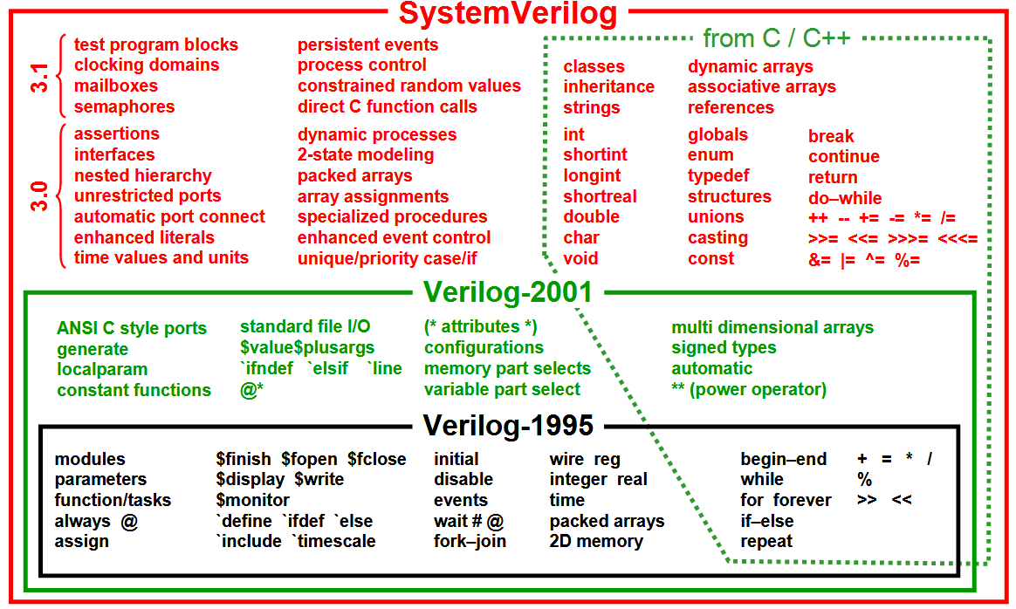

http://www.sutherland-hdl.com/papers/2003-DVCon-presentation_SystemVerilog.pdf

Scan-path design is to reduce test generation
complexity for circuit containing storage devices
and feedback path with combinational logic

A mux is placed at the input of each flip-flop in such a way that all flip-flops can be connected in a shift register for one mux selection and to work in a normal mode in the other

Digital Design and Fabrication
Book
https://www.csee.umbc.edu/~cpatel2/links/418/lectures/chap4_lect04_defects_faults.pdf

defects cmos integrated circuits
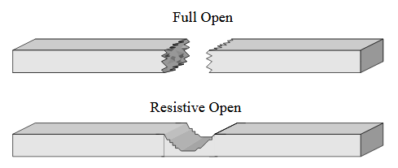

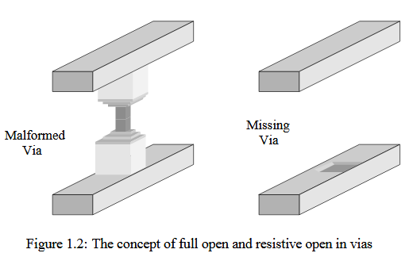
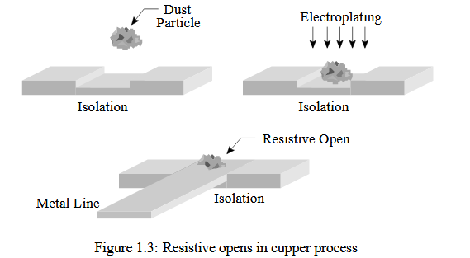

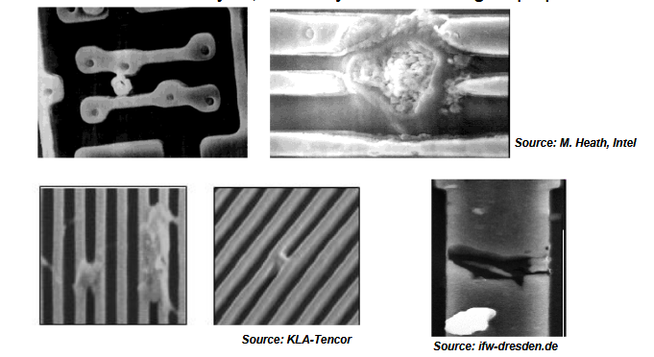

https://www.uio.no/studier/emner/matnat/ifi/INF4420/v12/undervisningsmateriale/INF4420_03_Layout_Print.pdf
https://embedded.eecs.berkeley.edu/Alumni/pinhong/ee244/14-1-dfm-cad.PDF

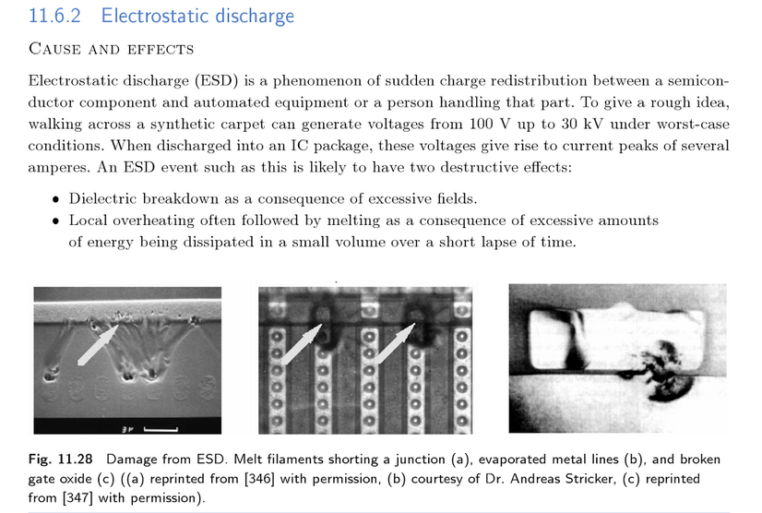

digital circuit dfm layout rules

http://publications.lib.chalmers.se/records/fulltext/199745/199745.pdf

