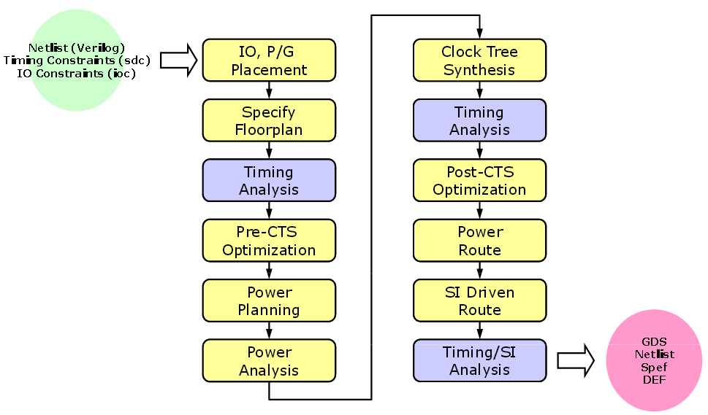

set rda_Input(ui_pwrnet) {VDD}
set rda_Input(ui_gndnet) {VSS}
################################################
# #
# FirstEncounter Input configuration file : map.conf #
# #
################################################
global rda_Input
set cwd .
set rda_Input(import_mode) {-treatUndefinedCellAsBbox 0}
set rda_Input(ui_netlist) "map.v"
set rda_Input(ui_netlisttype) {Verilog}
set rda_Input(ui_rtllist) ""
set rda_Input(ui_ilmdir) ""
set rda_Input(ui_ilmlist) ""
set rda_Input(ui_ilmspef) ""
set rda_Input(ui_settop) {0}
set rda_Input(ui_topcell) {CHIP}
set rda_Input(ui_celllib) ""
set rda_Input(ui_iolib) ""
set rda_Input(ui_areaiolib) ""
set rda_Input(ui_blklib) ""
set rda_Input(ui_kboxlib) ""
set rda_Input(ui_gds_file) “pipo.gds"
set rda_Input(ui_oa_oa2lefversion) {}
set rda_Input(ui_view_definition_file) ""
set rda_Input(ui_timelib,max) ""
set rda_Input(ui_timelib,min) ""
set rda_Input(ui_timelib) “vtvtlib25.tlf"
set rda_Input(ui_smodDef) ""
set rda_Input(ui_smodData) "“

Starting Encounter
Read In Your Design
Floor plan your Design
Power Rails
Power Stripes
Placement
Clock Tree Generation
Routing
Filler
Verification
Save
encounter-user-guide.pdf
- Encounter user guide
•
encounter-command-line-ref.pdf
- Encounter text command reference
•
encounter-menu-ref.pdf
- Encounter GUI reference

Specify scan chain

Timing et Calculate Delay *.sdf

Design import

Floorplan specification

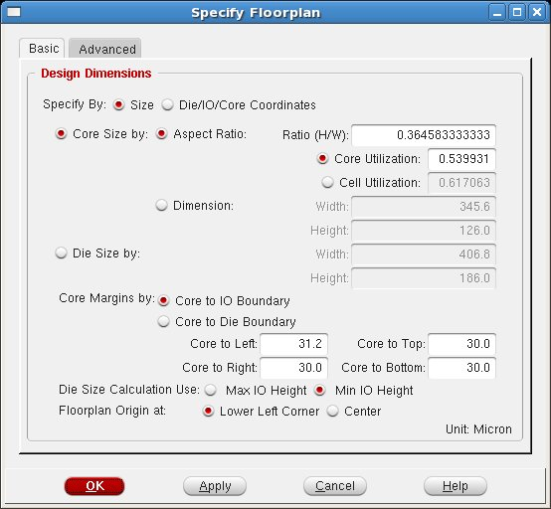

Power planning : Global net connections

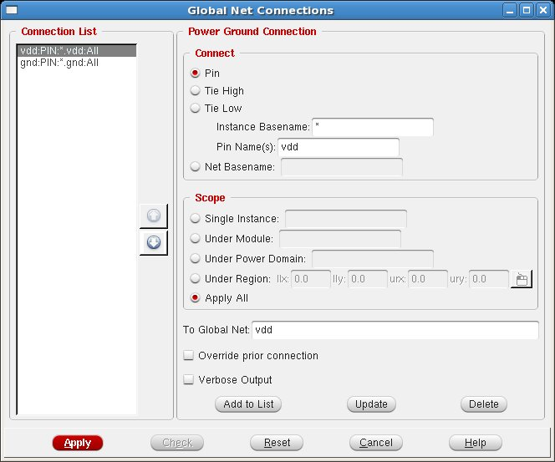

Power planning : Power add ring

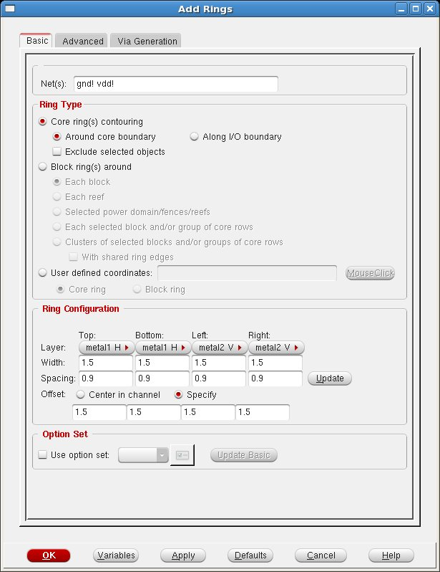

Power planning: Power add stripes

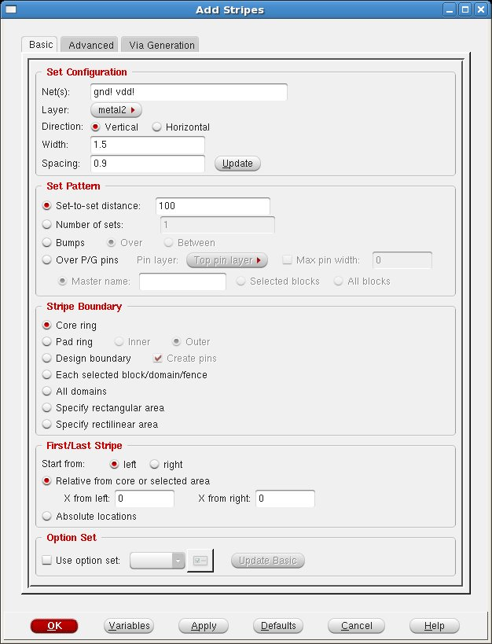

Connect Power to standard Cell Rows

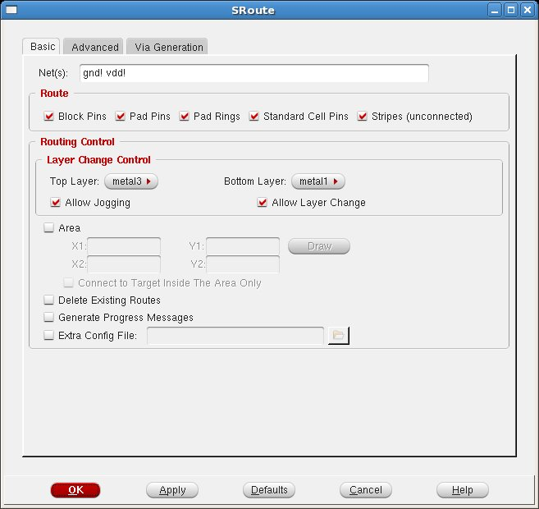

Cell placement
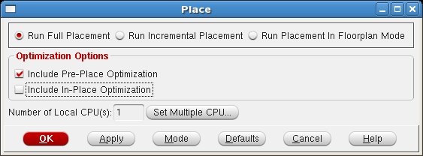

Routing
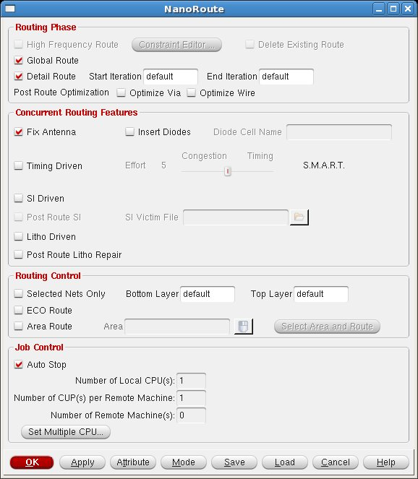

Global net connections
Cell placement
Post-placement timing analysis
The timing analysis engine in Encounter can now be run to get a
relatively good idea of
the timing performances of the design. It actually performs
a trial routing and a parasitic
extraction based on the current cell placement.
Select
Timing
⇒
Analyze Timing...
in the main menu. Define the path for the slack
report file. Click
OK
.
In the Encounter console window you get a summary of the timin
g analysis:

Clock tree synthesis CTS

Design routing

Post-routing timing optimization and analysis
Filler cell placement
Design checks
Report generation
Post-route timing data extraction
Post-route netlist generation

GDS2 file generation
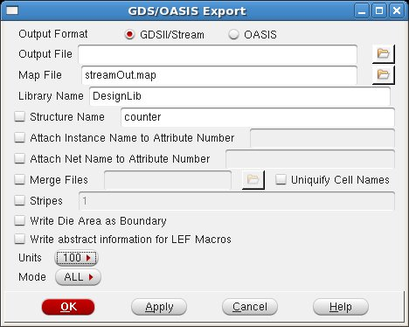
- Définir le map file

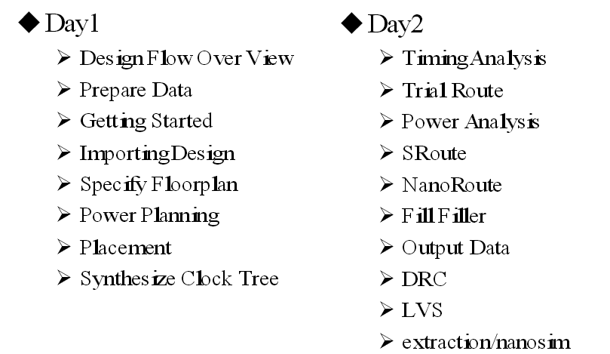

Synthèse arbre d’horloge
Il est nécessaire de maitriser la propagation des signaux dans un circuit numérique, notamment si on conçoit un système synchrone. Il est vitale que la répartition des horloges soient parfaires, c’est-à-dire sans dérive (« Skew »).
Chemin critique

synchrone . Par conséquent, le routage et l’ajout de buffer
L’objectif est de créer un ensemble d’arbres dont les branches soient équilibrées afin de minimiser les décalages entre les bascules.

L’analyse temporelle des arbres obtenus permet de vérifier le délai
Maximum du front d’horloge sur les entrées des bascules (« skew »).

