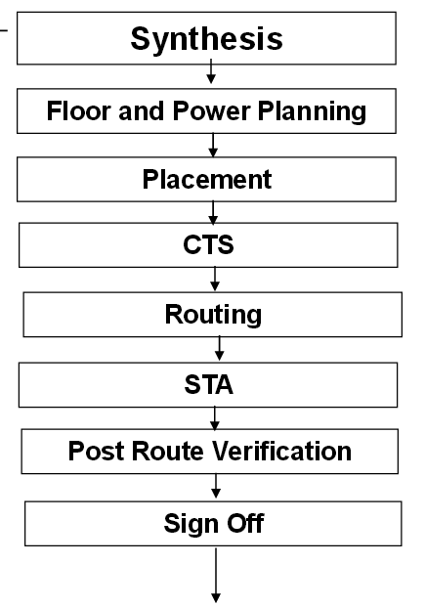
Etape successive:
Floor & power planning
Placement
Clocks Tree synthesis
Routing
Timing analysis
Verification & calcul de le puissance

//////////////////////////////////////////////////////////////////////////////////////////////
Avant de passer à l’étape de conception physique du circuit il est nécessaire :
- Lancer la synthése pour obtenir une netlist comprenent les portes (gate level)
- Vérifier que le niveau gate level rempli les fonctionnalitées (simulation)
- Générer le fichier de contrainte des delais sdc (standard delay contraints)

Design import :
- LEF , layer, via définition
- LIB (TLF), delay, capacitance
- Netlist verilog
- SDC
- DEF
Placement : Two Associated Cost functions
- Reduce Total wiring or routing length

- Distribute standard cell instances homogeneously
in ASIC Core such that optimal equilibrium among
vertical and horizontal routing is achieved

Detailed Placement

-After global placement

To Refine placement based on congestion, timing and
power

-Congestion Driven Placement

To distance standard cell instances from each other such
that more routing tracks are created between them

-Timing Driven Placement

To optimize large sets of path delays

- Net Based

Try to control the delay on signal path by imposing an
upper bound delay or weight to net

Power distribution :
- Stripes
- Rails
- Clock Tree Synthesis

- Automatic insertion of buffers/inverters along
- the clock path to balance the clock delay to all the clock inputs.
- Why balancing clock delay?
- Clock Skew?

