https://books.google.fr/books?id=RKd7AwAAQBAJ&pg=PA61&lpg=PA61&dq=cadence+irun+script&source=bl&ots=lS87HSEs2l&sig=yBQqVRSvl-ile0u6PHBP6TQIcyE&hl=fr&sa=X&ved=0ahUKEwiopb3svOTXAhWKuBoKHbGWCf0Q6AEIVDAE#v=onepage&q=cadence%20irun%20script&f=false
irun

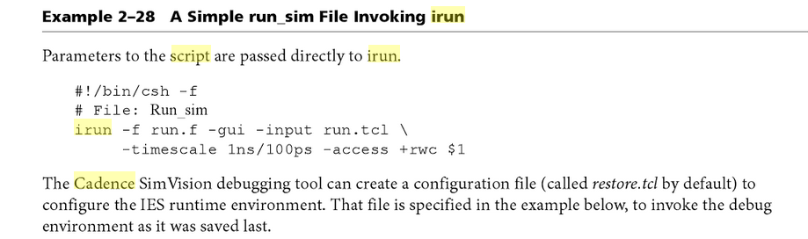
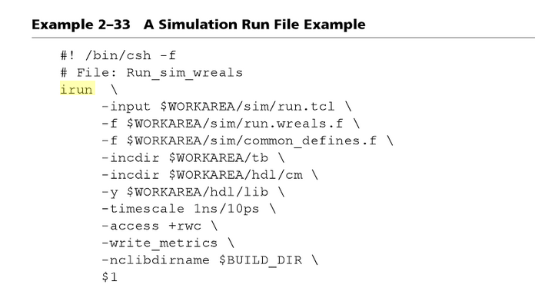
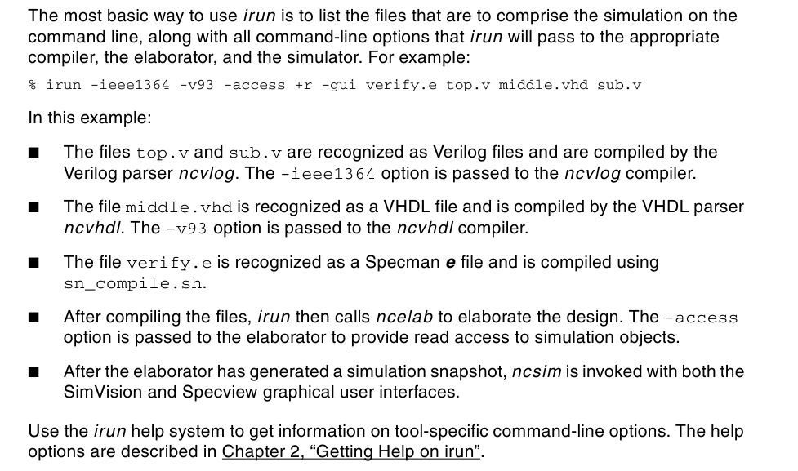

https://s2.smu.edu/~manikas/CAD_Tools/Verilog/
accu.cmd
accu.v
accu_test.v
http://www.ece.virginia.edu/~mrs8n/cadence/Simulation_Tutorial/sim_tutorial.html
https://github.com/freechipsproject/rocket-chip/issues/1046

irun
-64
-access +rwc
+sv
-I/home/aouldelhacen/design/rocket-chip/riscv-tools/include
-Wcxx -std=c++11
-verbose
-ccargs /home/aouldelhacen/design/rocket-chip/riscv-tools/lib
/home/aouldelhacen/design/rocket-chip/riscv-tools/lib/libfesvr.so
-incdir /home/aouldelhacen/design/rocket-chip/vsim/generated-src
+define+CLOCK_PERIOD=1.0
/home/aouldelhacen/design/rocket-chip/vsim/generated-src/freechips.rocketchip.system.DefaultConfig.v
/home/aouldelhacen/design/rocket-chip/vsim/generated-src/freechips.rocketchip.system.DefaultConfig.behav_srams.v
/home/aouldelhacen/design/rocket-chip/vsrc/TestDriver.v
/home/aouldelhacen/design/rocket-chip/vsrc/SimDTM.v
/home/aouldelhacen/design/rocket-chip/vsrc/jtag_vpi.v
/home/aouldelhacen/design/rocket-chip/vsrc/plusarg_reader.v
/home/aouldelhacen/design/rocket-chip/vsrc/ClockDivider2.v
/home/aouldelhacen/design/rocket-chip/vsrc/ClockDivider3.v
/home/aouldelhacen/design/rocket-chip/vsrc/AsyncResetReg.v
/home/aouldelhacen/design/rocket-chip/csrc/SimDTM.cc
/home/aouldelhacen/design/rocket-chip/csrc/jtag_vpi.c
+define+PRINTF_COND=TestDriver.printf_cond
+define+STOP_COND=!TestDriver.reset
+define+RANDOMIZE_MEM_INIT
+define+RANDOMIZE_REG_INIT
+define+RANDOMIZE_GARBAGE_ASSIGN
+define+RANDOMIZE_INVALID_ASSIGN
+libext+.v
-gui
-controlassert /home/aouldelhacen/design/rocket-chip/vsim/assert_off.v
-timescale 1ns/10ps

Test ok
irun -access +r -gui accu.v accu_tb.v &

http://hdvacademy.blogspot.fr/2014/07/simulation-using-cadence-ncsimncverilog.html

https://piazza-resources.s3.amazonaws.com/ixhux8jyk0b3pe/iz971gjmaffcd/SimVisionSourceBrowser.pdf?AWSAccessKeyId=AKIAIEDNRLJ4AZKBW6HA&Expires=1511997993&Signature=eF5o5TwrwKgHAq3vklpKzn5dOZk%3D
http://www.graser.com.tw/images/event_history/2013_uc_handout/c/3_Mixed-Signal_Design_for_Analog-Centric_Digital-Centric_Verification.pdf
https://ashrafi.sdsu.edu/PDF/CADENCE_Tutorial.pdf

ERROR: can't determine installation root.
can't find tools/bin/cds_root in any parent directory of executable "/sbin/vconfig"
Add IUS/tools/lib to LD_LIBRARY_PATH environment variable.
LD_LIBRARY_PATH $IUS/tools/lib

export LD_LIBRARY_PATH=$CDS_ROOT/MMSIM111/tools/lib/64bit:$LD_LIBRARY_PATH

export LD_LIBRARY_PATH="$CADENCE_HOME/IUS/tools/lib:$CADENCE_HOME/IUS/tools/dfII/lib:$CADENCE_HOME/IC614/tools/lib:$CADENCE_HOME/IC614/tools/dfII/lib:$CADENCE_HOME/MMSIM/tools/lib:$CADENCE_HOME/MMSIM/tools/dfII/lib:$CADENCE_HOME/IUS/tools/verilog/lib:$LD_LIBRARY_PATH"

http://www.vlsi.itu.edu.tr/ituvlsi/webs/courses/undergraduate/ele425/course-materials/NCLaunch_behavioral.pdf
https://piazza-resources.s3.amazonaws.com/ixhux8jyk0b3pe/iz971hogfpl357/SimVisionWaveform.pdf?AWSAccessKeyId=AKIAIEDNRLJ4AZKBW6HA&Expires=1512000837&Signature=Cyq9YQ9fGf3ajQVETk08jheRkqc%3D

