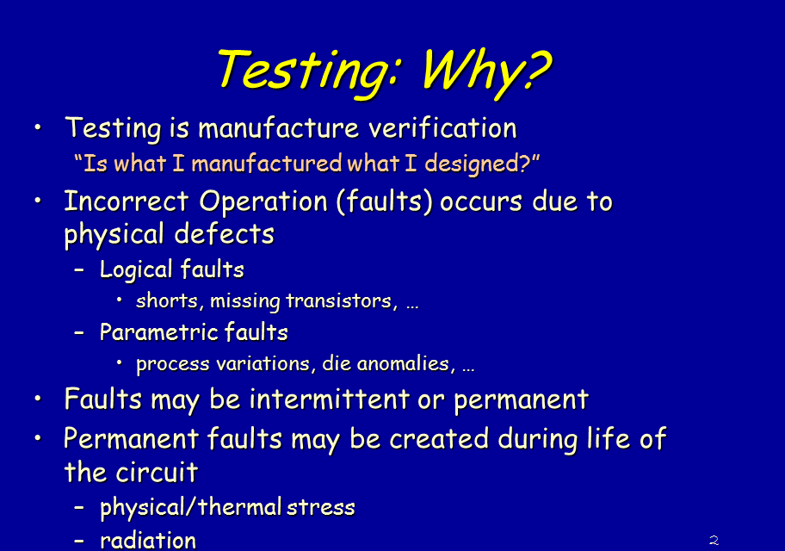

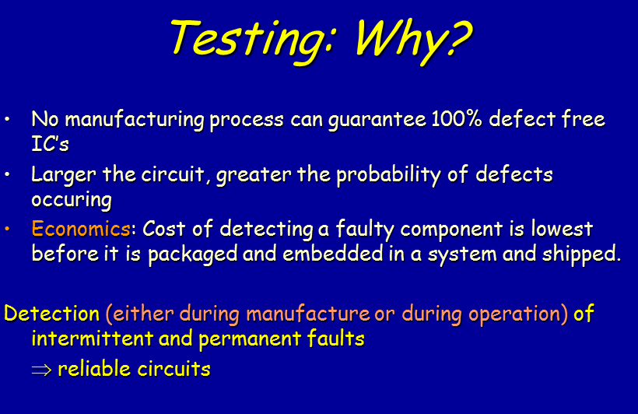

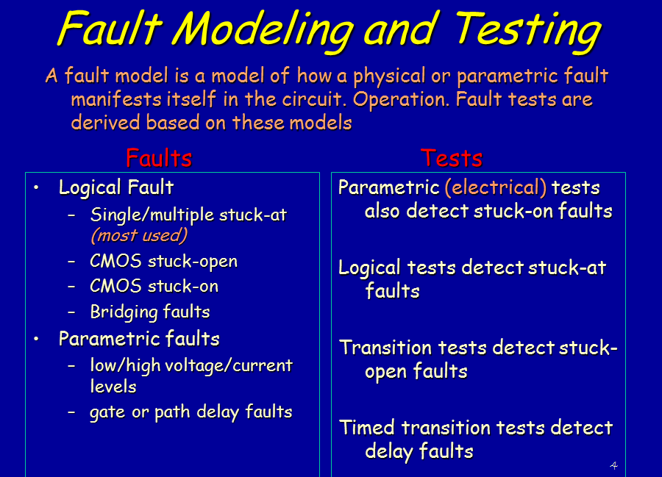

If no test vector exists to activate and sensitize the fault is undetectable

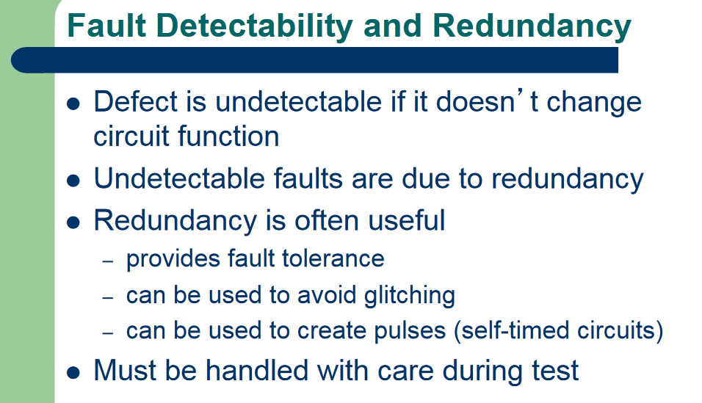
.
Redundancy ?

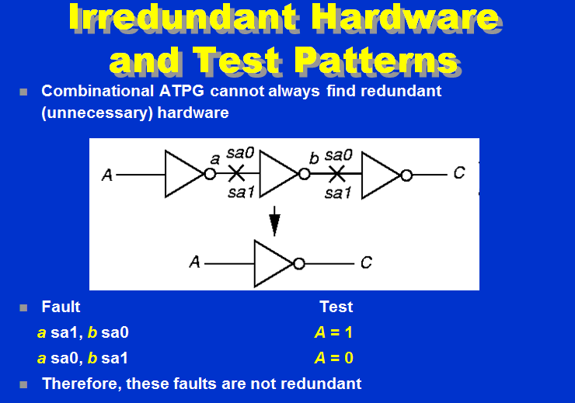

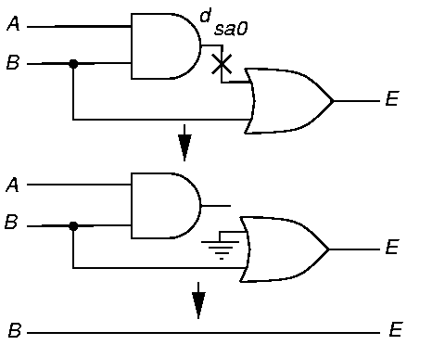

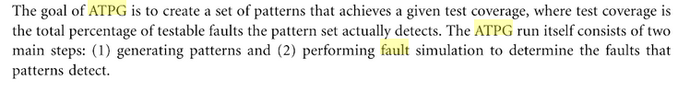
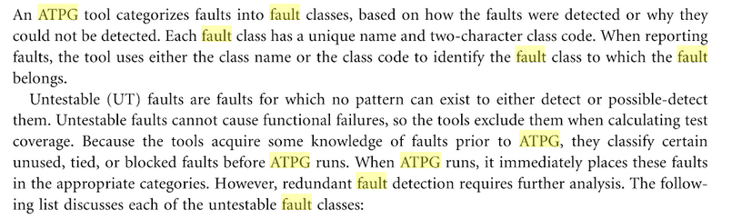

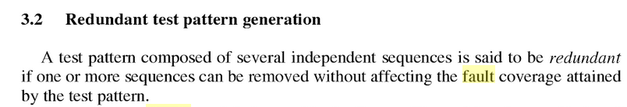

Debugging low test coverage situations electronicdesign.com
ATPG statistics

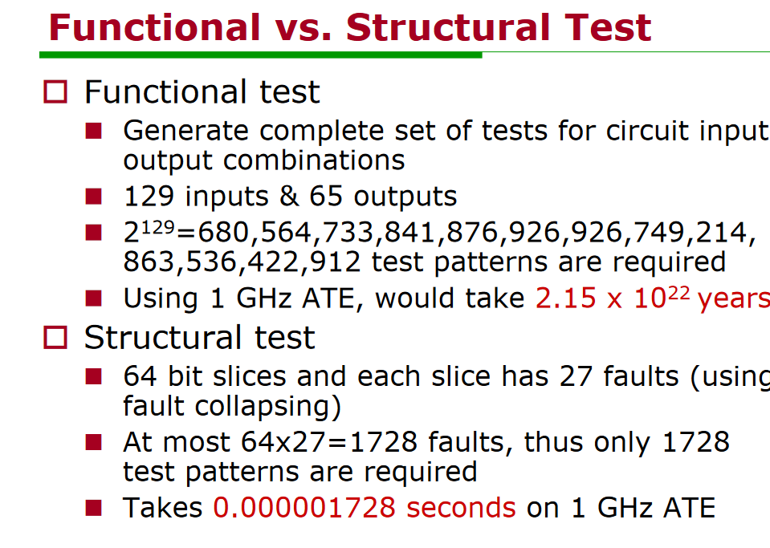
Untestable fault
– no test for it even after entire tree searched

Every fault in a circuit changes its functionality as if some nodes were steadily tied to either logic 0 or 1

JEUFFRAULT

User Defined Fault Modeling (UDFM) patterns.
Traditional IC test-pattern generation, including stuck-at, transition, small delay, and bridge, produces high-quality tests that detect most defects. All of these tests use fault models that define fault sites at IC gate boundaries.
User defined fault models (UDFM) and a new cell-aware ATPG flow together allow customers to target subtle shorts and open defects internal to standard cells that are not adequately detected with the standard stuck-at or transition fault models.

Cell-aware testing based on UDFM allows us to increase the quality of our manufacturing test by catching defects that would have gone undetected using conventional fault models," said Jeff Rearick, senior fellow at AMD. "Traditional fault models ensure that the periphery of standard cells and the interconnections between them are fully tested, but can miss some bridging or open defects internal to the cells. With the UDFM and cell-aware capabilities, TestKompress can generate patterns to specifically target these additional defects, giving us higher confidence in our production testing with minimal impact to test time. This takes us a big step closer to true zero defect quality control."
https://tel.archives-ouvertes.fr/tel-01807948/document

Scan Design Overview
The goal of scan design is to make a difficult-to-test sequential circuit behave
(during the testing process) like an easier-to-test combinational circuit. Achieving
this goal involves replacing sequential elements with scannable sequential
elements (scan cells) and then stitching the scan cells together into scan registers,
or scan chains. You can then use these serially-connected scan cells to shift data in
and out when the design is in scan mode.

Understanding ATPG
ATPG stands for Automatic Test Pattern Generation.
Test patterns, sometimes called test vectors, are sets of 1s and 0s placed on primary input pins during the
manufacturing test process to determine if the chip is functioning properly. When
the test pattern is applied, the Automatic Test Equipment (ATE) determines if the
circuit is free from manufacturing defects by comparing the fault-free output--
which is also contained in the test pattern--with the actual output measured by the
ATE.

The ATPG Process
The goal of ATPG is to create a set of patterns that achieves a given test coverage,
where test coverage is the total percentage of testable faults the pattern set actually
detects .The ATPG run itself consists of two main steps: 1) generating patterns and, 2) performing
fault simulation to determine which faults the patterns detect. This section
discusses only the generation of test patterns.
“Fault Classes” on page 2-32
discusses the fault simulation process.
The two most typical methods for pattern generation are random and
deterministic

Deterministic Test Pattern Generation
An ATPG tool uses
deterministic test pattern generation
when it creates a test
pattern intended to detect a given fault. The procedure is to pick a fault from the
fault list, create a pattern to detect the fault, fault simulate the pattern, and check to
make sure the pattern detects the fault

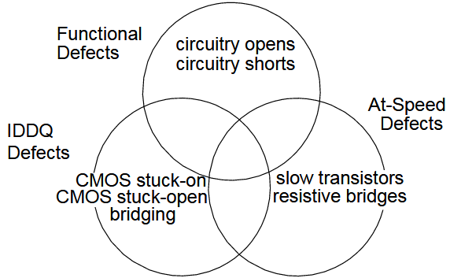

Each of these defects has an associated detection strategy

Test types
Static defects (open, shorts, stuck on stuck open)
IDDQ testing measures power supply current, excessive current
Timing faillures or At spice test
Delay variations exist in the
chip due to statistical variations in the manufacturing process, resulting in defects
such as partially conducting transistors and resistive bridges

The slow-to-rise transition fault models a device pin that is defective because its value is slow to change from a 0 to a 1.

The actual fault detection methods vary. One common approach is
path
sensitization
. The path sensitization method, which is used by FastScan and
FlexTest to detect stuck-at faults, starts at the fault site and tries to construct a
vector to propagate the fault effect to a primary output. When successful, the tools
create a stimulus set (a test pattern) to detect the fault. They attempt to do this for
each fault in the circuit's fault universe.
Figure 2-16
shows an example circuit for
which path sensitization is appropriate

