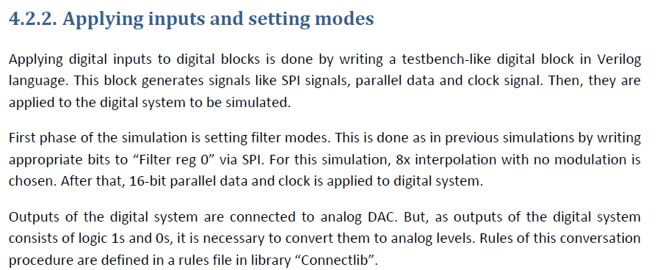

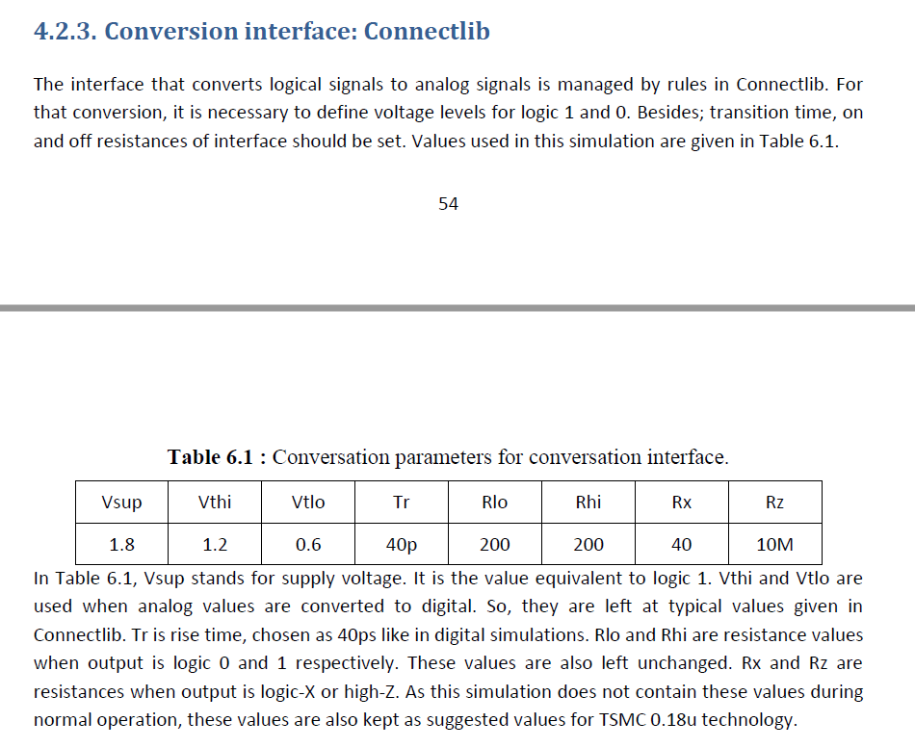

DEFINE cdsDefTechLib $CDS_ROOT/tools/dfII/etc/cdsDefTechLib
DEFINE basic $ CDS_ROOT /tools/dfII/etc/cdslib/basic
DEFINE analogLib $ CDS_ROOT E/tools/dfII/etc/cdslib/artist/analogLib
DEFINE sbaLib $ CDS_ROOT /tools/dfII/etc/cdslib/artist/sbaLib
DEFINE sample $ CDS_ROOT /tools/dfII/samples/cdslib/sample
DEFINE US_8ths $ CDS_ROOT /tools/dfII/etc/cdslib/sheets/US_8ths
DEFINE ahdlLib $ CDS_ROOT /tools/dfII/samples/artist/ahdlLib
DEFINE rfExamples $ CDS_ROOT/tools/dfII/samples/artist/rfExamples
DEFINE rfLib $ CDS_ROOT /tools/dfII/samples/artist/rfLib
DEFINE functional $ CDS_ROOT /tools/dfII/etc/cdslib/artist/functional
DEFINE connectLib $IUS_ROOT/tools/affirma_ams/etc/connect_lib/connectLib
DEFINE avTech $ASSURAHOME/tools/assura/etc/avtech/avTech
DEFINE cmrf8sf /home/eda/technology/IBM_PDK/cmrf8sf/relDM/cdslib/cmrf8sf
DEFINE esd8rf /home/eda/technology/IBM_PDK/cmrf8sf/relDM/cdslib/esd8rf
DEFINE iogpil_cmrf8sf_rvt /home/eda/technology/IBM_PDK /iogpil_cmrf8sf_rvt
http://www.cittumkur.org/ece/VLSI%20MANUAL_2017-18.pdf
https://support.cadence.com/apex/ArticleAttachmentPortal?id=a1O0V000007MoQhUAK&pageName=ArticleContent&oMenu=People%20who%20viewed%20this%20also%20viewed
https://support.cadence.com/apex/ArticleAttachmentPortal?id=a1Od0000000nUL5EAM&pageName=ArticleContent&oMenu=Documents%20which%20may%20be%20similar%20to%20this%20document
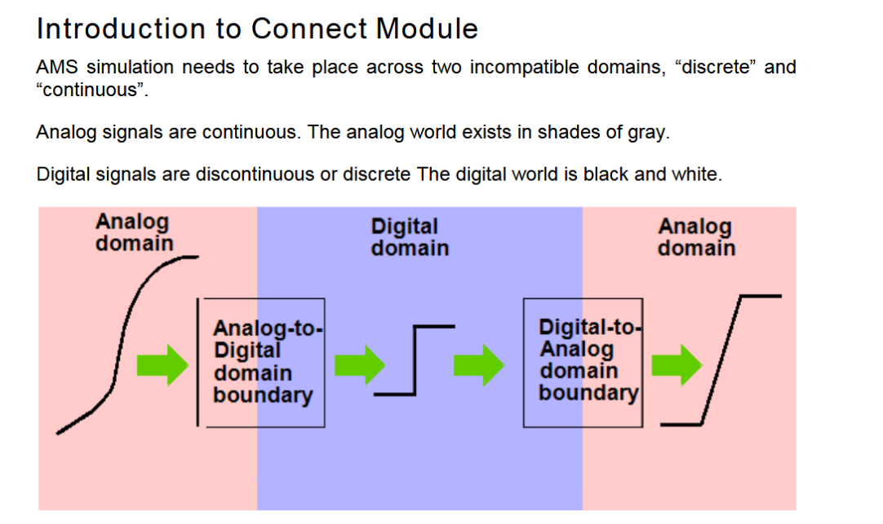
https://support.cadence.com/apex/ArticleAttachmentPortal?id=a1Od000000050MNEAY&pageName=ArticleContent&oMenu=People%20who%20viewed%20this%20also%20viewed
https://support.cadence.com/apex/articleattachmentportal?id=a1O0V000007MnZlUAK&pageName=ArticleContent&attachId=0690V000003xwUGQAY
