Blocking vs. Nonblocking Assignments
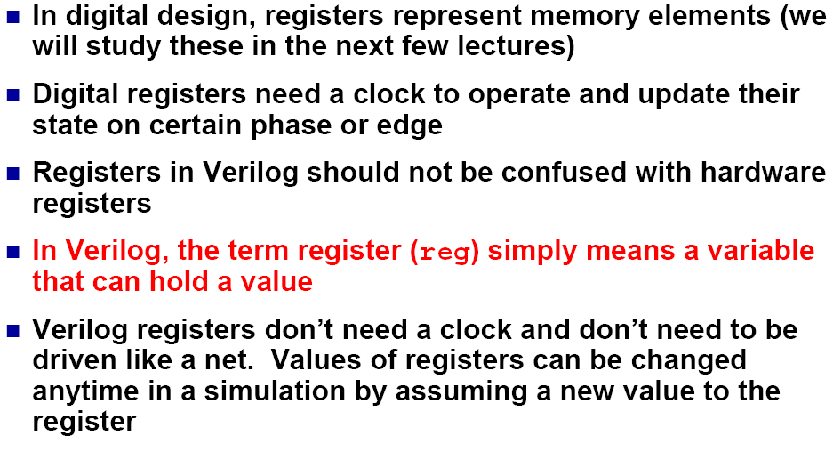

Affectations continues: assign
Type wire: logique combinatoire

Type reg: procedurals
http://inst.eecs.berkeley.edu/~cs150/Documents/Nets.pdf
http://www.utdallas.edu/~zhoud/EE%203120/Verilog%20HDL%20(2).pdf
http://www.lsi.upc.edu/~jordicf/Teaching/secretsofhardware/VerilogIntroduction_Nyasulu.pdf

