Design views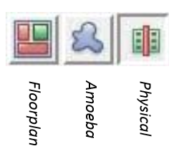

- Design import
Configuration
- Floorplanning
ratio, core utilization, core margins

- Connecting global nets
Power > Connect Global Nets
assigns VCC GND
- Power rings
Power > Power Planning > Add Ring
- Power Stripes
Power > Power Planning > Add Stripe
width, spacing, number of sets, relative from core
- Routing Power nets
Route >Special Route

http://lsm.epfl.ch/files/content/sites/lsm/files/shared/Resources%20documents/TopdownDF.pdf

