Latchup phenomena :
Low resistance path beetween VDD and GND -> current flowing -> short circuit -> destructive or severe risk of malfunction .
Proximity of the PN junctions that form the NMOS and PMOS create inherent parasitic transistor.
Latchup is caused by a trigger current injection or voltage excursion (overshoots and undershoots) .
Parasitic bipolar formed by the substrate, well and diffusion can turn ON.
Requirements: apply Layout strategy (rules) to prevents latchup problems.

CMOS inverter: cross section
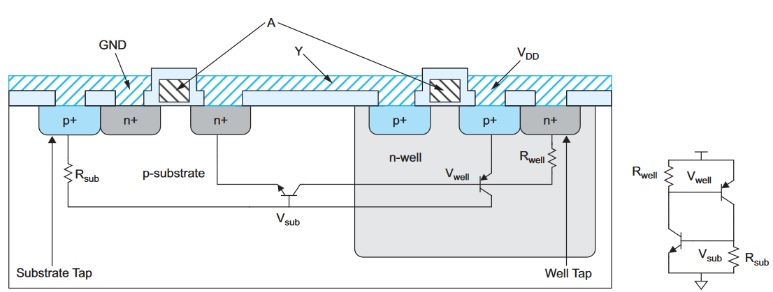

In fact, we can found in the structure an lateral NPN and a lateral PNP. The cross-coupled transistors form a SCR (Thyristor).
Normally, parasitic bipolar are OFF. Latchup can be triggered when transient currents flow through the substrate during power up or when external voltages outside the normal operating range are applied.
In latchup mode, current flowing between VDD and GND persists until the power supply is turned off.
- Self sustaining

Prevention: minimize Rsub and Rwell.
The gain of the cross-coupled bipolar is kept less tan 1 by having low impedance paths from the power supplies to the sub.
Most importantly, the designer should place substrate and well taps close to each transistor.
Nmos should be clustered together near GND and PMOS should be clustered together near VDD.

I/O are susceptible to latchup because external voltage can ring below GND or above VDD, forward biasing the junction between the drain ans substrate or well and injecting current into the substrate.
Guard ring should be used to collect the current. This ring is simply substrate or well taps tied to the proper supply that completely surround the transistor.
Example:
N+ diffusion (Nmos) can inject electrons into sub if Vdiode drop below 0 V. The P+ guard ring tied to the ground provide a low resistive path to collect these electrons

