module moore_3processes(input clk, input reset, inp
ut x, output reg parity);

reg state, nextstate;
parameter S0=0, S1=1;

always @(posedge clk or posedge reset)
if (reset)
state <= S0;
else
state <= nextstate;

always @(state) begin // always block to compute output

case(state)
S0: parity = 0;
S1: parity = 1;
endcase
end

always @(state or x) // always block to compute
nextstate

begin
nextstate = S0;
case(state)
S0: if(x)
nextstate = S1;
S1: if(!x)
nextstate = S1;
endcase
end
endmodule

https://pdfs.semanticscholar.org/b4d2/38899ab8ac75a271d3dcc07b595867946b7a.pdf
http://www.sunburst-design.com/papers/CummingsSNUG2000Boston_FSM.pdf

1 seul process

module fsm (clk, reset, x1, outp);
input clk, reset, x1;
output outp;
reg outp;

reg [1:0] state;
parameter s1 = 2'b00; parameter s2 = 2'b01;
parameter s3 = 2'b10; parameter s4 = 2'b11;

always@(posedge clk or posedge reset)
begin
if (reset)
begin
state = s1; outp = 1'b1;
end
else
begin
case (state)
s1: begin
if (x1==1'b1) state = s2;
else state = s3;
outp = 1'b1;
end
s2: begin
state = s4; outp = 1'b1;
end
s3: begin
state = s4; outp = 1'b0;
end
s4: begin
state = s1; outp = 1'b0;
end
endcase
end
end
endmodule

Avec 2 process
module fsm (clk, reset, x1, outp);
input clk, reset, x1;
output outp;
reg outp;

reg [1:0] state;
parameter s1 = 2'b00; parameter s2 = 2'b01;
parameter s3 = 2'b10; parameter s4 = 2'b11;

always @(posedge clk or posedge reset)
begin
if (reset)
state = s1;
else
begin
case (state)
s1: if (x1==1'b1) state = s2;
else state = s3;
s2: state = s4;
s3: state = s4;
s4: state = s1;
endcase
end
end

always @(state)
begin
case (state)
s1: outp = 1'b1;
s2: outp = 1'b1;
s3: outp = 1'b0;
s4: outp = 1'b0;
endcase
end
endmodule

Avec 3 process
module fsm (clk, reset, x1, outp);
input clk, reset, x1;
output outp;
reg outp;

reg [1:0] state;
reg [1:0] next_state;
parameter s1 = 2'b00; parameter s2 = 2'b01;
parameter s3 = 2'b10; parameter s4 = 2'b11;

always @(posedge clk or posedge reset)
begin
if (reset) state = s1;
else state = next_state;
end

always @(state or x1)
begin
case (state)
s1: if (x1==1'b1) next_state = s2;
else next_state = s3;
s2: next_state = s4;
s3: next_state = s4;
s4: next_state = s1;
endcase
end

always @(state)
begin
case (state)
s1: outp = 1'b1;
s2: outp = 1'b1;
s3: outp = 1'b0;
s4: outp = 1'b0;
endcase
end
endmodule

http://asic.co.in/Index_files/verilogexamples.htm#link1
https://www.slideshare.net/PaulLaskowski1/verilog-hdl-training-course
https://learn.digilentinc.com/Documents/263
https://learn.digilentinc.com/classroom/tutorials/

// Verilog code
module test001(clk, pulse, clkout);
input clk;
input pulse;
output clkout;
reg cnt, temp;
initial begin cnt = 0;
temp = 0;
end
always @(posedge clk)
if(pulse && !cnt) begin
cnt <= ~cnt;
temp <= 1;
end
else if(!pulse) begin
cnt <= 0;
end
else
temp <= 0;
assign clkout = temp|clk;
endmodule

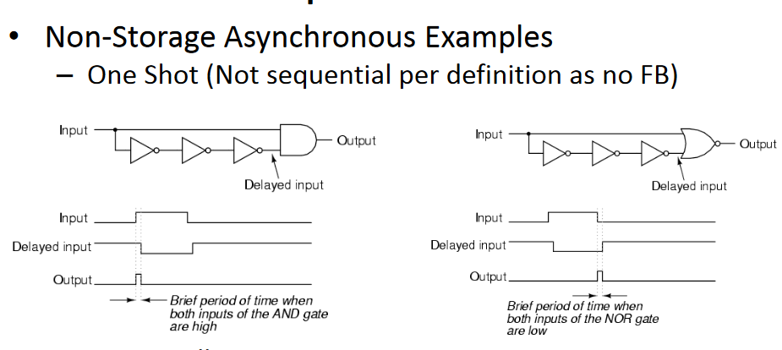

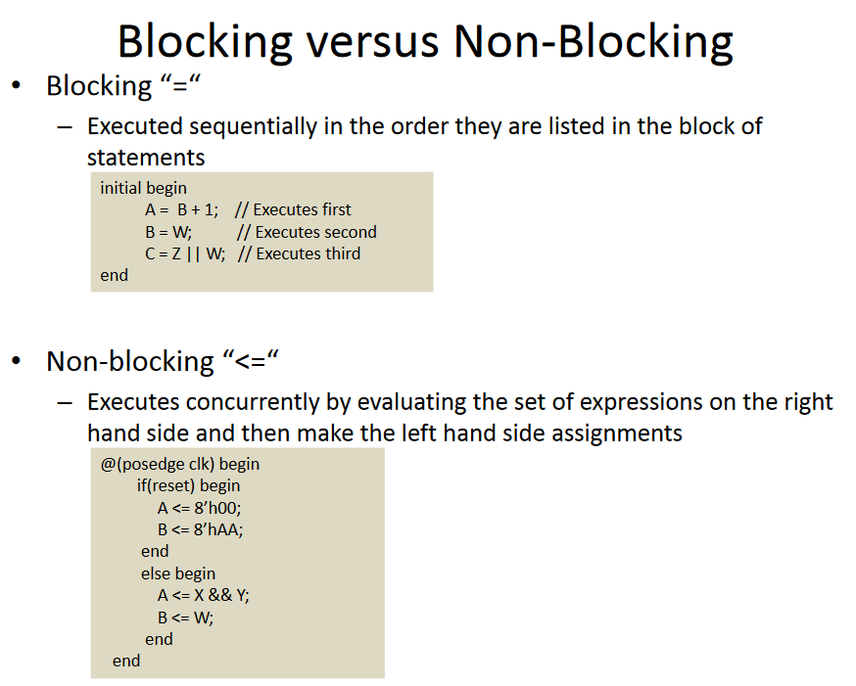

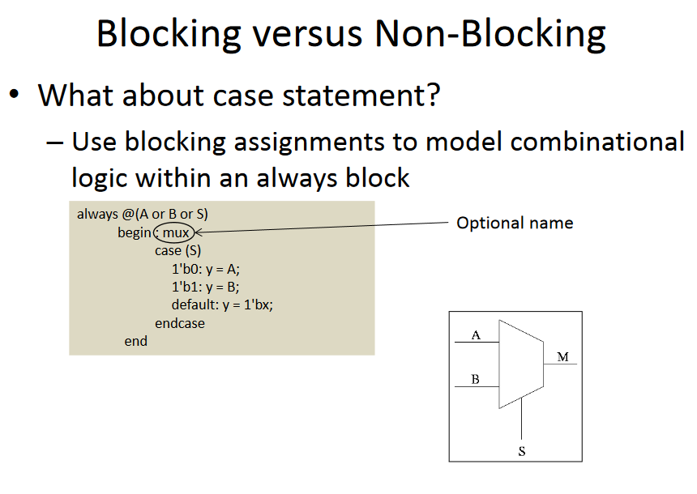

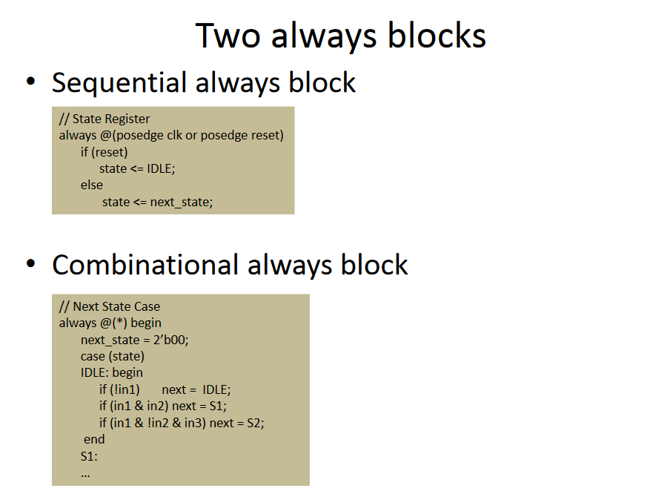

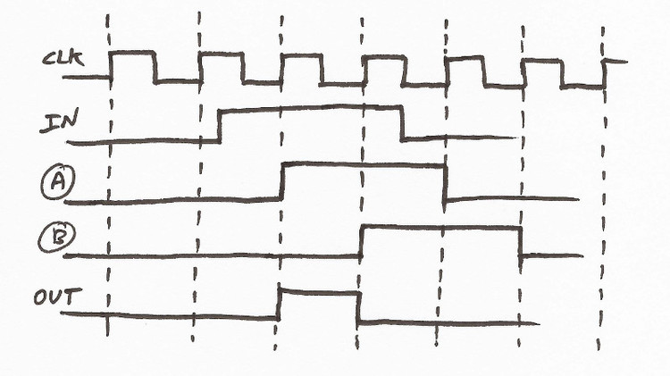
// edge detect module
module edge_detect(
input CLK,
input RST,
input IN,
output OUT
);

reg a, b;

// the edge detect signal is (b AND (NOT a))
assign OUT = a & !b;

always @(posedge CLK) begin
// It's always good to have a reset condition, otherwise
// the state of the register will show up as undertemined
// in simulation ('x')
if (RST == 1'b1) begin
a <= 0;
b <= 0;
end
else begin
a <= IN;
b <= a;
end
end

endmodule

edge detector: rising

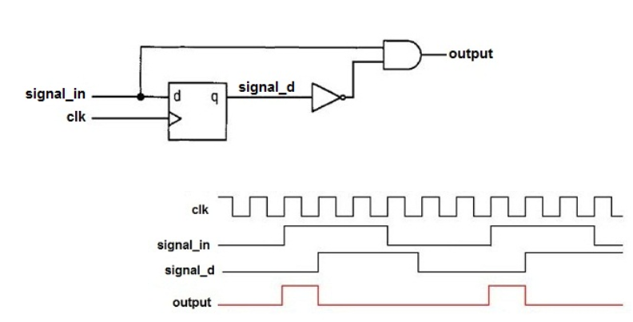

edge detector: failing

