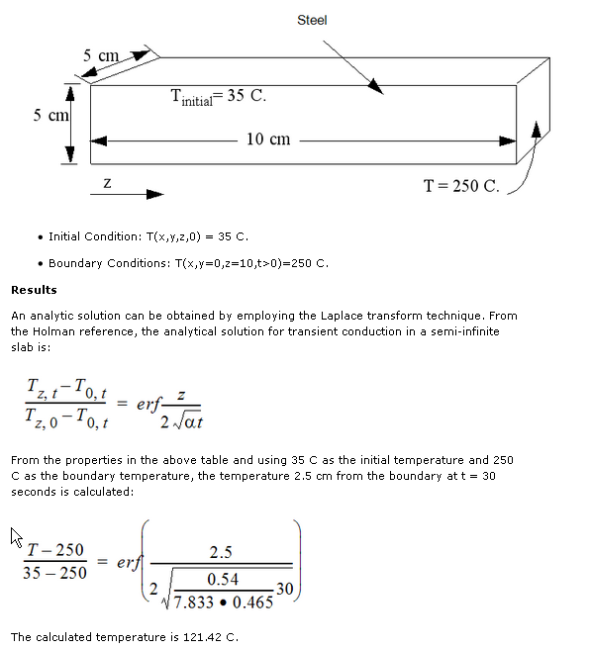

http://www.powerguru.org/heat-transfer-in-power-semiconductor-devices/
lien interessant :
http://journalogy.net/Publication/26253755/use-of-3d-transient-analytical-solution-based-on-green-s-function-to-reduce-computational-time-in
Use of 3D-transient analytical solution based on Green’s function to reduce computational time in inverse heat conduction problems (Citations: 2)
Ana P. Fernandes, Priscila F. B. Sousa, Valerio L. Borges, Gilmar Guimaraes

Use Thermal Analysis to Predict an IC's Transient Behavior and Avoid Overheating
transient thermal analysis matlab
Fast Thermal Simulation for Runtime Temperature
Tracking and Management

HotSpot
0-7803-XXXX-X/07/$00.00 ©2008 IEEE 24th
IEEE SEMI-THERM Symposium
Fast Computation of Temperature Profiles of
VLSI ICs with High Spatial Resolution

plotting - diffusion and Green's function

diffusion and Green's function 3D

Solution for Green's Function to Transient Temperature Equation for Rectangle

http://books.google.fr/books?id=9U4TlddKTMcC&pg=PA261&lpg=PA261&dq=Green%27s+Function+to+Transient+Temperature+Equation+for+Rectangle&source=bl&ots=OHAcUFRZws&sig=4s5skRjj_RecvuhyzeogB4g6m70&hl=en&sa=X&ei=a3d5UcP3D5CXhQfp9oDgCQ&redir_esc=y#v=onepage&q=Green%27s%20Function%20to%20Transient%20Temperature%20Equation%20for%20Rectangle&f=false

bien
http://www.engr.unl.edu/~glibrary/glibcontent/node4.html

Green's function (GF) is a fundamental solution to a linear differential equation, a building block that can be used to construct many useful solutions. For heat conduction, the GF is proportional to the temperature caused by a concentrated energy source. The exact form of the GF depends on the differential equation, the body shape, and the type of boundary conditions present. Green's functions are named in honor of English mathematician and physicist George Green (1793-1841).

Full-chip thermal analysis based on Green’s function

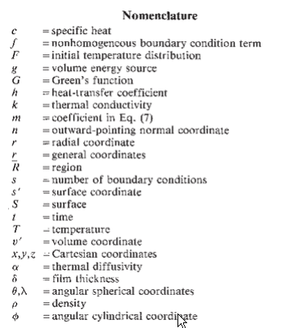

http://en.wikipedia.org/wiki/Heat_equation

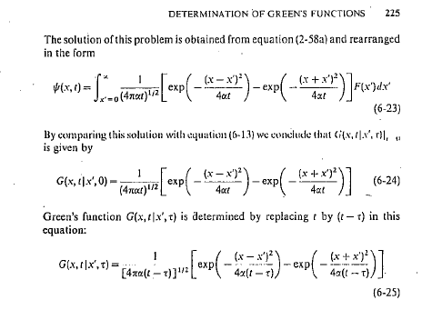

http://books.google.fr/books?id=J-HQL3nEOAwC&pg=PP10&lpg=PP10&dq=Green%27s+Function+for+Rectangle&source=bl&ots=PXDBXD0JvW&sig=d3XCNJc280PBFlJZPZigGiuF2zg&hl=en&sa=X&ei=e4J5UYSMAsuJhQfPi4GYBQ&redir_esc=y

http://books.google.fr/books?id=ibAEa95-VSAC&pg=PA59&lpg=PA59&dq=Green%27s+Function+for+Rectangle&source=bl&ots=swVQIOd_Nk&sig=ja0F8H7Y2p92R2nw-oTWB8cNyqc&hl=en&sa=X&ei=IYV5UaHSDIe2hQfb0oGYCQ&redir_esc=y#v=onepage&q=Green%27s%20Function%20for%20Rectangle&f=false

Caracteristiques physiques :
ρC = 1 J/m3/°C , Chaleur volumique
λ = 1 W/m/°C , Conductivite thermique de Ω
k = 0.2 W/m2/°C , Coefficient de radiation
L = 1 m, Demi-cote de la plaque

Thermal conductivity al 2.08
λth : conductivité thermique du matériau [W/m⋅°K]
- c : capacité thermique spécifique [J/(kg⋅°K)]
- ρ : masse volumique du matériau [kg/m3]

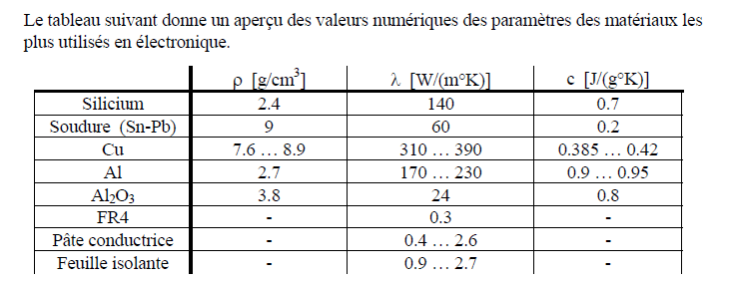

rho = Density (Kg/mm3), a = _ = Diffusivity (mm2/s), K = Thermal conductivity (W/mmk),
c = specific heat capacity (J/kgk).

f = feval (params {1}, t - u.^2./(4*alfa), params {2 : end}) .* ...
(erf ((W./2+x)./u) + erf ((W./2-x)./u)) .* ...
(erf ((L./2+y)./u) + erf ((L./2-y)./u)) .* ...
(exp (-(z-D).^2./u.^2) + exp (-(z+D).^2./u.^2));

Alpha = 0.5 ;
sqrt_pi = 1.77245385090552;

var_tmp1 = 1 / (8 * k * sqrt_pi * W * L))

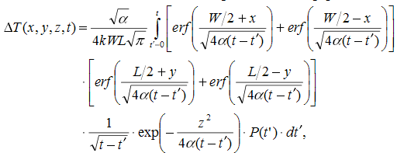

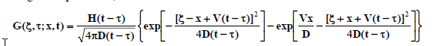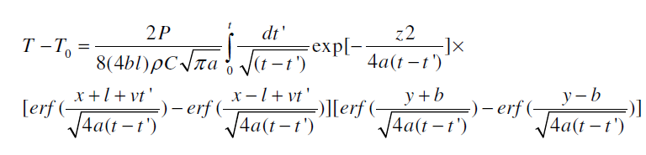

rho = Density (Kg/mm3), a = alpha = Diffusivity (mm2/s), K = Thermal conductivity (W/mmk),
c = specific heat capacity (J/kgk).

Full-chip thermal analysis based on
Green’s function

