Numerical evaluation of the Green’s function
Integral representation and equation
Solutions of boundary value problems in terms of the Green’s function.

[56] N. Rinaldi, ‘’On the Modeling of the Transient Thermal Behaviour of Semiconductor Devices’’, IEEE Trans.
Electron Devices, 48, 2001, pp. 2796-2802.

Green’s function solution of the heat diffusion equation

Adiabatic boundary conditions using the method of
Images

Exact analytical solution (based on Green’s function):

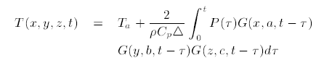
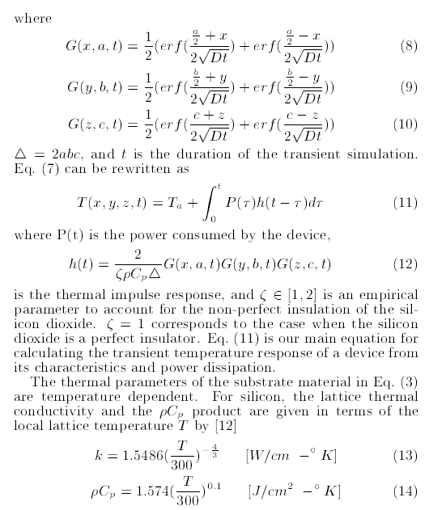

Based on analytical equations = solution of the heat diffusion
equation for a homogeneous rectangular power source.

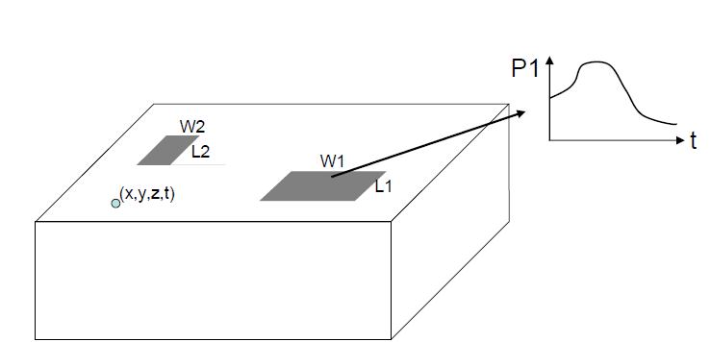

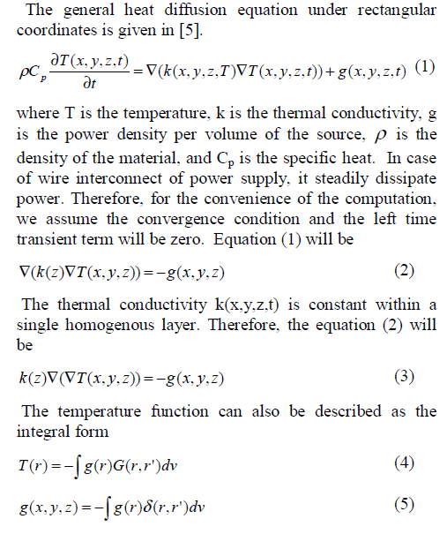
A Logarithmic Full-Chip Thermal Analysis Algorithm Based on Multi-Layer Green’s Function

The method of Green’s functions is an important technique for solving boundary
value and initial value problems. In engineering and applied sciences the steady state and
transient heat conduction equation is one of this type of problems that is used to model
and study physical phenomenon arising in the real world. It is not at all surprising that
their solution has been the major concern of many engineers and scientists.

THERMAL ANALYSIS green’s function

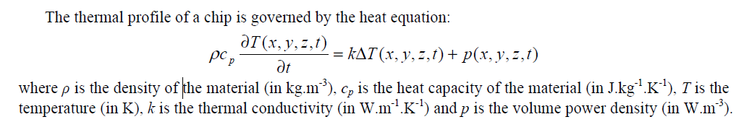

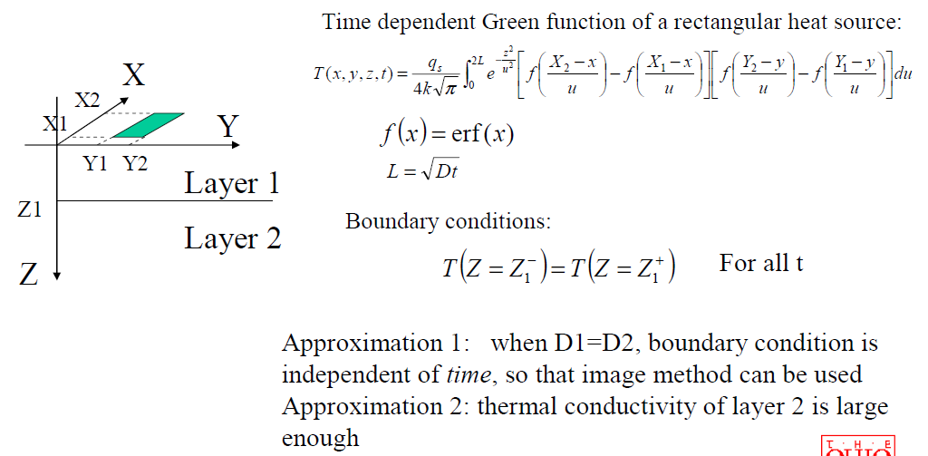

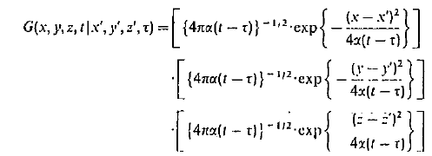

Transient Thermal Analysis of a Plate Fin Heat Sink
with Green’s Function

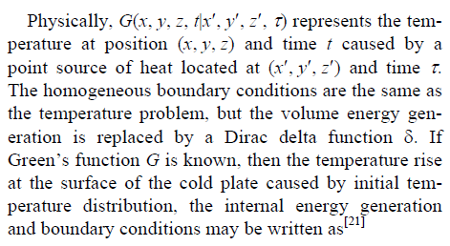

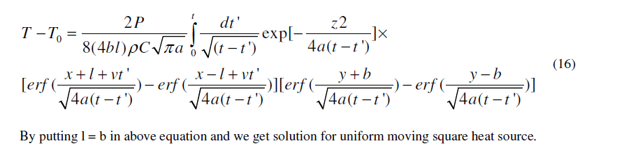

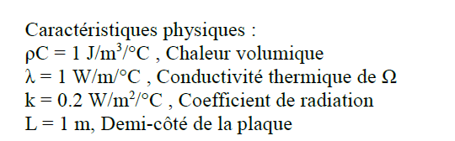

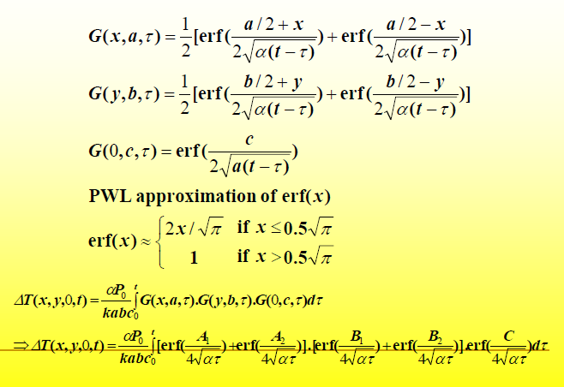

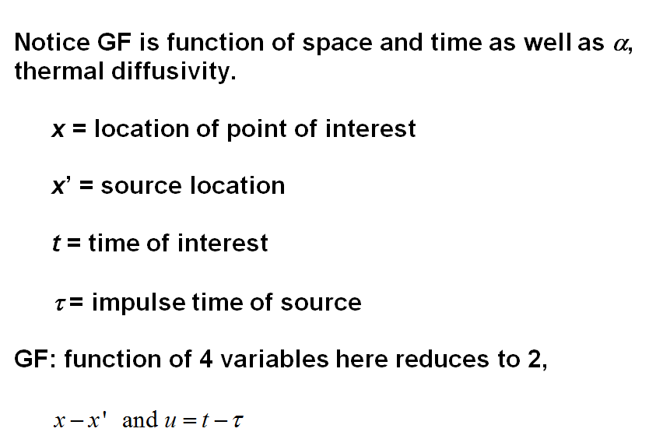

Ebook ESD Physics and Devices

Springer Electrothermal Analysis of VLSI Systems

green's function transient electrothermal diffusion
green’s function Analytical Solutions diffusion Heat Transfer

The Freespace Green’s Function for the Diffusion Equation

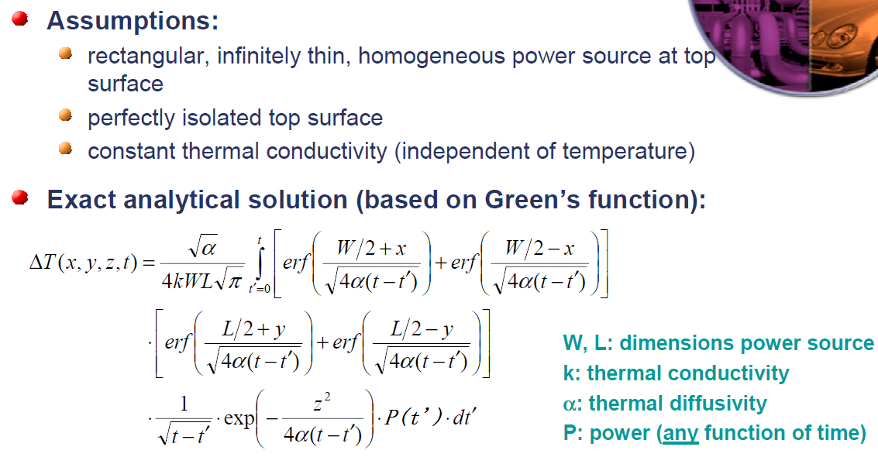

Image Method for Approximated Transient Temperature Rise in Multilayer Structure. Time dependent Green function of a rectangular heat source:

Green function Transient Temperature Rise of a rectangular heat source

An Introduction to Partial Differential Equations With Matlab

Time dependent Green function of a rectangular heat source

