https://www.ooprint.fr/tampon-encreur/tampon-encreur-7-lignes/tampon-encreur-te-c13588?utm=160610_flux_googleshoptamp_acqugoogleshop&utm_source=google&utm_medium=shopping&utm_campaign=160610_flux_googleshoptamp_acqugoogleshop&gclid=Cj0KCQjwreT8BRDTARIsAJLI0KJtTRjSRVhocUMspSt1fACXPTd2vuzhYffas1W_ngNwLLVE_JdHq2gaAsWiEALw_wcB
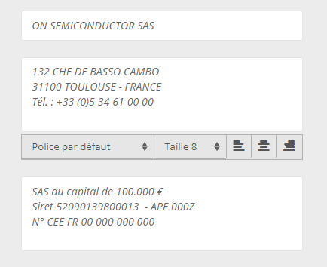



Ff






