module counter (C, CLR, Q);
input C, CLR;
output [3:0] Q;
reg [3:0] tmp;

always @(posedge C or posedge CLR)
begin
if (CLR)
tmp = 4'b0000;
else
tmp = tmp + 1'b1;
end
assign Q = tmp;
endmodule

http://www.ece.utep.edu/courses/web5375/Notes_files/ee5375_asynch.pdf
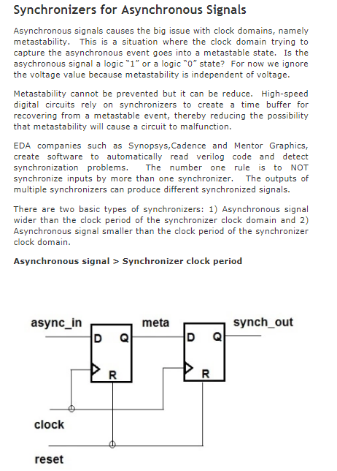

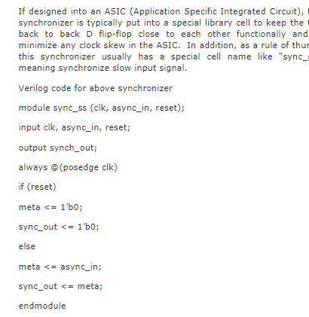
Synchronizers
When passing signals between clock domains, an important question to ask is, do I need to sample every value of a signal that is passed from one clock domain to another?

http://www.sunburst-design.com/papers/CummingsSNUG2008Boston_CDC.pdf

counter glitch ??

module tb;

reg clk;
reg [2:0] cnt;
reg reset;

always begin
#5 clk <= 0;
#5 clk <= 1;
end

always @(posedge clk or posedge reset) begin
if (reset) begin
cnt <= 0;
end else begin
cnt <= cnt + 1;
end
end

always begin: inject_clk_glitch
wait(cnt == 7);
#1 force clk = 1;
#1 force clk = 0;
#1 release clk;
end

initial begin
reset = 1;
#20 reset = 0;
#500 $finish;
end

endmodule

https://www.eetimes.com/document.asp?doc_id=1202359#
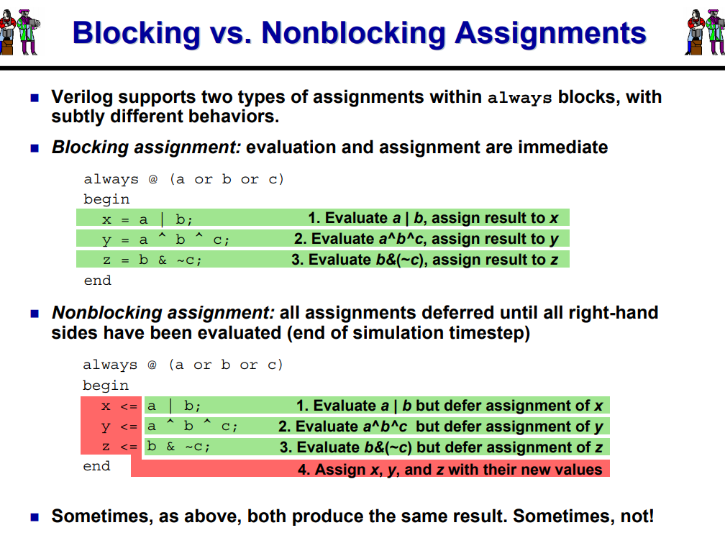

http://www.ee.ic.ac.uk/pcheung/teaching/ee2_digital/Lecture%205%20-%20Counters%20&%20Shift%20Registers.pdf +++++
Eliminating output glitch
https://www.so-logic.net/documents/knowledge/tutorial/Basic_FPGA_Tutorial_Verilog/sec_pwm.html
sinusoide

The PWM outputs are double buffered to avoid glitches caused by duty cycle changes while running.
To avoid glitches on the outputs of the component it was required that all outputs are synchronized.
https://www.cypress.com/documentation/application-notes/an2141-psoc-1-glitch-free-pwm
http://www.ee.ic.ac.uk/pcheung/teaching/msc_experiment/Lecture%203%20-%20PWM%20FSM%20&%20SPI.pdf

https://www.fpga4student.com/2017/08/verilog-code-for-pwm-generator.html
http://web.mit.edu/6.111/www/f2016/handouts/L07_4.pdf
module pwm_control(clk,rstb, ctrl, pwm);
input clk;
input rstb;
input [1:0] ctlr;
ouput y;
reg [10:0] counter;
reg pwm;
always @(posedge clk or negedge rstb)
begin
if(!rstb)
counter <= 10’d0;
else
counter < = counter;
end

always @(counter)
begin
out = counter < duty_cycle) ? 1’b1 : 1’b0;
end

always @ (clk)
pwm <= out

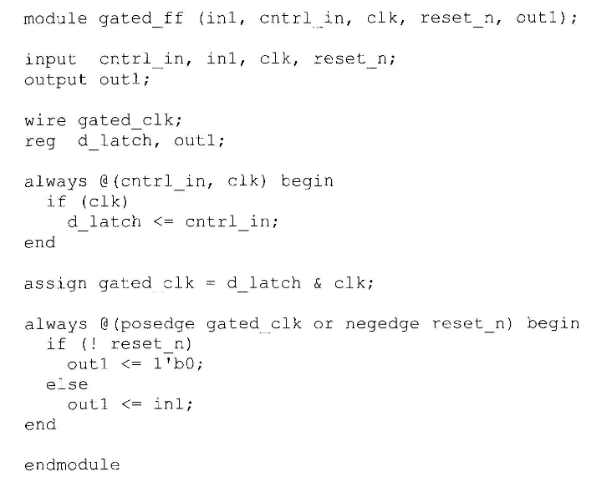
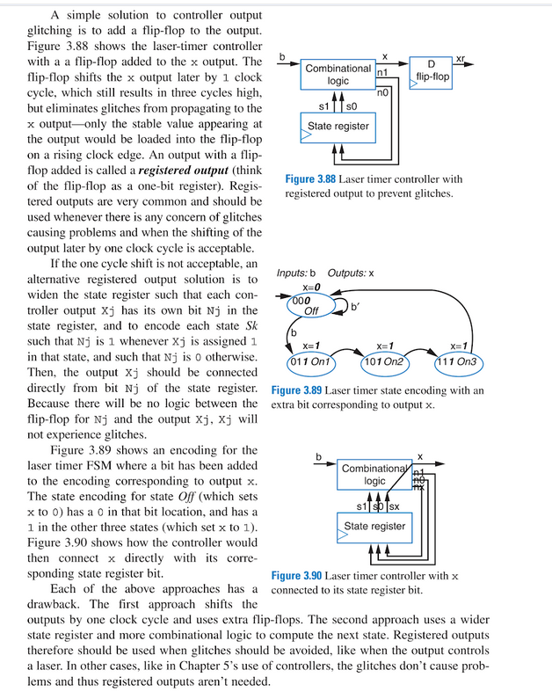

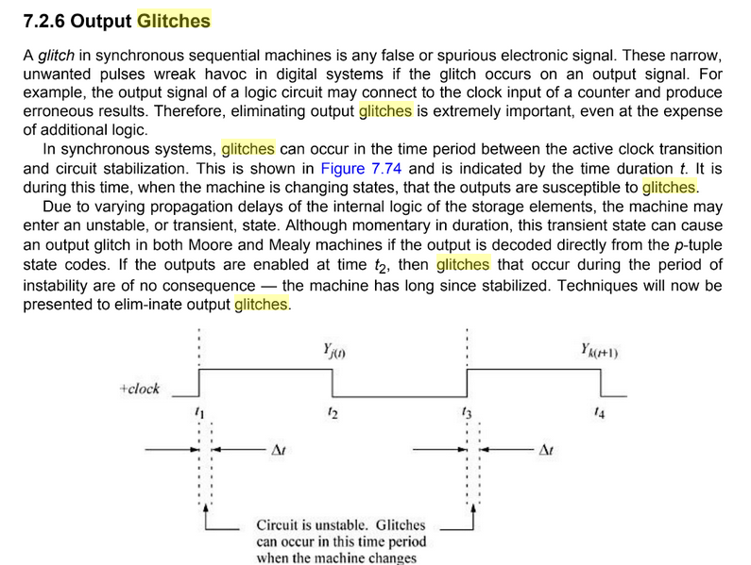

Can a glitch-free mux be designed in an FPGA
digital design fundamentals kenneth j breeding pdf

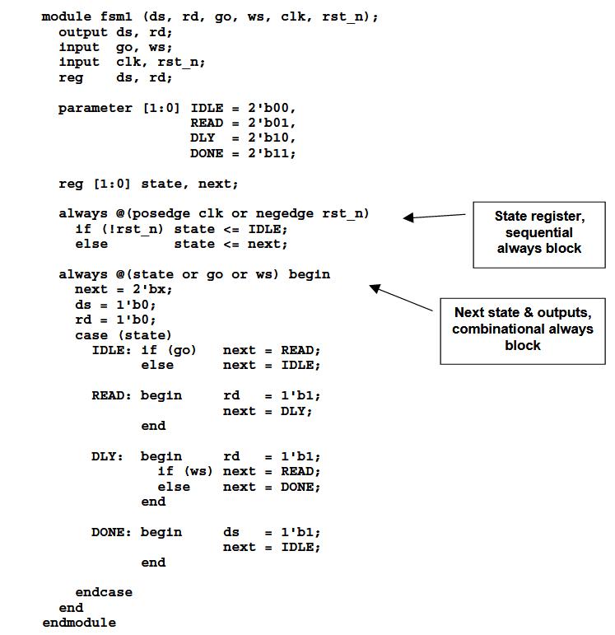

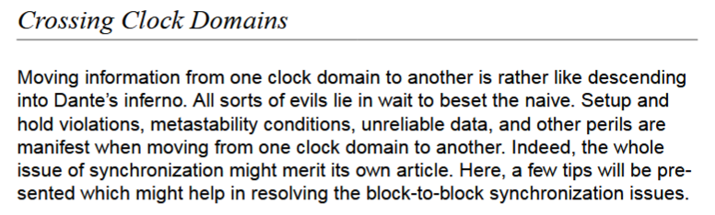
http://www.asic-world.com/code/verilog_tutorial/peter_chambers_10_commandments.pdf ++++

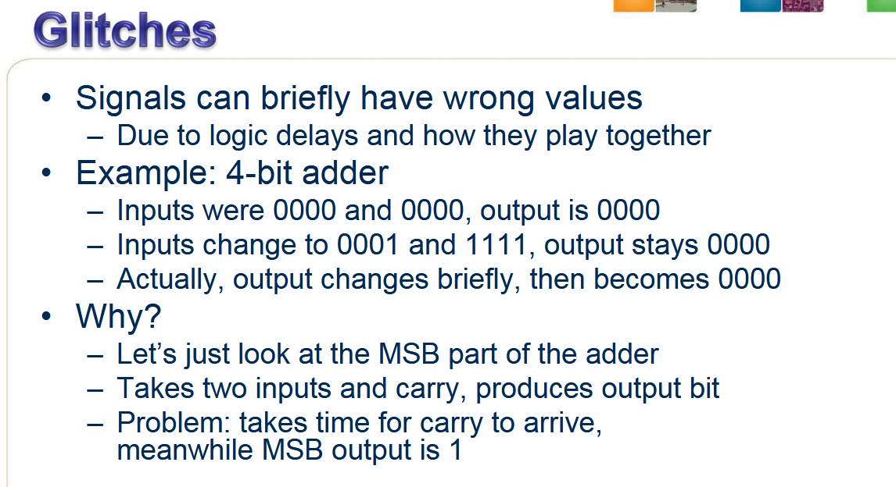

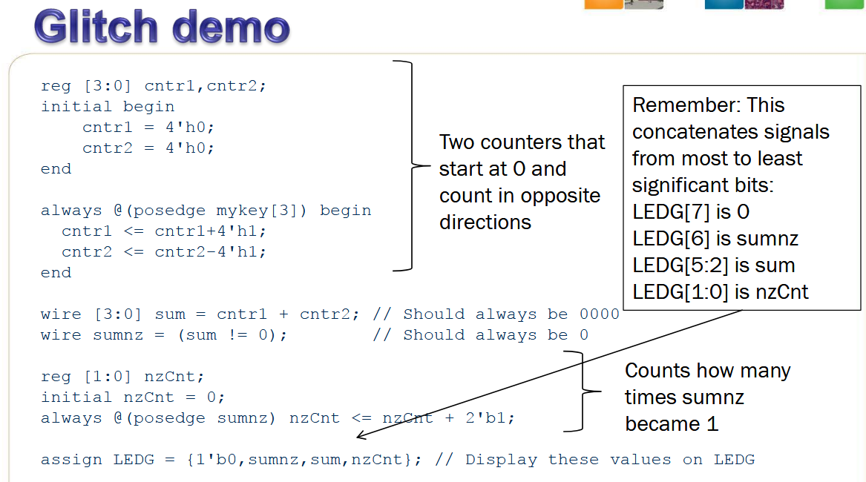

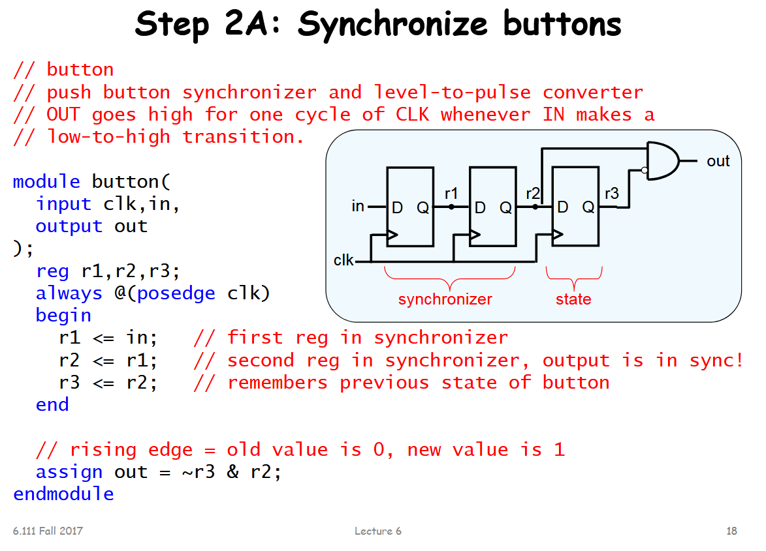

https://people.ece.cornell.edu/land/courses/ece5760/Verilog/FreescaleVerilog.pdf
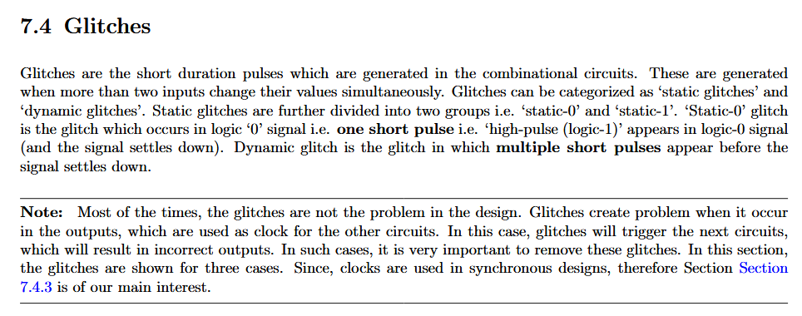
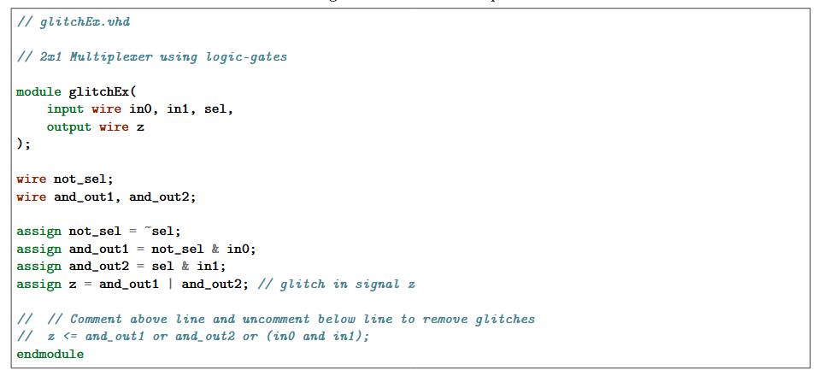

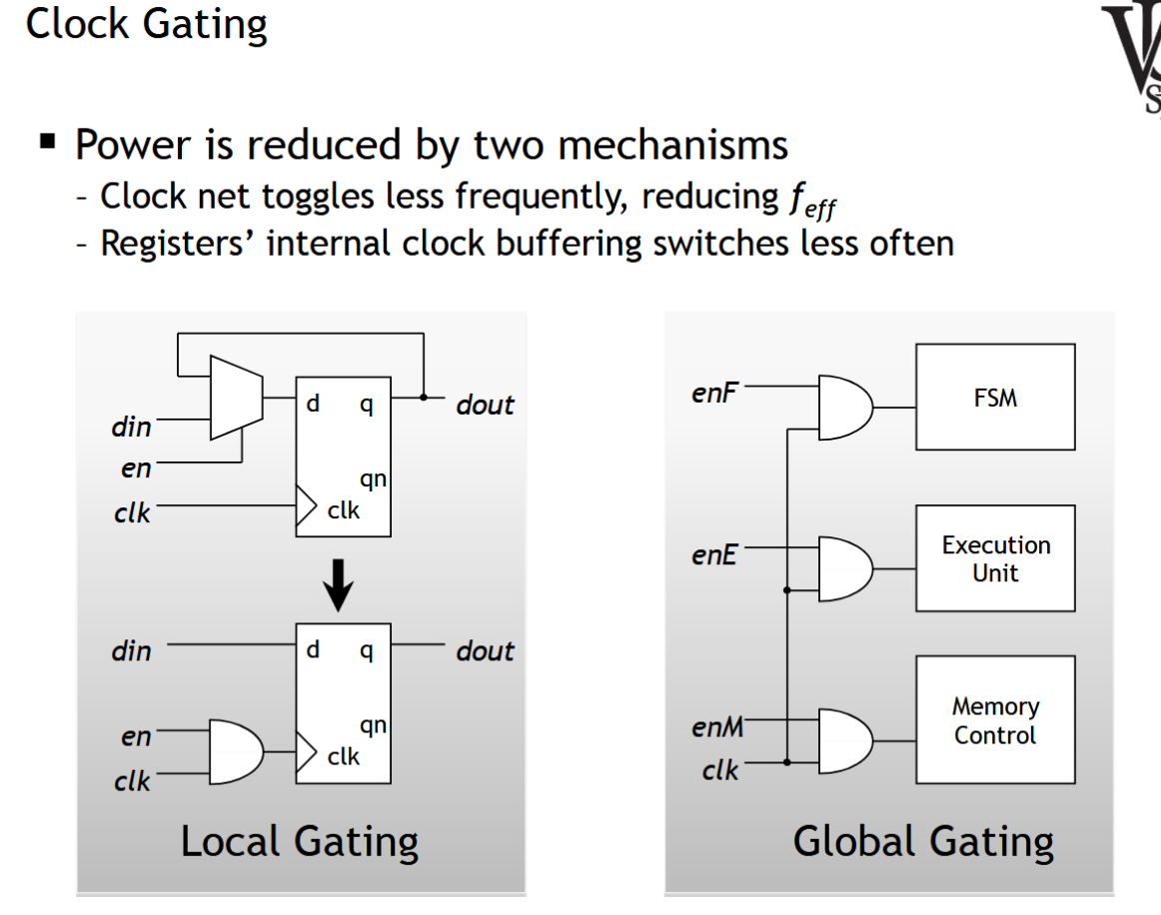
Meta-stability

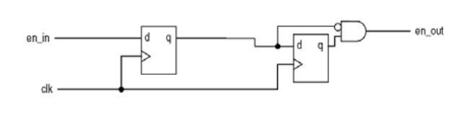

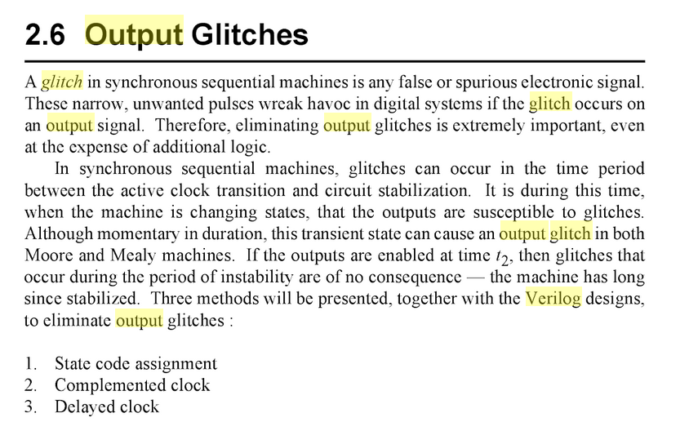
https://books.google.fr/books?id=H-SYCgAAQBAJ&pg=PA317&lpg=PA317&dq=verilog+glitch+output&source=bl&ots=cDLuzKUlI5&sig=ACfU3U1h5Zx0YPlzHP4FMWAMV8UXQ0pNyQ&hl=fr&sa=X&ved=2ahUKEwjpt7TzhuzgAhUjxYUKHTo7BBYQ6AEwBXoECAYQAQ#v=onepage&q=verilog%20glitch%20output&f=false

http://www.ee.ic.ac.uk/pcheung/teaching/ee2_digital/Lecture%207%20-%20FSM%20part%202.pdf 9+++++++++++++
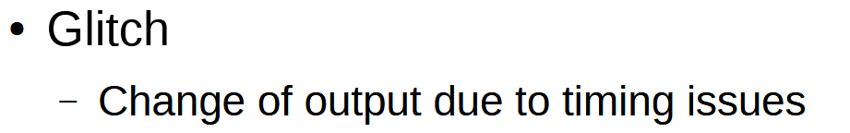

https://www.intel.cn/content/dam/altera-www/global/zh_CN/pdfs/literature/hb/qts/qts_qii51006.pdf

https://cseweb.ucsd.edu/classes/wi06/cse140L/CSE%20140L-Lecture%207.pdf
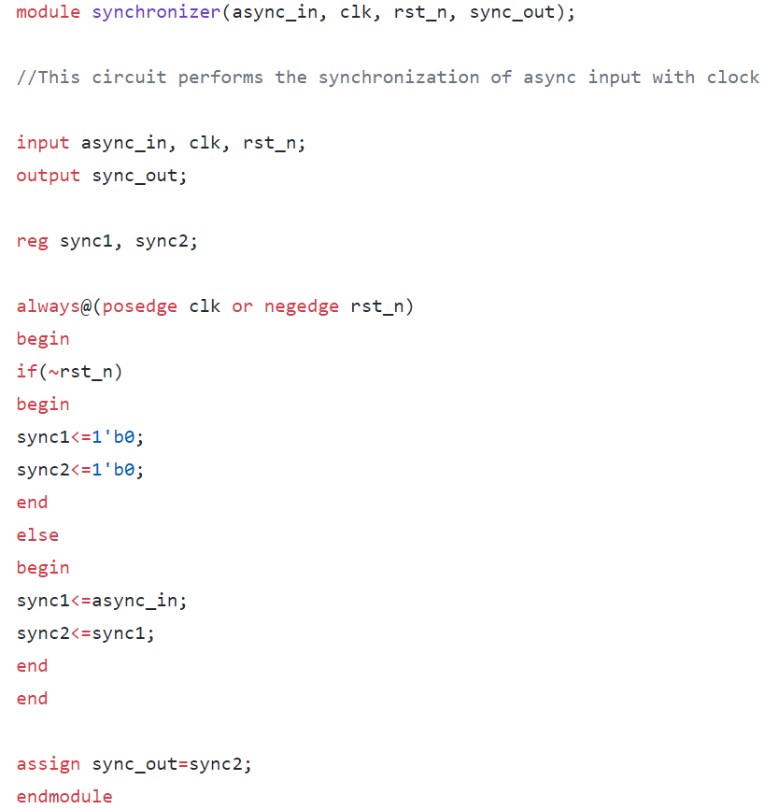

RAMP WAVE GENERATION
Code
`timescale 1ns / 1ps
module Ramp(Ramp,En,Clk,Rst);
output reg [7:0] Ramp;
input En,Clk,Rst;
always@(posedge Clk or posedge Rst)
begin
if (Rst)
Ramp<=0;
else begin
if (En)
begin
Ramp <= Ramp+1′b1;
end
end
end
endmodule

sawtooth waveform

Digital Sawtooth Signal Generation with FPGA

module Counter(
input Clk,
output [13:0] Count
);

reg [13:0] Count;

always@(negedge Clk) begin
if(Count == 9999) Count = 0;
Count = Count + 1;
end

endmodule

https://gist.github.com/rohit-numato/8c7eafb1f3363beacb15#file-square_wave_top-v

integer i; // 32-bitcomplement
time t; // 64-bit, unsigned
i = 123.456;
r = 123456e-3;
t = 123456e-3;

module sine_wave(output real sine_out);
import math_pkg::*;

parameter sampling_time = 5;
const real pi = 3.1416;
real time_us, time_s ;
bit sampling_clock;
real freq = 20;
real offset = 2.5;
real ampl = 2.5;

always sampling_clock = #(sampling_time) ~sampling_clock;

always @(sampling_clock) begin
time_us = $time/1000;
time_s = time_us/1000000;
end
assign sine_out = offset + (ampl * sin(2*pi*freq*time_s));
endmodule

https://groups.google.com/forum/#!topic/comp.lang.verilog/zs3k_VjVbSI

#include <stdio.h>
#include <math.h>

int main(int argc, const char * argv[])
{
/* Define temporary variables */
double value;
double result;

/* Assign the value we will find the exp of */
value = 5;

/* Calculate the exponential of the value */
result = exp(value);

/* Display the result of the calculation */
printf("The Exponential of %f is %f\n", value, result);

return 0;
}

result = pow(value1, value2);

#include <stdio.h>
#include <math.h>

#define PI 3.14159265

int main () {
double x, ret, val;

x = 45.0;
val = PI / 180;
ret = sin(x*val);
printf("The sine of %lf is %lf degrees", x, ret);

return(0);
}

#include <stdio.h>
#include <math.h>
double I,s;
main()
{
for (I = 1 ; I < 360 ; I++)
{
s = sin( I * 6.28/360);
printf("%f\n",s);
}
}

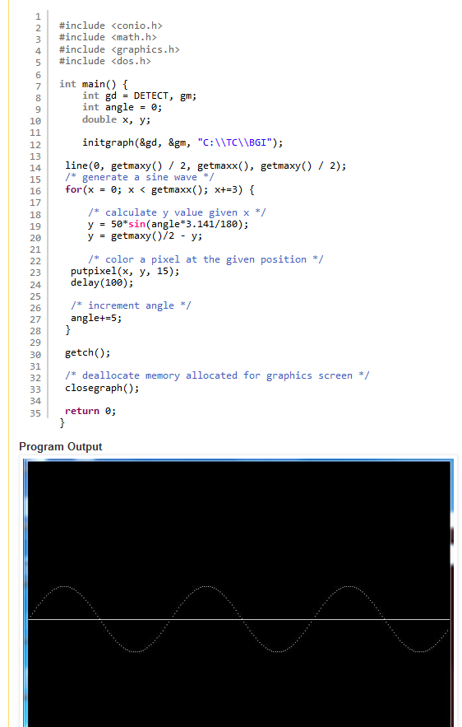
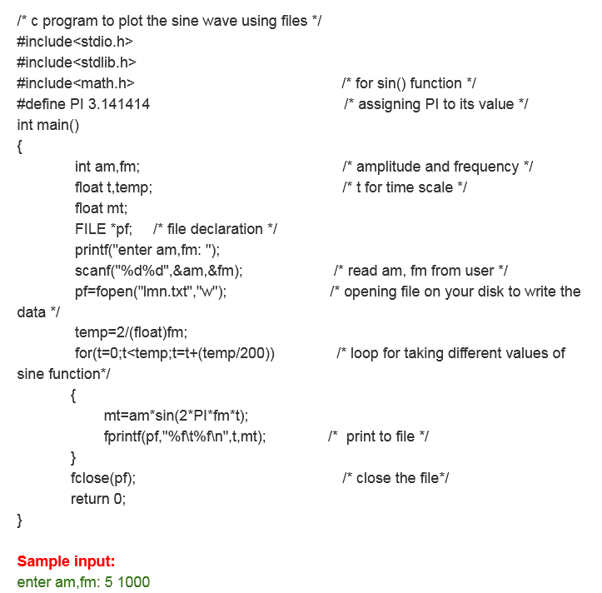

http://www.asic-world.com/verilog/pli1.html
https://en.wikipedia.org/wiki/SystemVerilog_DPI
http://www.asicguru.com/system-verilog/tutorial/dpi/14/
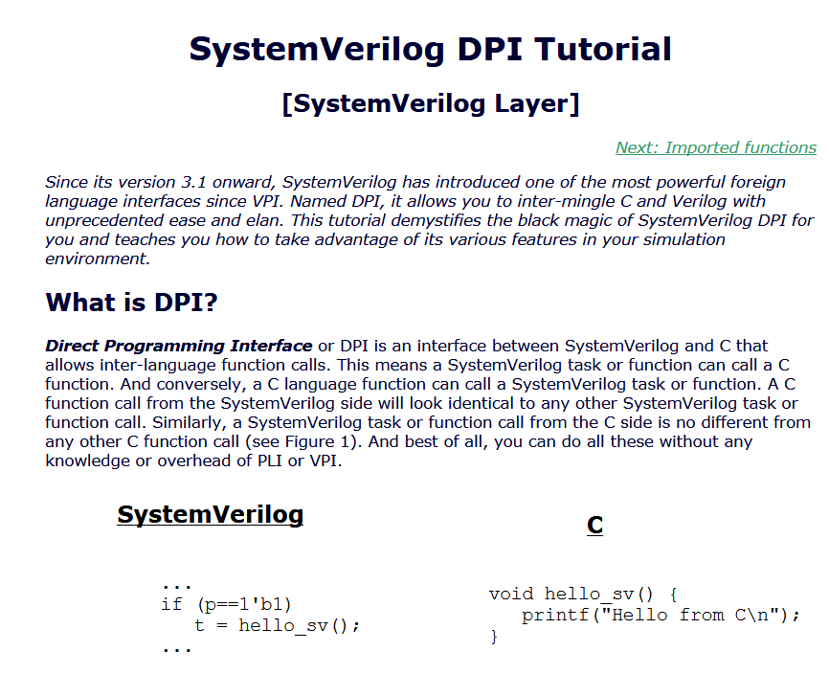

http://www.testbench.in/DP_03_IMPORT.html
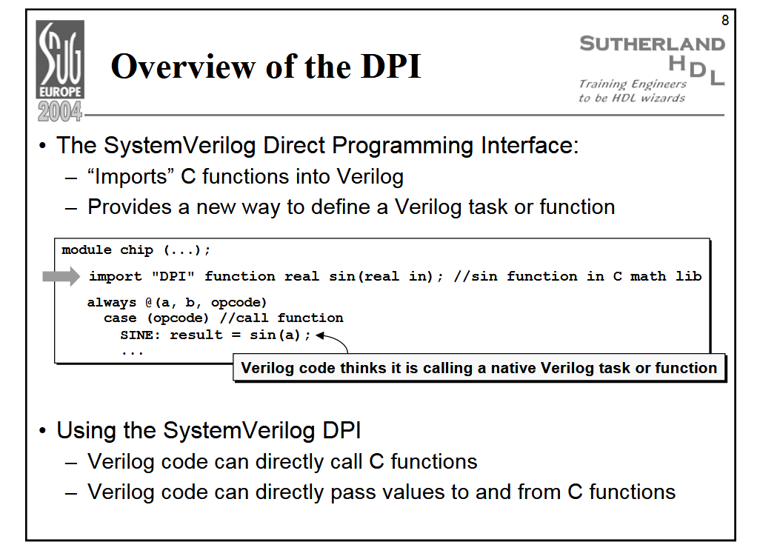
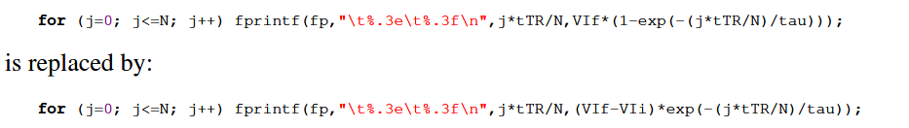

`timescale 1ns/10ps

module foo(clk);
input clk;

real t0;
real t1;
real frequency;

initial
begin
@ (posedge clk) t0 = $realtime;
@ (posedge clk) t1 = $realtime;
frequency = 1.0e9 / (t1 - t0);
$display("Frequency = %g", frequency);
$finish;
end
endmodule

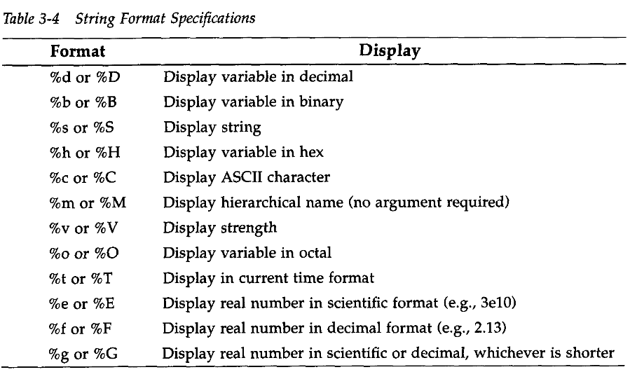
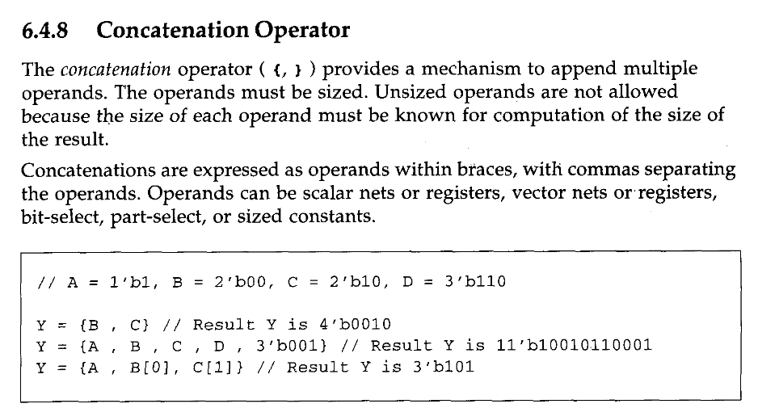
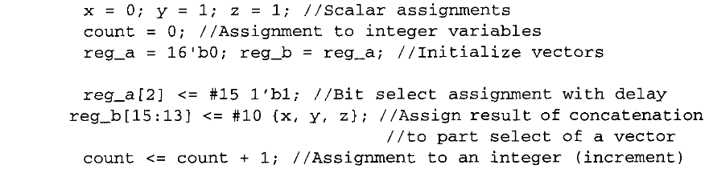

Timing control
Level sensitive timing control
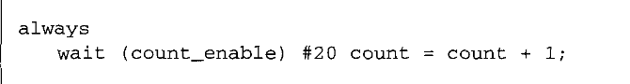

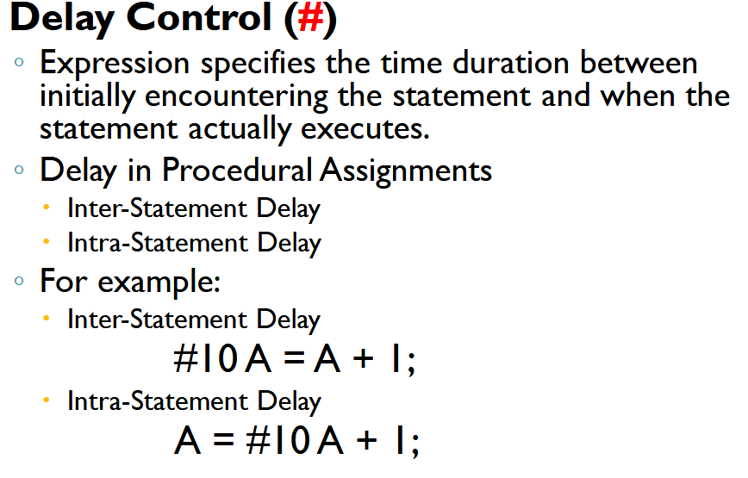
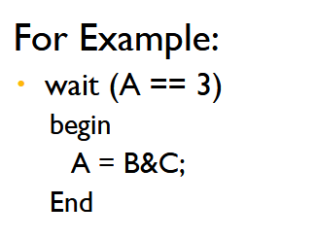
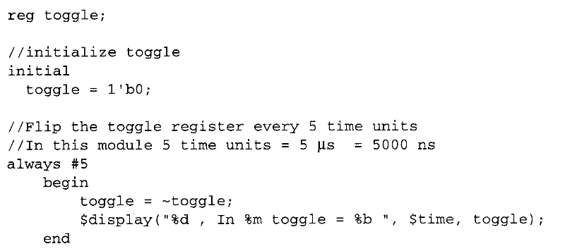

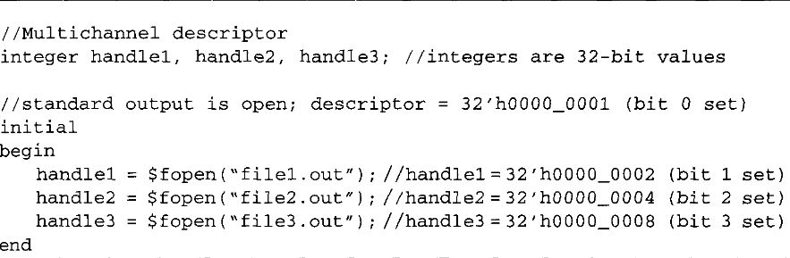

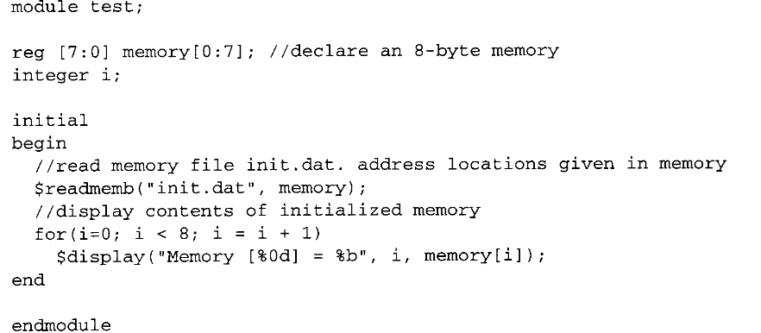

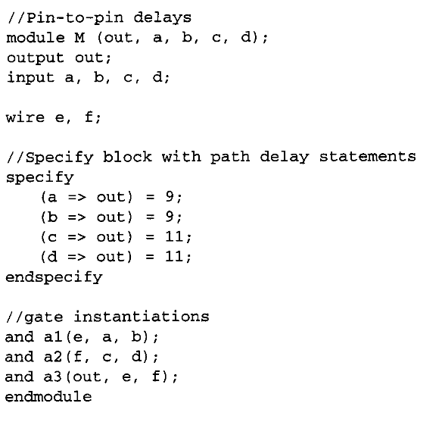

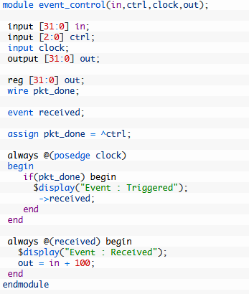
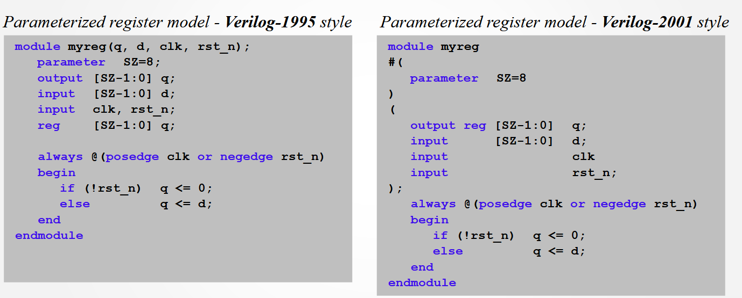

https://indico.in2p3.fr/event/14305/contributions/17793/attachments/14707/18027/ChFlouzat-Intro2theDigitalFlowInMixedEnv-FrontEnd.pdf

https://books.google.fr/books?id=CGZPGmac9JwC&pg=PA150&lpg=PA150&dq=verilog+bus+glitch&source=bl&ots=KTi-choxKR&sig=ACfU3U3UG4SQ2fXdYrhkqLzUEb4Qr9Difg&hl=fr&sa=X&ved=2ahUKEwjdtNT7gPHgAhUG3uAKHa_6ChcQ6AEwAHoECAMQAQ#v=onepage&q=verilog%20bus%20glitch&f=false ++++
code
https://www.springer.com/gp/book/9783319047881#reviews

