https://github.com/mikemat/SmartHome-Server/blob/master/smart_home1.c

SimpleMjpegView
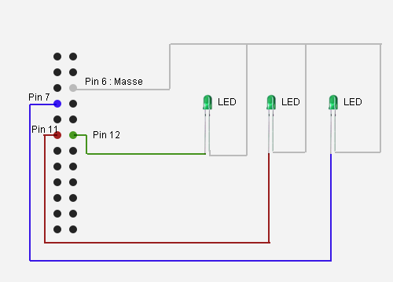
Les pins 7,11,12,13,15,16,18 et 22 (en vert) sont les ports que nous pouvons utiliser pour nos magouilles
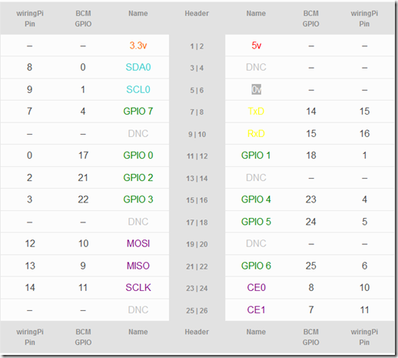
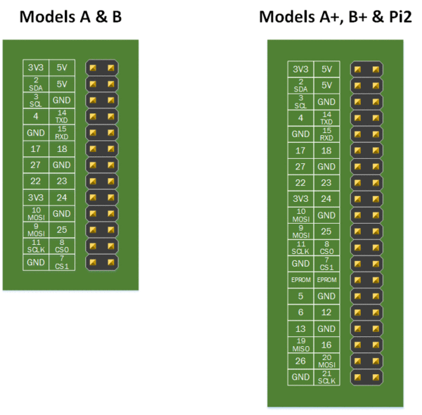
import RPi.GPIO as GPIO ## Import GPIO library
import time ## Import 'time' library. Allows us to use 'sleep'
GPIO.setmode(GPIO.BOARD) ## Use board pin numbering
GPIO.setup(7, GPIO.OUT) ## Setup GPIO Pin 7 to OUT
##Define a function named Blink()
def Blink(numTimes,speed):
for i in range(0,numTimes):## Run loop numTimes
print "Iteration " + str(i+1)## Print current loop
GPIO.output(7,True)## Switch on pin 7
time.sleep(speed)## Wait
GPIO.output(7,False)## Switch off pin 7
time.sleep(speed)## Wait
print "Done" ## When loop is complete, print "Done"
GPIO.cleanup()
## Ask user for total number of blinks and length of each blink
iterations = raw_input("Enter total number of times to blink: ")
speed = raw_input("Enter length of each blink(seconds): ")
## Start Blink() function. Convert user input from strings to numeric data types and pass to Blink() as parameters
Blink(int(iterations),float(speed))

http://pi4j.com/example/control.html
https://calpilot.wordpress.com/2014/05/11/raspberry-pi-and-pi4j-tutorial-1/

gpio -g mode 4 out
gpio -g write 4 1
gpio -g write 4 0
Thread.sleep(4000);

Installing Pi4J

Pi4J is installed quite simply on the Pi by using the following commands which will download and install the distribution;

wget http://pi4j.googlecode.com/files/pi4j-0.0.5.deb
sudo dpkg -i pi4j-0.0.5.deb

Pi4J is now installed in /opt/pi4j. This comes with some example classes and a build script which you can now run. this will also test that your java install is set up correctly. Navigate to the examples root and run the build as follows

cd /opt/pi4j/examples/
./build

You can now test the examples. I have a PiFace connected to my Pi, and there are a couple of test classes on mine so I ran the following command to run one of them. Note the class declaration which you must use in the java command in order to pick up the P14J libraries. You also have to be in the correct location to pick up the class - i.e. /opt/pi4j/examples

cd /opt/pi4j/examples/
sudo java -classpath .:classes:/opt/pi4j/lib/'*' PiFaceGpioExample

And that's it - Java installed and classes running in a few simple steps!
http://pi4j.com/install.html

https://github.com/ffxmph/Projet.git

