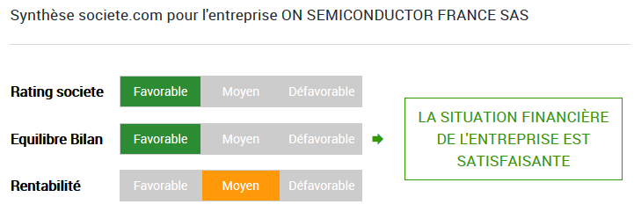


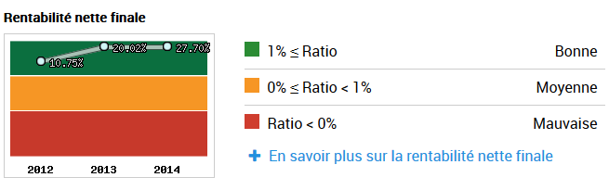

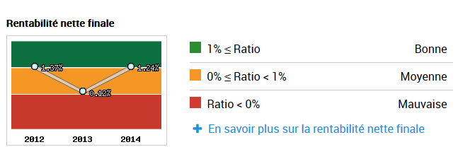

1.6 105000

VA | 8171900
masse salariale | 8000000
capitaux propres | 14896200
benefice | 2891700
1/2 . [2.8 – (0.05 * 14.8) ) * ( 8 / 8.17)
