Recrutement
https://zety.fr/blog/cv-en-anglais
https://modeles-cv.fr/builder/onboard/start?from=blog
http://neil.minkley.fr/anglais-pratique/pdf/CV_EN.pdf
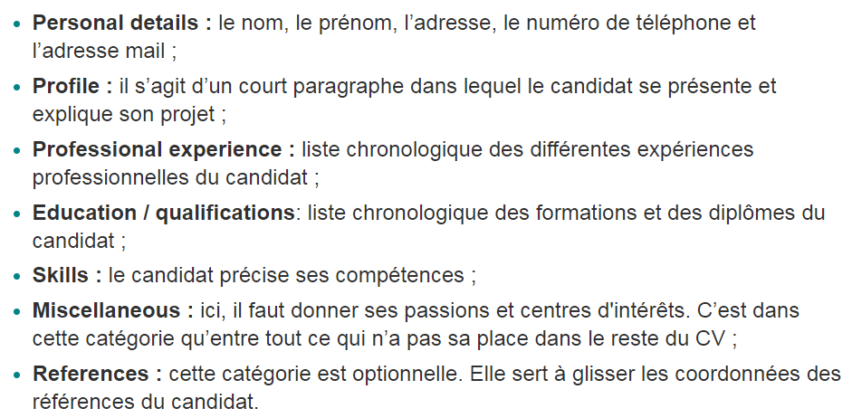

https://www.modeles-de-cv.com/exemple-cv-classique/
https://www.livecareer.com/resume-search/r/analog-design-engineer-54466595079f46b4b2ff909712dd9332
https://www.mintresume.com/resumes/layout-engineer
https://www.velvetjobs.com/resume/layout-engineer-resume-sample
https://www.jobhero.com/resume/examples/electrical-engineering/ic-design-engineer
https://app.qwikresume.com/resumes/e8f2b9f7-ad8e-47b8-87e6-9b726b0299e4?job=Layout%20Engineer
https://www.qwikresume.com/resume-samples/layout-engineer/
https://icmaskdesign.com/analog-layout-engineer-resume/ ??? documentation
https://icmaskdesign.com/careers/
https://www.aroj.com/sample-Engineering/IC-Layout-Engineer-Resume.html

IC Senior Layout Engineer Resume

https://www.velvetjobs.com/resume/layout-engineer-resume-sample
https://www.bestsampleresume.com/examples/engineering/ic-layout-engineer-resume.html
https://fr.indeed.com/jobs?q=Ic+Layout+Engineer&from=mobRdr&utm_source=%2Fm%2F&utm_medium=redir&utm_campaign=dt&vjk=d9a5ec0a77185f39
https://fr.indeed.com/jobs?q=Ic+Layout+Engineer&from=mobRdr&utm_source=%2Fm%2F&utm_medium=redir&utm_campaign=dt&vjk=c0991c495364ca22&advn=2420616975043318
https://uk.indeed.com/jobs?q=Ic+Layout+Engineer&from=mobRdr&utm_source=%2Fm%2F&utm_medium=redir&utm_campaign=dt&vjk=980fba7efb065579
https://uk.indeed.com/jobs?q=Ic+Layout+Engineer&from=mobRdr&utm_source=%2Fm%2F&utm_medium=redir&utm_campaign=dt&vjk=cc000c72b0be1a79

IC Layout Engineer Resume

As a member of the product development (layout) team, you will be in-charge of:
- Translation of schematic designs into mask layouts.
- Floor-planning in Analog cell/block to chip-level layout with good matching.
- Verifications of layout to ensure in compliance with foundry design rules and design requirements.
- Generation of mount bond diagram for assembly checks.
- Proper documentation and checks for all tape-outs.
Profile
- Graduated with a Degree or Diploma in Electrical/Electronic Engineering with a specialization in Microelectronics.
- Minimum 5 years of related experience in custom layout.
- Strong layout skills in understanding of critical matching, electro-migration, latch-up and ESD.
- Experience in CMOS and BCD process technologies.
- Familiar with Unix, Cadence Virtuoso XL, Mentor Graphics Calibre tools and environment.
- Discipline and committed team player to work in a diversified environment.
Work closely with Design team from chip planning to tape-out
Ensure on-time delivery and high quality of layout design
https://www.glassdoor.sg/Job/ic-layout-design-engineer-jobs-SRCH_KO0,25.htm
- Expert-level knowledge with Cadence Virtuoso tool suite.
- Able to work independently on challenging problems.
Strong experience in advanced node IC layout
Excellent communication skills (both oral and written)
- Project Leadership – determine and plan layout schedules and deliverables
- Be able to lead a team to complete a full-scale of layout development task (including scheduling tracking)

- Continuous driving methodology development and flow improvement

THE PERSON:
Candidate shall be basically an individual contributor with leadership skills. Candidate shall be able to manage timelines effectively and quality oriented. Good layout electrical parameter knowledge along with quick learning capabilities.

KEY RESPONSIBILITIES:
- Full-custom layout design of CMOS high speed and high performance analog mixed signal circuits.
- Cell based layout design (auto place and route) of high speed digital circuits
- Ownership up to entire Gigabits Transceiver (GT) top level or Chip level
- Be able to lead a team to complete a full-scale of layout development task (including scheduling tracking)
- Project Leadership – determine and plan layout schedules and deliverables
- Interface with design engineers, peer layout designers and other internal support groups
- Design high quality layouts meeting circuit design requirements by applying knowledge on analog layout techniques and wide spectrum of process technologies from 16nm and below, and layout methodologies such as hierarchical planning, integration
- Design should also meeting Process technology-dependent terminologies like device matching, electro-migration, advanced process proximity effects and special techniques like designing latch-up & electro-static discharge immune layouts
- Floor plans complex integration layout with considerations of circuit behaviour and integration requirements
- Verify the correctness and integrity of the layout with respect to design rules, schematics, and integration guidelines.
- Able to run and analyses RC extraction and EM analysis for layout optimization purposes
- Able to do chip floor plan, assemble and verification with digital IP from PNR, foundry IP and analog top level.
- Communication with ESD engineers to implement ESD strategy
- Follow all the necessary prescribed procedures as part of the quality system.
- Collaborate with circuit design team to develop a fully functional silicon product (including project scheduling)
- Perform the above listed duties using advance EDA tools like Cadence Virtuoso Layout XL/GXL suite , Mentor Calibre verification suite & etc.
- Continuous driving methodology development and flow improvement
- Driving layout productivity improvement initiatives (pcell development and automation)
- Other responsibilities include supervision of layout contractors (onsite and offsite), assessing and correcting layout quality issues, and providing feedback to design teams.

JOB REQUIREMENTS:
- At least six (6+) years of layout design experience in lower process nodes
- Good understanding of reliability concepts and layout electrical parameters/closure
- Hands-on experience using Cadence and Mentor tools or equivalent
- Strong debug capabilities with parasitic extraction, LVS/DRC, and other physical/electrical verification checks
- Familiarity with circuit design concepts/flows and IC manufacturing processes
- Understanding of parasitic impact on circuit performance and/or digital SoC flow is a plus
- Scripting skills is a plus (Perl, Python, Tcl, etc…)
- Ability to work across functions, levels, and remote sites
- Ability to work outside of official working hours, if assigned, to support remote design teams
- Outstanding communication skills and teamwork

ACADEMIC CREDENTIALS:
- Bachelor’s in Electrical/Electronics Engineering is required
- Master’s in Electrical/Electronis Engineering is preferred
- Any certification course(s) in VLSI custom layout field will be an added advantage

ASIC Physical Design Engineer
Responsibilities
- Advanced low-power physical design/integration flow development
- Synthesis, floor planning and place & route
- Full-chip floor planning and layout
- Power network design and analysis
- Support signoff timing closure, power integrity, and signal integrity
- Physical Verification using DRC, LVS
Qualifications
- Degree or related field required
- 3+ years industry experience required
- Experience on high performance and low-power physical design
- Experience on deep sub-micron process technology (14nm and below) taped outs
- Experience on floor planning, power network design, power optimization/analysis, clock-tree design, static-timing analysis, DRC, LVS
- Excellent interpersonal and communication skills
- Experience on using Perl, TCL, Make, and other script languages
- Experience on Synopsys or Cadence tools (Design Compiler, IC Compiler, StarRCXT, Primetime, Innovus)
- Experience on Mentor or Synopsys verification tools (Calibre, ICV)

- Responsible for in-house IP / library developments / Full chip integration

- Implement top quality layout which meet the specifications set forth by designers and layout leads while meeting the project objectives and fast paced milestones

- Good knowledge in analog layout fundamentals, such as floorplan, device matching, EM and IR
- Knowledge of microelectronic fundamentals & semiconductor electronics

Sr. IC Layout Design Engineer

https://www.salary.com/job/spacex/sr-ic-layout-design-engineer/j202302062331469055327
- Design full custom layout for analog and mixed signal blocks for NVM memories
- Provide pre-layout block size and schedule estimations
- Apply best layout practice such as device matching, signal integrity, ESD and Latch Up prevention, etc.
- Run DRC, LVS and parasitic extraction
- Experience in block level layout verification, RC&EM extraction
Experience in top level integration and sign-off verification checks, EMIR fixes
IR/EM (customSim, Voltus) , calibre DRC/LVS/DFM, Virtuoso , LPE (StarRCxt, XRC, XAct ,...)

Requirements:
- PhD with 7 years of experience or MSc with 10+ years of analog design experience
- In depth familiarity with transistor level circuit design - sound CMOS design fundamentals
- Experience with FinFET technologies
- Detailed design experience with at least one, and familiarity with several other DDR or SerDes sub-circuits:
- receive equalizers, samplers, voltage/current-mode drivers, serializers, deserializers, voltage-controlled oscillator, phase mixer, delay-locked loop, phase locked loop, bandgap reference, ADC, DAC
- Experience of ESD protection, ESD network review and debug (i.e. circuit techniques, layout for ESD/Latch-UP protection robustness).
- Familiarity with custom digital design (i.e. high-speed logic paths).
- Knowledge of design for reliability (i.e. EM, IR, aging, etc.).
- Knowledge of layout effects (i.e. matching, reliability, proximity effects, etc.).
- Experience with tools for schematic entry, physical layout, and design verification.
- Hands-on experience with physical layout of high-speed circuits is a plus.
- Knowledge of SPICE simulators and simulation methods.
- Knowledgeable in Verilog-A for analog behavioral modeling and simulation-control/data-capture.
- Experience with TCL, Perl, C, Python, MATLAB, or other scripting languages is desired.
- Good communication and documentation skills.

As an Analog Design Engineer and as part of the Analog IP team the individual will:
- Work with analog design lead and architects to design specific analog IP blocks
- Simulate analog circuits across process corners and operating conditions
- Models design blocks to be included on top level mixed signal simulations
- Block level validation of process silicon devices and system level lab evaluation
Analog layout design

Requirements/Qualifications:
- Bachelor's or master’s degree in Electrical Engineering
- Minimum 5 years’ experience as an IC layout designer using deep submicron CMOS process technology
- Knowledge of chip level integration and ESD concepts is a plus
- Knowledge in scripting using SKILL language, Perl and TCL is a plus
- Strong knowledge in Cadence IC layout flow and tools
- Familiar with Innovus, is a plus
- Experience in layout verification and debugging such as DRC, ERC, LVS, ANTENNA DRC
- Floor planning from sub-block to chip top level
- Very good understanding of matching techniques
- Knowledge in TCL, Perl, Python and/or SKILL languages is a plus
- Good communication, teamwork skills and experience working with multi-site team desirable

Analog IC Design Engineer – Power Management

- experience in analog/mixed-signal layout design of deep sub-micron CMOS circuits
- Experience implementing analog layouts to achieve tight matching, low noise, and low power consumption. Layouts may include analog blocks, resistors, capacitors, pad IOs, ESD structures, etc.
- High level of proficiency in custom and standard cell based floor-planning and hierarchical layout assembly.
- Must understand techniques for managing IR drop, RC delay, electromigration, self heating and coupling capacitance.
- Must recognize failure prone circuit and layout structures, have experience with analog and DFM best practices, and proactively work with circuit designer to identify the best approach to solving problems.
- High level proficiency in interpretation of CALIBRE DRC, ERC, LVS, etc. reports.
- Knowledge of MENTOR GRAPHICS or CADENCE layout tools.
- Scripting skills in PERL or SKILL are considered a plus, but not required.
- Excellent communication skills and able to work with cross-functional teams.

esponsibilities:
Candidate would oversee the complete design of large full custom analog mixed signal layout blocks. Working collaboratively with circuit design engineers to meet product schedules. Driving the creation from the beginning floor planning stage to routing, physical verification (LVS/DRC/ERC), running in-house quality checks and final checklist. Will need to direct and review work from other team members locally and across sites giving daily guidance and feedback. Will also need to pass on weekly status to the program managers. The candidate would also contribute to the overall development of layout flows, automation and methodology within the layout organization.
Requirements:
- Typically requires a minimum of 5+ years of related experience.
- Has a solid desire to learn and explore advanced deep submicron technology nodes.
- Demonstrates good investigation and problem-solving skills.
- Has good communication and documentation skills.
- Builds productive internal/external working relationships. Contacts are primarily within business unit and occasional organizational and external customer contacts on routine matters.
- Would need to work semi-autonomous and be able to direct and collaborate with remote layout resources.
- Must have a solid working knowledge of DRC, LVS and be able to debug results.
- Prior knowledge and proficiency of schematic driven layout editor tools such as Virtuoso XL or Custom Compiler SDL is required.
- Must be familiar with creating quality layout with consideration for device matching, DFM and current requirements (EMIR).
- Should be familiar with using foundry design rule manuals to debug DRC errors. Working knowledge of PERC, latch-up risks and related ESD components for I/O pads is highly desired.
- Other pluses are:
  - TCL, SKILL, Python or other language scripting.
  - Experience with MS Office tools like PowerPoint, SharePoint, Visio, Word, etc.
The base salary range across the U.S. for this role is between $117,000 to $204,000. In addition, this role may be eligible for an annual bonus, equity, and other discretionary bonuses. Synopsys offers comprehensive health, wellness, and financial benefits as part of a of a competitive total rewards package. The actual compensation offered will be based on a number of job-related factors, including location, skills, experience, and education. Your recruiter can share more specific details on the total rewards package upon request.

- Solid understanding of RC delay, electromigration, and coupling.
- Understanding of guard rings, DNW, PN junctions, and advanced process effects such as LOD, WPE, etc.

Co-work with designers on block level and top-level floorplanning. - Layout review for power/gnd routing, electromigration, signal path check, differential and IQ matching, and signal coupling. - Top-level layout integration and verification, schedule management.
- Floor planning from sub-block to chip top level

- Very good understanding of matching techniques
- Experience of critical analog layout design of blocks such as Temperature sensor, PLL, ADC, DAC, Bandgap, Ref Generators, Current Mirrors, Comparator, Differential Amplifier, etc.

- Optimize layout design for matching, parasitic reduction, reliability, etc.
density optimization to reduce cost (slack)
- Experience in manual full-custom analog layout of IC in CMOS/Bi-CMOS process
- Excellent team player
- Consider trade-off analysis/optimization and common layout issues (noise, power vs. performance, dynamic range, device mismatch, etc.) in back-end design for analog/mixed-signal, RFIC, and SoC projects.

RESPONSIBILITIES:
- Serve as Team Lead, collaborating with the design team on analog/mixed-signal layout for high-performance analog circuits including ADC/DACs, PLLs, Op-Amps, LDO regulators, oscillators, etc.
- Complete layout tasks and address issues such as multi-Vt design, electromigration, current density issues, IR drop, and power distribution issues.
- Consider trade-off analysis/optimization and common layout issues (noise, power vs. performance, dynamic range, device mismatch, etc.) in back-end design for analog/mixed-signal, RFIC, and SoC projects.
- Foster strong relationships with all team members and engineering leadership.

QUALIFICATIONS & SKILLS:
- 5+ years of experience in transistor-level IC design and layout of complex analog circuits; RF circuit experience a plus.
- Comfortable using current version of the Cadence® Virtuoso® XL or GXL Layout Suites (IC6.1.n and Virtuoso Advanced Node ICADVM18.n).
- Familiarity with trade-off analysis/optimization and common layout issues such as noise, power vs. performance, dynamic range, device mismatch, etc.
- Experience with advanced nodes and innovative layout methodologies, including FinFET and deep sub-micron CMOS technologies.
- Familiarity with Mentor Calibre verification tool.
- Experience scripting/developing solutions to automate analog layout functions is a plus.
- Demonstrated ability to get the job done with minimal direction/supervision.
- Excellent management and communication skills with the ability to mentor and develop staff while interfacing effectively with upper management and external customers.
- Demonstrated ability to plan, organize, and prioritize tasks to meet deadlines and drive initiatives to completion.

MINIMUM REQUIREMENTS: (Candidates must meet the following criteria to be considered.)
- Associate’s or Bachelor’s Degree in Electrical or Computer Engineering (or an equivalent course of training with at least 5 years of custom ASIC/SoC design and integration).
- Must be able to communicate with native-level fluency in written and spoken English.
- Ability to work efficiently from home utilizing video-/audio-conferencing technologies (Zoom, Microsoft Teams, etc.).
- Must be a U.S. person with permanent authorization to work and reside in the United States. *

Position Responsibilities:
- Proficiency in custom and standard cell-based floor-planning and hierarchical layout assembly.
- Understanding of IR drop, RC delay, electro migration, self-heating and coupling capacitance management techniques.
- Proficiency in physical verification including DRC, LVS, and ERC, Support parasitic extraction and analysis.
- Scripting skills are considered a plus.
- Good communication skills and ability to work with a cross-functional team
- Working closely with the IC design team on layout floor planning and implementation to product finalization
- From component level layout up to top-level chip assembly
- Verification including DRC, LVS, and ERC
- Support parasitic extraction and analysis
- Drive continued improvement of layout practices and procedure
- Written and verbal communication of requirements and responsibilities in all platforms
- 5+ years experience in full-custom analog mixed-signal IC layout
- Through understanding of industry standard EDA tools from Cadence, Mentor, and Synopsys
- Standard cell development experience and/or familiarity with structured, pitched, or arrayed layout
- Experience in layout of FinFET technologies.
- Knowledge of performance analog and high-power layout techniques
- Experience exercising and debugging the IC verification flow (DRC, LVS, XOR, PEX, etc.)
- Demonstrated experience in successfully tapeouts of production IC’s
- Self-motivated—requiring minimal supervision

ASIC Layout Design Engineer

Qualifications
- Ability to plan and complete assignments independently by understanding customer requirements and calls attention to issues that impact customer satisfaction
- Effectively work with co-workers to achieve goals and solve problems. Demonstrate the ability to lead a small to medium project
- Good analytical, debug and problem-solving skills in resolving layout design challenges and physical verification issues.
- Flexible to work in a cross functional and multi-site team environment, spanning different time zones
- Must have good verbal and written communication skills

https://www.naukri.com/layout-design-engineer-jobs-2

Job description
- Bachelors or Masters Degree and or PhD in Electrical/Electronics Engineering, Microelectronics or related fields and 8+ years of related professional experience.
- Good understanding of advanced semiconductor technology process and device physics.
- Full-custom circuit layout/verification and RC extraction experience. Experiences in one or more of the following area is preferable : Mixed signal/analog/high speed layout, e.g. SerDes, ADC/DAC, PLL, etc.
- Familiar with Cadence Virtuoso environment and various industry physical verification tools (DRC,LVS,DFM, etc).
- Experiences in advanced technology node under 32nm/28nm/16nm/14nm and FinFET is preferable.
- Experience with EMIR analysis, ESD, antenna and related layout solutions.
- Good communication skills and willingness to work with global team.
- Good learning competency, self-motivated, and ability to work in diverse areas in a flexible and dynamic environment.
- Programming skills, automation and circuit Design background is a plus

Job description
Hands-on experience in developing Analog Layout /IO layout design
• Good exposure on FinFet layouts in lower nodes
• Expertise in using the best and latest features of Cadence and Calibre DRC/LVS
• Good exposure to ESD, LUP, antenna layout challenges, and analyzing/fixing EMIR issues
• Capable of working independently and with the team and getting work done
• The ability to work communicate effectively with global engineering teams

Physical design engeniier

Analog Layout Design Engineer

Job description
Developing analog/mixed-signal layout blocks that are integrated into multiple SoCs. The development of the blocks includes ADCs, DACs, DC/DC converters (buck/boost topologies), comparators, temperature sensors, on-chip sensing circuits, LDOs, GPIOs, etc.

Profile
Familiarity with analog matching requirements and practice of it in layouts is a must
Expertise on Cadence virtuoso custom/analog layout platform
Knowledge of layout techniques for device matching, minimize parasitic, high speed routing.
Working knowledge on various analog IP blocks: DCDC converters, LDOs, PLLs, ADC, DAC, Bandgap ref and other high speed connectivity circuits.
Good understanding of parasitic RC delay, power and signal integrity
Good understanding of layout extractions, verification methods which includes LVS, DRC and ERC checks.
Chip planning and block implementation (ability to estimate layout schedule for a given circuit, layout planning and provide early feedback to circuit design engineers)

https://www.linkedin.com/pulse/how-do-feasibility-study-semiconductor-product-kaushal-jha
++++
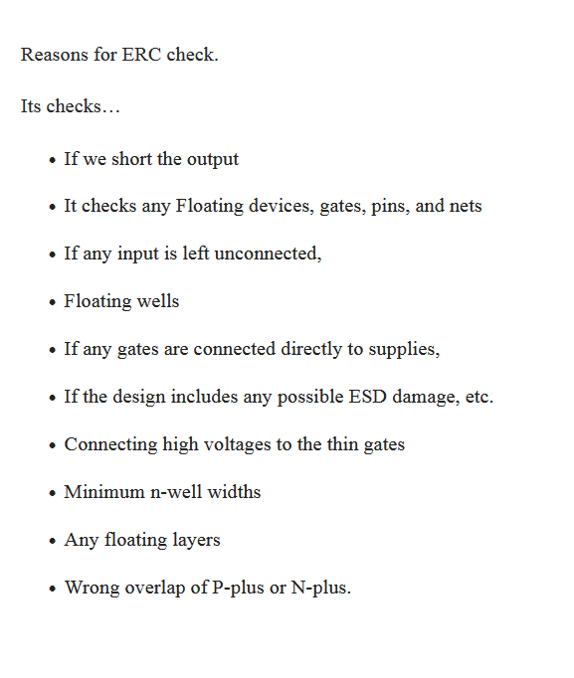

Job description
Developing analog/mixed-signal layout blocks that are integrated into multiple SoCs. The development of the blocks includes ADCs, DACs, DC/DC converters (buck/boost topologies), comparators, temperature sensors, on-chip sensing circuits, LDOs, GPIOs, etc.

Profile
Familiarity with analog matching requirements and practice of it in layouts is a must
Expertise on Cadence virtuoso custom/analog layout platform
Knowledge of layout techniques for device matching, minimize parasitic, high speed routing.
Working knowledge on various analog IP blocks: DCDC converters, LDOs, PLLs, ADC, DAC, Bandgap ref and other high speed connectivity circuits.
Good understanding of parasitic RC delay, power and signal integrity
Good understanding of layout extractions, verification methods which includes LVS, DRC and ERC checks.
Chip planning and block implementation (ability to estimate layout schedule for a given circuit, layout planning and provide early feedback to circuit design engineers)

What are analog layout dependent effects?
Layout-dependent effects (LDEs) have become a critical issue in modern analog and mixed-signal circuit designs. The three major sources of LDEs, well proximity, length of oxide diffusion, and oxide-to-oxide spacing, significantly affect the threshold voltage and mobility of devices.

They will build circuits from novel thoughts or enhancing reuse according to specifications. The designer will evolve in a rich team with key experience in ..

