The Performance and Potential Matrix (9 Box Model)

9-box performance and potential matrix

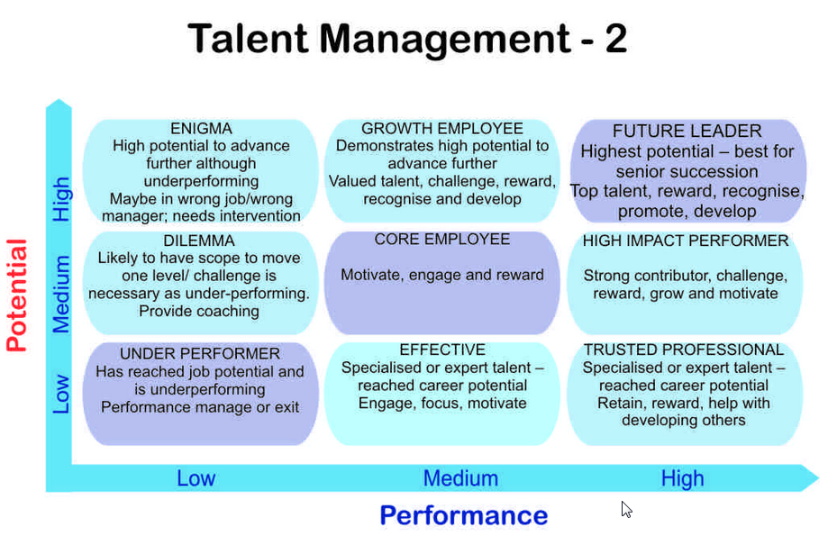

Trusted professional

Specialised or expert talent reached career potential

Retain, reward, help with developing others

Effective – Individuals with high performance levels but low potential. Such employees have reached their full career potential and need to be engaged and motivated to keep going.

3A (high performance, limited potential):
· Ask what motivates them and how they want to develop
· Provide recognition, praise, and rewards
· Provide opportunities to develop in current role, to grow deeper and broader capabilities and knowledge
· Provide honest feedback about their opportunities for advancement if asked
· Watch for signs of retention risks; know how to “save” a “hi-pro” (high professional)
· Ask them to mentor, teach, and coach others
· Allow them to share what they know, presentations at company meetings, external conferences, to be “the highly valued expert”

