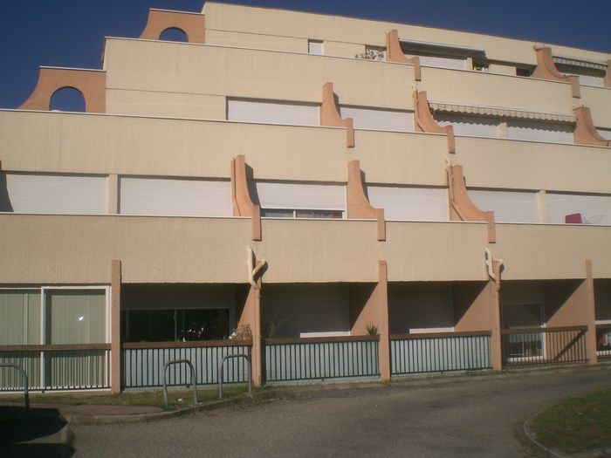
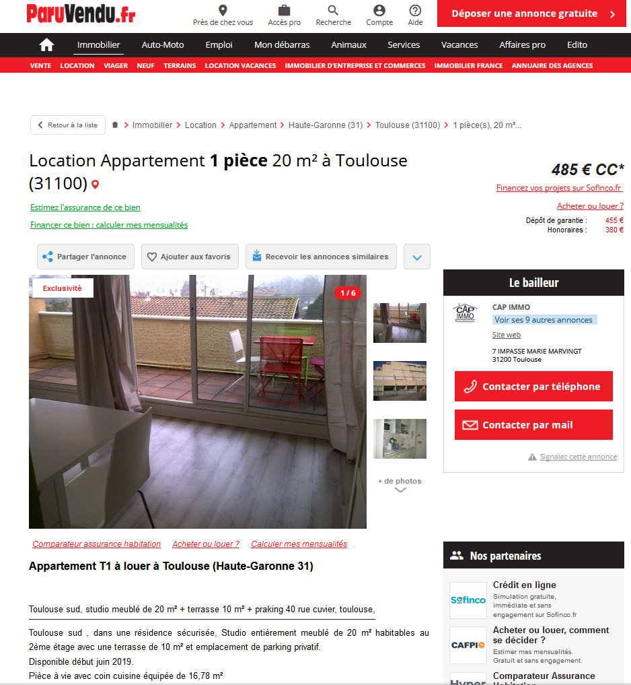

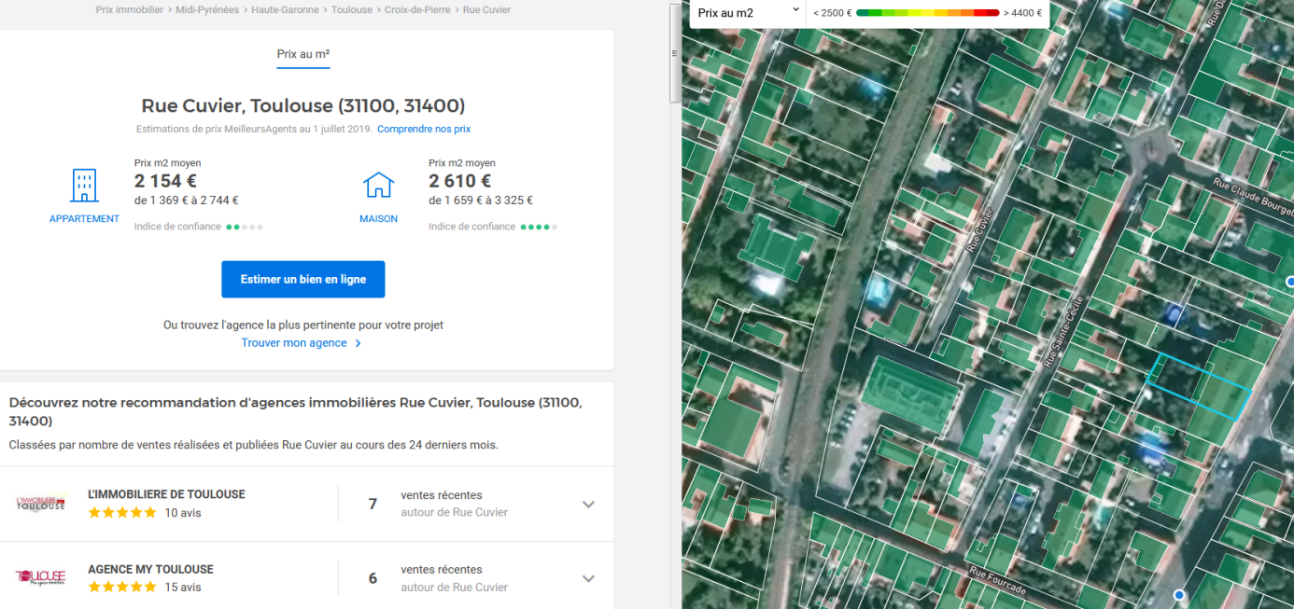

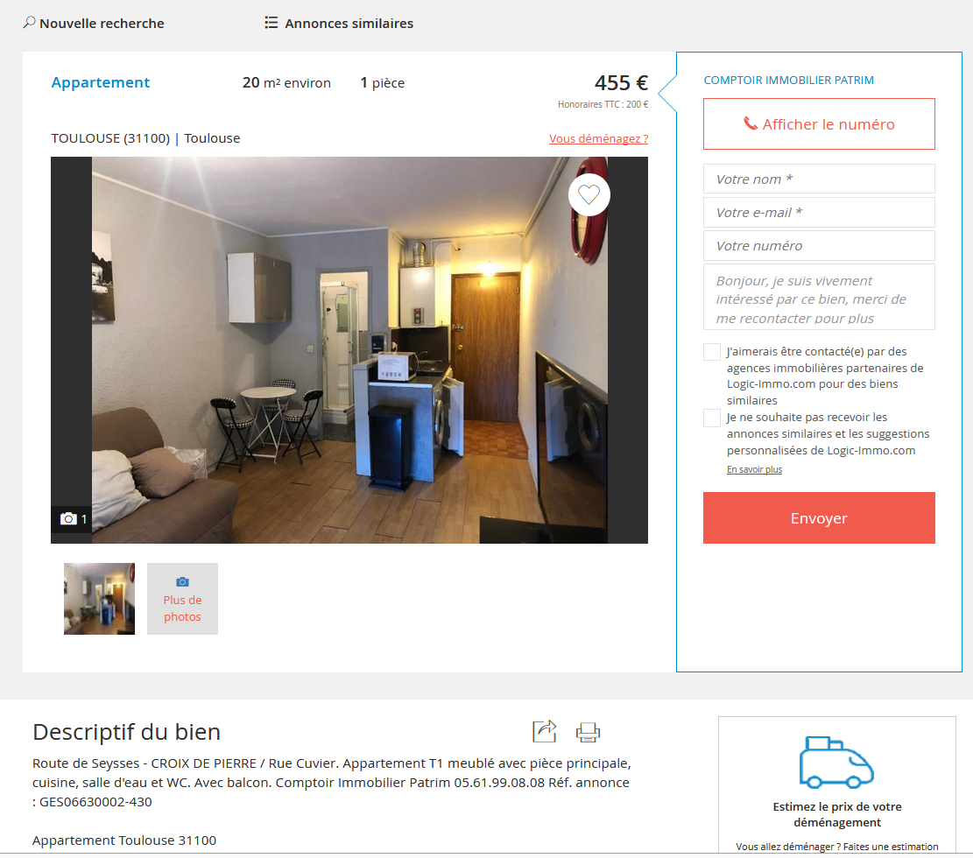

https://www.monsieurparking.com/location/parking-aerien/6625.html
40 Rue Cuvier, 31100 Toulouse
https://www.parkadom.com/parking-40-rue-cuvier-31100-toulouse-france

