https://uat.pauloamaral.com/code/scripts-snippets/burndown-chart-js/
https://perso.liris.cnrs.fr/vdesland/lib/exe/fetch.php?media=start:ens:agile:cours3-taskboard-revue-retro-28s.pdf
https://codepen.io/paulera/pen/ejGKEr
chartsJS
https://jsfiddle.net/derflocki/xnb5jLua/
https://www.youtube.com/watch?v=imYdYPANmD8
https://dyclassroom.com/chartjs/chartjs-how-to-draw-bar-graph-using-data-from-mysql-table-and-php
https://www.nicesnippets.com/blog/php-mysql-charts-js-chart-example-tutorial
https://phppot.com/php/creating-dynamic-data-graph-using-php-and-chart-js/
https://dyclassroom.com/chartjs/chartjs-how-to-draw-line-graph-using-data-from-mysql-table-and-php

https://write.corbpie.com/using-chart-js-with-php-and-mysql/
http://www.java2s.com/example/javascript/chart.js/create-chart-from-form-value.html
https://medium.com/@kingsleyatanang/inserting-data-into-a-mysql-database-table-from-form-b2330b3297b7
https://stackoverflow.com/questions/5466256/add-more-fields-on-form-and-insert-into-mysql-database

https://www.devbabu.com/insert-html-form-data-into-mysql-database-using-php/
https://github.com/xianhuazhou/burndown_chart
https://www.opensourcescrum.com/
https://github.com/andreyluiz/burn-it-down
https://www.methodsandtools.com/archive/scrumburndown.php
https://www.youtube.com/watch?v=_2G3HAdE7Js
burn down chart input data

https://gist.github.com/paulera/422aa0b7facde7618d4e3dab504df090
https://chef-de-projet.fr/burndown-chart/

https://fr.wikipedia.org/wiki/Burndown_chart

burndown chart = graphique d’avancement
Il s’agit d’une représentation graphique de l’évolution de la quantité de travail restante par rapport au temps alloué sur une période de temps donnée.
Le travail restant se situe en général sur l’axe vetical alors que le temps est sur l’axe horizontal
https://www.appvizer.fr/magazine/operations/gestion-de-projet/burndown-chart
https://www.sqlshack.com/how-to-create-an-advanced-sprint-burn-down-chart-in-excel/#gallery-1
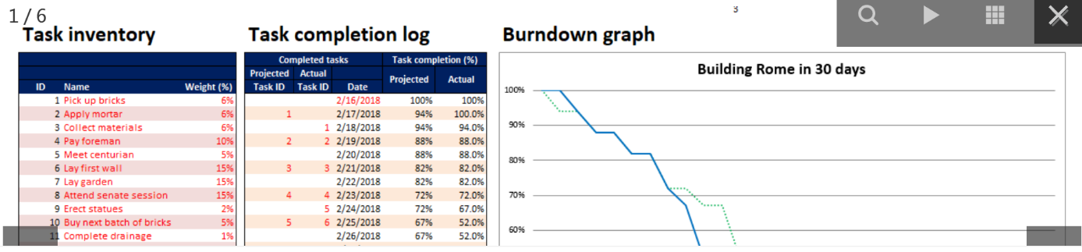
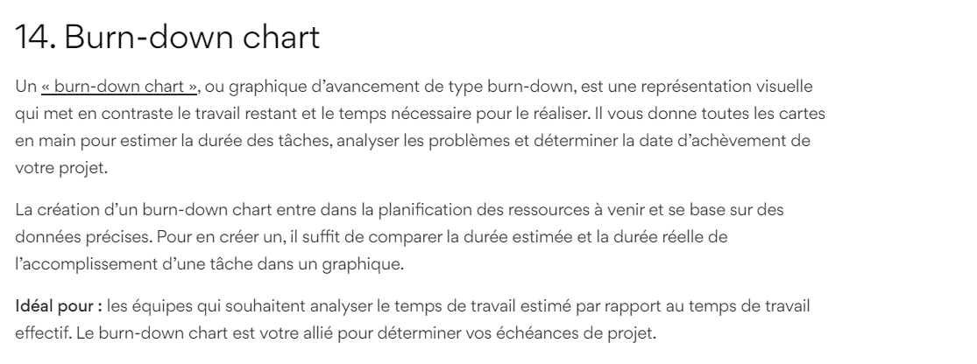
https://hotexamples.com/examples/-/phpMyGraph/-/php-phpmygraph-class-examples.html
https://www.chartjs.org/docs/latest/samples/bar/border-radius.html
https://github.com/xianhuazhou/burndown_chart
https://www.youtube.com/watch?v=J17dOgmjS2c
https://www.youtube.com/watch?v=UeSEGW1SbOw

