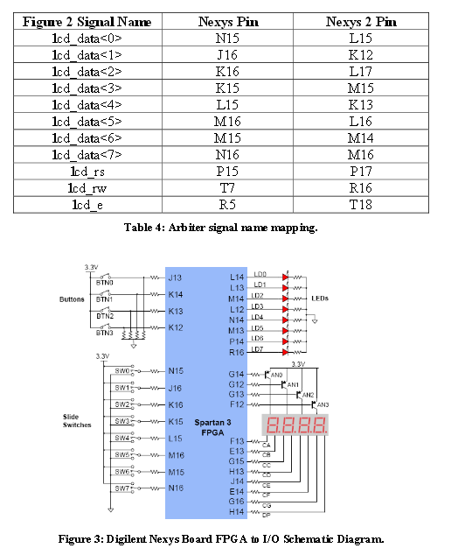

Module "PMOD" afficheur à commande parellèle
Référence : PMODCLP | 30.40 € HT 36.48 € TTC

Lextronic.fr
HD44780
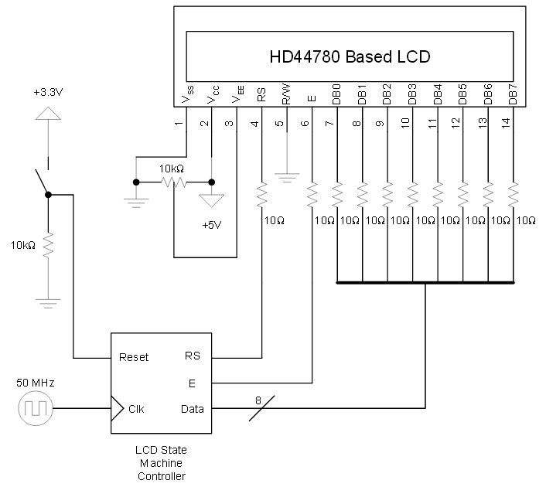
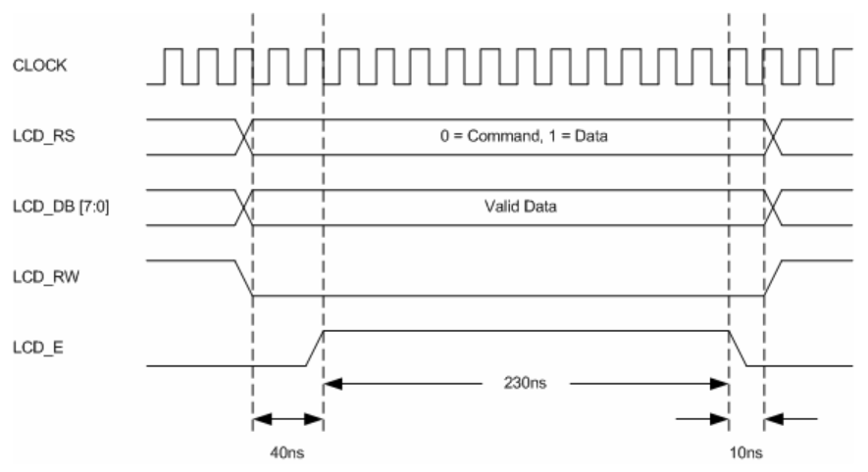
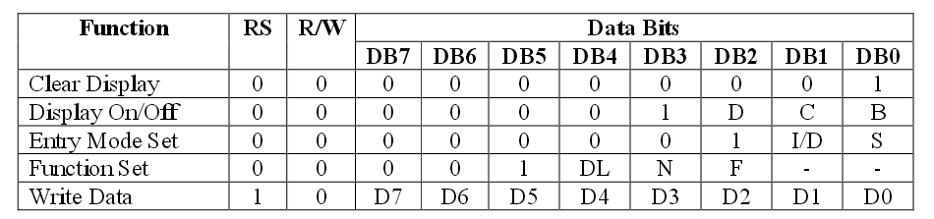

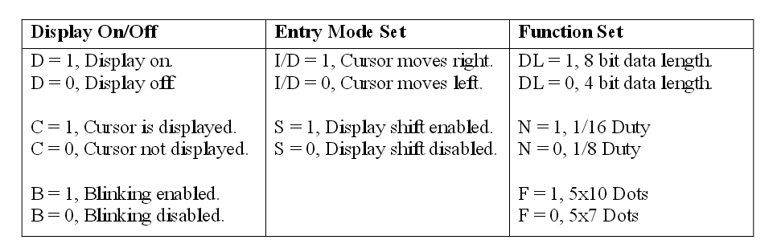
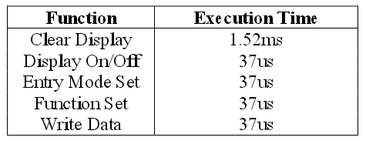
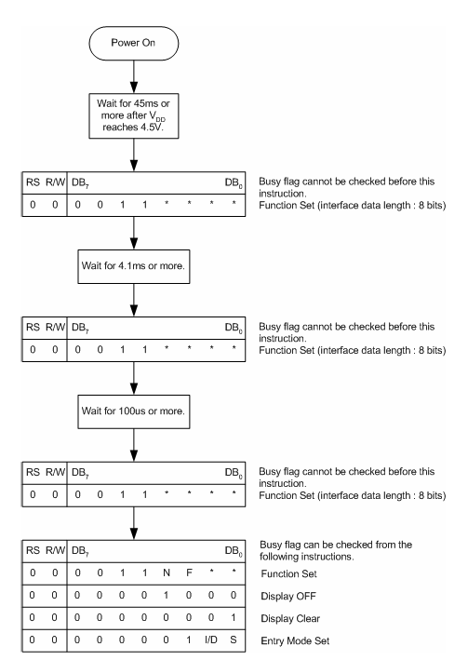
http://www.youtube.com/watch?v=lQ6YKQt6Rz4

`timescale 1ns / 1ps

module LCDTest1(iClock, LCD_E, LCD_RS, LCD_RW, LCD_DB);
input iClock;
output LCD_E;
output LCD_RS;
output LCD_RW;
output LCD_DB;

wire LCD_E;
wire LCD_RS;
wire LCD_RW;
wire[7:0] LCD_DB;

reg e;
reg rs;
reg rw;
reg[7:0] db;

//Responsible for putting the data on the bus
// and then pulsing the LCD_E line for 12 clocks
task WriteNybble;
input reg[3:0] nyb;
begin
db[7:4] = nyb;
#40 e = 1'b1;
#12 e = 1'b0;
end
endtask

initial
begin
#100; //Waiting for global reset to complete

//initialize my variables
e =0;
rs =0;
rw =0;
db =8'b0000_0000;

#750000;//Wait for LCD to come on line ~15 ms

//Do the initialization sequence.
WriteNybble(4'b0011);
#250000;//5 ms
WriteNybble(4'b0011);
#8000;//160 us
WriteNybble(4'b0011);
#8000;//160 us
WriteNybble(4'b0010);
#8000;//160 us

//Function Set 0x28
WriteNybble(4'b0010);
#50;
WriteNybble(4'b1000);
#8000;//160 us

//Entry Mode Set 0x06
WriteNybble(4'b0000);
#50;//1 us
WriteNybble(4'b0110);
#8000;//160 us

//Display On 0x0C
WriteNybble(4'b0000);
#50;//1 us
WriteNybble(4'b1100);
#8000;//160 us

//Clear display 0x01
WriteNybble(4'b0000);
#50;//1 us
WriteNybble(4'b0001);

#85000;//1.64 MS

//Set Initial DD Ram
WriteNybble(4'b1000);//sets to the first spot, upper left
#50;//1 us
WriteNybble(4'b0000);//
#8000;//160 us

rs = 1;
#50;
//0100_0001 - write an 'A' to the screen!!!!
WriteNybble(4'b0100);
#50;//1 us
WriteNybble(4'b0001);
#8000;//160 us
rs=0;

end

//and finally, connect the wires
assign LCD_E = e;
assign LCD_RS = rs;
assign LCD_RW = rw;
assign LCD_DB = db;

endmodule

http://www.cosmiac.org/pdfs/09Tutorial6.pdf

module mylcd(clk, sf_ce0, lcd_rs, lcd_rw, lcd_e, lcd_4, lcd_5, lcd_6, lcd_7);
parameter k = 18;
input clk; // synthesis attribute PERIOD clk "50 MHz"
reg [k+8-1:0] count;
output sf_ce0; // high for full LCD access
reg sf_ce0;

output lcd_e, lcd_rs, lcd_rw, lcd_7, lcd_6, lcd_5, lcd_4;
reg lcd_e, lcd_rs, lcd_rw, lcd_7, lcd_6, lcd_5, lcd_4;

reg lcd_busy;
reg lcd_stb;
reg [5:0] lcd_code;
reg [6:0] lcd_stuff;

always @ (posedge clk) begin
count <= count + 1;
lcd_busy <= 1'b1;
sf_ce0 <= 1; // StrataFlash Chip Enable
case (count[k+7:k+2])
0: lcd_code <= 6'h03; // power-on initialization
1: lcd_code <= 6'h03;
2: lcd_code <= 6'h03;
3: lcd_code <= 6'h02;
4: lcd_code <= 6'h02; // function set
5: lcd_code <= 6'h08;
6: lcd_code <= 6'h00; // entry mode set
7: lcd_code <= 6'h06;
8: lcd_code <= 6'h00; // display on/off control
9: lcd_code <= 6'h0C;
10: lcd_code <= 6'h00; // display clear
11: lcd_code <= 6'h01;
12: lcd_code <= 6'h24; // H
13: lcd_code <= 6'h28;
14: lcd_code <= 6'h26; // e
15: lcd_code <= 6'h25;
16: lcd_code <= 6'h26; // l
17: lcd_code <= 6'h2C;
18: lcd_code <= 6'h26; // l
19: lcd_code <= 6'h2C;
20: lcd_code <= 6'h26; // o
21: lcd_code <= 6'h2F;
22: lcd_code <= 6'h22; //
23: lcd_code <= 6'h20;
24: lcd_code <= 6'h25; // W
25: lcd_code <= 6'h27;
26: lcd_code <= 6'h26; // o
27: lcd_code <= 6'h2F;
28: lcd_code <= 6'h27; // r
29: lcd_code <= 6'h22;
30: lcd_code <= 6'h26; // l
31: lcd_code <= 6'h2C;
32: lcd_code <= 6'h26; // d
33: lcd_code <= 6'h24;
34: lcd_code <= 6'h22; // !
35: lcd_code <= 6'h21;
default: lcd_code <= 6'h10;
endcase
lcd_stb <= ^count[k+1:k+0] & ~lcd_rw & lcd_busy;
lcd_stuff <= {lcd_stb,lcd_code};
{lcd_e,lcd_rs,lcd_rw,lcd_7,lcd_6,lcd_5,lcd_4} <= lcd_stuff;
end
endmodule

NET "lcd_e" LOC = "M18";
NET "lcd_rs" LOC = "L18";
NET "lcd_rw" LOC = "L17";
NET "sf_d8" LOC = "R15";
NET "sf_d9" LOC = "R16";
NET "sf_d10" LOC = "P17";
NET "sf_d11" LOC = "M15";
NET "sf_ce0" LOC = "D16";
NET "clk" LOC = "C9";

Interfacing

F = 50 Mhz donc T = 20ns
Tempo de 15ms :
Tempo de 4.1ms :
Tempo de 100us :
Tempo de 40us :
Enable : il faut maintenir à l’état haut pendant au moins 230ns.
Si on prend 240 ns , on obtient 12 cycles d’horloge 12 * 20ns = 240ns

Initialisation de l’afficheur en mode 8 bits
WAIT 15ms
RS | R/W | D7 | D6 | D5 | D4 | D3 | D2 | D1 | D0
0 | 0 | 0 | 0 | 1 | 1 | * | * | * | *
0x30 avec enable = 1 pendant 240ns
WAIT 4.1ms
RS | R/W | D7 | D6 | D5 | D4 | D3 | D2 | D1 | D0
0 | 0 | 0 | 0 | 1 | 1 | * | * | * | *
0x30 avec enable = 1 pendant 240ns
WAIT 100us
RS | R/W | D7 | D6 | D5 | D4 | D3 | D2 | D1 | D0
0 | 0 | 0 | 0 | 1 | 1 | * | * | * | *
0x30 avec enable = 1 pendant 240ns
WAIT 4.1ms
RS | R/W | D7 | D6 | D5 | D4 | D3 | D2 | D1 | D0
0 | 0 | 0 | 0 | 1 | 1 | * | * | * | *
avec enable = 1 pendant 240ns

http://nalhossri.free.fr/LCD4bits.h/Fonctions_LCD4bits.h.pdf
http://www.eng.utah.edu/~cs3710/slides/OtherIOx6.pdf
http://www.xilinx.com/support/documentation/application_notes/xapp904.pdf

